DPT 4th
Course Title: Pharmacology I
Student Name: Aftab ahmad
Student ID: 15096

Note:
Attempt all questions
Each question carry equal marks
Pay attention to every point of question
Give to the point answers
Extra detail may leads to marks deduction

Q 1: What is neurotransmission process ?
Neurotransmission :
Latin word Transmission meaning passage ,crossing
It is a process by which signaling molecules called neurotransmitters are released by axon terminals of a neuron (the presynaptic neuron ) and bind to and react with a receptor on the dendrites of another neuron ( the postsynaptic neuron ) a short distance away .
Neurotransmission is regulated by several different factors :
- The availability and rate of synthesis of neurotransmitters
- Base line activity of postsynaptic cell.
- The number and available postsynaptic receptors for neurotransmitters to bind .
- Subsequent removal or deactivation of neurotransmitters by enzymes or presynaptic reuptake.
Neurotransmission process:
- In response to threshold action potential , a neurotransmitter is released at presynaptic terminal.
- Synthesis of neurotransmitter , This takes place in cell body ,in axon or in axon terminal .
- Storage of neurotransmitter in storage granules or vesicles in axon terminal .
- Calcium enters the axon terminals during an action potential causing release of neurotransmitter into synaptic cleft
- After its release the transmitter binds to and activates a receptors in the post synaptic membrane .
- The post synaptic neuron may receive input from many additional neurons both excitatory and inhibitory
- The excitatory and inhibitory effects are summed up and if the net effect is inhibitory the neuron will be less likely to fire ,and if net effect is excitatorythe neuron will be more likely to fire .
G-protein
regulated
Agonist
Opioid
receptor
G protein
complex
- As a result of it voltage regulated Na ⁺ channels will get open is postsynaptic neuron at the axon hillock. It will propagate along neuron leading to release of neurotransmitter at synaptic button to pass along information to yet another adjacent neuron 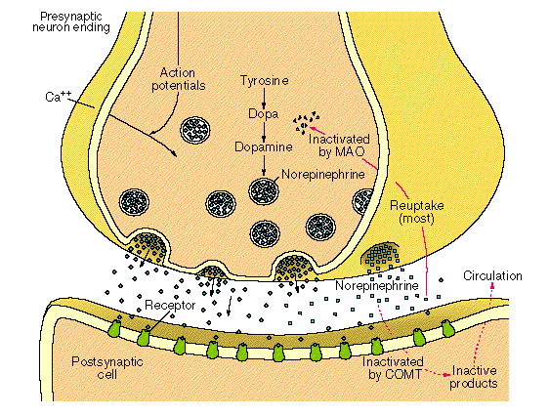
- The neurotransmitter is either destroyed enzymatically , or taken up back into the terminal from which it can be reused , degraded or removed 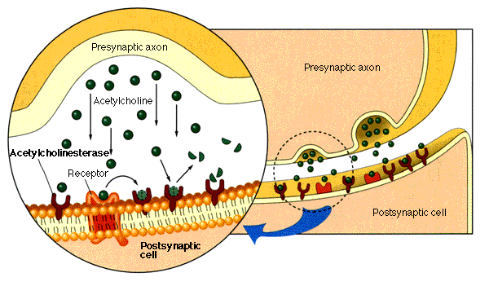Acetylcholine example:
- The precursor choline is transported into cholinergic nerve terminals
- Once synthesized, acetylcholine is transported into vesicles for storage
- Because of the ubiquitous nature of acetylcholine, these drugs are not used in clinical pharmacology Acetylcholinesterase (AChE) is one of only a few enzymes that have obtained near catalytic perfection
- the rate of hydrolysis is close to the rate of diffusion to the active site
- a single enzyme can hydrolyze 14,000 ACh molecules/second
- Blockade of acetylcholinesterase will rapidly increase synaptic levels of acetylcholine
- neostigmine-reversible inhibitor
- sarin, malathion-irreversible inhibitors

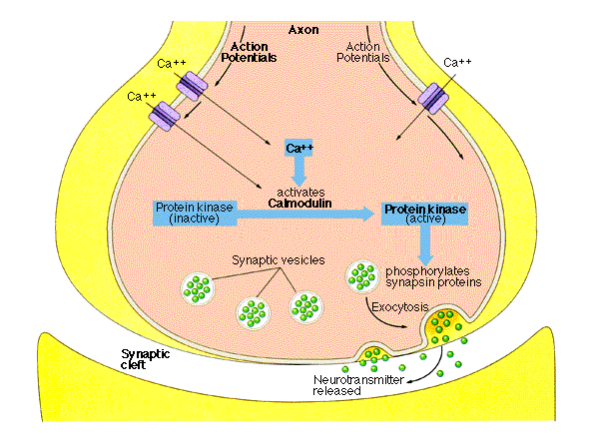

Ans no 2 : Cholinergic Drugs :
Those drugs that causes effects similar to those resulting from introduction of acetylcholine or stimulation of ganglions of the parasympathetic nervous system .
These drugs imitate action of endogenously released acetylcholine .
Cholinomimetic can be classified as :
- Direct acting (receptors agonists ) Acting on muscarinic and nicotine .
- Indirect acting (Cholinesterase Inhibitors ) which in turn can be reversible or irreversible .
Direct acting cholinomimetics :
Drugs that act directly by stimulating cholinergic receptors .
These drugs are divided into
These drugs are divided into drugs that stimulate muscarinic ( M – cholinoreceptors )
Mechanism of action
- Muscarinic receptors are coupled to G-proteins that activate phospholipase C (M₁ and M₃) or inhibit adenylyl cyclase (M₂)
increased production of IP₃ and DAG, decreased levels of cAMP
- These second messengers produce a number of intracellular effects
increase intracellular Ca²⁺ levels and activation of protein kinase C
opening of K⁺ channels --> hyperpolarization of the cell
- Activation of nicotinic receptors produces an influx of Na⁺ ions and depolarization of the cell --> action potential The CNS contains both muscarinic and nicotinic receptors
- Nicotine has important effects on the brainstem and cortex
- stimulant type effects, addiction liability
- high doses can cause tremor and convulsions
- Muscarinic receptors play a role in movement, cognition, learning and memory, and vestibular function
- potential therapeutic applications to CNS diseases, though side-effects limit the clinical use of these agents
- 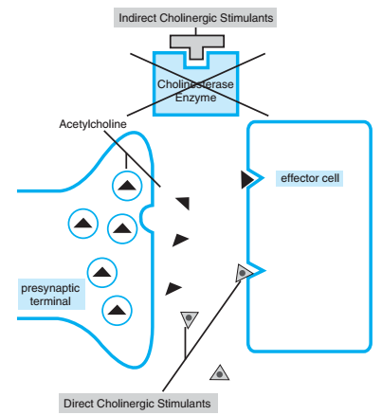

- Nicotinic ( N – cholinoreceptors )
- These mimic the action of endogenous neurotransmitters acetylcholine (Ach) .which is the primary neurotransmitter released from nerve terminal of preganglionic fibers of parasympathetic and sympathetic nervous system .
- Finally those synapse in CNS that contain nicotinic and muscarinic receptors and their stimulation by cholinomimetic agonists allows the penetration of blood brain barrier .

Indirect acting clinometric drugs :
Such as anticholinesterase drugs are inhibitors of acetylcholine metabolism and have similar effect to direct acting cholinomimetics
- These drugs inhibit the hydrolysis of Acetylcholine by the enzyme acetylcholinesterase and produce their cholinomimetic effect indirectly .
- The enzyme acetylcholinesterase prolong the effective life of acetylcholine released from cholinergic nerves .
a. Mechanism of action
- Indirect-acting parasympathomimetics inhibit the enzymatic destruction of acetylcholine by inactivating cholinesterase, leaving acetylcholine free to act on the effector cells.

Therapeutic Applications of cholinergic agents
1. Myasthenia Gravis
- Myasthenia gravis is an autoimmune disorder that attacks the nicotinic ACh receptors at the neuromuscular junction
  - leads to profound muscle weakness
- Acetylcholinesterase inhibitors increase the amount of acetylcholine in the neuromuscular junction
  - neostigmine is frequently used for this disorder
- If muscarinic side-effects are prominent, anticholinergics can be administered (e.g., atropine)
  - tolerance usually occurs to the muscarinic side-effects
2. By increasing levels Neuromuscular Blockade :
  - Acetylcholine in the NMJ, the compounds are able to facilitate recovery from competitive neuromuscular blockade
  - restores neuromuscular transmission
  - Reversal of Neuromuscular Blockad
3. Glaucoma:
Constriction of the ciliary body promotes aqueous humor outflow --> decreased intraocular pressure
Direct and indirect cholinomimetics can be used to treat glaucoma
pilocarpine is the most commonly used agent
typically formulated as eye drops
Ans no 3 :Nitrates :
Nitrates are class of medication not to be confused with the( byproducts from nitrogen fertilizers ) that cause vasodilation by donating nitric oxide (NO .Nitrates exert their effect by dilating venous vessels , coronary arteries and small arterioles , its maximal vasodilation is in venous vessels .
Effects of Nitrates on Angina pectoris :
Nitroglycerine was the first medication used in 1879 by William mar well for treatment of angina pectoris
- They act as vasodilators , coronary vasodilators and modest arteriolar dilators .
- The primary ant ischemic effect of nitrate is to decrease myocardial oxygen demand by producing systemic vasodilation . This systemic vasodilation reduce left ventricular systolic wall stress .
- For patients with stable angina or predictable angina , long nitrates can be used as prophylaxis ,
- Increasing exercise tolerance in patients .
- For patients with acute angina pain , short acting nitrates are useful for symptoms relief .
- Rapid development of tolerance ,loss or diminution of antianginal and antiishenic effect
- Nitrate work by dilatory blood vessels
- Nitrate has been used to treat chest pain since 1870
- Nitroglycerine patchehesapplied to 10-12 hours during day increases exercise duration for 8-12 hours
- Nitrate dilates arteries and veins net only in the heart but also else where in the body .by dilatory blood vessels of the heart by importory blood flow to heart muscles
Adverse effect:
Main adverse effect from nitrate use come from dilation of the venous blood vessels
Other side effect can be reflexes from the activation of sympathetic nervous system or re-exposure after with drawl . these side effect induside
Head ach (grater then 10%)
Hypothensiance (0.1 to 10%)
Syncope (0.1 to 10 %)
Reflex tachycardia methemoglobinenia
Monday disease tachycardia headache and dizziness during re- exposes
- Head ach dizziness
- Light head ach flushing
- Warm feeling in the face not everyone experience these
Treatment algorithm for improving symptoms of stable angina:
- If your angina is stable you may be able to control it with is life style changes and medication treatment for stable angina includes life style changes medication
- You can usually predict when the pain will occur , so reducing physical exertion can help manage your chest pain
- Dietary changes (eating head ach )
- Daily exercise
- Quit smoking
- Blood thinning medication
- Angioplasty
- Bypass graft
- Treat blockages to avoid heart attack

Medication :
Several medication can improve angina symptoms inducing
- Aspirin (anti platelet medication ) make easy for blood flow through narrowed arteries
  - Nitrates: widen blood vessel and allow more blood to flow to your heart muscles
- Beta blocker :
  - These block the effect of hormones epinephrine . due to which heart beat slowly with less force decrease heart effect and angina pain
- Statins :
    - It lower blood cholesterol
- Calcium channel blockers:
  - Then drugs relax and widens blood vessels this increase blood flow in your heart reducing or preventing angina
- Ranolazine (ra na xa )
    - Antianginal medications use as a substitute if your symptoms don’t impore with other medications

Differentiate between primary and secondary hypertension
Primary hypertension: | Secondary hypertension:
Definition:  High blood pressure above 130/80 where no cause is known. | Definition:  High blood pressure above 230/80 where the cause is known.
Prevalence:  - Common, in 85% of people with ↑Bp. | Prevalence:  - Rare, in 15% or less of people with ↑ Bp.
Family history of hypertension:  - Very common | Family history of hypertension:  - Not common
High BMI:  - Very common. | High BMI:  - Not common.
Causes:  - Unknown, but is suspected to be a combination of factors. | Causes:  - Tumor of adrenal gland, causing overproduction of aldosterone.  - Kidney diseases.  - Too little or too much thyroid hormones.  - Problems with the renal arteries.  - Sleep apnea.  - Alcohol and the use of oral contraceptive are also causes of hypertension.
Can be cured:  Since the cause is not known it is usually not possible to cure the condition. | Can be cured:  In some cases the condition can be cured if the underlying cause is treated.

Explain the effect of renin on hypertension.
Renin
↓
Angiotensin 1
↓
Angiotensin 2
↓
Aldosterone
↓
Na⁺ retention
↓
Blood volume ↑
↓
Arterioral wall pressure ↑
↓
Blood pressure ↑

- Renin hormone is released from the juxtamedulary cells of kidneys.
- Angiotensin 1 is released from liver.
- Renin converts the Angiotensin 1 to Angiotensin 2.
- Angiotensin 2 Stimulates the release of aldosterone from adrenal cortex.
- Aldosterone helps in the retention of Na⁺ ions.
- With each Na⁺ ion two water molecules are reabsorbed.
- Blood volume increases due to this increased water reabsorption.
- Thus due to high blood volume the blood pressure also increases.

What is the importance of pharmacological treatment of hypertension.
Pharmacological treatment of hypertension:
- Many types of the drugs using to treat high blood pressure, including :
- Angiotensine converting enzyme (ACE) inhibitors.
- Angiotensine ll receptors blockers (ARBs)
- Diuretics.
- Beta blockers
- Alpha blockers
- Alpha agonists.
- Rennin inhibition.
- Diuretics are often recommended as the first line of the therapy for most person who have high blood pressure.
Importance of pharmacological treatment of hypertension:
The hypertension treatment lowers high blood pressure and protect important organs, like the brain, heart, and kidneys from damage.
Treatment for hypertension reduce an average of:
- Stroke:(reduced an average of 35%-40%),
- heart attack (20%-25%),
- Heart failure (more than 50%),
The aim of antihypertensive therapy is to prevent morbidity and mortality associated with persistently raised BP by lowering it to an acceptable level , with minimum inconvenience to the patient . both systolic and diastolic BP predict the likelihood of target organ damage and complications
Such as :
- cerebrovascular disease , transient ischæmic attacks, stoke, encephalopathy.
- hypertensive heart disease left ventricular hypertrophy, CHF
- coronary artery disease (CAD), angina, myocardial infarction, sudden cardiac death
- Arteriosclerotic peripheral vascular disease, retinopathy
- Dissecting aneurysm
- Glomerulopathy, renal failure
Hypertension shout be treated timely, because chronic high blood pressure (hypertension) left untreated can lead to:
- Blood vessel damage (Arteriosclerosis).
- Heart failure or heart attack.
- Kidney failure

Differentiate between right heart failure and left heart failure.
Left heart failure:
In left heart failure, the left atrium and ventricle are unable to adequately handle the blood retuning from the lungs. This causes pressure to build up in the pulmonary veins, and fluid accumulates in the lungs. Consequently, left heart failure is associated with pulmonary edema.
Right heart failure:
In right heart failure, the right atrium and ventricle are unable to handle blood returning from the systematic circulation. This cause fluid to accumulate in the peripheral tissues, and ankle edema and organ congestion (liver, spleen) are typical manifestations.
If both left and right heart failure occur simultaneously, congestion is found in the lungs as well as the periphery.
Left heart failure | Right heart failure
Definition:  Left CHF happens when the left ventricle can’t pump blood to the body and fluids build up leak into the lungs resulting in shortness of breath. | Definition:  Right CHF happens when the right ventricle can’t properly pump blood to the lungs.  Fluid and blood may backup in the veins that transport blood into the heart. This can result in fluid to leak into organs and tissues thus causing CHF right.
Cause:  - Decreased cardiac output  - Pulmonary congestion | Cause:  - Congestion of peripheral tissues.
Sign and symptoms:  - Fatigue  - Othopnea  - Restlessness  - Confusion  - Extreme weakness  - Cyanosis | Sign and symptoms:  - Bloating  - Anorexia  - Nausea  - Distended neck vein  - Cool legs  - Oliguria
Fluid retention:  - Pulmonary edema  - Pleural effusion | Fluid retention:  - Abdomen (ascites)
Back flow:  Back flow to pulmonary veins. | Back flow:  Back flow to vena cav
Neck veins:  Mild to moderate raised jugular venous pressure. | Neck veins:  Severe jugular venous pressure.  Neck veins are distended.
Clinical manifestation:  Pulmonary congestion, crackles | Clinical manifestation:  Peripheral and visceral congestion.
Final result:  Pulmonary congestion/ edema is the final result. | Final result:  Peripheral generalized edema is the final result.

Summarize the pharmacotherapy of heart failure
Pharmacotherapy:
The basic goal of pharmacotherapy in congestive heart failure is to improve the heart’s pumping ability.
Strategies:
There are two types of strategies of pharmacotherapy.
Strategy 1:
Drugs increases the cardiac contractile performance and produces a positive inotropic effect.
Positive inotropic effect: “inotropic” means force of muscular contraction, so positive inotropic effect means the effect of increasing the muscular contraction and cardiac contractile performance.
Example: primary drugs used to exert a positive inotropic effect are cardiac glycosides.
  - Cardiac glycosides:
Mechanism of action: they inhibits the Na/K ATPase which results in a small increase in intracellular sodium, due to which driving force of sodium calcium exchange is altered and less calcium is removed from the cell. The increased calcium is stored in the sarcoplasmic reticulum and upon release increases contractile force.
Specific agents:
- Digoxin (Lanoxin)
- Digitioxin (Digitaline)
  - Phosphodiesterase inhibitors:
Mechanism of action: These agents cause a cAMP-mediated increase in intracellular calcium, which subsequently increases the force of contraction within the myocardial cell.
Specific agents:
- Inamrinone
- Milrinone
  - Beta-1 agonists:
Mechanism of action: Dopamine and dobutamine stimulates the beta-1 receptor on myocardium, and exerts a fairly specific positive inotropic effect.
Specific agents:
- Dopamine
- Dobutamine
Strategy 2:
Drugs decrease workload through an effect on the heart or peripheral vasculature (vasodilation), or by controlling fluid volume.
Examples:
- Angiotensin converting enzyme inhibitors
- Beta blockers.
- Diuretics
- Vasodilation
- Drugs affecting the Renin-Angiotensin system:
  - Angiotensin converting enzyme inhibitors.
Mechanism of action: ACE inhibitors suppress the enzyme that converts angiotensin 1 to angiotensin 2 in the blood Stream. Angiotensin 2 is a potent vasoconstrictor. By inhibiting the formation of angiotensin 2, ACE inhibitors limit peripheral vasoconstriction. This effect results in a decrease in cardiac workload primarily by decreasing the pressure against which the heart must pump(cardiac afterload). Decreased cardiac afterload eases the strain on the failing heart, resulting in improved cardiac performance and increased exercise tolerance.
Specific agents:
- Captopril (Capoten)
- Enalapril
  - Angiotensin 2 receptor blockers:
Mechanism of action: These drugs prevent angiotensin 2 from binding to receptor on vascular tissues, thus inhibiting angiotensin 2-induced damage of the cardiovascular system. It appears that ARBs are as effective as ACE inhibitors in treating heart failure and preventing mortality
Specific agents:
- Candesartan,
- Losartan
- Valsartan
- Beta blockers:
Mechanism of action: Beta blockers bind to beta-1 receptors on the myocardium and block the effects of norepinephrine and epinephrine.
These drugs therefore normalize sympathetic stimulation of the heart and help reduce heart rate (negative chronotropic effect) and myocardial contraction force (negative inotropic effect)
Specific agents:
- Acebutolol (Sacral)
- Atenolol (Tenormin)
- Certeolol (Cartol)
- Carvedilol ( Coreg)
- Labetolol (Normodyne, Trandate)
- Metoprolol (Lopressor)
- Diuretics:
Mechanism of action: Diuretic work by inhibiting the reabsorption of sodium from the nephron, which, in turn decreases the amount of water that is normally reabsorbed with sodium, thus increasing water excretion. This effect reduces congestion caused by fluids retained in the body and decreased cardiac preload by excreting excess fluid in the vascular system.
Specific agents:
- Furosemide
- Thiazide diuretics
- Spironolactone
- Eplerenone
- Vasodilators
Mechanism of action: Produce vasodilation by blocking alpha-1 receptors on vascular smooth muscle. These vasodilators work by different mechanisms, they all can decrease cardiac workload by decreasing peripheral vascular resistance.
Specific agents:
- Prazosin, hydrazine and organic nitrates (e.g nitroglycerin, isosorbide dinitrate, sodium nitroprusside).

