Iqra National University

Department of Civil Engineering

Final- Term Summer Assignment 2020

Discipline: MS Civil Engineering
Course Title: Advance Mechanics of Material Instructor Name: Engr. Fawad Ahmad
SUBMITTED BY: Syed Muhammad
ID: 15403

Date: 01/10/2020
Q1
Application of Mohr’s Circle:

Mohr's Circles for 3-D Stress Analysis
The 3-D stresses, so called spatial stress problem, are usually given by the six stress components σ_{x}€, σ_{y} , σ_{z}, τ_{xy} , τ_{yz} , and τ_{zx} , (see Fig. 3) which consist in three-by-three symmetric matrix (stress tensor):

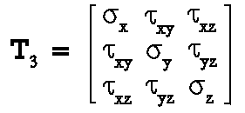

What people usually are interested in more are the three principal stresses σ₁ , σ₂ , and σ₃which are eigenvalues of the three-by-three symmetric matrix of Eqn ,and the three maximum shear stresses τ_{max1} , τ_{max2} , and τ_{max3} , which can be calculated from σ₁ , σ₂ , and σ₃.
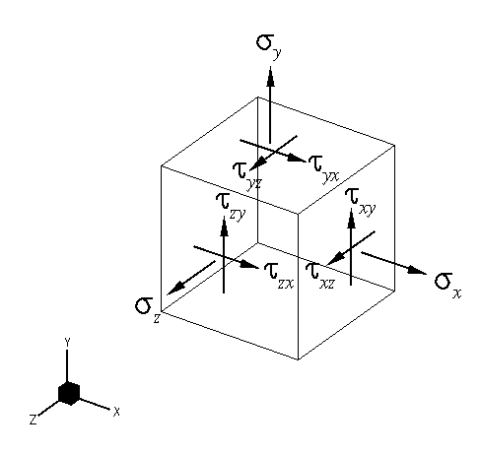

Mohr's Circles for Strain and for Moments and Products of Inertia
Mohr's circle(s) can be used for strain analysis and for moments and products of inertia and other quantities as long as they can be represented by two-by-two or three-by-three symmetric matrices (tensors).

Q2:
Dimensional Analysis of Stress.
Comparing and converting between different units is a very useful and important skill. We do this every day without realizing it. For instance, when we follow a recipe, we may need to do simple conversions, like converting grams to ounces, or quarts to cups.
In science and math, we often convert a number or quantity with a dimensional unit to a different unit, like meters to kilometers. Dimensional analysis, also known as factor-label method or unit-factor method, is a method to convert one different type of unit to another. This way, we can convert to a different unit, but their values are the same. To convert from one unit to another, we make use of a conversion factor, which is a numerical quantity that we can multiply or divide to the number or quantity that we want to convert.
For example, if I want to know how many yards are there in 10 feet, we can recall that 3 feet is equivalent to 1 yard. Then, I can use dimensional analysis and convert feet into yards by using the conversion factor shown below in yellow. If I want to know how many minutes there are in two hours, I can use the conversion factor shown in blue.
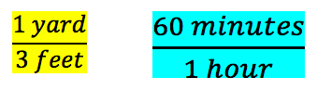
Conversion Factors
Dimensional analysis is something that we have done without realizing it. We convert minutes to hours, or days to hours all the time. Also, if we travel to another country that normally measures distance by kilometers instead of miles, then we convert between the two units as well by using the dimensional analysis method.

Q3:
Simple bending and Pure Bending
Simple Bending:
Bending will be called as simple bending when it occurs because of beam self-load and external load. This type of bending is also known as ordinary bending and in this type of bending results both shear stress and normal stress in the beam. As shown below in the figure.
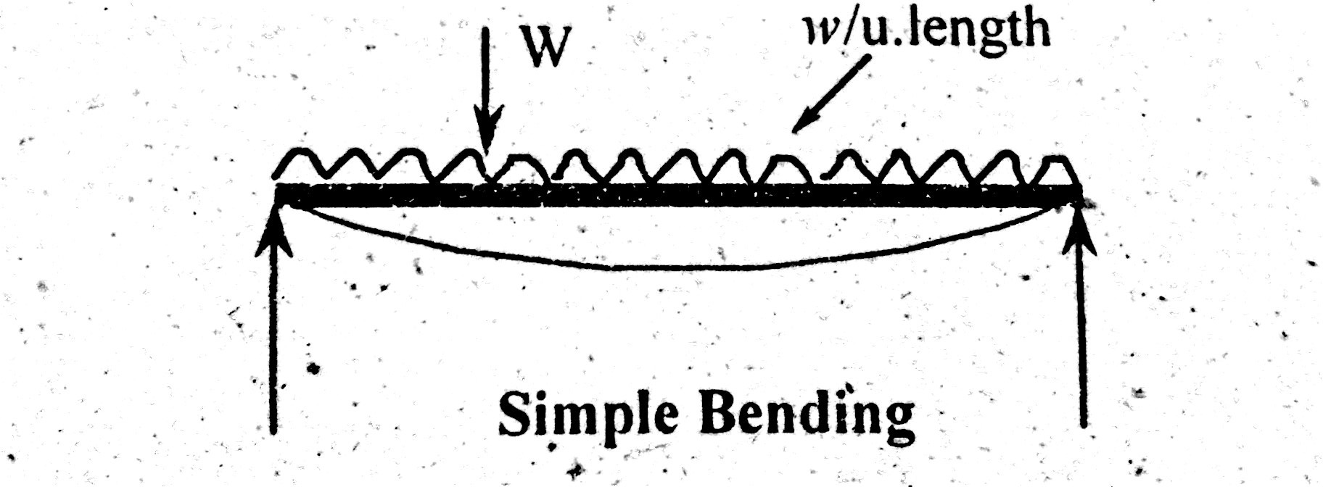

Pure Bending:
Bending will be called as pure bending when it occurs solely because of coupling on its end. In that case there is no chance of shear stress in the beam. But, the stress that will propagate in the beam as a result will be known as normal stress. Normal stress because it not causing any damages to beam. As shown below in the picture.
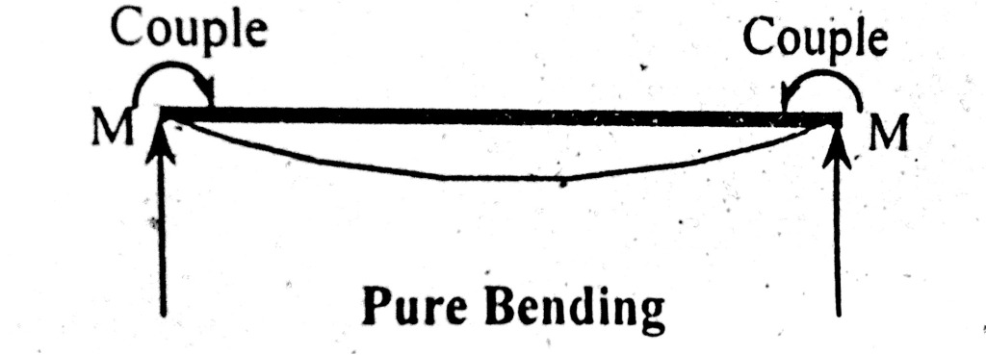

Q4:

Assumption made in theory of pure bending.

Assumptions made in the theory of Pure Bending. The material of the beam is homogeneous 1 and isotropic 2. The value of Young's Modulus of Elasticity is same in tension and compression. The transverse sections which were plane before bending, remain plane after bending also. The beam is initially straight and all longitudinal filaments bend into circular arcs with a common centre of curvature.
- The material of the beam is homogeneous¹ and isotropic².
- The value of Young's Modulus of Elasticity is same in tension and compression.
- The transverse sections which were plane before bending, remain plane after bending also.
- The beam is initially straight and all longitudinal filaments bend into circular arcs with a common centre of curvature.
- The radius of curvature is large as compared to the dimensions of the cross-section.
- Each layer of the beam is free to expand or contract, independently of the layer, above or below it.

Q5:
Classic Flexure Equation.

The flexural formula is given by the relation:

M/I = E/R = 𝛔/y

The assumptions in simple bending theory are:
- The material of the beam is homogeneous and isotropic
- The transverse section of the beam remains plane before and after bending.
- The value of young's modulus is the same in tension and compression
- The beam is initially straight and all the longitudinal filaments bend into circular arcs with a common center of curvature
- The radius of curvature is large compared with the dimensions of the cross-section.
- Every layer of the beam is free to expand or contract independent of the layer below it.

Derivation of Flexural Formula

Simple bending theory can be explained by following beam element consideration, as shown in figure-2 below.

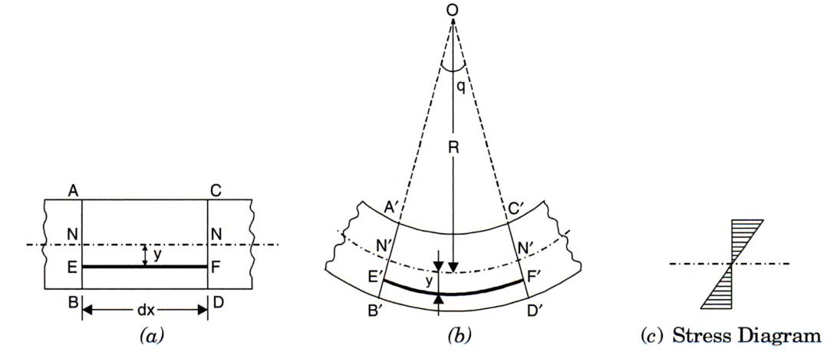
As shown in the figure above, consider a beam small beam section ABCD with a length of dx. The N-N forms the neutral axis of the beam element. Section AB and CD are perpendicular to the neutral axis N-N. The beam element under the action of bending gets deformed as shown in figure-2(b).

The layers of the beam before bending do not remain the same after bending. The layer AC and BD have deformed to A'C' and B'D' respectively. The layer gets shorten at top and expands at the bottom layer. The beam layer does not undergo any change at the neutral layer. This means,
NN = dx = N'N'
The layers above the neutral axis are shortened, hence subjected to a compressive force. The layer below the neutral axis is elongated, thus subjected to tensile stress. Hence, the compressive stress is maximum at the top layer and the tensile stress is maximum at the bottom layer.

As we move from the bottom layer to the neutral layer, the length of layers decreases. Hence, the increase or decrease of length of the layer is dependent on its distance from the neutral axis. This theory of bending is called the theory of simple bending.

Derivation of Bending Equation
As shown in figure-2(a), consider a layer EF from a distance 'y' from the neutral axis. After bending, EF gets deformed to E'F' as shown in 2(b).

Given:
- The radius of the Neutral layer = R
- The angle subtended by A'B' and C'D' at O = θ
Then,
Original length of layer = EF = dx;
Original length of Neutral layer = NN = N'N' = dx
From Figure,
N'N' = R x θ = dx
E'F' = (R + y ) θ

Strain in the layer EF = Increase in the length of layer EF / (Original Length)
= (E'F' -EF)/EF
= ( (R +y) θ - (Rx θ))/dx
= (R θ + y θ - R θ)/ dx
= y θ/dx
= y θ/R θ
=y/R
Hence,
the strain in the layer EF is directly proportional to the distance of the layer from the neutral axis. This relation shows the vairation of the strain along the depth of the beam. The variation of strain is linear.

Stress Variation along Depth of Beam
Young's modulus E = stress in layer EF / Strain in layer EF = 𝛔 /(y/R)

=> E = 𝜎R/y

=> E/R = 𝛔/y
- Moment of Resistance
The layer above the neutral axis experience compressive force Fc and the layers below the neutral axis experiences tensile force Ft. For equilibrium:
- Fc= Ft
- The moments caused due to these internal forces must be equal and opposite the BM caused at section f the beam.
Moment of resistance is defined as the algebraic sum of moments about the neutral axis of the internal forces developed in the beam.

If the cross-sectional area of the element is dA, then

Total Moment of resistance M = ∫ (𝛔 dA . y) = ∫(Ey. y. dA)/R
=> M = (E/R)∫y^2 . dA

Moment of Inertia I = ∫y^2. dA

Hence, we get
M = EI/R

Hence, we get

M/I = E/R = 𝛔/y ;

The above equation is called as the Bending Equation/ Flexura Formula.

Q6

Section Modulus

Section modulus is a geometric property for a given cross-section used in the design of beams or flexural members. Other geometric properties used in design include area for tension and shear, radius of gyration for compression, and moment of inertia and polar moment of inertia for stiffness. Any relationship between these properties is highly dependent on the shape in question. Equations for the section moduli of common shapes are given below. There are two types of section moduli, the elastic section modulus and the plastic section modulus. The section moduli of different profiles can also be found as numerical values for common profiles in tables listing properties of such.

Elastic section modulus
For general design, the elastic section modulus is used, applying up to the yield point for most metals and other common materials.
The elastic section modulus is defined as S = I / y, where I is the second moment of area (or area moment of inertia, not to be confused with moment of inertia) and y is the distance from the neutral axis to any given fibre. It is often reported using y = c, where c is the distance from the neutral axis to the most extreme fibre, as seen in the table below. It is also often used to determine the yield moment (M_{y}) such that M_{y} = S × σ_{y}, where σ_{y} is the yield strength of the material.

Plastic section modulus
The plastic section modulus is used for materials where elastic yielding is acceptable and plastic behavior is assumed to be an acceptable limit. Designs generally strive to ultimately remain below the plastic limit to avoid permanent deformations, often comparing the plastic capacity against amplified forces or stresses.
The plastic section modulus depends on the location of the plastic neutral axis (PNA). The PNA is defined as the axis that splits the cross section such that the compression force from the area in compression equals the tension force from the area in tension. So, for sections with constant yielding stress, the area above and below the PNA will be equal, but for composite sections, this is not necessarily the case.
The plastic section modulus is the sum of the areas of the cross section on each side of the PNA (which may or may not be equal) multiplied by the distance from the local centroids of the two areas to the PNA:
The Plastic Section Modulus can also be called the 'First moment of area'

Q7

Application of Bending Equation in any object

Moments of Area
In order to calculate stress (and therefore, strain) caused by bending, we need to understand where the neutral axis of the beam is, and how to calculate the second moment of area for a given cross section.
Let's start by imagining an arbitrary cross section – something not circular, not rectangular, etc.
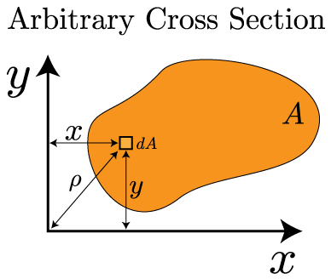
In the above image, the arbitrary shape has an area denoted by A. We can look at a small, differential area dA that exists some distance x and y from the origin. We can look at the first moment of area in each direction from the following formulas:
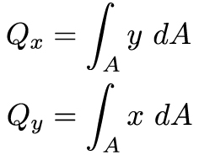
The first moment of area is the integral of a length over an area – that means it will have the units of length cubed [L³]. It is important because it helps us locate the centroid of an object. The centroid is defined as the "average x (or y) position of the area". Mathematically, this statement looks like this:
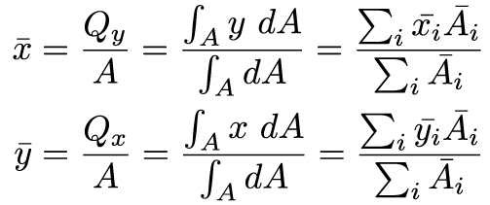
The far right side of the above equations will be very useful in this course – it allows us to break up a complex shape into simple shapes with known areas and known centroid locations. In most engineering structures there is at least one axis of symmetry – and this allows us to greatly simplify finding the centroid. The centroid has to be located on the axis of symmetry. For example:
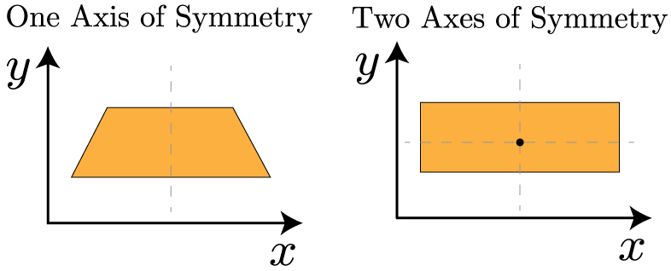
For the cross section on the left, we know the centroid has to lie on the axis of symmetry, so we only need to find the centroid along the y-axis. The cross section on the right is even easier – since the centroid has to line on the axes of symmetry, it has to be at the center of the object.
Now that we know how to locate the centroid, we can turn our attention to the second moment of area. As you might recall from the previous section on torsion, this is defined as:
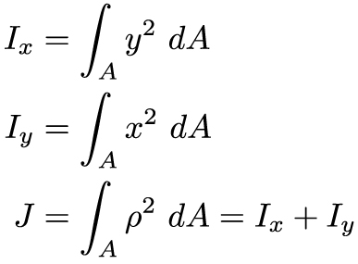
And, finally sometimes we will need to determine the second moment of area about an arbitrary x or y axis – one that does not correspond to the centroid. In this case, we can utilize the parallel axis theorem to calculate it. In this case, we utilize the second moment of area with respect to the centroid, plus a term that includes the distances between the two axes.
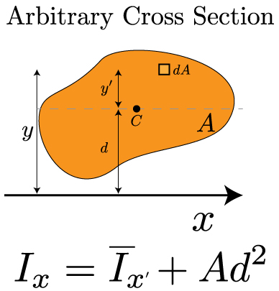
This equation is referred to as the Parallel Axis Theorem. It will be very useful throughout this course. As described in the introductory video to this section, it can be straightforward to calculate the second moment of area for a simple shape. For more complex shapes, we'll need to calculate I by calculating the individual I's for each simple shape and combining them together using the parallel axis theorem.

Shear and Moment Diagrams
Transverse loading refers to forces that are perpendicular to a structure's long axis. These transverse loads will cause a bending moment M that induces a normal stress, and a shear force V that induces a shear stress. These forces can and will vary along the length of the beam, and we will use shear & moment diagrams (V-M Diagram) to extract the most relevant values. Constructing these diagrams should be familiar to you from statics, but we will review them here. There are two important considerations when examining a transversely loaded beam:
- How is the beam loaded?
- point load, distributed load (uniform or varying), a combination of loads…
- How is the beam supported?
- simply supported, cantilevered, overhanging, statically indeterminate…
Knowing about the loads and supports will enable you to sketch a qualitative V-M diagram, and then a statics analysis of the free body will help you determine the quantitative description of the curves. Let's start by recalling our sign conventions.
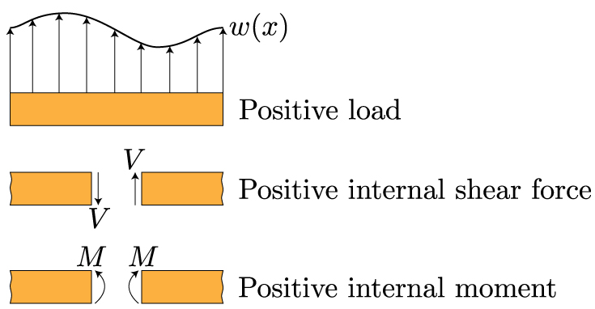
These sign conventions should be familiar. If the shear causes a counterclockwise rotation, it is positive. If the moment bends the beam in a manner that makes the beam bend into a "smile" or a U-shape, it is positive. The best way to recall these diagrams is to work through an example. Begin with this cantilevered beam – from here you can progress through more complicated loadings.

Normal Stress in Bending
In many ways, bending and torsion are pretty similar. Bending results from a couple, or a bending moment M, that is applied. Just like torsion, in pure bending there is an axis within the material where the stress and strain are zero. This is referred to as the neutral axis. And, just like torsion, the stress is no longer uniform over the cross section of the structure – it varies. Let's start by looking at how a moment about the z-axis bends a structure. In this case, we won't limit ourselves to circular cross sections – in the figure below, we'll consider a prismatic cross section.
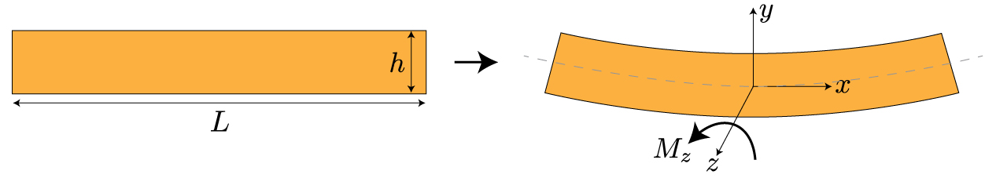
Before we delve into the mathematics behind bending, let's try to get a feel for it conceptually. Maybe the be way to see what's happening is to overlay the bent beam on top of the original, straight beam.
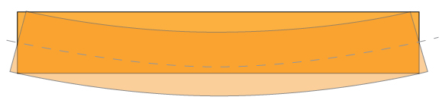
What you can notice now is that the bottom surface of the beam got longer in length, while the to surface of the beam got shorter in length. Also, along the center of the beam, the length didn't change at all – corresponding to the neutral axis. To restate this is the language of this class, we can say that the bottom surface is under tension, while the top surface is under compression. Something that is a little more subtle, but can still be observed from the above overlaid image, is that the displacement of the beam varies linearly from the top to the bottom – passing through zero at the neutral axis. Remember, this is exactly what we saw with torsion as well – the stress varied linearly from the center to the center. We can look at this stress distribution through the beam's cross section a bit more explicitly:
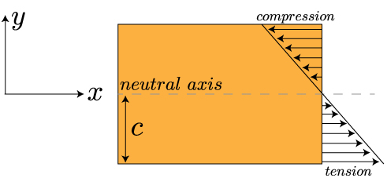
Now we can look for a mathematical relation between the applied moment and the stress within the beam. We already mentioned that beam deforms linearly from one edge to the other – this means the strain in the x-direction increases linearly with the distance along the y-axis (or, along the thickness of the beam). So, the strain will be at a maximum in tension at y = -c (since y=0 is at the neutral axis, in this case, the center of the beam), and will be at a maximum in compression at y=c. We can write that out mathematically like this:
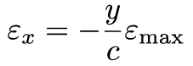
Now, this tells us something about the strain, what can we say about the maximum values of the stress? Well, let's start by multiplying both sides of the equation by E, Young's elastic modulus. Now our equation looks like:
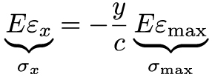
Using Hooke's law, we can relate those quantities with braces under them to the stress in the x-direction and the maximum stress. Which gives us this equation for the stress in the x-direction:
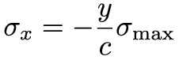
Our final step in this process is to understand how the bending moment relates to the stress. To do that, we recall that a moment is a force times a distance. If we can imagine only looking at a very small element within the beam, a differential element, then we can write that out mathematically as:
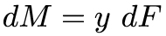
Since we have differentials in our equation, we can determine the moment M acting over the cross sectional area of the beam by integrating both sides of the equation. And, if we recall our definition of stress as being force per area, we can write:
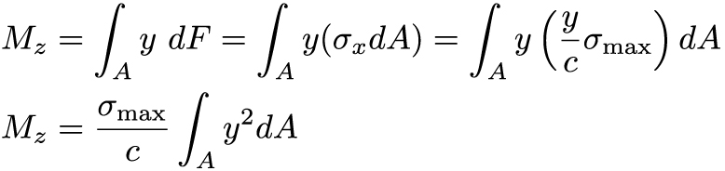

The final term in the last equation – the integral over y squared – represents the second moment of area about the z-axis (because of how we have defined our coordinates). In Cartesian coordinates, this second moment of area is denoted by I (in cylindrical coordinates, remember, it was denoted by J). Now we can finally write out our equation for the maximum stress, and therefore the stress at any point along the y-axis, as:

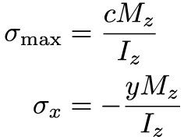
It's important to note that the subscripts in this equation and direction along the cross section (here, it is measured along y) all will change depending on the nature of the problem, i.e. the direction of the moment – which axis is the beam bending about? We based our notation on the bent beam show in the first image of this lesson.
Remember at the beginning of the section when I mentioned that bending and torsion were actually quite similar? We actually see this very explicitly in the last equation. In both cases, the stress (normal for bending, and shear for torsion) is equal to a couple/moment (M for bending, and T for torsion) times the location along the cross section, because the stress isn't uniform along the cross section (with Cartesian coordinates for bending, and cylindrical coordinates for torsion), all divided by the second moment of area of the cross section.
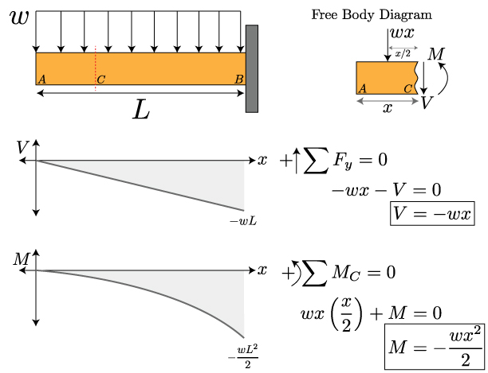

Q8:

Moment of resistance
The moment of resistance of the concrete section is the moment of couple formed by the total tensile force (T) in the steel acting at the centre of gravity of reinforcement and the total compressive force (C) in the concrete acting at the centre of gravity (c.g.) of the compressive stress diagram. The moment of resistance is denoted by M.
The distance between the resultant compressive force (C) and tensile force (T) is called the lever arm, and is denoted by z.
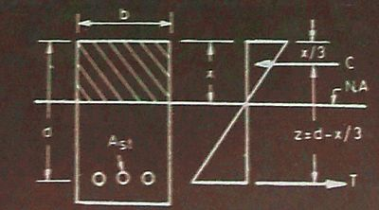Moment of resistance | Singly reinforced Section
From the diagram above, it is clear that the intensity of compressive stress varies from maximum at the top to zero at the neutral axis.
Therefore, centre of gravity of the compressive force is at a distance x/3 from the top edge of the section.
Therefore, z = d-x/3
Moment of resistance is given by,
Mr = C x z
= bx (σcbc/2)(d-x/3)
OR
Mr = T x z
= Ast σst(d – x/3)

For balanced section, the formula is as follows,
Mr = bxc σcbc (d – xc/3)
= Ast σst(d – xc/3)

For under-reinforced section, the formula is as follows,
Mr = T x z
= Ast.σst (d – x/3)

For over-reinforced section, the formula is given as,
Mr = C x z
M_{r} = bx( σ_{cbc} /2) (d – x/3)

Q9:

Design of Columns under Centric Load

Loading Location Centric loading: The load is applied at the centroid of the cross section. The limiting allowable stress is determined from strength (P/A) or buckling. Eccentric loading: The load is offset from the centroid of the cross section because of how the beam load comes into the column. This offset introduces bending along with axial stress. (This can also happen with continuous beams across a column or wind loading.)

Q10:

Castigliano's Theorem
In 1873, Alberto Castigliano made two theorems related to the analysis of structures: (1) the theorem of least work, and (2) the partial derivative method.
The latter states the following: “the partial derivative of the strain energy (U), considered as a function of the applied forces acting on a linearly elastic structure, with respect to one of these forces, is equal to the displacement in the direction of the force of its point of application.”

Derivation

First Situation
There are lots of ways from different technical references on how to interpret Castigliano’s theorem, or rather, on how it was derived. Let’s discuss a simple derivation: consider a simple beam that is loaded with three point loads: P₁, P₂, and P₃ at points 1, 2, and 3 respectively.
Say that we are interesting in finding the vertical translation at point 1. The first thing we have to assume is that these point loads were applied gradually. As a result of these applications, there is external work .

Second Situation
Now, let’s consider the same beam, but this time, there is a change on how we apply the loads. For this instance, all points loads including the small increase at point 1 are gradually placed in the beam.

Definition •
Castigliano’s Theorem is given as:
• Where δ is the deflection, U is the strain energy and P is the force (or torque) at a certain point. P U ∂ ∂ δ =
Variations
• Different loading conditions require different strain energies. For axial loading: L • Where P is the load, E is the material’s Young’s Modulus (usually either in GPa or ksi), A is the cross sectional area, and L is the length. ∫ = L EA P dx U
Variations
• For a material in bending: • L • Where M is the moment applied, and I is the area moment of inertia. ∫ = L EI M dx U 0 2 2

