Paper:Hospital Management
Sarosh gohar
DPT 8th semester
Id#13436
Question#1
Difference between Public, Community, population health?
Public:
Public health has been defined as “the science and art of preventing disease”, prolonging life and improving quality of life through organized efforts and informed choices of society, organizations, public and private, communities and individuals.
Public Health:
The science and art of preventing disease prolonging life and promoting human health through the organized efforts and informed choices of society, organizations, public and private.
Improving health of populations.
Making people healthy
World health organizations:
A state of complete physical, mental, social well-being rather than the absence of disease.
The WHO defines public health broadly as ‘all organized measures (whether public or private) to prevent disease, promote health and prolong life among the population as a whole. Or
The CDC Foundation defines public health as being ‘concerned with protecting the health of entire populations.’ Or
Science of protecting the safety and improving the health of communities through education, policy making and research for disease and injury prevention.
Responsible for public health :
All sectors of society
Health department
Coordinated efforts other shakeholders
Other areas of government
Private sector
NGO’s
International organizations.
Public Health :
It now widely recognized that demands on health care systems will always be greater than the resources available to meet these needs.
The dilemma is not confined to the developing world.
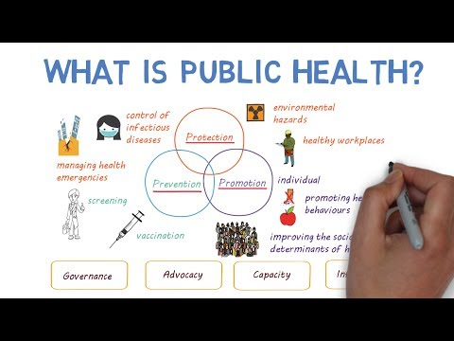
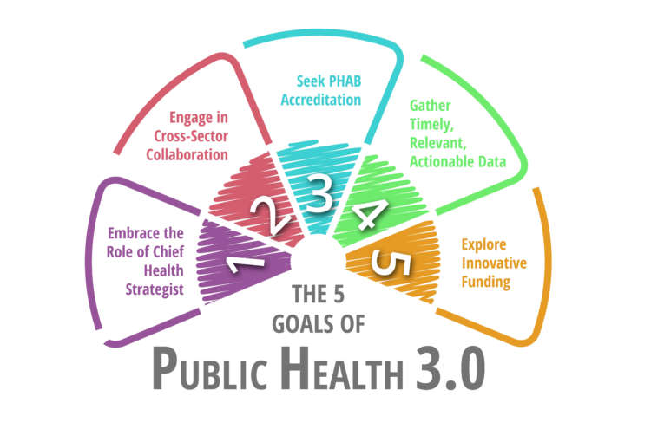

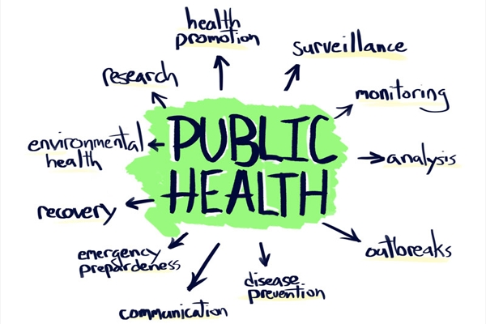
Community health :
Community health is a branch of public health which focuses on people and their role as determinants of their own and other people’s health in contrast to environmental health, which focuses on the physical environment and its impact on people’s health.
Community Health shares similarities with both population health and public health but tends to be more strictly geographically based.
Community health is often seen as a field within public health, focusing on the health of a particular population group that has common characteristics, such as culture, work, physical traits, geography or other demographics.
Community health meaning
Community health is a field of public health that focuses on studying, protecting, or improving health within a community.
Difference between Public and community :
Public Health includes community health. … Community health tends to focus on geographical areas, and includes primary, secondary and tertiary healthcare.
Community health problems:
Top 10 Most Common Health Issues
Physical Activity and Nutrition.
Overweight and Obesity.
Tobacco.
Substance Abuse.
HIV/AIDS.
Mental Health.
Injury and Violence.
Environmental Quality.

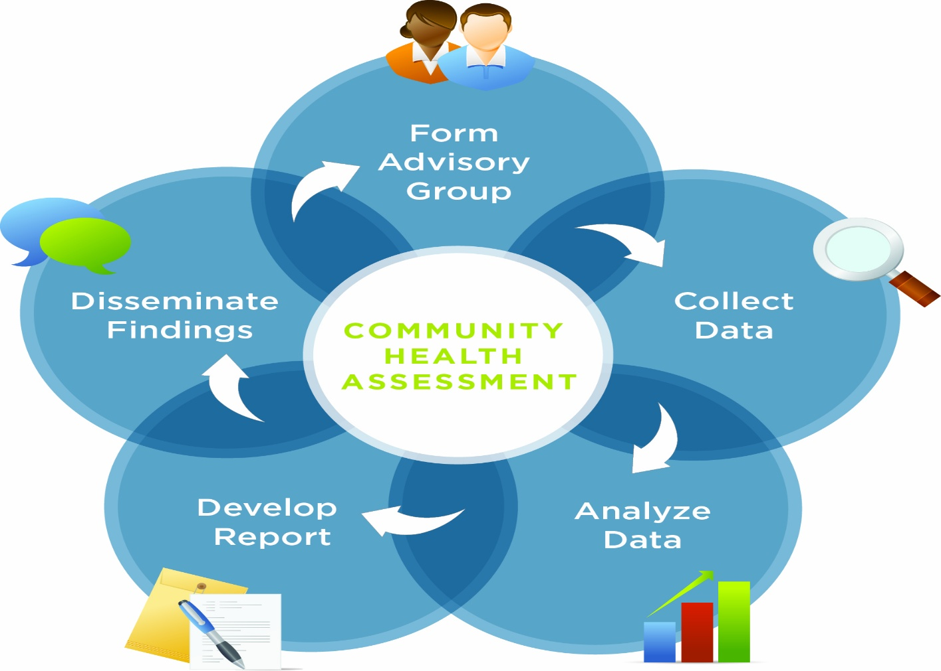
Population health:
Population health is “the health outcomes of a group of individuals, including the distribution of such outcomes within the group”.
Four components of population health :
Here are the four main components of a strong population health initiative leaders discussed during the roundtable.
- Emphasis on primary care. …
- Careful data driven environment. …
- Physician leadership. …
- Off–the-radar disease management.
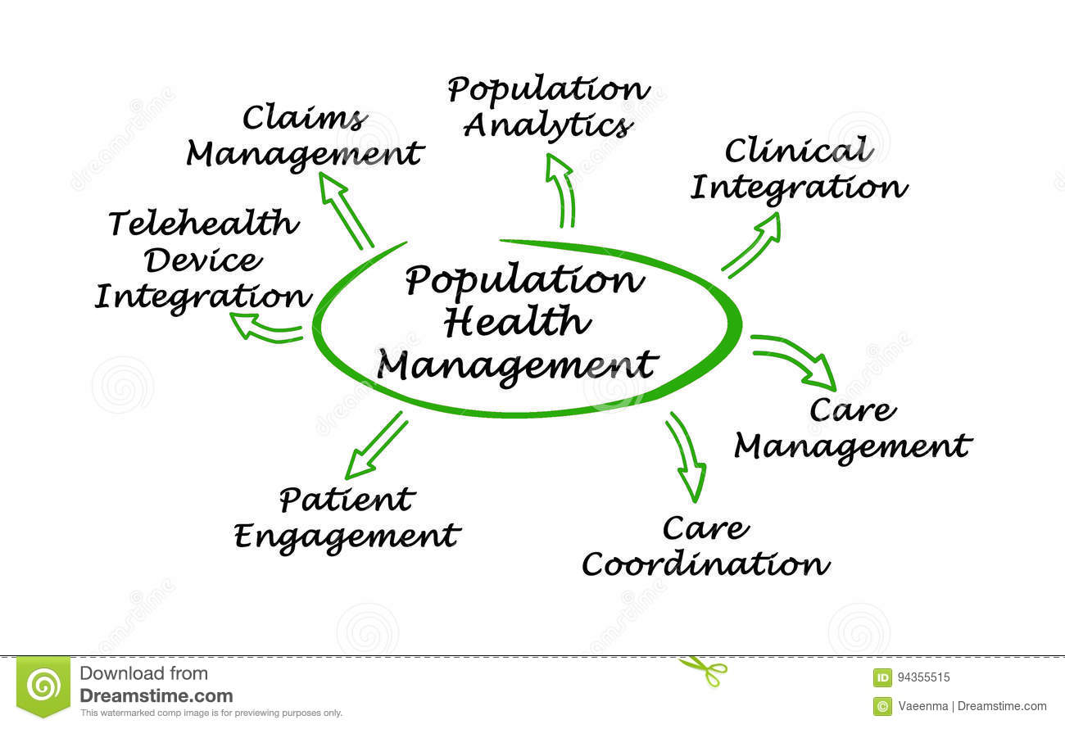
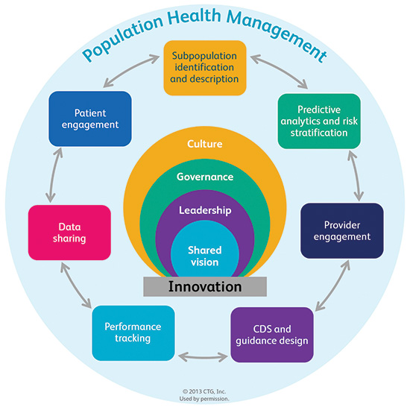
Part B
Difference between Impairment, Handicap, disability?
Impairment :
Any loss, or abnormality. Of psychological physiological. Anatomical structure or function.
Difference :
Impairment is defined as “any loss or abnormality of psychological, physiological or anatomical structure or function.” Disability, on the other hand, means “any restriction or lack (resulting from an impairment) of ability to perform an activity in the manner or within the range considered normal for a human being.”
Different types of impairment:
Vision Impairment.
Deaf or hard of hearing.
Mental health conditions.
Intellectual disability.
Acquired brain injury.
Autism spectrum disorder.
Physical disability.
Example :
Impairment in a person’s body structure or function, or mental functioning; examples of impairments include loss of a limb, loss of vision or memory loss. Activity limitation, such as difficulty seeing, hearing, walking, or problem solving

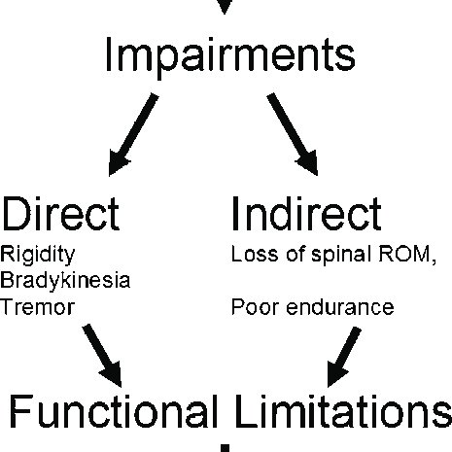
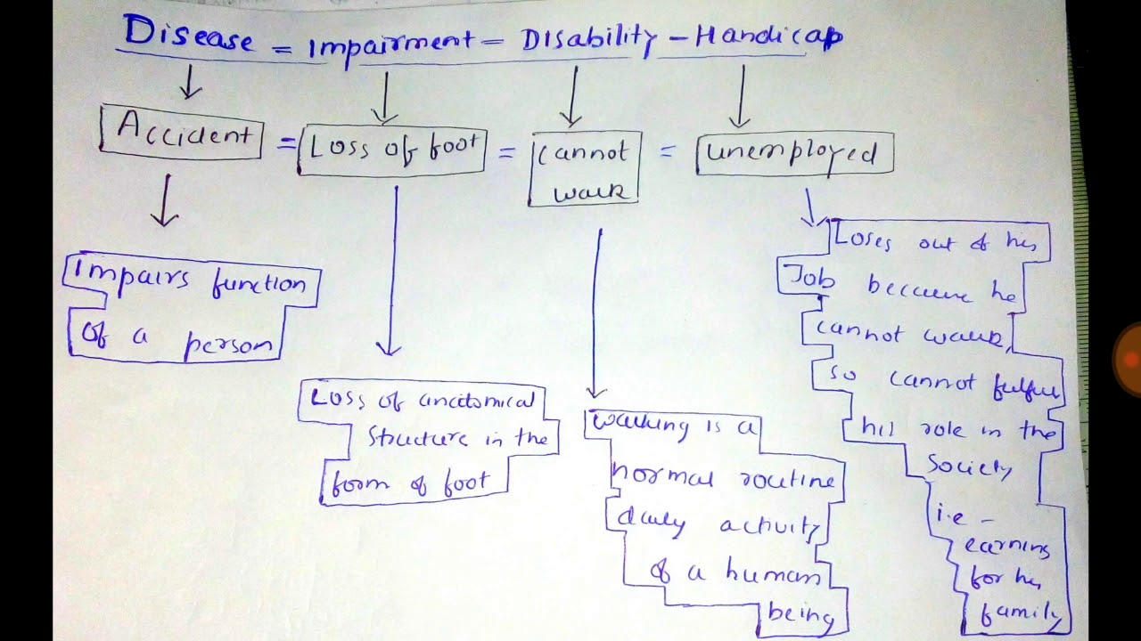
Handicap:
Handicap is a condition of the body or mind that makes it more difficult for the person.
Types of Disabilities
Physical disabilities. A physical disability is one that affects a person’s mobility or dexterity. …
Intellectual or Learning Disabilities. …
Psychiatric disabilities. …
Visual impairments. …
Hearing impairments. …
Neurological disabilities
Example :
Some examples of common disabilities you may find are:
Vision Impairment.
Deaf or hard of hearing.
Mental health conditions.
Intellectual disability.
Acquired brain injury.
Autism spectrum disorder.
Physical disability.
Handicap :
A physical handicap
In cases of severe mental handicap, constant supervision is recommended.
Difference between disability and Handicap :
Disability describes the person’s limitation, while handicap refers to the impact the person’s disability has on normal life activities such as going to school or driving a car. Chris is handicapped. His cerebral palsy restricts his ability to move as freely as other children his age.
Example :
Handicap. … An example of a handicap is a race where heavier people have to carry less weight and the lighter people have to carry more weight. An example of a handicap is a broken leg.
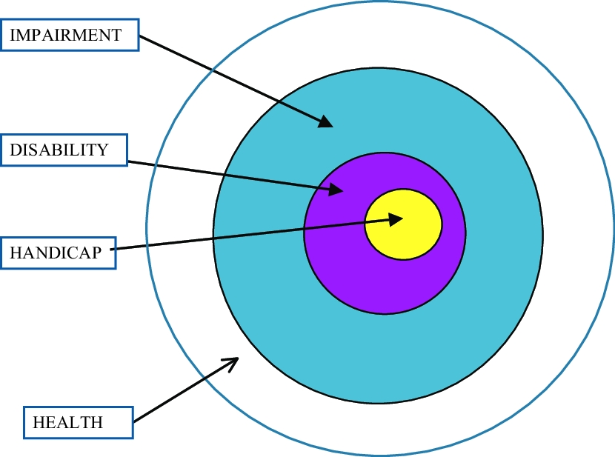
END….
Questions #2
Health planning for common health problem:
- Health Planning
– Is the process of defining community health problems, Identifying needs and resources, establishing priority goals, and setting out the administrative action needed to reach those goals.
Identification and elaboration
- Step… assess need
- Step… identify and priorities
- Set goals and objectives
- Develop strategy
- Implementation
- Monitor and evaluate
Most Common Health Issues
- Physical Activity and Nutrition.
- Overweight and Obesity.
- Tobacco.
- Substance Abuse.
- HIV/AIDS.
- Mental Health.
- Injury and Violence.
- Environmental Quality.
Health planning important :
- Planning is an important skill for Health Extension Practitioners because it is a key management function for all healthworkers and health managers. Planning is the process of determining in advance what should be accomplished – when, by whom, how and at what cost.
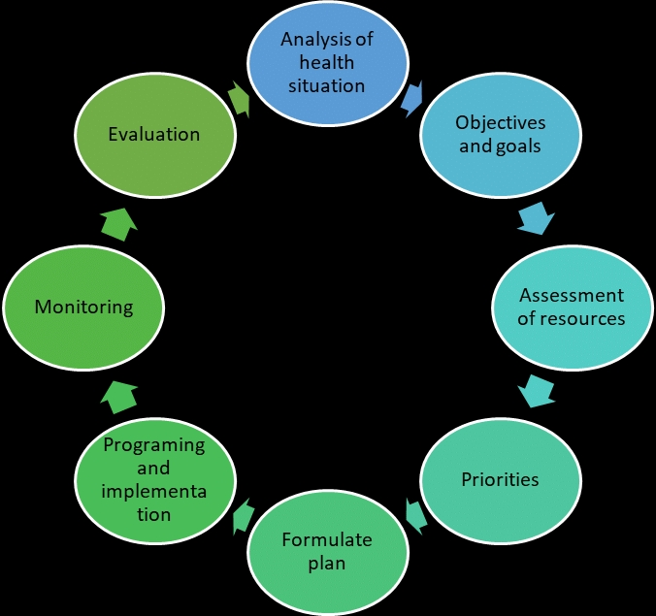

STEPS in health planning model :
- Meet with group leaders of aggregate to clarify Mutual expectation.
- Determine sociodemograhpic character
- Interview a key informant
- Consider both positive and negative factors
- Research potential problems
- Identify health problems and needs
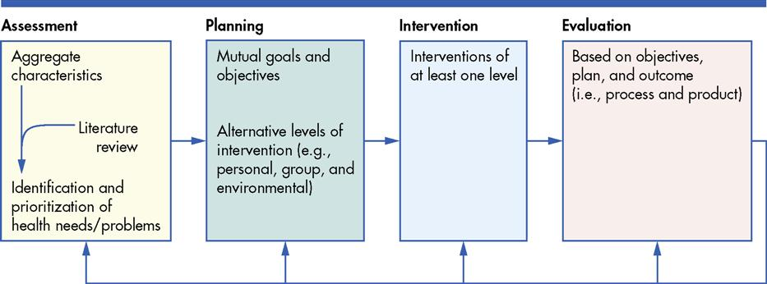
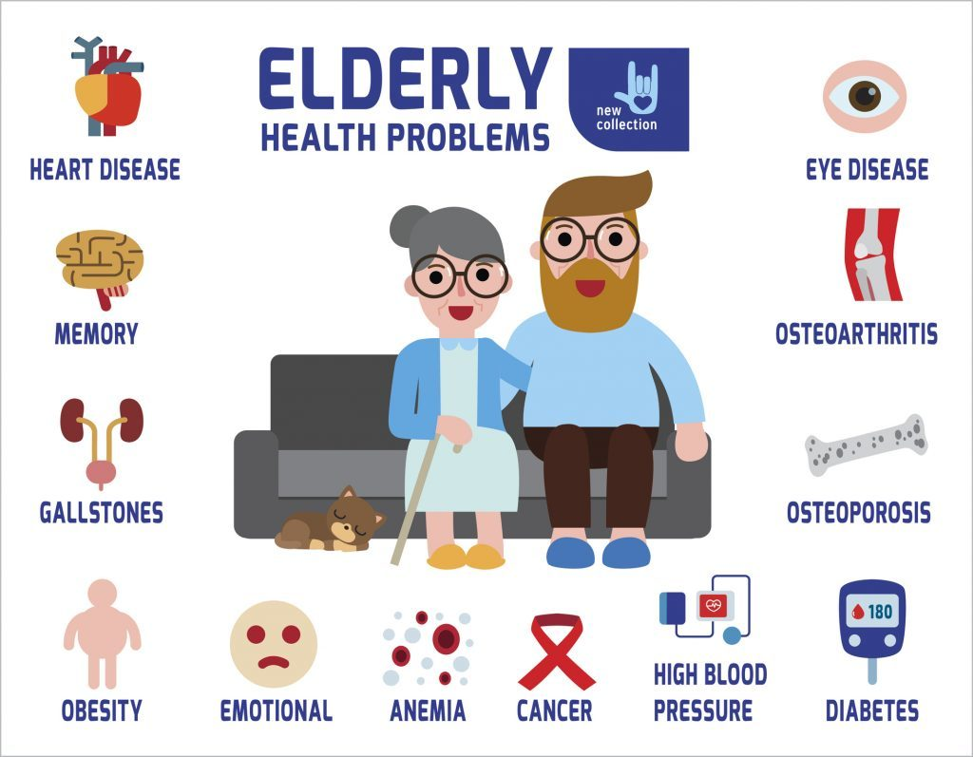

Location.:
Should be located on the ground floor
Direct access from the main road
Separate approach, other than OPD with a spacious parking area
Located adjacent to OPD
Well lighted & boldly sign posted both for day & night
A helipad is required for major trauma centres, hilly or unapproachable areas.
Close relationship with:
OT
ICU
Blood bank
Laboratory
OPD
Corridor plan
Entrance.
Reception and information area.
Waiting area.
Treatment area
Observation ward
Blood bank.
END…..
Questions #3
Characteristics of accountable orginazation:
Accountable orginazation:
Accountability is an assurance that an individual or an organization will be evaluated on their performance or behavior related to something for which they are responsible. … Corporate accountability involves being answerable to all an organization’s stakeholders for all actions and results.
Role of accountability :
Accountable Care Organizations (ACOs) are groups of doctors, hospitals, and other health care providers, who come together voluntarily to give coordinated high quality care to the Medicare patients they serve.
Types :
ACO professionals (such as physicians and hospitals) in group practice arrangements.
Networks of individual practices of ACO professionals.
Partnerships or joint venture arrangements between hospitals and ACO professionals.
Hospitals employing ACO professionals
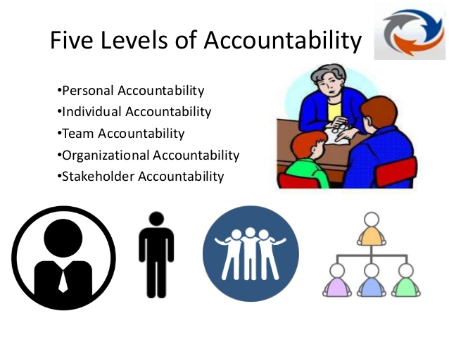

10 steps of accountable orginazation :
From your entity and invoke your waivers
Set strategic goals
Analyze your network
Approve work plan
Approve a budget and pro format
Get board approval for ACO participation
Review ACO legal agreements
Recruit physicians
Submit applications
Characteristics of accountable orginazation :
Value based leadership
Strategic and visionary leadership
Team culture and engagement
People management
Change leadership
Personal leadership
Clear vision and priorities
Shared Ownership: Shared accountability for all top priorities.
Effective Execution: Linking people and processes to achieve high performance.
Relentless Attack of Dysfunctional Habits: Accountable leaders make a point to surface and address these habits and develop new and effective behavior.
Surface and Resolve Problems and Conflicts: No one should feel afraid to be punished or terminated from their position. Focus on where the problem lies.
Proactive Recovery – Accountable organizations realize that successful people make mistakes and learn from their experiences. – Create recovery plans for mistakes. – When perfection is in demand people tend to cover their errors and create larger catastrophes.
Measure Performance Execution
Recognize Success!! Ensure people feel a sense of accomplishment.
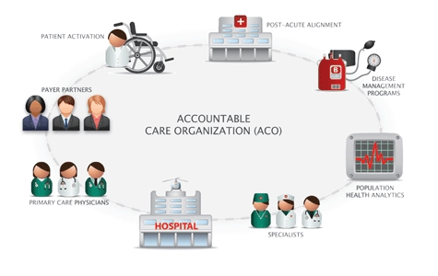

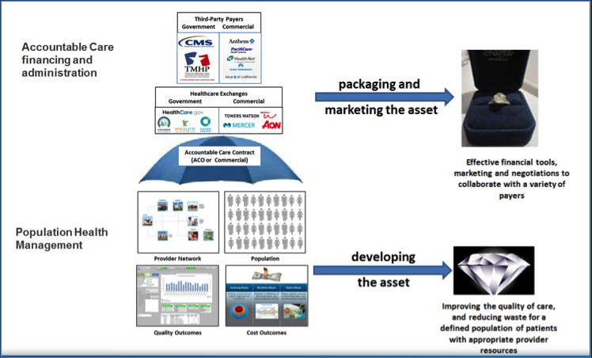

Questions #4
Medical audit:
Medical audit is defined as the review of the clinical care of patients provided by the medical staff only.
Retrospective evaluation of quality of medical care through scientific analysis.
Clinical audit is the review of the activity of all aspects of the clinical care of patients by medical and paramedical staff.
Medical audit cycle :
The aim of medical audit is to improve the effectiveness and efficiency of medical care. Achieving this aim may involve a cycle of activities: (i) observing practice; (ii) setting a standard of practice; (iii) comparing the observed practice with the standard; (iv) implementing change; and (v) re-observing practice.
Need if medical audit :
- Professionals motives
- Social motives
- Pragmative motives
- Health promotions
- Professional motives- Health care providers can identify their deficiencies and make necessary corrections
- Social motives- To ensure safety of public and protect them from care that is inappropriate, suboptimal & harmful
Other needs of medical audit :
The main reason of that is helps to improve quality of the service being offered
It identifies and promotes good practice and can lead to improvement in service delivery and outcomes for users.
Can provide The information We need to show others. That our service is effective.
Provides opportunities for training and education
Helps to ensure better use of resources and so increased efficiency
Can improve working relationships, communication
, liaison between staff and services users.
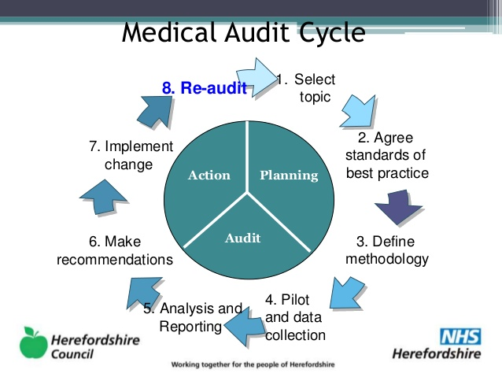
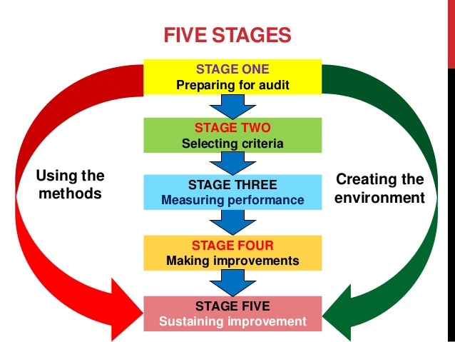
10 main reason:
Determine outliers and focus first in this area.
Protect against fraudulent claims and billing activity.
Reveal whether there is variation from national averages.
Identify and correct problem areas before insurance or government payers challenge inappropriate coding.
Prevent governmental investigational auditors such as recovery audit contractors or zone program integrity contractors from knocking at your door.
Remedy undercoding, overcoding, upcoding, unbundling habits, code overuse and documentation deficiencies. Bill appropriately for documented procedures and services.
Identify payment deficiencies and opportunities for appropriate payment.
Stop the use of outdated or incorrect codes for procedures or diagnoses.
- Patient complaints
- Employee and competitor tips
- Information from other investigation
- Data Gathered from Claims Processing
- Abnormal Distribution of Evaluation and Management Codes
- Billing Errors
- Repetitive Care Protocols
- Co-Payment and Deductible Violations
- Failure to Follow Non-Par Medicare Rules
- Random Audits
END…
Questions #5
Hospitals information system:
Hospital information system (HIS) is a computer system that can manage all the information related to health care providers allowing them to do their job effectively. They were introduced in the 1960s and have changed over time
Uses :
Healthcare Information Systems
Electronic Medical Record (EMR) and Electronic Health Record (HER) Electronic medical records replace paper patient records. …
Practice Management Software. …
Master Patient Ind0ex (MPI) …
Patient Portals. …
Remote Patient Monitoring (RPM) …
Clinical Decision Support (CDS)
Types :
Types of clinical information systems and applications
Ambulatory or Outpatient Clinical Information Systems including the Ambulatory/OPD Electronic Medical Record (EMR)
Inpatient Clinical Information Systems including the Inpatient Electronic Medical Record (EMR) and Computerised Provider Order Entry (CPOE) systems.

Examples of health information systems include:
Electronic Medical Record (EMR) and Electronic Health Record (HER)
Practice Management Software.
Master Patient Index (MPI)
Patient Portals.
Remote Patient Monitoring (RPM)
Clinical Decision Support (CDS
Important
The objective of the HMIS would be to record information on health events and check the quality of services at different levels of health care. The importance of patient assessment is a part of the concept of giving importance to patient’s views in improving the quality of health services..
Information Systems :
Computer hardware. This is the physical technology that works with information. …
Computer software. The hardware needs to know what to do, and that is the role of software. …
Telecommunications. …
Databases and data warehouses. …
Human resources and procedures

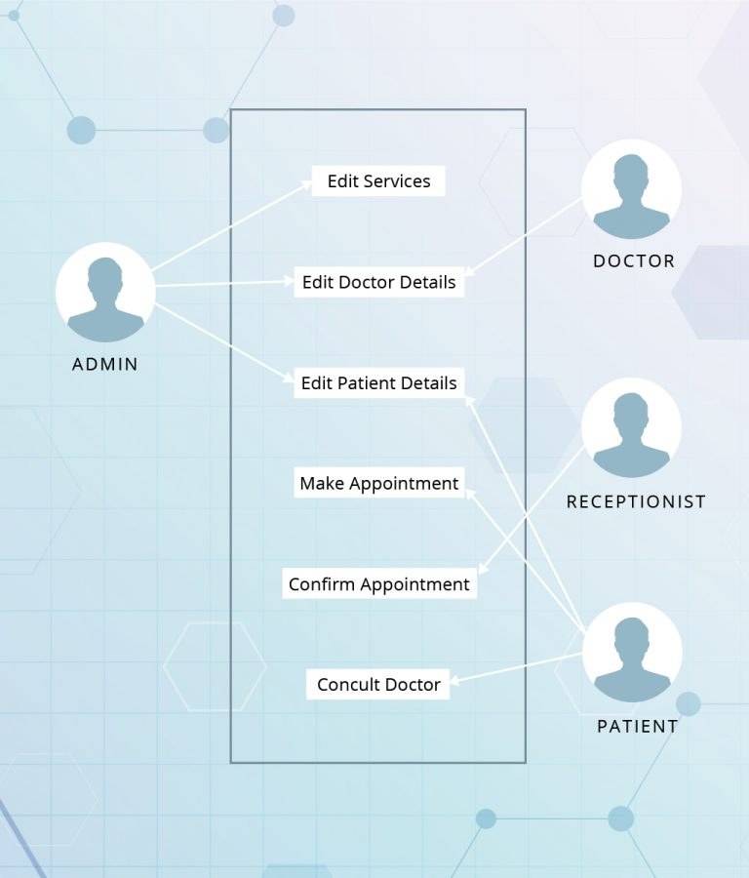
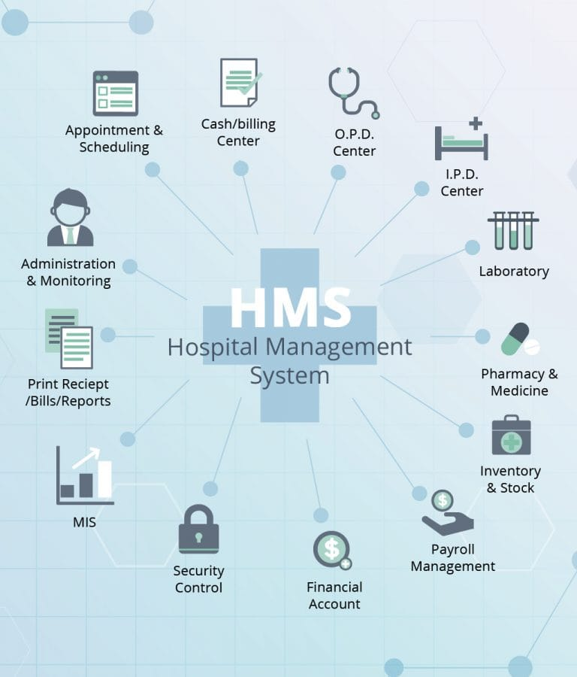

Aims of hospitals information system:
Patients will experience outstanding care
Provide care that is based on the best evidence for every patient, every time. Continuously seek out and reduce avoidable patient harm. Deliver good patient experience
To promote awareness of health care among all sections of the Indian people.
To promote awareness among functionaries involved in Health and Hospital Management.
To promote research in the field of Health and Hospital Management. In order to improve the efficiency of Health Care delivery Systems.
To promote the development of high quality hospital services and community health care.
To promote a forum for the exchange of ideas and information among health and hospital planners, academicians, administrators, various statutory bodies and the general public for the improvement of Hospital and Health Care delivery Systems.

To develop norms and standards for accreditation of the Health Care Organization and adopt means of evaluation of such institutions, so as to improve the quality of health care in the community.
To provide opportunities for training and research in all aspects of Hospital Services Health Care Delivery System and Health Care Administration.
To update the knowledge and skill of the Health & Hospital Administrators and other personnel involved in the management of health care organization through continuous education and research.
To promote and grant recognition to research in the fields of Health and Hospital Management and to grant awards, scholarship and assistance in other suitable forms to meritorious individuals and institutions.
To act as Advisory /Consultative Body, in the best interest of community and country, to Central and State Governments, Public Sector Undertakings, Health Care Delivery Organization, Public Health & Health System Development, Teaching and Training Organization and any other Health related allied organization, when need so arises or services are asked for.
To provide Health Care Advocacy for the benefit of health system management and to endeavor to become a national advisory body for union and state governments.
To publish text books and periodic monographs on current and futuristic trends in health and hospital management.

To help in preparation of SOPs, Manuals, Literature and Books
To undertake Professional Consultancy in the field of Health System Management, Quality & Accreditation, Health Technology Assessment, Medical Tourism, Disaster Management, Health Care Delivery Organization, Public Health Facilities & Services for overall improvement of the facilities.
To conduct inter hospital/ Institution awards competition on various parameters to bring competitiveness for improving healthcare quality & training.
To recognize and felicitate the individuals who have made exceptional and significant contributions in the field of Health and Hospital Management in general and to the Academy in particular.
Benefits of hospital information system :
Reduce medical costs.
Improve medical care
Increase patients access personal information
Reduce operating costs
Improving quality services
Helping decision maker
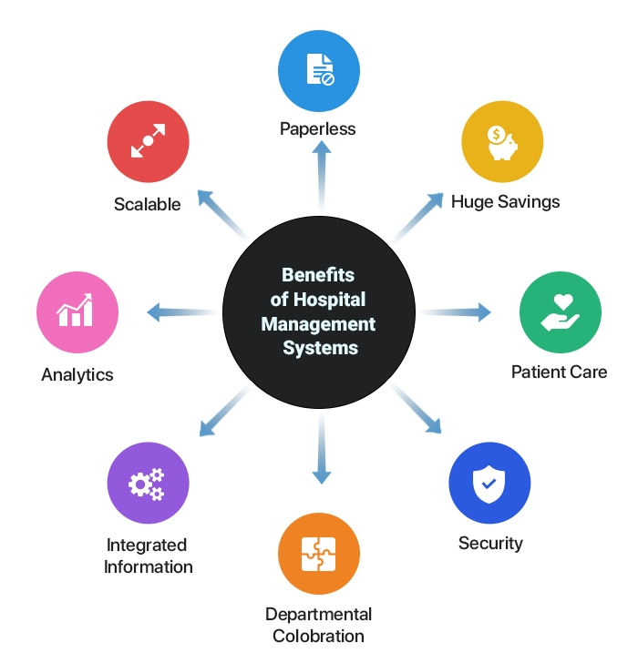
Improve patients friendliness

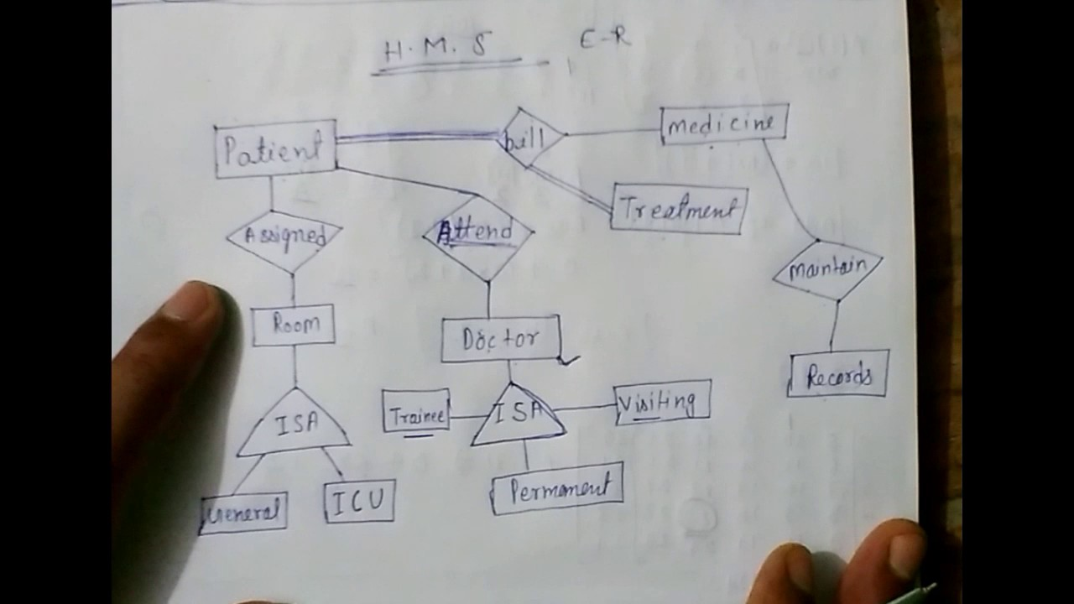

END…

