DENTAL SEC A ANATMOY, 2ND SEMESTER,FINAL TERM
MAM KOUSAR SHAH JEHAN
STUDENT NAME: Hasnain Javed ID: 16120 Class : D.T 2ND (sec : A)
Attempt all questions. Every question carry 10 marks.
Q1. Write a note on pituitary gland, its harmones and abnormalities?
ANSWER :::
PITUITARY GLAND :
The pituitary gland is a small pea-sized gland that plays a major role in regulating vital body functions and general wellbeing. It is referred to as the body's 'master gland' because it controls the activity of most other hormone-secreting glands.
FUNCTION :
The pituitary gland is a part of your endocrine system. Its main function is to secrete hormones into your bloodstream. These hormones can affect other organs and glands, especially your: ... adrenal glands
Hormones Secreted By Pituitary Gland :
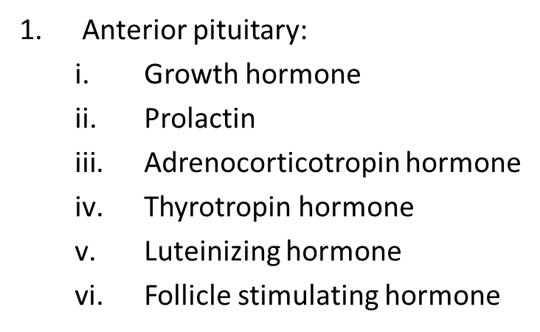
2. Posterior pituitary:
- Oxytocin
- Antidiuretic hormone
1.Growth hormone
- Somatotrpin
- Increases secretions at low glucose level.
- Growth hormone promotes growth of almost all the body tissues
- It promotes increase in size of cells, increased mitosis and differentiation of certain type of cells such as bone growth cells, muscle cells
Abnormalities of growth hormone
PANHYPOPITUITARISM(dec ant pitutary harmones)
- It may be congenital or occur slowly at time during life due to any tumor that destroys the pituitory gland
- Dwarfism is due to deficiency of ant pituitory hormone during childhood
- All the physical parts of the body develop in an inappropriate portion to one another
1.GIGANTISM:
Gigantism when large quantities of growth hormones are produced, tissues grow rapidly, including the bones.
- Height increaes so that a person may become 8 feet tall.
2.Acromegaly
- The person cannot grow taller but the bones can become thicker and the soft tissues continue to grow
- Bones of hands and feet, membranous bones ,portions of the vertebrae have marked changes as their growth do not cease at adolescence.
- Tongue ,liver and many soft tissue organs become enlarged.

Q2.write a note on shoulder joint and wrist joint?
ANSWER :::
: SHOULDER JOINT :
The shoulder joint (glenohumeral joint) is a ball and socket joint between the scapula and the humerus. It is the major joint connecting the upper limb to the trunk.
It is one of the most mobile joints in the human body, at the cost of joint stability.

Structures of the Shoulder Joint

Articulating Surfaces
The shoulder joint is formed by the articulation of the head of the humerus with the glenoid cavity (or fossa) of the scapula. This gives rise to the alternate name for the shoulder joint – the glenohumeral joint.

Joint Capsule and Bursae
The joint capsule is a fibrous sheath which encloses the structures of the joint.
To reduce friction in the shoulder joint, several synovial bursae are present. A bursa is a synovial fluid filled sac, which acts as a cushion between tendons and other joint structures.

Ligaments
In the shoulder joint, the ligaments play a key role in stabilising the bony structures.

Movements
As a ball and socket synovial joint, there is a wide range of movement permitted:
- Extension (upper limb backwards in sagittal plane) – posterior deltoid, latissimus dorsi and teres major.
- Flexion (upper limb forwards in sagittal plane) – pectoralis major, anterior deltoid and coracobrachialis. Biceps brachii weakly assists in forward flexion.
- Abduction (upper limb away from midline in coronal plane):
  - The first 0-15 degrees of abduction is produced by the supraspinatus.
  - The middle fibres of the deltoid are responsible for the next 15-90 degrees.
  - Past 90 degrees, the scapula needs to be rotated to achieve abduction – that is carried out by the trapezius and serratus anterior.
- Adduction (upper limb towards midline in coronal plane) – pectoralis major, latissimus dorsi and teres major.
- Internal rotation (rotation towards the midline, so that the thumb is pointing medially) – subscapularis, pectoralis major, latissimus dorsi, teres major and anterior deltoid.
- External rotation (rotation away from the midline, so that the thumb is pointing laterally) – infraspinatus and teres minor.

:WRIST JOINT :

The wrist joint (also known as the radiocarpal joint) is a synovial joint in the upper limb, marking the area of transition between the forearm and the hand.

Structures of the Wrist Joint

Articulating Surfaces
The wrist joint is formed by:
- Distally – The proximal row of the carpal bones (except the pisiform).
- Proximally – The distal end of the radius, and the articular disk

Joint Capsule
Like any synovial joint, the capsule is dual layered. The fibrous outer layer attaches to the radius, ulna and the proximal row of the carpal bones. The internal layer is comprised of a synovial membrane, secreting synovial fluid which lubricates the joint.

Ligaments
There are four ligaments of note in the wrist joint, one for each side of the joint

Neurovascular Supply
The wrist joint receives blood from branches of the dorsal and palmar carpal arches, which are derived from the ulnar and radial arteries.
Innervation to the wrist is delivered by branches of three nerves:
- Median nerve – Anterior interosseous branch.
- Radial nerve – Posterior interosseous branch.
- Ulnar nerve – deep and dorsal branches.

Movements of the Wrist Joint
The wrist is an ellipsoidal (condyloid) type synovial joint, allowing for movement along two axes. This means that flexion, extension, adduction and abduction can all occur at the wrist joint.
All the movements of the wrist are performed by the muscles of the forearm.
Flexion – Produced mainly by the flexor carpi ulnaris, flexor carpi radialis, with assistance from the flexor digitorum superficialis.
Extension – Produced mainly by the extensor carpi radialis longus and brevis, and extensor carpi ulnaris, with assistance from the extensor digitorum.
Adduction – Produced by the extensor carpi ulnaris and flexor carpi ulnaris
Abduction – Produced by the abductor pollicis longus, flexor carpi radialis, extensor carpi radialis longus and brevis.
: Injuries to the Wrist Joint:
Scaphoid Fracture
The scaphoid bone of the hand is the most commonly fractured carpal bone – typically by falling on an oustretched hand (FOOSH).
Colles’ Fracture
The Colles’ fracture is the most common fracture involving the wrist, caused by falling onto an outstretched hand.

Q3.what is axilla and cubital fossa and its important contents?
ANSWER:::
:AXILLA :
- The axilla or armpit is 4 sided pyramid-shaped space between upper part of arm and side of chest.
- It forms an important passage for nerves, blood, and lymph vessels as they travel from the root of the neck to the upper limb.
BOUNDARIES :
- Apex
- Base
- Anterior wall
- Posterior wall
- Medial wall
- Lateral Wall
CONTENTS OF AXILLA :
- Axillary artery and its branches
- Axillary vein and its branches
- Brachial plexus
- Axillary lymph nodes
CUBITAL FOSSA:
Cubital fossa is a triangular depression situated on the front of elbow.
BOUNDARIES :
- LATERALLY: Brachioradialis muscle
- MEDIALLY: pronator teres muscle
- superior: directed upward and represented by an imaginary line joining front of two epicondyles of humerus.
CONTENTS :
The fossa contains the following structures from medial to lateral side.
- Median nerve
- The bifurcation of brachial artery into ulnar and radial arteries
- The tendon of biceps muscle
- Radial nerve and its deep branch
Q4.write a note on lower limb and its main important structures briefly?
ANSWER :::
:LOWER LIMB :
The lower leg is the part of the lower limb that lies between the knee and the ankle. The thigh is between the hip and knee and makes up the rest of the lower limb. The term lower limb or "lower extremity" is commonly used to describe all of the leg.
CLASSIFFICATION OF LOWER LIMB :
The lower limb is divided into three regions. The thigh is that portion of the lower limb located between the hip joint and knee joint. The leg is specifically the region between the knee joint and the ankle joint. Distal to the ankle is the foot.
BONES IN LOWER LIMB :
The lower limb contains 30 bones.
The femur is the single bone of the thigh. The patella is the kneecap and articulates with the distal femur. The tibia is the larger, weight-bearing bone located on the medial side of the leg, and the fibula is the thin bone of the lateral leg.
BONES OF FOOT :
The bones of the foot are divided into three groups.
The posterior portion of the foot is formed by a group of seven bones, each of which is known as a tarsal bone, whereas the mid-foot contains five elongated bones, each of which is a metatarsal bone. The toes contain 14 small bones, each of which is a phalanx bone of the foot.
: STRUCTURE OF LOWER LIMB :

FEMUR:
The femur, or thigh bone, is the single bone of the thigh region. It is the longest and strongest bone of the body, and accounts for approximately one-quarter of a person’s total height. The femur is the single bone of the thigh region. It articulates superiorly with the hip bone at the hip joint, and inferiorly with the tibia at the knee joint.
SHAFT OF FEMUR :
The elongated shaft of the femur has a slight anterior bowing or curvature. At its proximal end, the posterior shaft has the gluteal tuberosity, a roughened area extending inferiorly from the greater trochanter.
LATERAL SIDE OF FEMUR :
The distal end of the femur has medial and lateral bony expansions. On the lateral side, the smooth portion that covers the distal and posterior aspects of the lateral expansion is the lateral condyle of the femur. The roughened area on the outer, lateral side of the condyle is the lateral epicondyle of the femur.
MEDIAL SIDE OF FEMUR :
The smooth region of the distal and posterior medial femur is the medial condyle of the femur, and the irregular outer, medial side of this is the medial epicondyle of the femur.
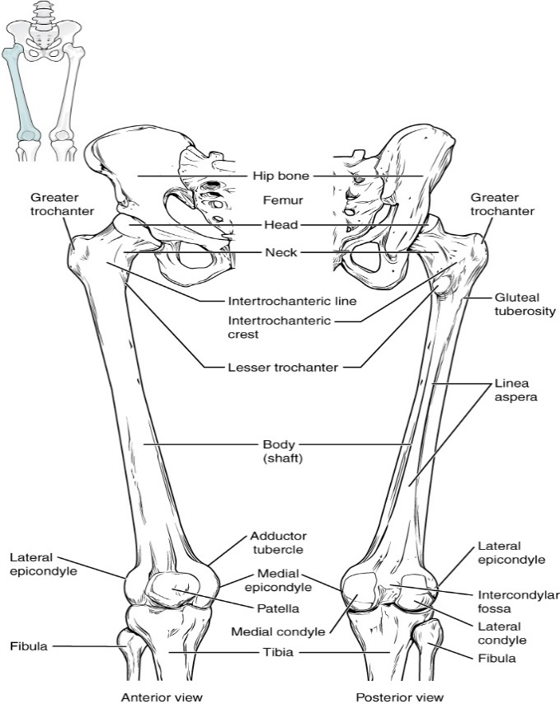

PATELLA:
The patella (kneecap) is largest sesamoid bone of the body . A sesamoid bone is a bone that is incorporated into the tendon of a muscle where that tendon crosses a joint. The sesamoid bone articulates with the underlying bones to prevent damage to the muscle tendon due to rubbing against the bones during movements of the joint.
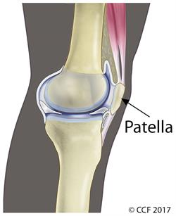

TIBIA:
The tibia (shin bone) is the medial bone of the leg and is larger than the fibula, with which it is paired . The tibia is the main weight-bearing bone of the lower leg and the second longest bone of the body, after the femur.
STRUCTURE OF TIBIA :
The proximal end of the tibia is greatly expanded. The two sides of this expansion form the medial condyle of the tibia and the lateral condyle of the tibia. The shaft of the tibia becomes triangular in shape. A small ridge running down the lateral side of the tibial shaft is the interosseous border of the tibia. This is for the attachment of the interosseous membrane of the leg. On the lateral side of the distal tibia is a wide groove called the fibular notch. This area articulates with the distal end of the fibula, forming the distal tibiofibular joint.
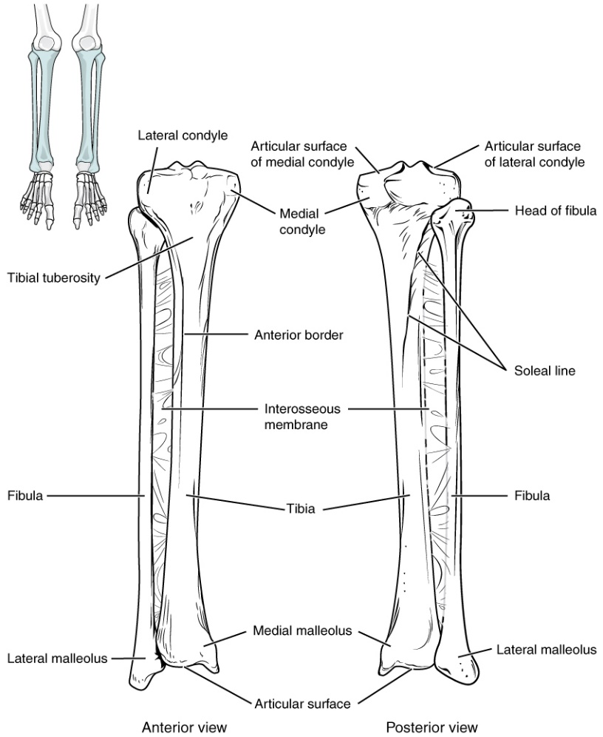

FIBULA:
The fibula is the slender bone located on the lateral side of the leg. The fibula does not bear weight. It serves primarily for muscle attachments and thus is largely surrounded by muscles. Only the proximal and distal ends of the fibula can be palpated.
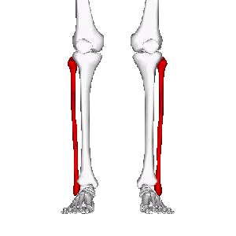

TARSAL BONES:
The posterior half of the foot is formed by seven tarsal bones . The most superior bone is the talus. This has a relatively square-shaped, upper surface that articulates with the tibia and fibula to form the ankle joint.
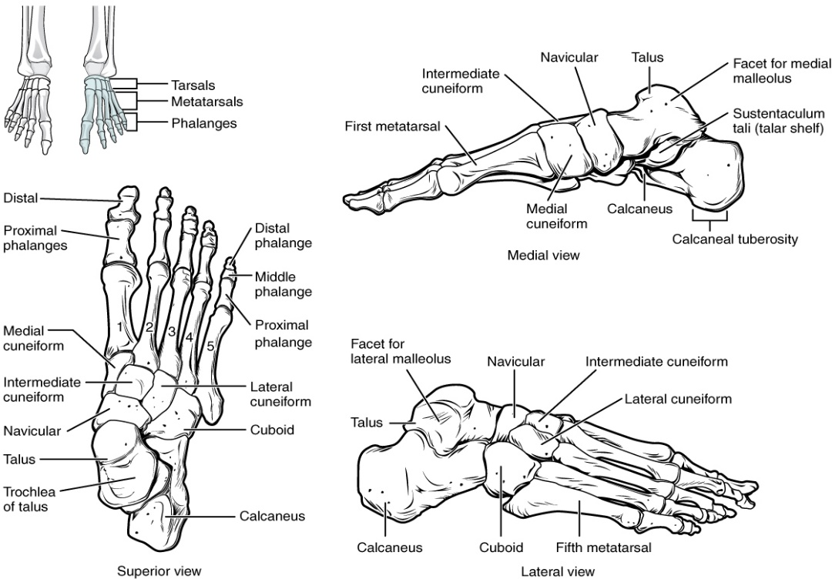

METATARSAL BONES:
The anterior half of the foot is formed by the five metatarsal bones, which are located between the tarsal bones of the posterior foot and the phalanges of the toes . These elongated bones are numbered 1–5, starting with the medial side of the foot
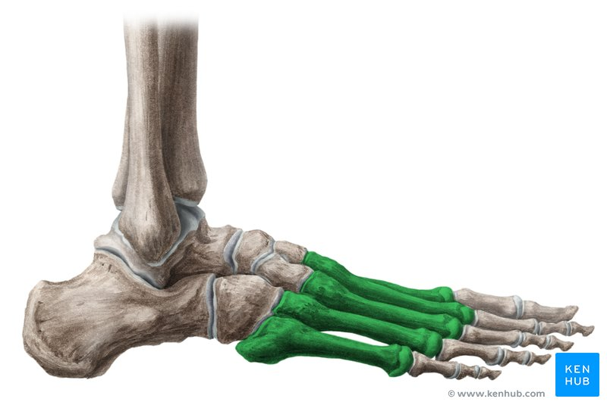

PHALANGES:
The toes contain a total of 14 phalanx bones (phalanges), arranged in a similar manner as the phalanges of the fingers . The toes are numbered 1–5, starting with the big toe (hallux). The big toe has two phalanx bones, the proximal and distal phalanges. The remaining toes all have proximal, middle, and distal phalanges. A joint between adjacent phalanx bones is called an interphalangeal joint.
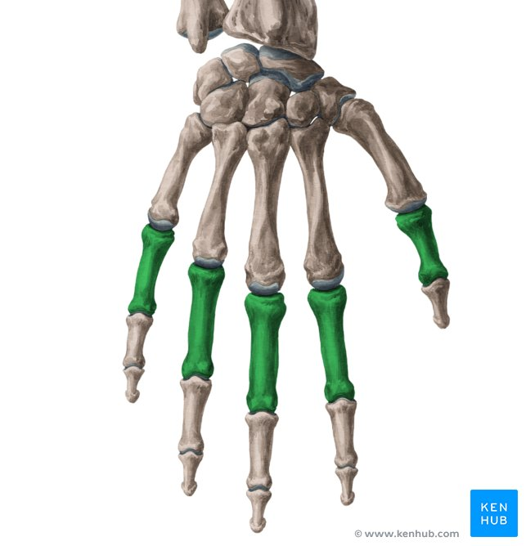
Q5.(i) A person fell down from a tree and become unconscious, with bleeding from head, what will you do as a first aid?
ANSWER :::
If a person fell down from a tree and become unconscious, with bleeding from head,I will do the following measures as a first aid.
Approach them calmly and reassuringly be alert to any dangers to either you or the casualty.Do not rush to move them. Get onto the floor so you are the same level as them and immediately assess:
IF THE WOUND IS OPEN :
The following measures need to be taken in giving first aid to a victim of a open wound :
1. Stop the bleeding
- Minor cuts and scrapes usually stop bleeding on their own.
- If they don't, apply gentle pressure with a clean cloth or bandage.
- Hold the pressure continuously for 20 to 30 minutes and if possible elevate the wound.
2. Clean the wound:
- Rinse out the wound with clear water. Soap can irritate the wound, so try to keep it
- out of the actual wound.
- If dirt or debris remains in the wound after washing, use tweezers cleaned with
- alcohol to remove the particles.
- To clean the area around the wound, use soap and a washcloth.
- There's no need to use hydrogen peroxide, iodine or an iodine-containing cleanser.
3. Cover the wound:
- If the bleeding slows, cover the wound with a clean dressing and bandage.
- Dressings and bandages can help keep the wound clean and keep harmful bacteria out.
- A dressing is a sterile pad or compress (usually made of gauze or cotton wrapped
in gauze) used to cover wounds, to control bleeding and/or prevent further
contamination.
- A dressing should be large enough to totally cover the wound, with
a safety margin of about 2.5 cm on all sides beyond the wound.
- A bandage is used to secure a dressing in place and to apply pressure to bleeding
wounds.

IF THE WOUND IS CLOSE :
The following measures need to be taken in giving first aid to a victim of a closed wound :
1. Application of direct pressure, preferably with ice wrapped in a cloth, for several
minutes, in order to arrest the bleeding as well as to reduce the swelling.
2. Elevation of the affected region will also support in reducing the pressure as well as
the re-absorption process and it should be practiced as and when appropriate.
(ii) you have to meet with your friend and you came to know he is covid positive, what precautionary measures will you take?
ANSWER :
Precautionary Measures :
I meet my friend and when I come to know that he is covid positive then I will take the following precautionary measures,
- I Will Stay home.
- It is important that i avoid contact with others. I know that i can spread COVID-19 to others beginning two days before symptoms start until a few days after you recover; this is known as the “infectious period.”
I will remain in isolation for:
    - At least three days (72 hours) after I feel well, and
    - At least 10 days from the date i first had symptoms.
- Take steps to prevent others in my household from getting sick.
  - I will separate myself from other people in my home.
  - I will wear a face mask or covering if i have to be around other people.
  - I will cover my coughs and sneezes.
  - I will clean my hands often.
  - I will avoid sharing personal household items.
SELF QUARANTINE :
- Stay home as much as possible.
- It is important that I have avoid others to prevent spreading the infection.
- Avoid travel.
- If travel is absolutely necessary, and i become ill, i may not be able to return home until after you recover. When i get home, i will be asked to continue self-quarantining and self-monitoring for 14 days.
- Wash your hands.
- I will regularly wash my hands,because it is very important to stay hygiene.
- Go out only if absolutely necessary.
- If i need to go out, I will limit my travel to essential needs, for example, going to the doctor, getting groceries, or picking up medication. I will remember to always wear a cloth face covering,sanitizer and wearing gloves.

