**Name : Malaika Muhammad**

**Department : HND ,semester 2nd**

**Student id : 15906**

**Subject : Applied mathematics**

**Instructor : Anwar Shamim**

Question 1

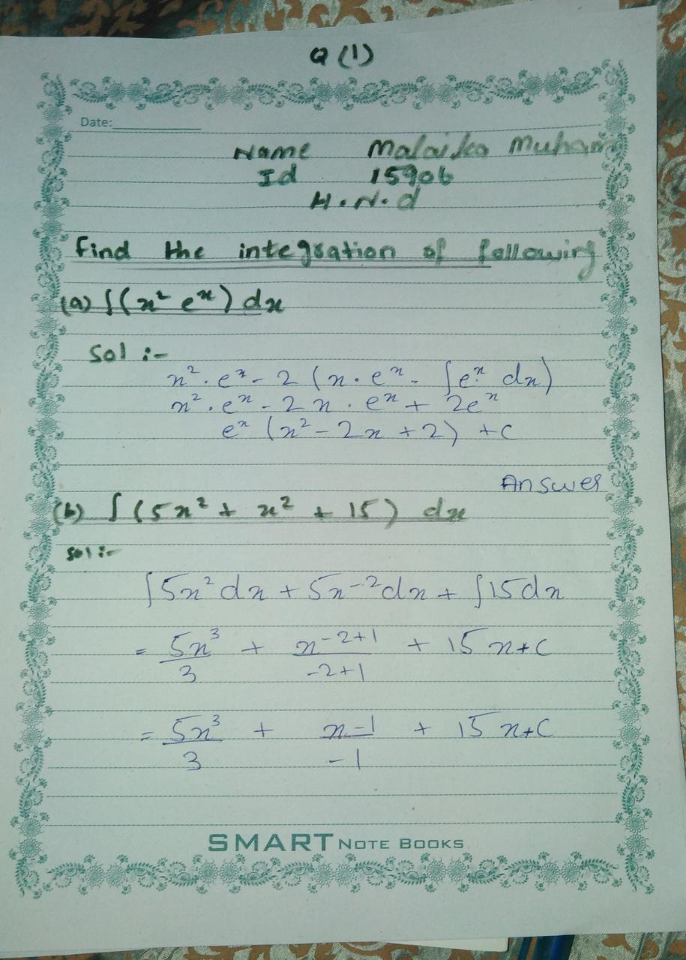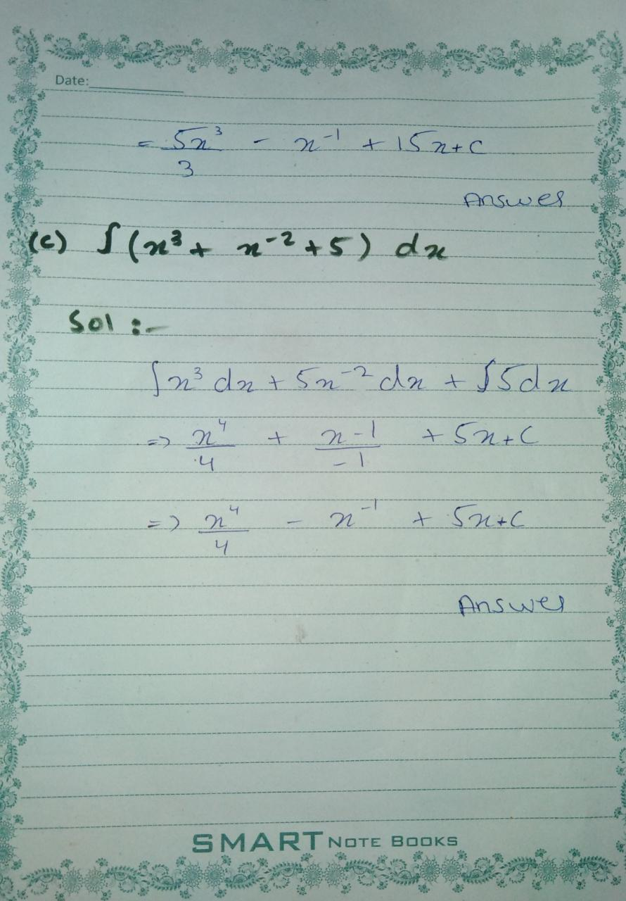

**Question 2**

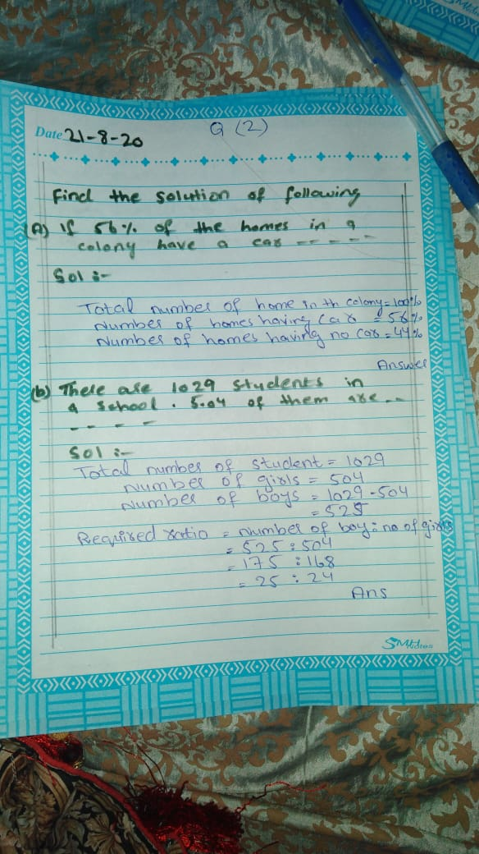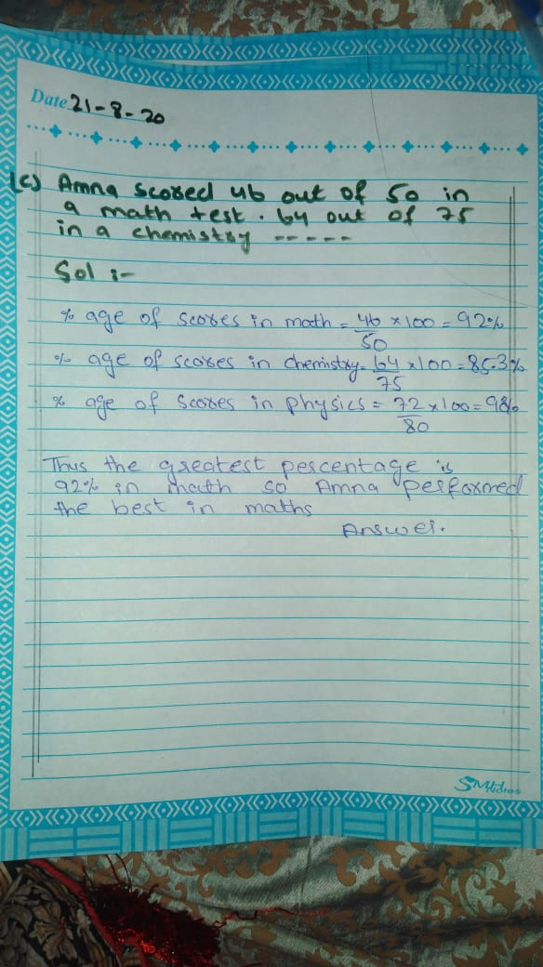

**Question 3**

