Paper:
Hematology
Submission Date:
April 16, 2020
Submitted By:
Abdullah
(ID#15897)
Submitted to:
Dr. Adnan Ahmad
Department of MLT
Iqra national university, peshawar, pakistan.
“Section A”
1. The most commonly ordered blood tests
- Urine RE
- T3
- T4
- Hemoglobin HB
- None of them
2. When a person has been diagnosed with a disease known to affect blood cells, a ___ will often be ordered on a regular basis to monitor their condition
- Urine RE
- T3
- T4
- Hemoglobin HB
- None of them
3. The cells that are part of the body's defense system against infections and cancer and also play a role in allergies and inflammation
- Neutrophils
- Lymphocytes
- Eosinophils
- Monocytes
- All of the above
4. Normal RBC range in:Male:
- 4.7 to 6.1 million cells p (cells/mcL)
- 4.2 to 5.4 million cells/mcL
- 6.7 to 6.1 million cells p (cells/mcL)
- 9.7 to 6.1 million cells p (cells/mcL)
5. Low platelet concentration is
- Thrombocytopenia
- Thrombocytosis
- Thrombocytopathy
- Leukopenia
6. Also known as myeloid tissue
- Red BM
- Yellow BM
- White BM
- Greenish fatty tissue
7. All red blood cells and platelets in humans adults are formed in____________
- Yellow BM
- White BM
- Greenish fatty tissue
- Myeloid tissue
8. Increase in red blood cells
- Anemia
- Polycythemia
- leukemia
- Clotting defects
9. Thrombopoietin is a glycoprotein hormone produced mainly by___
- Liver
- Kidney
- Both a and b
- Brain
10. life span of RBCs is_____
- 2 months
- 3 months
- 6 months
- None of them

“Section B”
Q.1 Enlist characteristics of blood.
Ans. Blood
Blood is a specialized bodily fluid in humans and other animals that delivers necessary substance such is nutrients and oxygen to the cell and transport metabolic waste products away from those same cells.
Characteristics of Blood
Some of the most important characteristics of blood are as under.
1. Composition :Blood is composed of formed elements (blood cells which includes; Erythrocytes ,Leukocytes and Platelets) and Plasma which is a nonliving fluid matrix.
2.Water: Dissolved materials e.g. gases, nutrients, proteins and hormones.
3. Density: More is denser than water due to presence of formed elements.
4. Viscosity: Blood is five time more viscous than water.
5. PH of Blood: Blood is slightly alkaline in nature due to the presence of carbonates and the Normal blood pH is 7.35 – 7.45.
6.Temperature: The temperature of blood is about 100.4 degrees F.
7. Volume: The average Volume of blood is about 5-6 L in males and 4-5 L in females.
8. Color: The arterial blood is scarlet red in color while the venous blood is bluish red in color due to the presence of CO₂.

Q.2 Briefly Explain hematopoiesis.
Ans: Hematopoiesis: The production of all types of blood cells including formation, development, and differentiation of blood cells. Prenatally, hematopoiesis occurs in the yolk sack, then in the liver, and lastly in the bone marrow. This process is also known as haemopoisis.
Stages of Hematopoiesis
1 Fetal stage: During fetal life there are various sites for Hematopoiesis, depending upon the life stages of fetus. In fetus of 0-2 months it occurs in yolk sack, while in 2-7 months fetus it occurs in liver and spleen. And in 5-9 months it mainly takes place in bone marrow.
2. Infants stage: The process of Hematopoiesis takes place in all bone marrows of the fetus.
3. Adult Stage: During adult stage the process of Hematopoiesis takes place in vertebrae, ribs, sternum, skull, sacrum and pelvis, proximal ends of femur.
The Process of Hematopoiesis
The monophyletic theory of hematopoiesis states that pluripotent stem cells multiply to produce more pluripotent stem cells, thus ensuring the steady and lasting supply of stem cells. Some of the pluripotent stem cells differentiate into precursor cells that are at least partially committed to become one type of mature blood cell.
Schematic representation of hematopoiesis
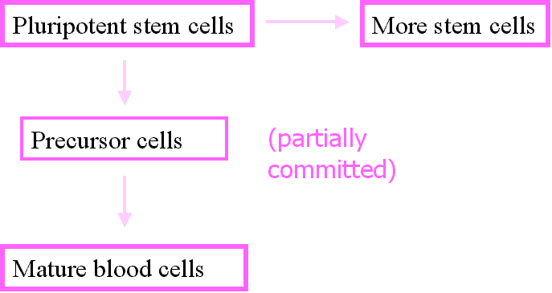
Pluripotent stem cells multiply slowly into one of five possible unipotential stem cells which then multiply rapidly into the precursor of the specific mature blood cell for which they are destined.

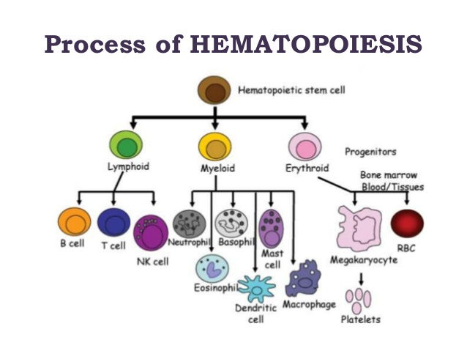

Q.3 write down a comprehensive note on bone marrow.
Ans: Bone Marrow:
Bone marrow is the spongy tissue inside some of your bones, such as your hip and thigh bones. It contains stem cells. The stem cells can develop into the red blood cells that carry oxygen through your body, the white blood cells that fight infections, and the platelets that help with blood clotting.
Structure of bone marrow
The inner surface of the bone cavities and the outer surface of the cancellous bone spicules within the cavities are covered by an endosteal lining consisting of a single layer of flat “bone-lining cells” supported by a thin layer of reticular connective tissue; osteoblasts and osteoclasts are also found within the endosteal lining.
The hematopoietic tissue consists of a variety of cell types including, the blood cells and their precursors, adventitial/barrier cells, adipocytes, and macrophages.
Functions of bone marrow
Red bone marrow is involved in hematopoiesis. This is another name for blood cell production. Hematopoietic stem cells that are found in red bone marrow can develop into a variety of different blood cells, including:
- Red blood cells. These are the cells that work to carry oxygen-rich blood to the cells of the body. Old red blood cells can also be broken down in red bone marrow, but this task is mostly performed in the liver and spleen.
- Platelets. Platelets help your blood clot. This prevents uncontrolled bleeding.
- White blood cells. There are several types of white blood cells. They all work to help your body fight off infections.
Newly produced blood cells enter your bloodstream through vessels called sinusoids.
While the Yellow bone marrow is involved in the storage of fats. The fats in yellow bone marrow are stored in cells called adipocytes. This fat can be used as an energy source as needed. Yellow bone marrow also contains mesenchymal stem cells. These are cells that can develop into bone, fat, cartilage, or muscle cells. Remember, over time, yellow bone marrow starts to replace red bone marrow. So, most bones in an adult body contain yellow bone marrow.
Q.4 Describe different sites of hematopoiesis in fetus, infants and adults.
Ans. Sites of hematopoiesis
There are various sites of hematopoiesis depending upon the life stage of an organism (Human). These sites are discussed shortly as under;
1 Fetal stage: During embryonic stage the hematopoiesis takes place in yolk sack and then liver. In fetus having age of 3-7 months it mainly takes place in spleen, and occurs in marrow cavity during age of 4-7 months.
2 Neonatal stage: Soon after birth the process of hematopoiesis takes place in bone marrow as well as liver and spleen when needed.
3 Childhood stage: During child hood to maturity the process of hematopoiesis mainly takes place in number of active sites in bone marrow decreases but retain ability for hematopoiesis.
4. Adult stage: On reaching adulthood a number of sites of bone marrow of skull, ribs, sternum, vertebral column, pelvis and proximal ends of femurs.
The End

