Programming Fundamentals

Mid-Term Exam

By Zarak Hassan & ID 16983

1 Year

**Programming Fundamentals Mid-Term:**

**By Syed Zarak Hassan**

**ID: 16983**

**“C++ & Flowcharts”**

|  |  |  |  |
| --- | --- | --- | --- |
| Q.1 |  |  |  |
|  |  | **Draw the flow chart and write a C++ program to get** two integer items from **keyboard** and **then** display to the screen their sum, difference, product and quotient.  **Code:**  #include <iostream>  using namespace std;  int main()  {  int Num1, Num2;  cout <<"Please enter the first number";  cin >> Num1;  cout <<"Please enter the second number";  cin >> Num2;  int Sum = Num1+Num2;  int Diff = Num1-Num2;  int Product = Num1 * Num2;  float Quotient = (float) Num1/Num2;  cout<<"Sum = " <<Sum<<endl;  cout <<"Diff = "<<Diff<<endl;  cout<<"Product ="<<Product<<endl;  cout<<"Quotient ="<<Quotient<<endl;  } |  |
|  |  | **Draw the flow chart and write a C++ program to** prompt the user for a temperature in degrees Celsius (C), then convert the temperature in degrees Fahrenheit (F) using the following formula and display temperature in Fahrenheit (F) on monitor.  Code:  #include<iostream>  using namespace std;  int main()  {  float fahrenheit, celsius;  cout << "Enter the temperature in Celsius : ";  cin >> celsius;  fahrenheit = (celsius * 9.0) / 5.0 + 32;  cout << "The temperature in Celsius : " << celsius << endl;  cout << "The temperature in Fahrenheit : " << fahrenheit << endl;  return 0;  } |  |
|  |  |  |  |
| Q.2 | a) | **Draw the flow chart and write a C++ program** that will prompt an operator to input three characters, receive those three characters, and display a welcoming message to the screen such as ‘**Hello xxx! We hope you have a nice day**.’   **Code:**  #include <iostream>  using namespace std;  int main() {  string characters;  cout<<" Input three characters:";  cin>>characters;  cout << "Hello " << characters.substr(0, 3) <<"! Hope you have a nice day";  return 0;  } |  |
|  | b) | You were asked by your project leader to write a simple program that obtains the radius of a circle. The program calculates the area and perimeter then prints radius, the area and the perimeter. **Draw the flow chart and write a C++ program.  Code:**  #include <iostream>  #include <cmath>  using namespace std;  int main()  {  float radius, area, circum;  cout << "\n\n Find the area and circumference of anycircle:\n";  cout<<" Input the radius(1/2 of diameter) of a circle : ";  cin>>radius;    circum = 2*M_PI*radius;  area = M_PI*(radius*radius);  cout<<" The area of the circle is : "<< area << endl;  cout<<" The circumference of the circle is : "<< circum << endl;    cout << endl;  return 0;  } |  |
|  |  |  |  |
| Q.3 | a) | A student has to take three tests per semester. Each test has maximum marks of 50. By using a system, lecturer can enter marks obtained for each test as input. Draw a flowchart and write C++ program to calculate the percentage obtained by the student. Print the result.  **Code:**  #include <stdio.h>  int main(void){  int num;  printf("Enter your mark ");  scanf("%d",&num);  printf(" You entered %d", num);  if(num >= 40){  printf(" You got A grade");  }  else if ( num >=35){  printf(" You got B grade");  }  else if ( num >=25){  printf(" You got C grade");  }  else if ( num < 25){  printf(" You Failed in this exam");  }  return 0;  } |  |
|  | b) | **Draw the flow chart and write a C++ program** to calculate energy needed to heat water from an initial temperature to a final temperature. The user will enter the water amount (in kilograms) and its initial and final temperatures. The formula to compute the energy is  Q = M * (final temperature – initial temperature) * 4184  Where M is the weight of the water (in kilograms), temperatures are in Celsius and energy Q is measured in joules. |  |

**Code:**

#include<iostream>

using namespace std;

int main()

{

float initialTemperature, finalTemperature, kilograms, joules, M, Q;

cout << "Enter the Amount of Water in Kilograms : ";

cin >> kilograms;

cout << "Enter the final temperature : ";

cin >> finalTemperature;

cout << "Enter initital temperature :";

cin >> initialTemperature;

Q = M*(finalTemperature-initialTemperature)*4184;

cout << "Q : " << joules << endl;

return 0;

}   
----------------------------------------------------------------------------------------------------------------

**Sponsored by Nyepuwu & NeXuS**

**Flowcharts:**

**The Flowcharts are not in order, page 12 has Q1(B) Flowchart, thanks.**

**Q1 (A) FLOWCHART**

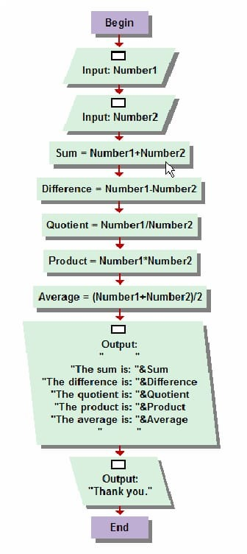

**Q2(A) FLOWCHART**

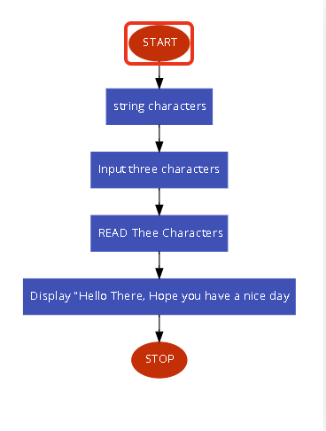

**Q2 (B) Flowchart**  
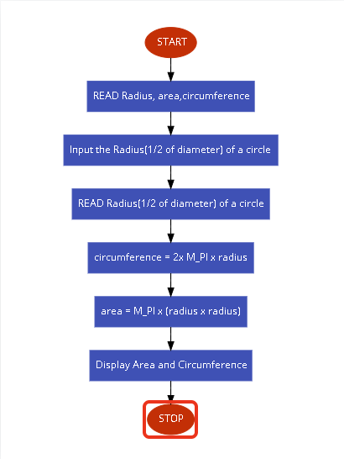

**Q3(A) Flowchart**

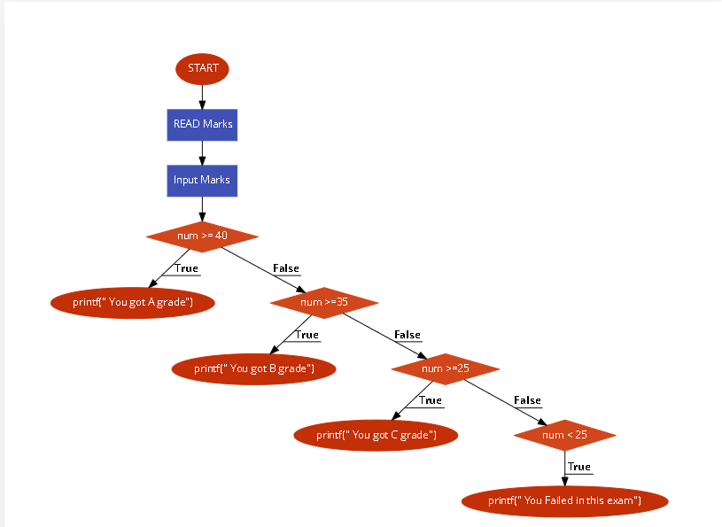

**Q3(B) Flowchart**

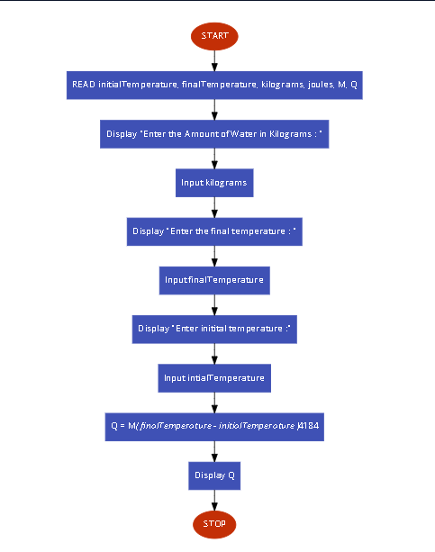

**Q1 (B) FLOWCHART**

Display Temperature in Fahrenhite

fahrenheit = (celsius * 9.0) / 5.0 + 32

Input temperature in Celsius

Read Celsius, Fahrenheit