NAME:ABRAR AHMAD

ID:15338

PROGRAM:BS RADIOLOGY 4th

Paper: crp and cp

Q no1:

Answer 1:barium swallow is the best diagnosis ,if patient have abnormality /difficulty in swallowing.

STANDARD PROTOCOL:

Allow better communication between clinicians
Permits standardization of exam
Ensures patients safety
Allows comparison to others patient ,Group,Normals
Allow comparison of performances overtime ,treatment
Lip closure

Q no 2:
Ans 2 :barium meal is used for the abnormality of duodenum and stomach study
FILMS:
Spot films of stomach lying :
RAO(Right anterior oblique ): in here we lies the patient in prone position and slightly RAO.
We put
Cr perpendicularly to IR.Due to it determine the pylorus cannel.As a results the antrum and greater curve of stomach clearly show.
B: SUPINE :
we lies the patient at supine position at compression pad ,due to it we demonstrate the antrum and the body.
C: LAO(LEFT ANTERIOR OBLIQUE ):
In this condition we lies the patient in left side obliquely.as a result we demonstrate lesser curve on face.
D:LEFT LATERAL TILTED:
In this condition we put the head up degree angle.due to it we demonstrate the fundus. As a result gas can accumulate in fundus and we see it clearly.
From lateral position we return the patient in supine position roll at left side. As a results the movement is required to avoid barium flooding in duodenal loop.
2: SPOT FILMS OF DUODENAL LOOP LYING:
PRONE:
In here the patient lies in prone position on compression pad.it prevent the barium flooding in duodenum.due to it we demonstrate the anterior wall of duodenal loop.it taken in RAO.
3:SPOTS FILMS OF DUODENAL LYING :
We lies the patient at prone position.
RAO POSITION :
The patient attain this position from prone ,by roll first on left side. As a result to avoid barium flooding into the duodenal loop.

SUPINE:
In this condition we lies the patient in supine position.
D: LAO(LATERAL ANTERIOR OBLIQUE):
In this condition we lies the patient in left anterior oblique
4: the first view of fundus in an erect position taken in this stage.
5:SPOTS FILM OF ESOPHAGUS :
It is taken when barium is swallowed to show complete examination. It demonstrate the esophagus spot film.
6:right lateral position from stomach and duodenum:
In here we lies the patient at right lateral position. We put the patient arms up by head and flex their knee. Adjust the body true lateral position. We canter the IR and CR to duodenal bulb at the level of LT,1-5 inches.

Q3:
Answer 3:
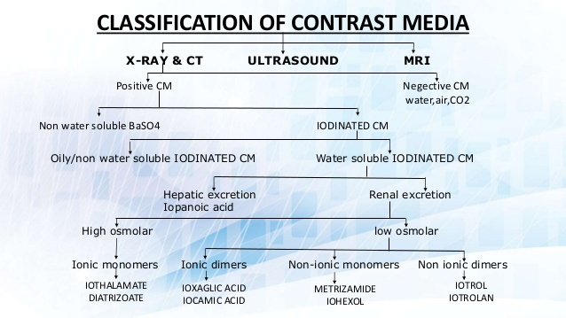

FURTHERS CLASSIFICATION:
POSITIVE CONTRAST MEDIA:
radio opaque
White on film
High atomic number
Barium sulphate
USE:
Commonly use for GI track studies
USE:
ANGIOGRAPHY:contrast study for vessels
MYELOGRAPHY:used for spinal cord
SIELOGRAPHY :used for salivary glands
HYSTEROSYLPINGOGRAPHY:contrast study of fallopian tube and uterus to check the patency of fallopian tube.
CHOLANGIOGRAPHY:contrast study of gallbladder ,cystic duct and common bile duct.

NEGATIVE CONTRAST MEDIA:
Radio lucent
Low atomic number
Black on films
Used for double contrast study,for colons to show outer borders
EXAMPLES: H2O,air,CO2
BARIUM SULPHATE :
Useful and essential contrast agent in radiology unit
Highly radio opaque
Nan toxic and soluble in water
Its atomic number is 56
Non absorbable
USES:
Barium swallow
Barium meal
Barium enema
ADVANTAGES :
Main advantage is excellent coating.affordable price and easy availability
DISADVANTAGES:
High morbidity rate
COMPLICATIONS:
Perforation,aspiration ,intravasation etc
3:INTRAVASATION:
It carry mortality up to 80%. as a result of barium pulmonary embolus.
IODINE CONTRAST MEDIA :
Its water soluble .we administer it only in IV because it is water soluble.its atomic wait is 127 and atomic number is 153.its usually classified as ionic and non ionic . due to their relatively harmful relation with our body solubility.
Hepatic excretion renal excretion
High osmolar low osmolar
Ionic non ionic
Positive contrast negative contrast
Radio opaque radio lucent
White on film black on flim
USE: Angiography ,venography etc
ADVERSE EFFECT OD IODINE:
It may cause allergic reaction,contrast include nephropathy and metformin accumulation.
RADIOGRAPHY DEPEND UPON :
Numbers of atoms in each molecules of cm.
3: OILY/NON WATER SOLUBLE IODINATED CM:
Insoluble in water
White on radiograph
EXAMPLE:
Myodil: study of spinal cord
Ethiodol :Both are oily contrast. it is contrast study of lymphatic vessels
COMPLICATION: Fat metabolism
USE: sialography, hysterosalpingography,its more commonly in oily CM. Decryocystography,galactography,and Myelography.
4:WATER SOLUBLE IODINATED CM: it is used for diagnose of gastrointestinal disease.it change their effectiveness in diagnosing gastrointestinal obstruction with safety.in perforating it enter the abdominal cavity as much as rapidly.
Adverse effect of water soluble CM :The toxic of contrast media function is osmolality ,ionic changes,chemical structure.
HIGH OSMOLAR CONTRAST MEDIA: its the oldest agents.it is relatively in expensive.it are monomers that ionize in solution.it osmolality range is 1,300 to 2,140/kg. it is about 7 times above to human blood.
USE: it is use for gastrointestinal and cystourethal administration. Include gastrografin,conray .
LOW OSMOLAR CONTRAST MEDIA :it is 2-3 time the osmolality of blood .it administer through intravascular and intrathecal.
Iso-osmolal contrast media :same as osmolality of blood.

