Name Riaz ahmad
Id 15419
Class BS(SE)

FULL ADDER
AIM:
Design and verify the logic circuit of Half-subtractor using logic gate. OBJECTIVES:
- To understand the principle of binary addition.
- To understand full adder concept.
- Use truth table and Boolean Algebra theorems in simplifying a circuit design.
- To implement full adder circuit using logic gates. PROCEDURE:
- Collect the components necessary to accomplish this experiment.
- Plug the IC chip into the breadboard
- Connect the supply voltage and ground lines to the chips. PIN7 = Ground and PIN14 = +5V.
- According to the pin diagram of each IC mentioned above, make the connections according to circuit diagram.
- Connect the inputs of the gate to the input switches of the LED.
- Connect the output of the gate to the output LEDs.
- Once all connections have been done, turn on the power switch of the breadboard
- Operate the switches and fill in the truth table (Write "1" if LED is ON and "0" if LED is OFF
. • Apply the various combination of inputs according to the truth table and observe the condition of Output LEDs.
FULL ADDER:
Full adder is a logical circuit that performs an addition operation on three binary digits. The full adder produces a sum and carry value, which are both binary digits. It can be combined with other full adders or work on its own

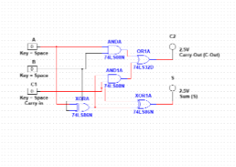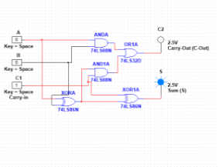
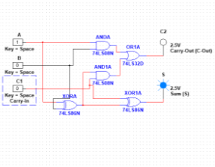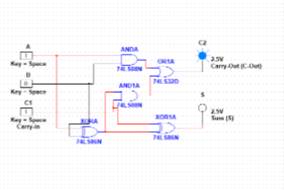

.
Observation table
A | b | Carry in | Sum | Carry out
0 | 0 | 0 | 0 | 0
0 | 0 | 1 | 1 | 0
0 | 1 | 0 | 1 | 0
0 | 1 | 1 | 0 | 1
1 | 0 | 0 | 1 | 0
1 | 0 | 1 | 0 | 1
1 | 1 | 0 | 0 | 1
1 | 1 | 1 | 1 | 1

RESULTS AND ANALYSIS:
Verified the truth table as follows. Full Adder: Verified the truth table of Full Adder as S = 1 i.e. LED which is connected to S terminal glows when inputs are A, B, Ci Verified the truth table of Full Adder as Co = 1 i.e. LED which is connected to Co terminal glows when inputs are A, B, Co.
CONCLUSION:
- To add two bits, we require one XOR gate (IC 7486) to generate Sum and one AND (IC 7408) to generate carry.
- To add three bits, we require two half adders.

