Name: Farkhanda jabeen
ID #: 14725
Department: BS (CS)
Paper:
OOP {LAB
Dated: 05th Oct 2020
Semester : 4th

Q1. How to calculate parameter of a triangle in java using object oriented approach?
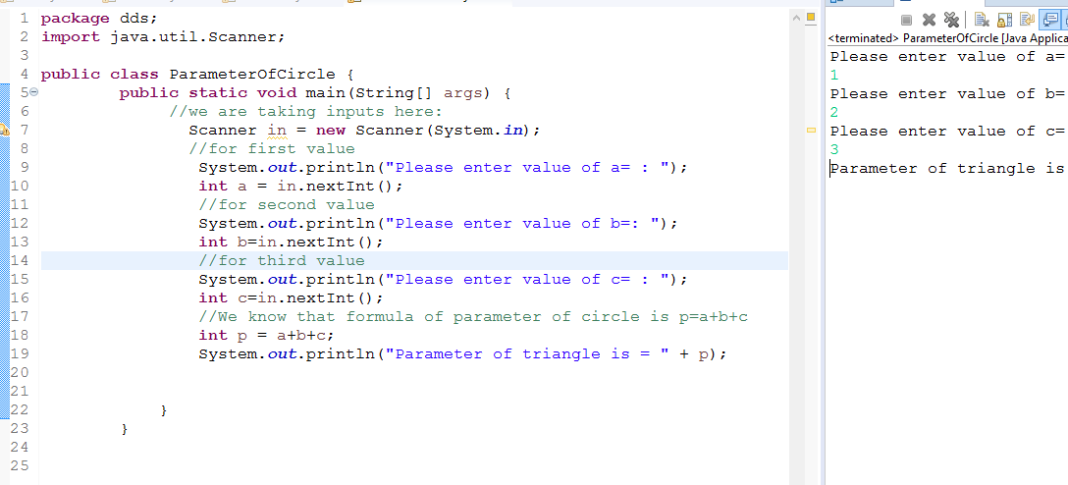
Q2. How to calculate diameter of a circle in java using object oriented approach?

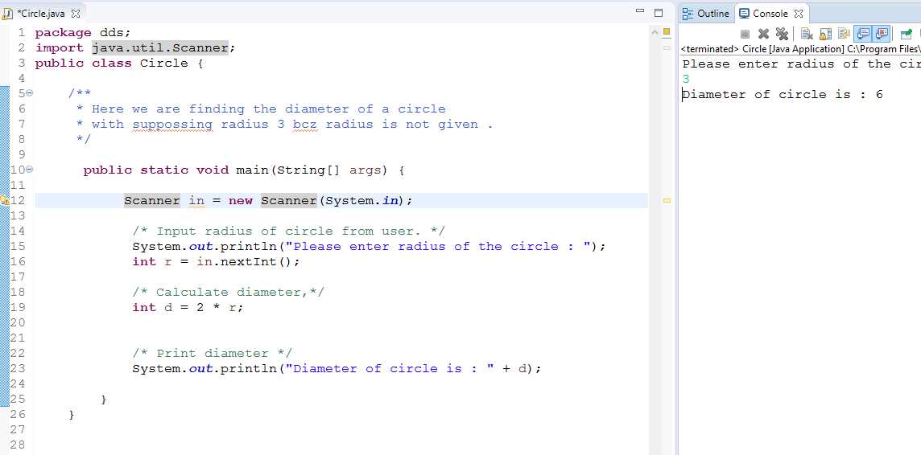

Q3. How to check Leap year in java using object oriented approach?

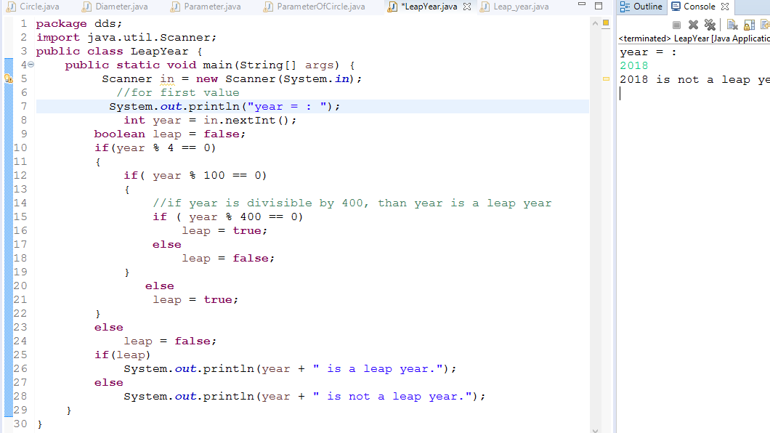

Q4. How to check that the input from the user is the vowel or not in java using
object oriented approach?

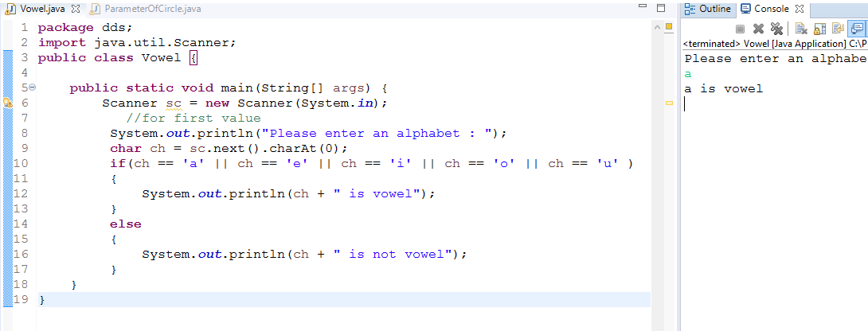

Q5. How to use power of a number in java using object oriented approach?

