Name: Rabia zaman
ID: 14180
Subject: operative dentistery
Department
Dental technology
INU
PESHSAWAR
Teacher: sir usman

Complete Ceramic Crown (Porcelain Jacket Crown)
The most esthetically pleasing fixed restoration, because there is no metal understructure to block light transmission. It can resemble natural tooth in term of color and translucency than any other restoration. Since it is made entirely from ceramic substance, it is the weakest type of crown restorations (more susceptible to fracture) and it is the least conservative type of crowns. Most of the time it used as single restoration on upper or lower incisors.
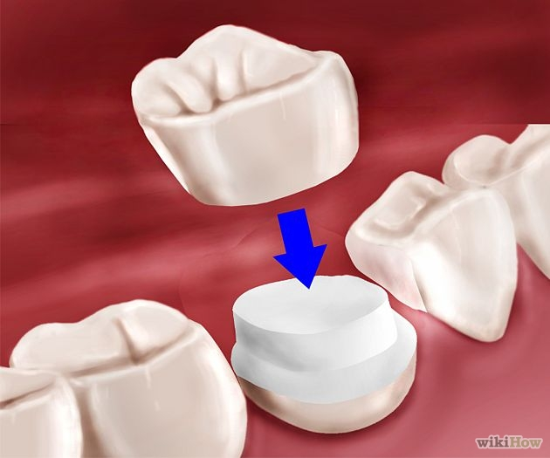
Indications:
• High esthetic requirements.
• Considerable proximal caries.
• Endodontically treated teeth with post & core.
• Incisal edge reasonably intact.
• Favorable distribution of occlusal load.
Contra indications:
• When superior strength is required.
• Thin teeth facio-lingually. • Unfavorable distribution of occlusal load.
• Insufficient coronal tooth structure for support (very short teeth).
• Edge to edge occlusion.
• Bruxism.
Advantages:
• Superior esthetic.
• Good tissue response even with subgingival margins (biocompatible).
• High retention since it can be etched and bonded.
Disadvantages:
• Reduced strength compared to metal crowns.
• Proper preparation is extremely critical.
• Among the least conservative preparations.
• Brittle nature of the material.
• Recommended as single restoration only
Tooth Preparation for Porcelain Jacket Crown)
Preparation requirements:
1. A shoulder of uniform width (1.5 mm) is used as gingival FL to provide a flat seat to resist the force directed from incisal.
2. Incisal edge should be flat and prepared with slight inclination lingually.
3. All sharp angles of preparation should be slightly rounded to reduce the danger of stress concentration and fracture.
4. It should be avoided on teeth with edge to edge occlusal relation.
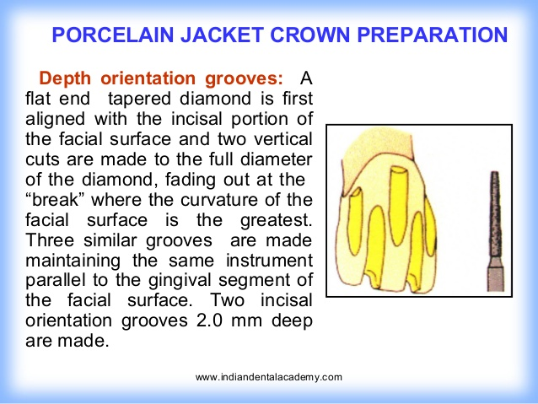

Steps in preparation
A. Incisal Reduction
• The aim of this step is the complete reduction of incisal edge that should provide 1.5 – 2 mm of clearance for porcelain in all masticatory movements, this step is extremely important to get cosmetically pleasing restoration with adequate strength.
• Flat end taper diamond bur is used, placed parallel to the incisal inclination (for post. teeth 2mm occlusal clearance is needed for all cusps).
• DOG 1.3mm in depth are made on the incisal edge using a flat-end tapered fissure bur, parallel to the incisal inclination of the prepared incisal edge.
• Any tooth structure between D.O.G should be removed using the same bur at the same angle (1.5 mm).
• Check in centric & eccentric occlusal relations.
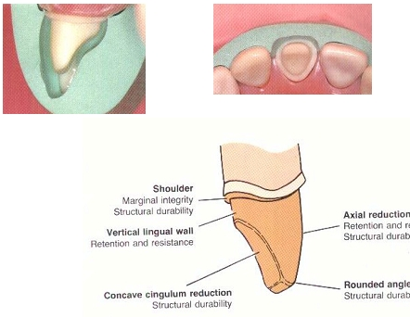
B. Labial (Facial) Reduction
Two planes reduction
Whenever needed, reduction should be done in 2 planes corresponding to the 2 geometric planes of the surface: incisal plane and gingival plane.
Incisal plan
• Three DOG (1mm) are placed, these grooves should be parallel to the inclination of this area.
• Any tooth structure between DOG were then removed following the contour of the tooth (keep the bur at the same angle).
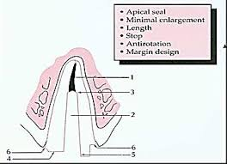
Gingival plan
• DOG (1mm) are placed in gingival part of lingual surface parallel to the long axis of the tooth.
• Any tooth structure between D.O.G should be removed using flat-end tapered fissure bur to create shoulder F.L.
C. lingual reduction:
As for PFM but with deeper reduction (1mm).
a. Cingulum area reduction:
• D.O.G. of 0.8mm placed in the center.
• Small wheel or pear shaped diamond bur is used (following the inclination of the tooth) to reduce this area.
b. Lingual axial reduction;
• D.O.G. of 0.8mm placed parallel to the long axis of the tooth.
• Flat-end T.F.B is used to reduce this area using the same angle (to create shoulder F.L.).
Types of finishing lines used for all ceramic crown
Shoulder all around has been advocated as gingival finishing line to be use with this crown. The depth and contour of shoulder is established with the tip of flat end tapered fissure bur. Sharp angles should be rounded to avoid creation of point of stress concentration.

