DPT 4th
Course Title: Pharmacology I
Student Name: wajeeha komal
Student ID: 15118
Note:
Attempt all questions
Each question carry equal marks
Pay attention to every point of question
Give to the point answers
Extra detail may leads to marks deduction

Question 1:
Explain the detailed neurotransmission process
Ans: Neurotransmitters are endogenous chemicals that enable communication within the nervous system and between the nervous system and the rest of the body. They relay information between individual neurons, and ultimately regulate a wide range of bodily functions.
There are various classes of neurotransmitters, with different functions and mechanisms of action. Neurotransmitter levels and function are crucial to maintaining homeostasis, and if altered can lead to diseases.

Mechanism of Action
Neurotransmitters transmit signals across a synapse at various locations, such as:
- From one neuron to another target neuron
- At the neuromuscular junction (NMJ), that is from a neuron to a target muscle cell
- From a neuron to a target gland.
A synapse is a junction through which a neuron relays information to another neuron; it has three main components:
- The axon terminal, or pre-synaptic side where information is transmitted from
- The synaptic cleft
- The dendrite, or post-synaptic side, receiving the information.
There is generally a low level baseline level of neurotransmitter release that occurs without any need for stimulation. However, the amount released is increased in response to threshold action potentials. Binding of neurotransmitters to the post-synaptic neuron then results in either excitation or inhibition depending on which is released and the receptor it binds to.
Some neurotransmitters also have a neuromodulatory action. These can act on large numbers of neurons at once and are involved in larger scale regulation of groups of neurons. This process takes place over a much slower time course than excitatory and inhibitory transmission however.
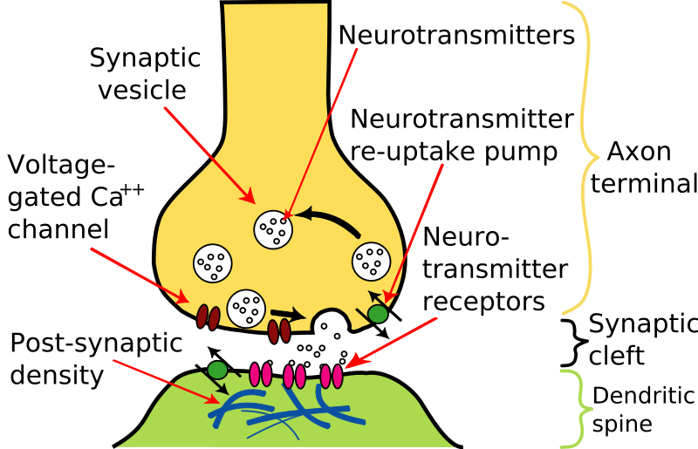

Classes of Neurotransmitter
There are hundreds of neurotransmitters, but they can be grouped into classes depending on their structure, or function.
Focusing on structure, neurotransmitters can be classed as:
- Monoamines – such as dopamine, noradrenaline, adrenaline, histamine, serotonin
- Amino acids – such as glutamate, GABA (gamma-aminobutyric acid), glycine, aspartate, D-serine
- Peptides – such as opioids, endorphins, somatostatin, oxytocin, vasopressin
- Other – such as acetylcholine (ACh), adenosine, nitric oxide
Often, it is more useful to classify neurotransmitters based on their function:
- Excitatory neurotransmitters increase electrical excitability on the post-synaptic side through modulation of the trans-membrane ion flow to facilitate transmission of an action potential.
- Inhibitory neurotransmitters decrease electrical excitability on the post-synaptic side to prevent propagation of an action potential.
- Neuromodulators function to alter the strength of transmission between neurons by affecting the amount of neurotransmitter that is produced and released
Two primary neurotransmitters in the ANS:
Acetylcholine:
–preganglionic cells of the parasympathetic and sympathetic branches
–postganglionic cells of the parasympathetic branch
–some postganglionic cells of the sympathetic branch
Norepinephrine:
–most postganglionic cells
Four Major Steps:
1. Synthesis and Storage of the neurotransmitter in the presynaptic neuron
2. Release of the neurotransmitter into the synaptic cleft
3. Interaction of the neurotransmitter with receptors on the post-synaptic cell
4. Termination of the synaptic actions of the neurotransmitter.
Acetylcholine example:
The precursor choline is transported into cholinergic nerve terminals
Once synthesized, acetylcholine is transported into vesicles for storage
Because of the ubiquitous nature of acetylcholine, these drugs are not used in clinical pharmacology.
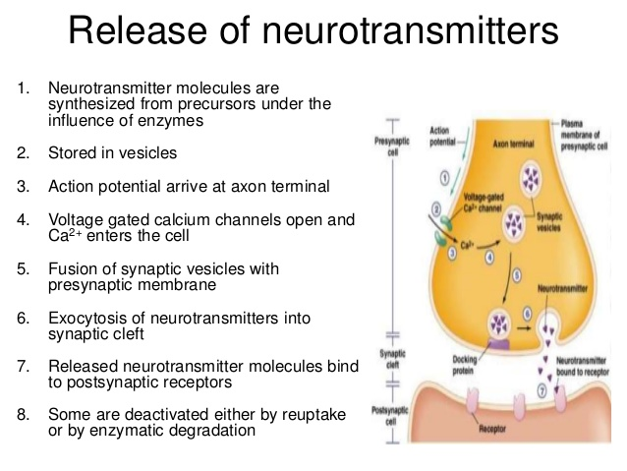

Question 2:
What does direct and indirect cholinergic agent means? Explain therapeutic application and adverse effects of cholinergic agents in detail.
Ans: A direct-acting cholinomimetic drug produces its pharmacological effect by receptor activation. Direct-Acting Cholinergic Agonists • Cholinergic agonists (parasympathomimetics) mimic the effects of acetylcholine by binding directly to cholinoceptors.choline esters, which include acetylcholine synthetic esters of choline, such as carbachol and bethanechol.
An indirect-acting drug inhibits acetylcholinesterase, thereby increasing endogenous acetylcholine levels, resulting in increased cholinergic response. These drugs inhibit anticholinesterase the enzyme which destroys acetylcholine secreted into the synapse by the cholinergic neuron.
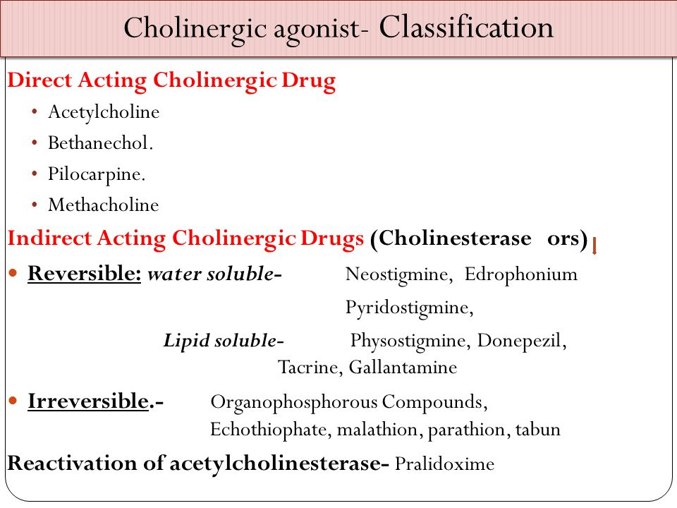
Cholinomimetic drugs:
Classification
Drugs that Increase Cholinergic Activity
Cholinergic agonists (direct acting)
•muscarinic agonists (pilocarpine)
•nicotinic agonists (nicotine)
Inhibitors of acetylcholinesterase (indirect acting)
•reversible inhibitors (neostigmine)
irreversible inhibitors (nerve gas, insecticides
Therapeutic Applications of cholinergic agents:
1. Myasthenia Gravis
•Myasthenia gravis is an autoimmune disorder that attacks the nicotinic ACh receptors at the neuromuscular junction
•leads to profound muscle weakness
•Acetylcholinesterase inhibitors increase the amount of acetylcholine in the neuromuscular junction
•neostigmine is frequently used for this disorder
•If muscarinic side-effects are prominent, anticholinergics can be administered (e.g., atropine)
•tolerance usually occurs to the muscarinic side-effects
2. Reversal of NeuroMuscularBlockade:
•By increasing levels of acetylcholine in the NMJ, the compounds are able to facilitate recovery from competitive neuromuscular blockade
•restores neuromuscular transmission
3. Glaucoma
Constriction of the ciliary body promotes aqueous humor outflow --> decreased intraoccular pressure
Direct and indirect cholinomimetics can be used to treat glaucoma
pilocarpine is the most commonly used agent
typically formulated as eye drops
4. Atonic GI/GU:
•The smooth muscle of the GI and GU systems can show depressed activity in certain states
•post-operative ileus
•congenital megacolon
•Bethanechol and neostigmine are the most widely used agents
•increases secretion and motility in the G.I. tract
•can be given orally or by injection
. Adverse effects of cholinergic agents
The primary adverse effects of cholinergic stimulants include gastrointestinal distress (nausea, vomiting, diarrhea, abdominal cramping), increased salivation, bronchoconstriction, bradycardia, and difficulty in visual accommodation
Question 3:
- Explain the effects and adverse effects of organic nitrates in angina pectoris.
Ans: organic nitrates:
They are effective in all types of angina pectoris.
Mechanism of action
at therapeutic doses :
has 2 major effects
a)Dilation of the large veins resulting in pooling of blood in the veins which diminish the preload and reduces the work of the heart
b)Dilates the coronary vasculature providing increased blood supply to the heart muscle.
- ↓ Preload
- ↓ Afterload
- Relieving vasospasm
- Redistribution blood flow
The total effect is a decrease in myocardial oxygen consumption because of decreased cardiac work.
Specific agents:
1)nitroglycerin,
2)isosorbid dinitrat
3)isosorbid mononitrate
Adverse effects:
Nitrates usage can cause headaches in about 30% to 60% of patients
Because of the pronounced vasodilation.
High doses can cause postural hypotension, flusing and tachycardia.
- Write down the treatment algorithm for improving symptoms of stable angina.
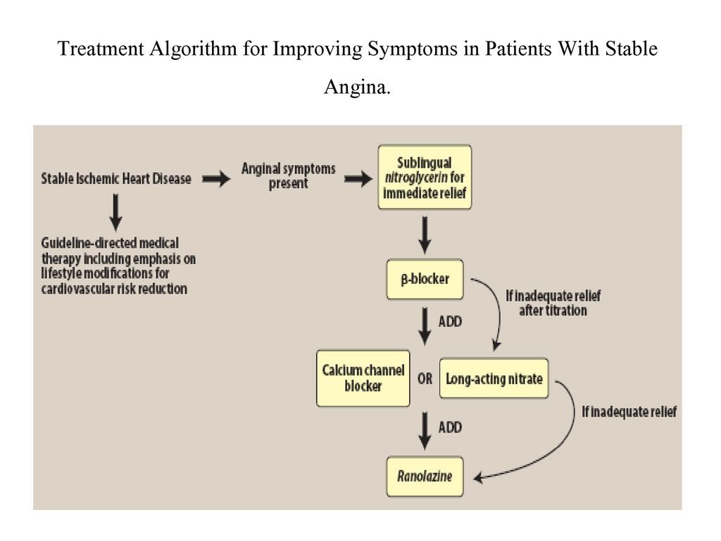
Question 4:
a.Differentiate between primary and secondary hypertension
Ans: primary hypertension:
Primary hypertension also known as essential hypertension Essential hypertension is high blood pressure that doesn’t have a known secondary cause. A disorder of unknown origin affecting the blood pressure regulating mechanism.
Blood pressure is the force of blood against your artery walls as your heart pumps blood through your body. Hypertension occurs when the force of blood is stronger than it should be normally.
Secondary hypertension:
Secondary hypertension differs from the usual type of high blood pressure (primary hypertension or essential hypertension), which is often referred to simply as high blood pressure. Secondary hypertension (secondary high blood pressure) is high blood pressure that's caused by another medical condition. Secondary hypertension can be caused by conditions that affect your kidneys, arteries, heart or endocrine system. Secondary hypertension can also occur during pregnancy
Risk factors:
1.hyperlipidaemia more LDL content
2.tension and stress
3.smoking more nicotine intake
4.diabetes mellitus
5.imbalance between vasoconstrictor and vasodilators peptides

b.Explain the effect of renin on hypertension
Ans: Renin converts angiotensinogen, which is produced in the liver, to the hormone angiotensin I. An enzyme known as ACE or angiotensin-converting enzyme found in the lungs metabolizes angiotensin I into angiotensin II. Angiotensin II causes blood vessels to constrict and blood pressure to increase.
“Scroll down”
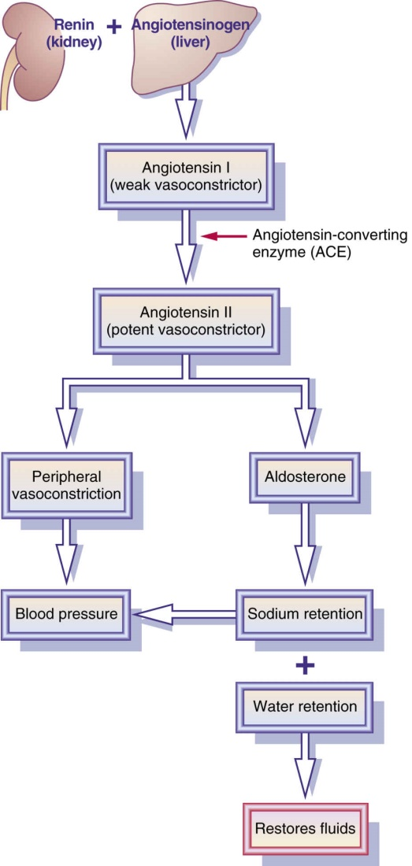
c.What is the importance of pharmacological treatment of hypertension
Ans: Hypertension, or high blood pressure, is dangerous because it can lead to strokes, heart attacks, heart failure, or kidney disease. The goal of hypertension treatment is to lower high blood pressure and protect important organs, like the brain, heart, and kidneys from damage, Hypertension is one of the most important preventable causes of premature death worldwide, and the benefits of antihypertensive drugs have been confirmed by the largest evidence base from clinical trials in medicine. Many classes of drugs are available for treatment A meta-analysis of trials of treatment for hypertension with the newer drugs found that ACE inhibitors and calcium channel blockers were likely to reduce cardiovascular morbidity and mortality by the same order of magnitude as β blockers or thiazides.
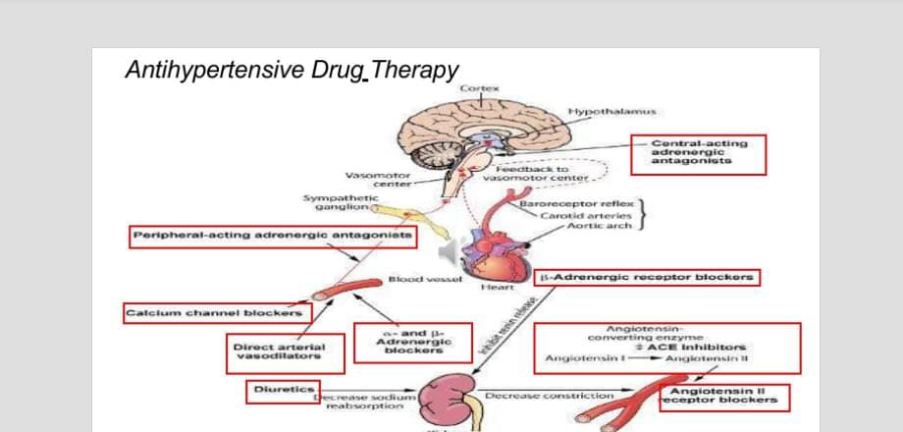
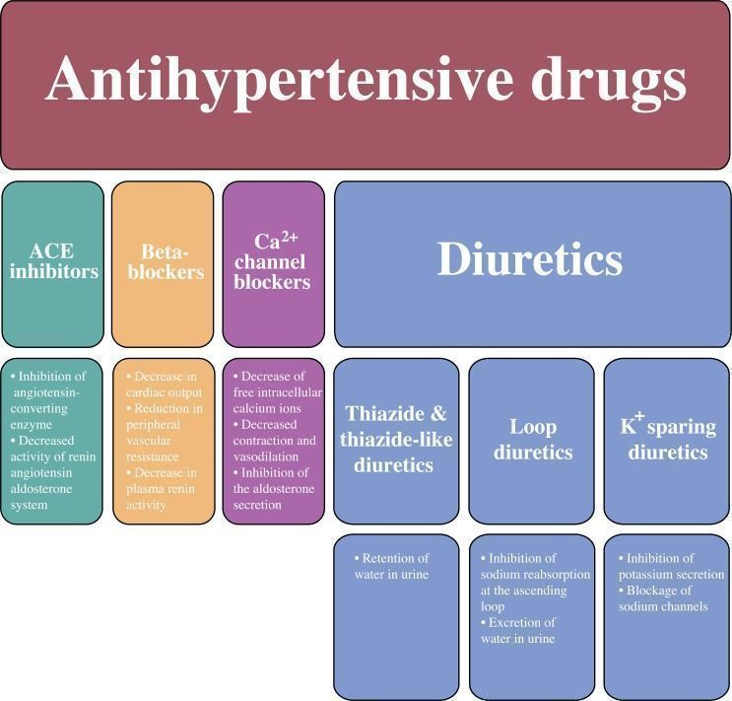

Question 5:
a.Differentiate between right heart failure and left heart failure .
Ans: heart failure:
In heart failure, the heart can no longer pump enough blood around the body. The heart muscle is either too weak or not elastic enough. Different parts of the heart may be affected too Heart failure often only affects the left or right side of the heart, but can affect both.
right heart failure vs left heart failure:
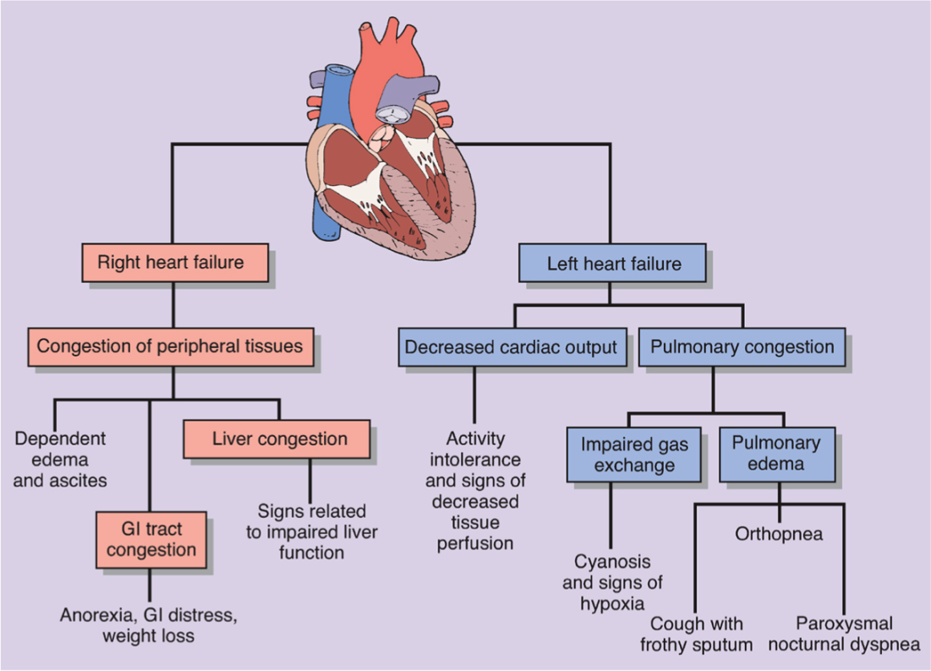
1.right heart failure:
The right ventricle of the heart is too weak to pump enough blood to the lungs. This causes blood to build up in the veins (the blood vessels that carry blood from the organs and tissue back to the heart). The increased pressure inside the veins can push fluid out of the veins into surrounding tissue. This leads to a build-up of fluid in the legs, or less commonly in the genital area, organs or the abdomen (belly).
2.Left-sided heart failure:
The left ventricle of the heart no longer pumps enough blood around the body. As a result, blood builds up in the pulmonary veins (the blood vessels that carry blood away from the lungs). This causes shortness of breath, trouble breathing or coughing – especially during physical activity. Left-sided heart failure is the most common type. Consequently, left heart failure is associated with pulmonary edema. Left-sided heart failure is usually caused by coronary artery disease (CAD), a heartattack or long-term high blood pressure.
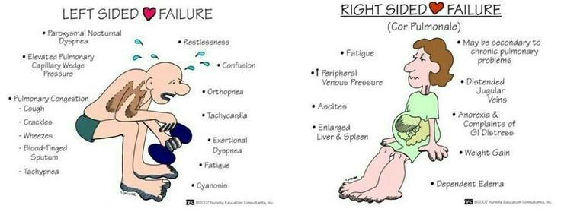

b.Summarize the pharmacotherapy of heart failure.
Ans: pharmacotherapy of heart failure:
Drugs used in heart failure
1.positive ionotropic drugs.
a.cardiac glycosides(digoxin)
b.beta agonists(dobutamine)
c.PDE inhibitors(milrinone)
2. vasodilators.
a.nitroprusside nitrates hydralazine
b.loop diuretics ACE inhibitors nesiritide
3.miscellaneous drugs for chronic failure.
a. loop diuretics ACE inhibitors nesiritide
b.Beta blockers spironolactone
………………………………………………………………………………………………………………………

