FINAL TERM EXAMINATION ( spring 2020)
Paper = Haematology
Bs. MLT 2nd semester
Name= shamsher Ali
Instructor= Adnan Ahmad
Id: 16849

Q5
Ans:
DEF:
Anemia:
A decrease in haemoglobin level for the age
And sex of a person is called as Amelia.
- On the basis of morphology and with regard of red
Cell induce can classify Amelia into the following.
Microcytic hypochromic Anemia.
This types of anemia individual RBCs are smaller in size and contain and
Sub normal amount of homoglobin.
Classification of morphological anaemia:
- Microcytic anemias:
_ iron deficiency
_ thalassemia
_ siderroblastic anemia
_ Anemia of chronic diseases.
- Microcytic anaemias:
_ Anemia of chronic diseases ( most classes)
_ iron deficiency ( early)
_ Anemia of renal diseases.
_ Morrow failure.
_ Hypothyroidism.
- Microcytic enemies:
_ Hypothyroidism.
_ Mylodysplasia.
_ Liver disease.
_ Megaloblastic anemia( folate or cobalamine deficiency)
_ Hemolytic Anaemia ( rreticulocytosis).

Q 1:
ANS:
Def:
Erythropoiesis: is the process which produces red blood cells, to
Which is development from erythropoitic stem cell to mature red
Blood cell. It is stimulated by deccreased O2 in circulation, which is
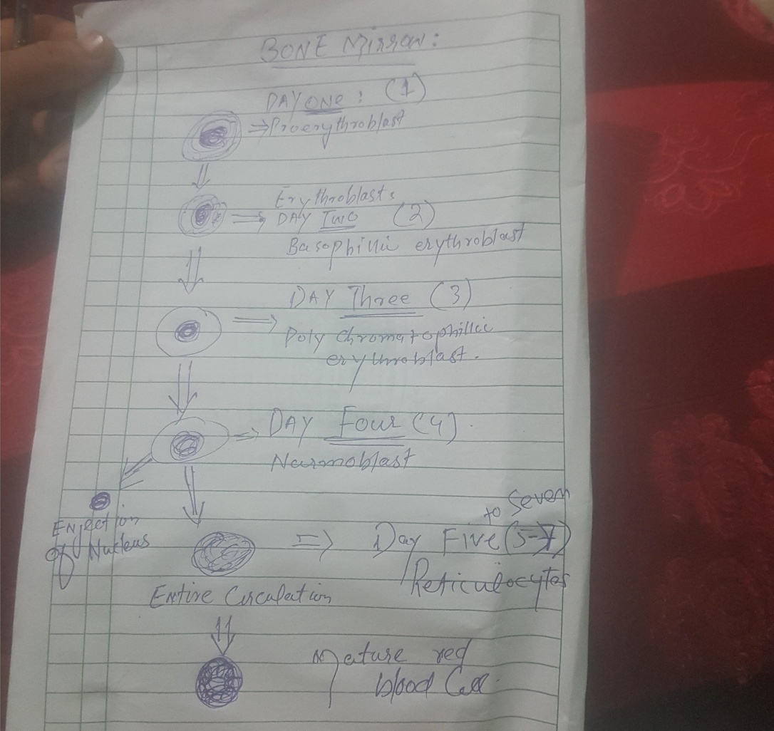
Detected by the kidneys, which then secrete the hormones erthropoietin.

Proerythroblast
- 15to20 micron
- Nucleus with multiple nucleoli
- Basophilic cytoplasmic with perinuclear halo
- No haemoglobin
- Mitosis present
Basophillic:
- Slight reduction in size 14to 17
- Large nucleus
- Basophillic cytoplasmic
- Active mitosis
Polychromatophillic
- 10 to15um size
- Polychromasia
- Reduce mitosis
- HB start appearing
Psychosomatic normoblast:
- Mitosis absent
- Cytoplasm is like mature red reflecting high IN constant
- Acidophilic erythroblast which is the last precursor with a nucleus
Reticulocytes:
- Nucleus extruded
- Testicular nuclear parchment.

DURATION OF ERTHROPOIESIS:
- HSC to RBC 21 days
- Maturation phase. From reticulocytes to RBC 2 days.
- Differentiates phase. From pronormoblast to reticulocytes phase 5 days

Q3:
Ans:- Granulupoiesis:
Under the stimulation of cytokines and the CFU – GEMM differentiates into the CFU-GM the common precursor for both neutrophils and monocytes
This the further differentiates into CFU-G.
FORMATION OF NEUTROPHILLSS.
- Myeloblast. An early precursor cell diameter 15- 20um lower nuclear cytoplasmic ratio, no cytoplasmic granules.
Large cell with a large nucleus which demonstrates basophilic stabbing. This stage exists for all granulocytes.
- Promyeoloctess. It is the nest stage of maturation, similar in size and appearance to myeloblast.
- Myelocyt. Secondary granules become apparent.
- Increased size and smaller primary granules.
- Secondary granules have several bactericidal enzyme.
- Nucleus become infected.
4 . Metamyelocyte. Next stage in myelopooiesis is a cell having more indebted and smaller nucleus
And having more granules.
5.Mature neutrophils. Arise from stem cells in approx. 10 days remain visible in systemic circulation for 8 to 12 hours

Q2:
Ans: the common causes of poor blood filam in the following below.
- Drop of blood to large of too small .
- Holes on dokan slide contaminated with fat or France.
- Irregular spread with ridges and long tail edge of spreader dirty or capped just slide.
- Spread slide spreader slide pushed across the slide a jersey manner
- Cellular generative change defray in fixing adequate fixing time methanol contaminated with water
- Failure to push the spreader slide completely across the slide
- .

Q4:
Ans:-
Define
Anemia is a number of red blood cell are deficiency in total haemoglobin contain per unite of blood value.
Disease cause
- Chronic blood lose
- Uterine
- Gastrointestinal e g peptic ulcer oesophageal varise,ingestion, partial gastretomy,carcinoma of stomach
- Painfully body
- Splenomegaly
- Shortness of breath
- Rarely, haematuria, aemoglobinuria pulmonary
- Skin polar

