Final Term Assignment
Information system and data processing

Name: Muhammad Raza Arshad
ID#: 13676
Module: 6th Semester
BSSE
Submitted To: Sir Muhammad Abrar Khan
Date: 27th/06/2020

Note: Attempt all questions. Use examples and diagrams where necessary.
(Question#1) What are systems? Explain in detail. Take a daily life example of system (any organization or company) and explain its component one by one in detail.
Systems
A system is a group of elements that are integrated with the common purpose of achieving an objective.
Example Purchase & Sales System
Components of a system
Following are the important components of the system.
- Input elements Raw Data input to the computer system
- Process Computation, analysis, application of any model
- Output elements Results of computation or analysis
- Control mechanism Comparison of actual with expected
- Feedback system Corrective action
- Objectives Expected/Ideal output
Types of Systems
Open-Loop System
The determinant factor is in an open loop system is that the information from the system not used for control purpose. This is done by using the output to generate feedback for control purposes.
• The output is not coupled to the input for measurement.
• Hence the components of open loop system do not include control and feedback mechanism due to non-existence of internally defined objectives. That is, input, process, output.
Example An information system that automatically generates report on regular basis and are not used to monitor input or activities.

Closed Loop System
Is a system where part of the output is fed back to the system to initiate control to change Either the activities of the system or input of the system Has the ability to control the output due to existence of.
Information System
- Control Mechanism
- Feedback System
- Objectives
Example
Budgetary control system in a company by which
- The results are communicated through feedback system o Results are compared with the objectives/budget through controls mechanism
Open Systems
A system that is connected to its environment by means of resource flows is called an open system. The environment exerts influence on the system and the system also influences the environment.
Example
- Business is a system where management decisions are influenced by or have an influence on suppliers, customers, society as a whole.
- Computerized system of a manufacturing entity, that takes influence from the society.
Closed Systems
A system that is not connected with its environment. Neither environment exerts any influence on the system nor does system influence the environment.
Examples
- An information system designed to control data in a research laboratory is a closed system.
- An information system designed to record highly sensitive information is a closed system
- To accept no input for amendment
- To give no output for disclosure
Quality Management system of Coca-Cola.
Coca-Cola uses KORE Quality Management System
- KORE is the framework of governance and management system around which the Coca-Cola system enables sustainable performance, meets customer and consumer demands, drives continuous improvement, manages risk and enhances the Company’s reputation.
- It provides a management system foundation that combines discipline toward producing the highest quality product while allowing flexibility to achieve global implementation.
- It brings an increased focus to the area of Food Safety and encourages alignment with the highest international manufacturing standards while recognizing the need to meet applicable government, legal and local regulations.
- It enforces necessary requirements to ensure product integrity and quality and to protect their trademark while supporting strategies toward its 2020 Vision.
- It enforces requirements not only to protect their products, but also to ensure the safety and well-being of their associates and partners and to be environmentally responsible.
- It is designed to create a dialogue of honest information sharing between the Company and the stakeholders.
(Question#2) What is Management information system? Take an example of MIS of any organization and elaborate in your own words.
Manufacturing Information Systems
It is an information system which deals with the
- Planning, development and maintenance of production facilities
- Establishment of Production goals
- Availability of production materials
- Scheduling

Management Levels in Manufacturing Information System

Strategic level
- Locating new plant which can save cost
- Investment in new manufacturing technology
Knowledge Level
- Distribute knowledge to drive the production process
- Innovating new forms of manufacturing processes
Management level
- Monitoring production costs and resources
Operational Level
- Status of production tasks
MIS of Toyota
These management information systems offer effective management for warehouses of the whole procedure from the period products are obtained, to storage and location control, to shipment. Individuals, products, and data are addressed, wastes are removed, and everyday enhancements are advocated. The Toyota WMS are tasked to offer an important function in generating comprehensive reports out of huge volumes of warehouse information that would otherwise be primarily considered as junk to decision makers. By analyzing these outputs warehouse management officers of Toyota can determine patterns and trends that would have stayed invisible if the raw information were consulted in manual terms (Toyota Comprehensive Warehouse Management System, 2010).
If any issue emerges at any point of the manufacturing process, Toyota’s error identification system, or Judoka, determines the problem and allows line workers to make the important measures to resolve it immediately even if that implies stopping the manufacturing process (Toyota Motor Corporation Global Site: Judoka, 2010). By determining the equipment where the problem initially happened, this management information system makes it more comfortable to determine the cause of the issue and stops defects from developing to the succeeding phases of production.
(Question#3) Explain Marketing Information system and its types in detail.
Note: You should make your answer understandable by taking a proper example.
Marketing Information Systems (MKIS)
MKIS is a type of Information System that helps the firm to achieve following objectives:
- Identification of customers for firm ‘s products and services.
- Development of those products and services to meet customers’ needs
- Promotion of the products and services, and
- Provision of after sale customer support
Types of Marketing Information
Every information system is designed to capture some sort of information. Information requirements need to be defined before the systems are made. While designing marketing information system, following types of information should be designed.
- Marketing Intelligence – information flowing from environment into the environment Internal Information – gathered within the firm
- Marketing Communication – Info flowing from firm to external environment An MKIS help in proper management and dissemination of all three kinds of information
MKIS System of Coca Cola
- It uses a Transaction Processing System (TPS) whereby the company’s activities are subdivided to individual indivisible transaction processes. These processes are;
- Manufacture of beverage solvent and syrups
- Distribution of the concentrates to local and foreign bottlers
- Production of soft drinks through mixing of solvents with carbonated water by bottle and can operations
- Packaging of finished products
- Distribution to wholesalers and retailers
As a multinational company, it uses high-speed computers networked via the internet for communication in international offices. This makes communication easy, fast and cheap enabling the company to make quick decisions.
The company keeps a computerized database of its customers, suppliers and bottling & canning operations. Over ¾ of its annual marketing expenditure is IT-oriented to provide mobile connection to customers, social networking sites and loyalty programs.
The Company launched “Coca-Cola Freestyle” in 2005, a new fountain dispenser that indicated a blueprint towards a technology-driven beverage industry that would be much different from the then industry.
Previous fountains were very mechanical naturally. “Coca-Cola Freestyle” incorporates a computer in the fountain machine that calculates precisely the contents of over 100 beverage brands. The company has implemented the ERP package in India where the payroll system, sales and distribution systems are already working in deports.
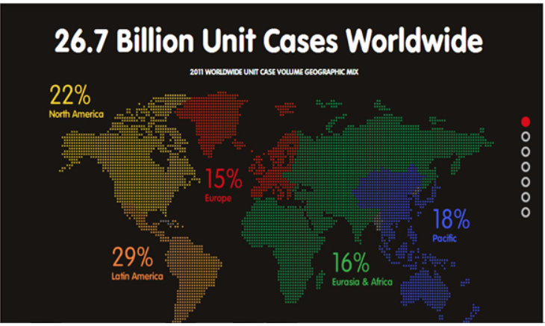
(Question#4) Why Decision Making is an important factor to run an organization. Explain your answer with the help of a proper example.
Decision making has a very huge role in an organization there for, the organizations created a system for such decision taking purposes known as decision support system (DSS) where the system is used to support managerial decisions. Usually DSS involves the analysis of many units of data in a heuristic fashion. As a rule, DSS processing does not involve the update of data.
For any scenario all the related factors with their ranges of variability are entered into DSS, which helps guide managers for any new scenario that emerges. DSS can stimulate innovation in decision making by helping managers to existing decision-making procedures.
Example
An outfit store maintains readymade garments and stitched clothes for various classes of society. Due to fluctuating changes in fashion trends, pre-seasonal planning becomes critical.
- A Planning and forecasting software can be used by management to
- Measure customer reactions to re-pricing
- When to initiate clearance sales for old stock
- Deciding about discount percentages
- When to order new stock for the season

