Name: HAMZA MEHMOOD ID:12715
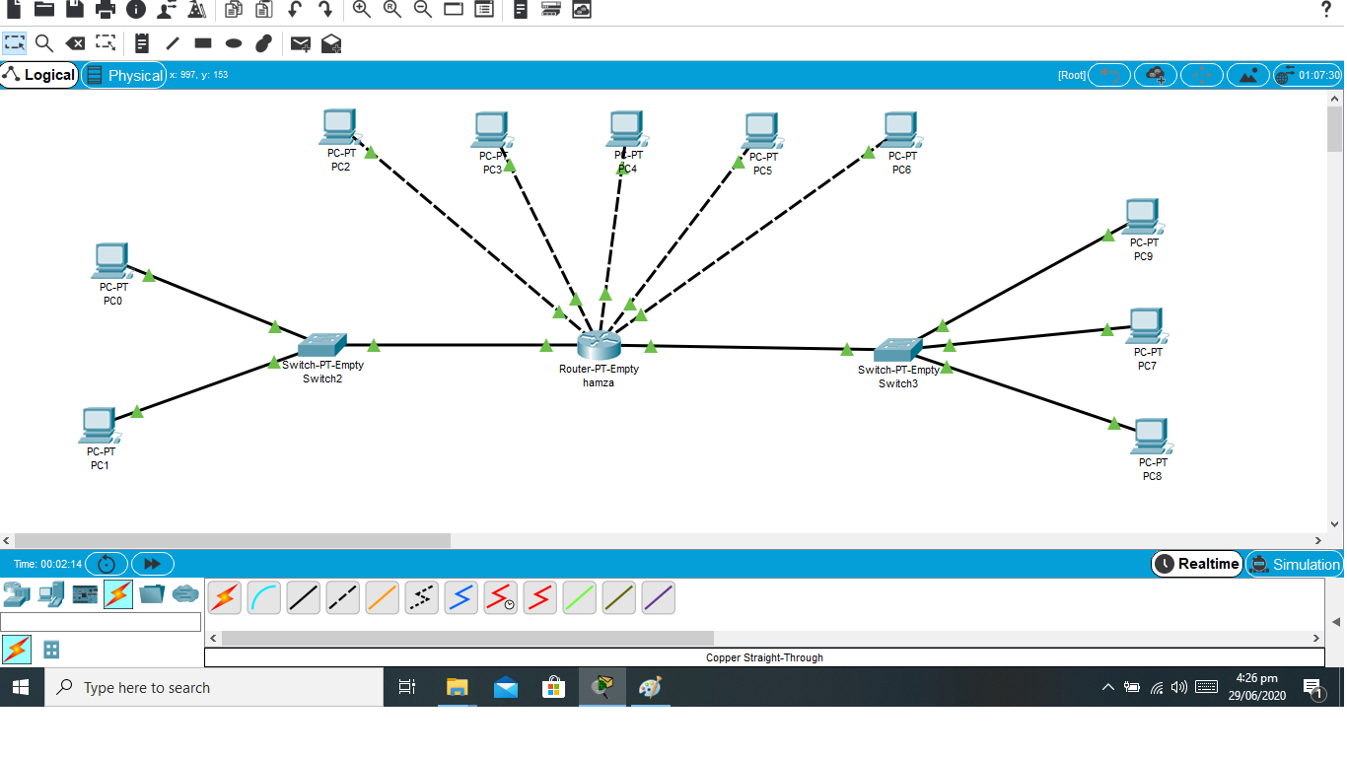
Q1) Construct a network topology which have one router.

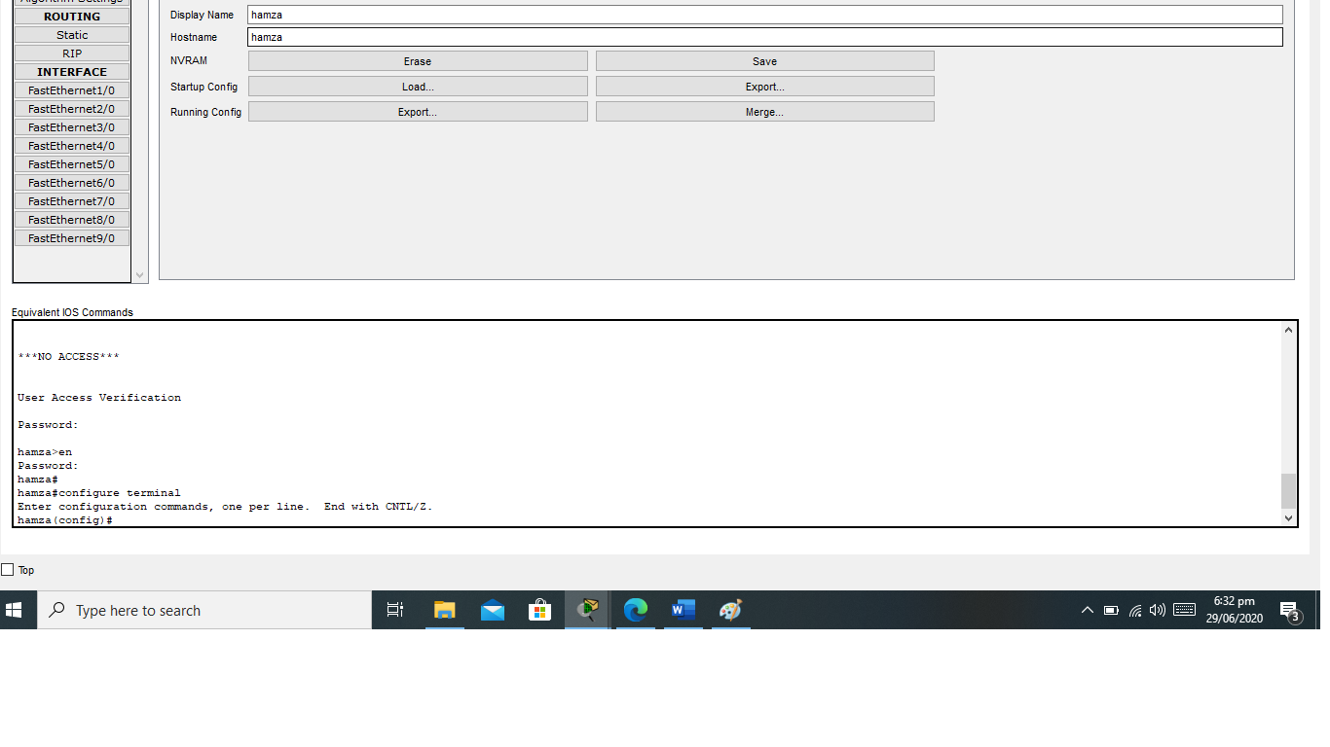
Q2) Give hostname to the router with your name like “hamza”

Q3) Apply login password as your roll number e.g. “12715” on the route

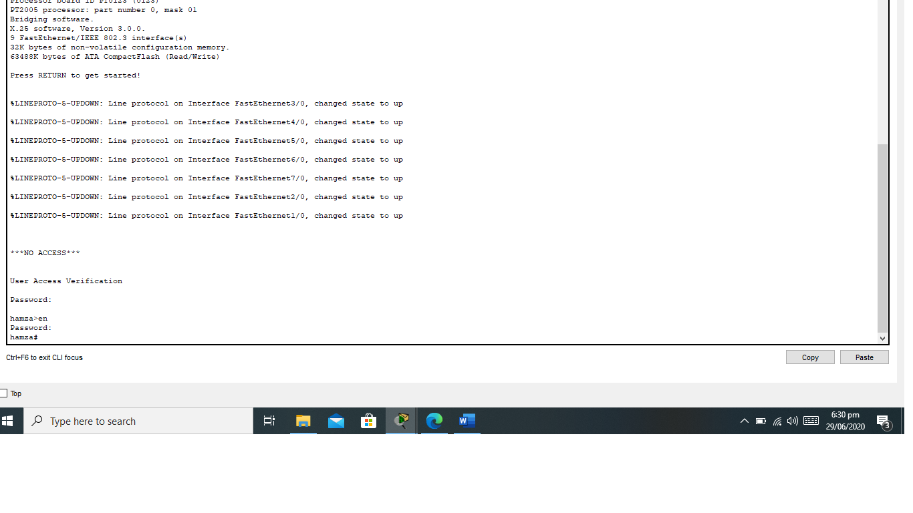

- Enable secret password to it

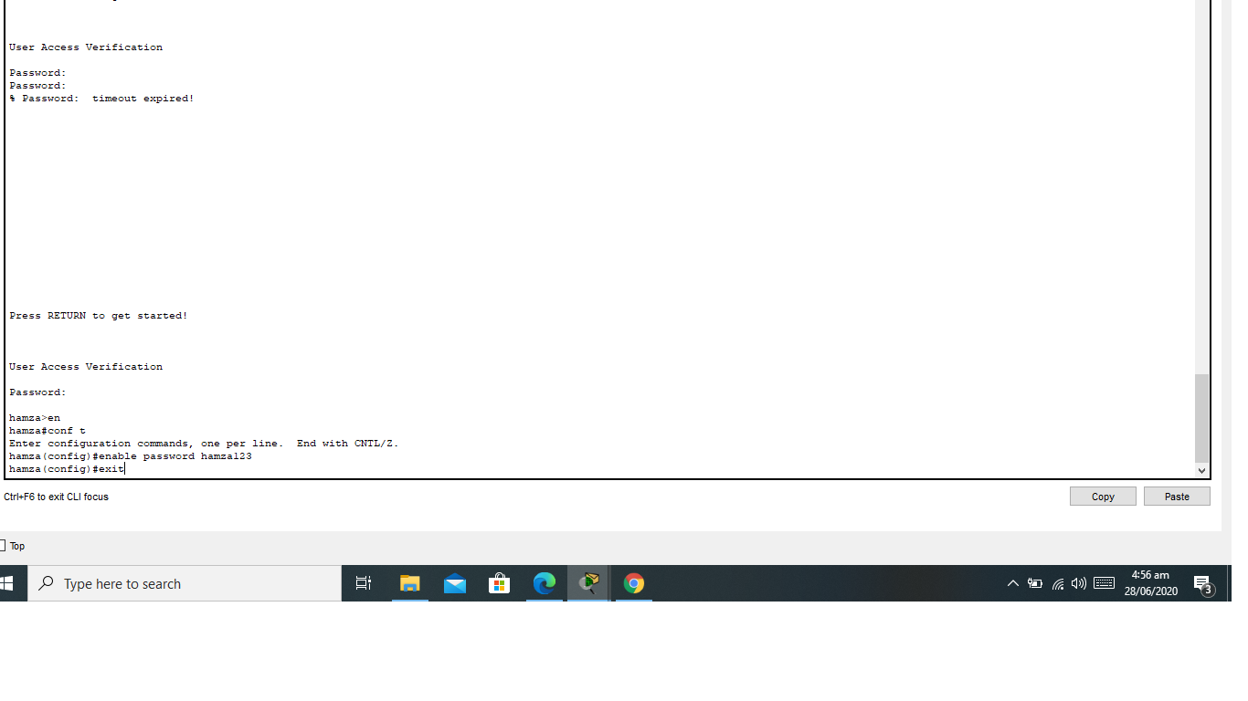
Q4) Enable secret password to it

Q5)Show banner of “NO ACCESS” before login on the router and show the results.

Q6) Router is connected with 5 computers

Q7) Also connect two switches with router which is connected with 2 of the computers from one side and 3 computers with other side

8. Assign the computers, switches and routers proper IP addresses, subnet mask and default gateways.
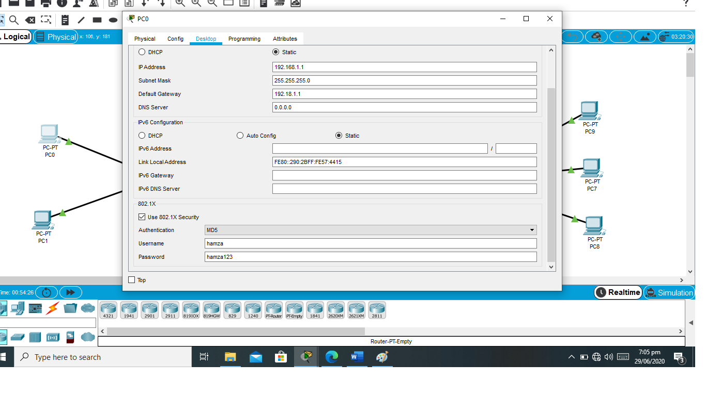
Note: Ip adress ,subnet mask and default get way of pc 1.

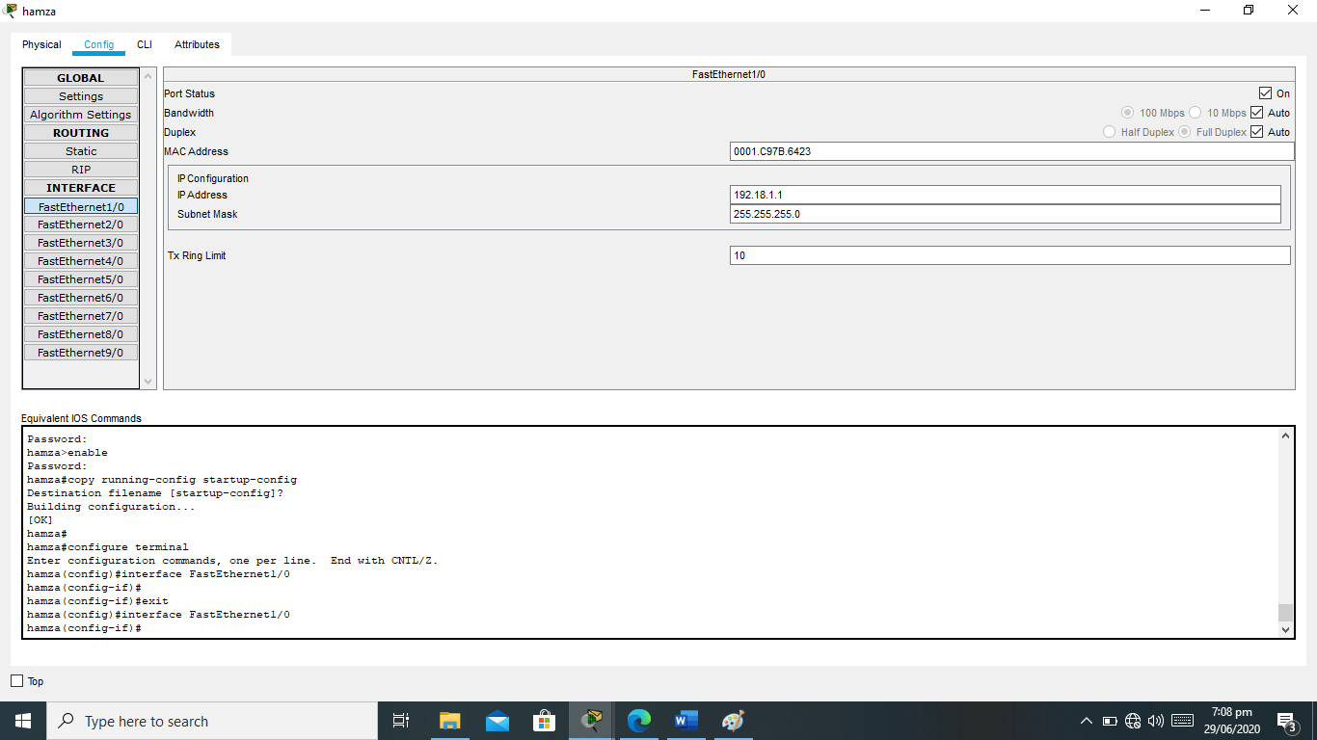
Note:ip configurationg of router

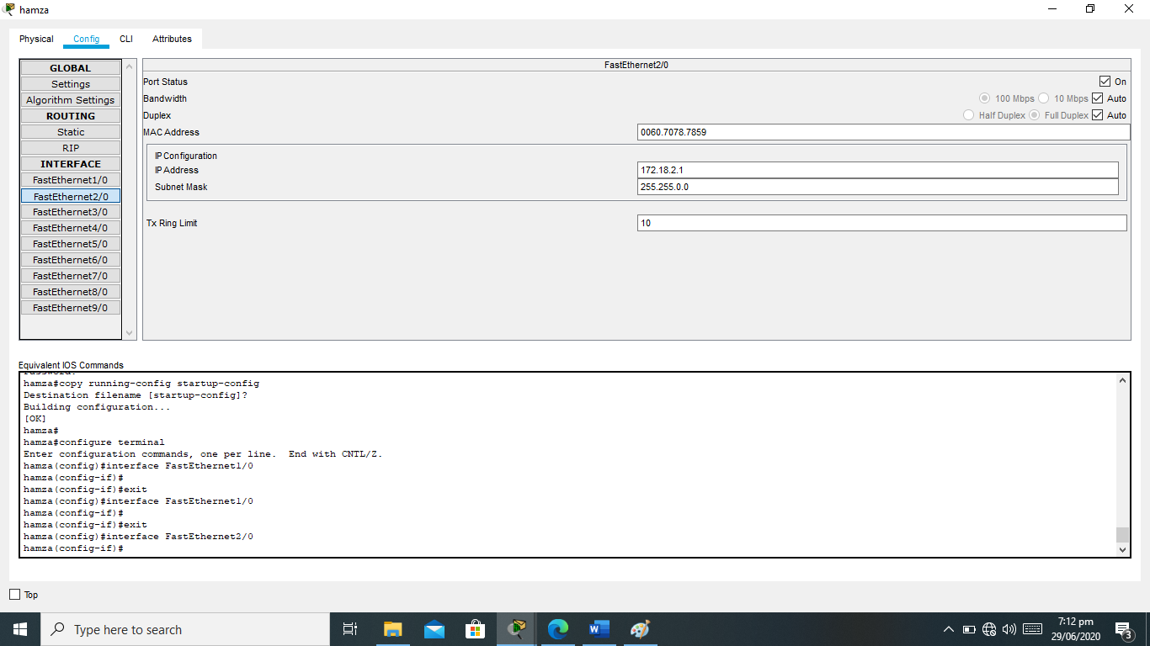

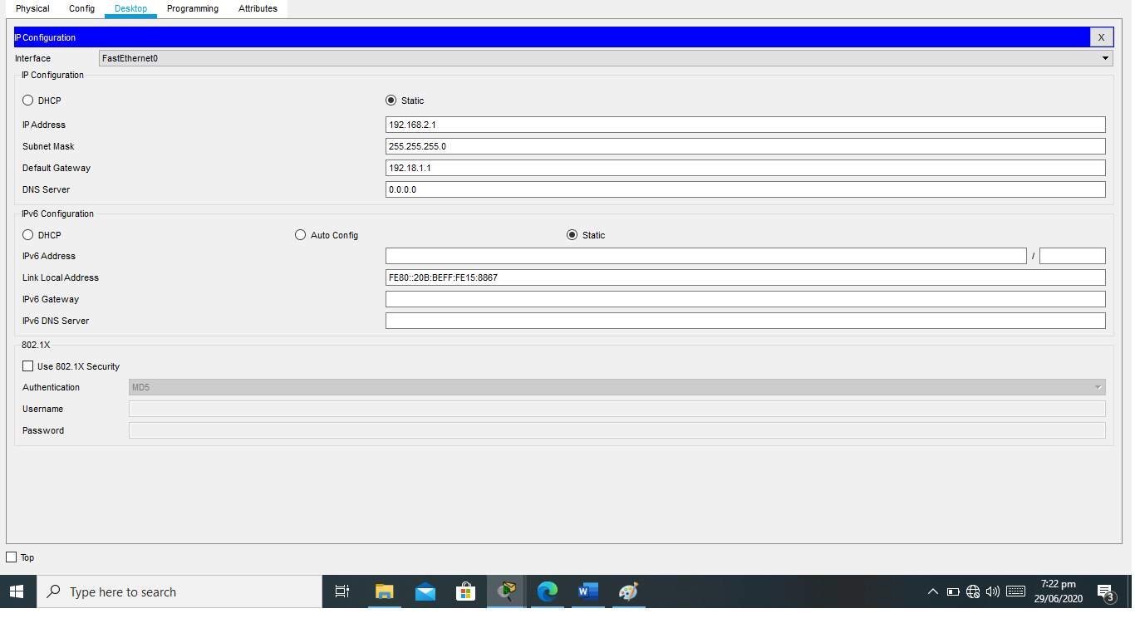
Note: pc 9 ip address:

9. Configure router using command line interface and ping one PC to other and show the results
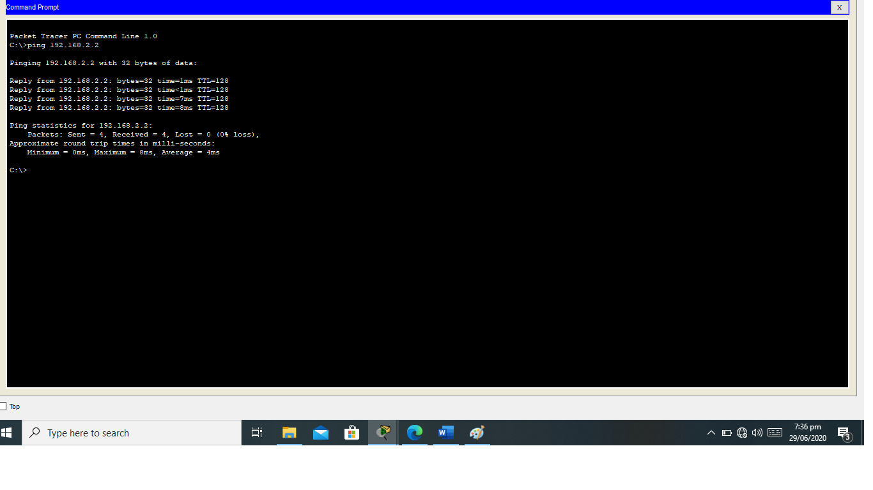

Q10) In the end use “save your configurations” command and show the result.

