Answer sheet of Object Oriented Software Engineering

Name : Mohammad Zubair
Id : 14358
Paper : OOSE
Department : Bs (SE)
Instructor : Sana Jeehan

Question #1 (20 Marks)
Consider your University Attendance Marking System in a class. Keeping in mind all the activities, both the start and end of the class, come up with the following:
- A Use Case Diagram
- A Textual Use Case Diagram

Answer :
- A Textual Use case diagram :
- Super admin : super admin is the responsible of hole system he/she has the authority of all things which other actors can doing it .
- Actor : An actor in use case modeling specifies a role played by a user or any other system that interacts with the subject .
- System : A system use case diagram displays the relationships between consumers and providers of application services.

Answer : 1. Use case diagram of university attendance management system
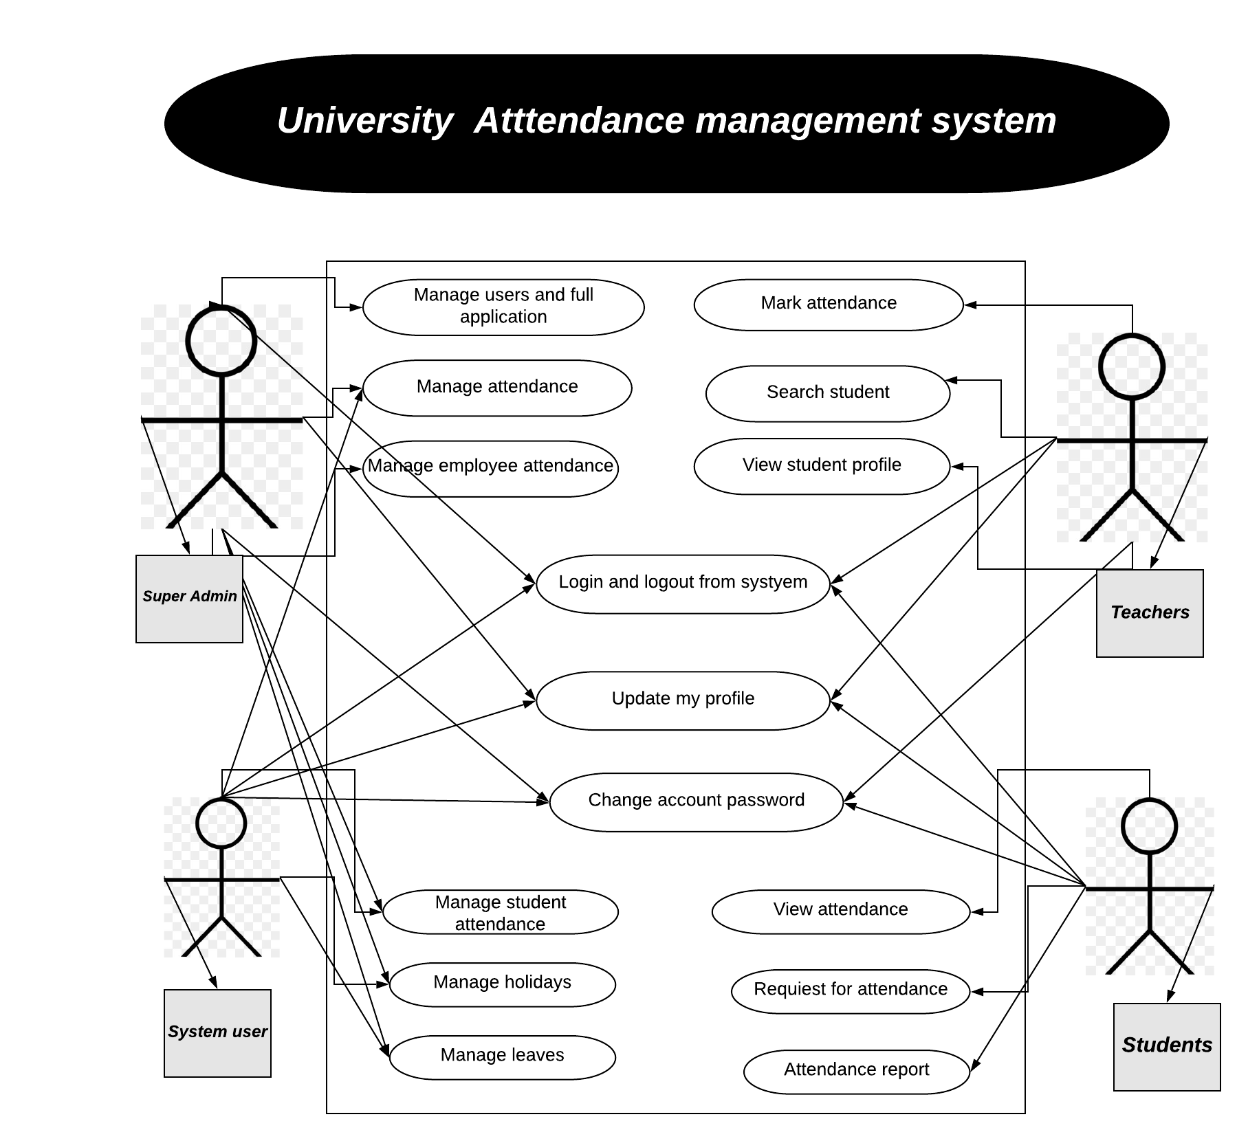
- A use case diagram is a graphic depiction of the interactions among the elements of a system. A use case is a methodology used in system analysis to identify, clarify, and organize system requirements

Question #2 (10 Marks)
You have to make a new Biometric Attendance System for your university. You are being assigned this task on April 21st, 2020 and you have to submit the whole system on 15th June. Come up with schedule for this whole project in the form of Gantt Chart and Pert Chart.

Answer :
- Gantt chart : A Gantt chart is a horizontal bar chart developed as a production control tool in 1917 by Henry L. Gantt, an American engineer and social scientist. Frequently used in project management, a Gantt chart provides a graphical illustration of a schedule that helps to plan, coordinate, and track specific tasks in a project.

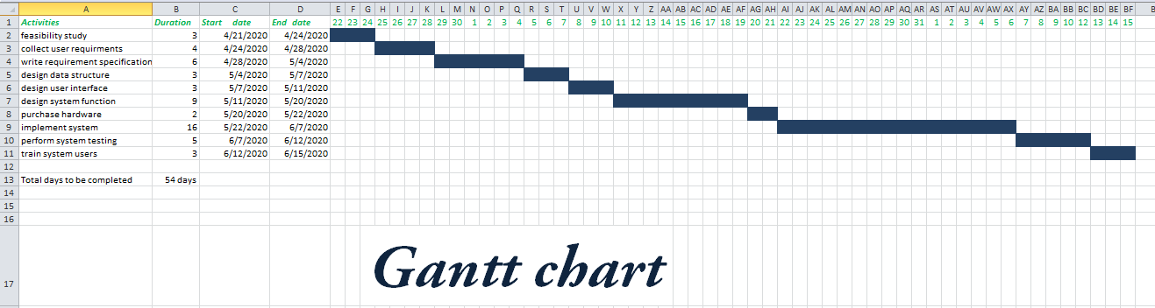

- PERT Chart: A PERT chart is a project management tool that provides a graphical representation of a project's timeline. The Program Evaluation Review Technique (PERT) breaks down the individual tasks of a project for analysis.

