Q: 1 while chaining across a pond two points A and B were taken on opposite side of the pond. A line CB 180 m long was laid on left of AB and another line BD was laid down on the right of line AB is 215 m, such that points C,A and D becomes in line with each other. CA and AD were then measured and found to be 126 m and 164 m respectively. Find the length AB.
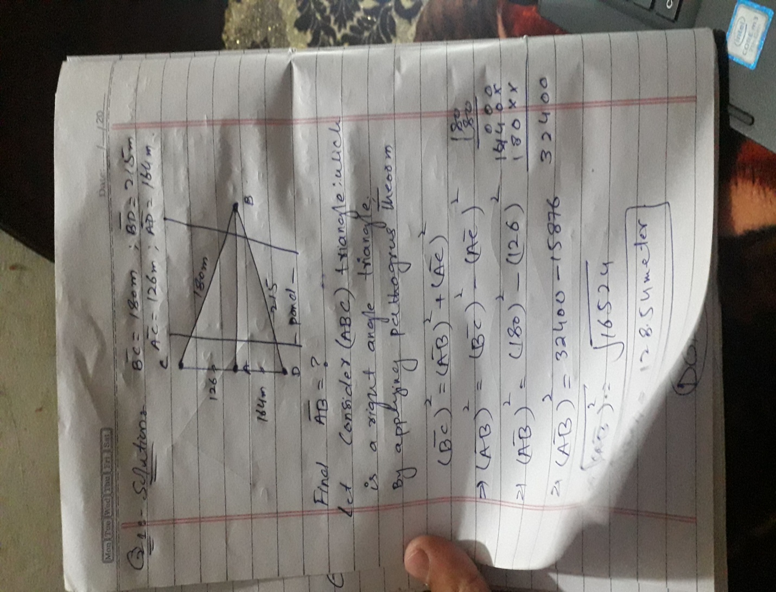

Q: 2 A survey line AC intersect a building. To prolong the line behind the building per CD 110m long drawn at C. From D two lines DF and DG are drawn at angle 60o and 45o respectively. • Determine the length DF and DG and also obstructed length CF.

Solution:
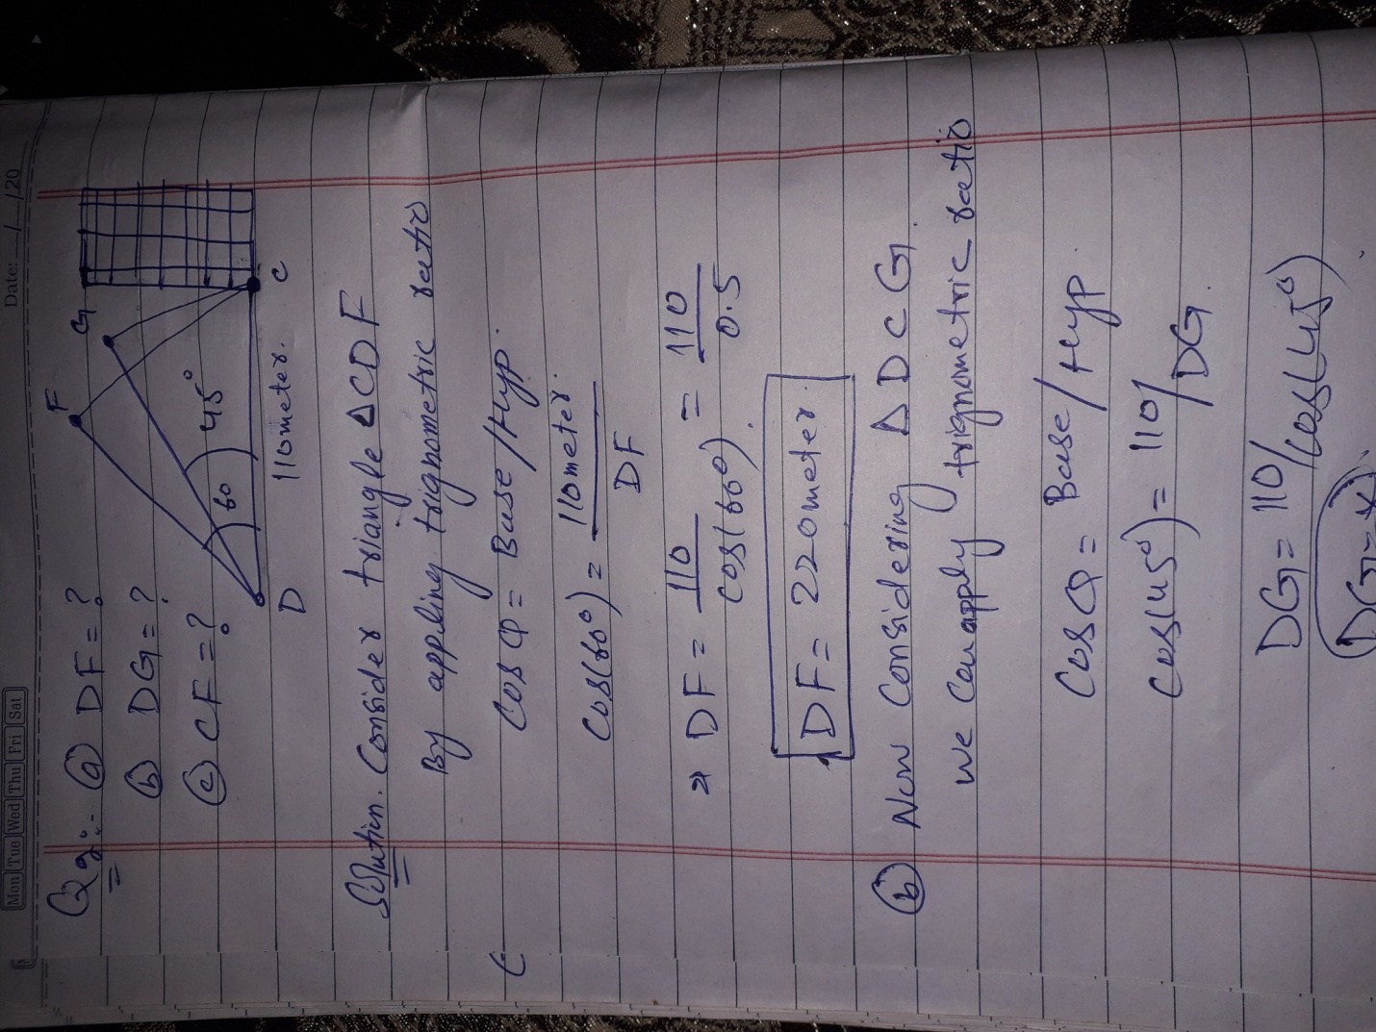
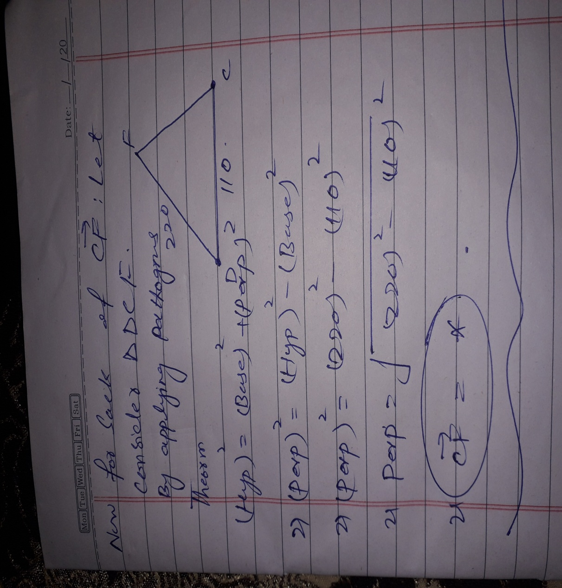
Q: 3 Explain the following terms:
- Base line
- Check line
- Tie line
- Tie station
- Well-conditioned triangle

Answer: All of the above terms are define one by one as below.

Tie or subsidiary lines:
A tie line joints two fixed points on the main survey lines. It helps to check the accuracy of surveying and to locate the interior details. The position of each tie line should be close to some features, such as paths, building etc.
Base Lines:
It is the main and longest line, which passes approximately through the center of the field. All the other measurements to show the details of the work are taken with respect to this line.

Check Line:
A check-line also termed as a proof-line is a line joining the apex of a triangle to some fixed points on any two sides of a triangle. A check-line is measured to check the accuracy of the framework. The length of a checking line, as measured on the ground should agree with its length on the plan.

Subsidiary or the tie stations:
Subsidiary or the tie stations are the points selected on the main survey lines, where it is necessary to locate the interior detail such as fences, hedges, building etc.
A well define triangle:
A well conditioned triangle is a triangle in which no angle is less than 30 degrees.
One of the way to survey the area is to divide the entire area is smaller triangles and then take the measurement of sides of the triangles. Triangles are preferred because it is easy to re-construct exact triangle on paper with only side's measurements (no angle measurement is required).
A well conditioned triangle will have its edges far enough and vertex will be clearly identified. Ill-conditioned triangle can have ambiguity in vertex position and so, it can lead to wrong measurements. Compare two triangles below:
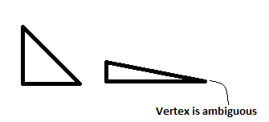

Q: 4 what is meant by traverse surveying? Distinguish between a closed traverse and an open traverse.
Definition:
Traversing is that type of survey in which a number of connected survey lines form the framework and the directions and lengths of the survey lines are measured with the help of an angle measuring instrument and tape or chain respectively.
Types of Surveying
There are two types of traverse surveying. They are:
- Closed traverse: When the lines form a circuit which ends at the starting point, it is known as a closed traverse.
- Open traverse: When the lines form a circuit ends elsewhere eccept starting point, it is said to be an open traverse.
- open transverse survey:

An open traverse is particularly useful as a control for preliminary and construction surveys for highways, roads, pipelines, electricity transmission lines, and the like. These surveys may be from a few hundred feet (meters) to many miles (kilometers) in length. The distances are normally measured by using EDM (sometimes steel tapes). Each time the survey line changes direction, a deflection angle is measured with a theodolite or total station.

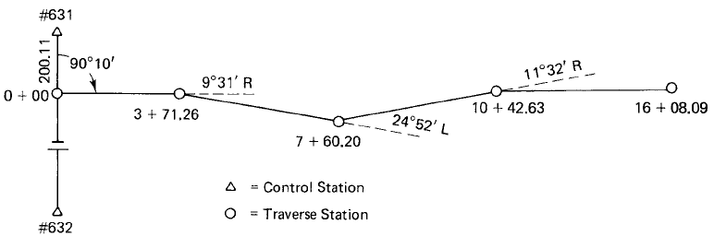

- Closed traverse:
A closed traverse is one that either begins and ends at the same point or begins and ends at points whose positions have been previously determined. In both cases, the angles can be closed geometrically, and the position closure can be determined mathematically. A closed traverse that begins and ends at the same point is called a loop traverse . In this case, the distances are measured from one station to the next and verified, using a steel tape or EDM instrument. The interior angle is measured at each station, and each angle is measured at least twice. In this type of survey, distances are booked simply as dimensions, not as stations or chainages.
