INU PESHAWAR
VIVA ASSIGNMENT CROSS SECTIONAL ANATOMY
SUBBMITTED TO SIR IHSAN
SUBBMITTED BY UMAR FARAZ
I D 14075
BS RAD 6TH #
DATE 11/07/2020

ANS NO 1
The brain is one of the largest and most complex organs in the human body.
It is made up of more than 100 billion nerves that communicate in trillions of connections called synapses.
The brain is made up of many specialized areas that work together:
• The cortex is the outermost layer of brain cells. Thinking and voluntary movements begin in the cortex.
• The brain stem is between the spinal cord and the rest of the brain. Basic functions like breathing and sleep are controlled here.
• The basal ganglia are a cluster of structures in the center of the brain. The basal ganglia coordinate messages between multiple other brain areas.
• The cerebellum is at the base and the back of the brain. The cerebellum is responsible for coordination and balance.
The brain is also divided into several lobes:
• The frontal lobes are responsible for problem solving and judgment and motor function.
• The parietal lobes manage sensation, handwriting, and body position.
• The temporal lobes are involved with memory and hearing.
• The occipital lobes contain the brain's visual processing system.
The brain is surrounded by a layer of tissue called the meninges. The skull (cranium) helps protect the brain from injury.

Brain Conditions
- Headache: There are many types of headaches; some can be serious but most are not and are generally treated with analgesics/painkillers.
- Stroke (brain infarction): Blood flow and oxygen are suddenly interrupted to an area of brain tissue, which then dies. A blood clot, or bleeding in the brain, are the cause of most strokes.
- Brain aneurysm: An artery in the brain develops a weak area that swells, balloon-like. A brain aneurysm rupture can causes a stroke.
- Subdural hematoma: Bleeding within or under the dura, the lining inside of the skull. A subdural hematoma may exert pressure on the brain, causing neurological problems.
- Epidural hematoma: Bleeding between the tough tissue (dura) lining the inside of the skull and the skull itself, usually shortly after a head injury. Initial mild symptoms can progress rapidly to unconsciousness and death, if untreated.
- Intracerebral hemorrhage: Any bleeding inside the brain.
- Concussion: A brain injury that causes a temporary disturbance in brain function. Traumatic head injuries cause most concussions.
- Cerebral edema: Swelling of the brain tissue in response to injury or electrolyte imbalances.
- Brain tumor: Any abnormal tissue growth inside the brain. Whether malignant (cancer) or benign, brain tumors usually cause problems by the pressure they exert on the normal brain.
- Glioblastoma: An aggressive, malignant brain tumor (cancer). Brain glioblastomas progress rapidly and are very difficult to cure.
- Hydrocephalus: An abnormally increased amount of cerebrospinal (brain) fluid inside the skull. Usually this is because the fluid is not circulating properly.
- Normal pressure hydrocephalus: A form of hydrocephalus that often causes problems walking, along with dementia and urinary incontinence. Pressures inside the brain remain normal, despite the increased fluid.
- Meningitis: Inflammation of the lining around the brain or spinal cord, usually from infection. Stiff neck, neck pain, headache, fever, and sleepiness are common symptoms.
- Encephalitis: Inflammation of the brain tissue, usually from infection with a virus. Fever, headache, and confusion are common symptoms.
- Traumatic brain injury: Permanent brain damage from a traumatic head injury. Obvious mental impairment, or more subtle personality and mood changes can occur.
- Parkinson's disease: Nerves in a central area of the brain degenerate slowly, causing problems with movement and coordination. A tremor of the hands is a common early sign.
- Huntington's disease: An inherited nerve disorder that affects the brain. Dementia and difficulty controlling movements (chorea) are its symptoms.
- Epilepsy: The tendency to have seizures. Head injuries and strokes may cause epilepsy, but usually no cause is identified.
- Dementia: A decline in cognitive function resulting from death or malfunction of nerve cells in the brain. Conditions in which nerves in the brain degenerate, as well as alcohol abuse and strokes, can cause dementia.
- Alzheimer’s disease: For unclear reasons, nerves in certain brain areas degenerate, causing progressive dementia. Alzheimer’s disease is the most common form of dementia.
- Brain abscess: A pocket of infection in the brain, usually by bacteria. Antibiotics and surgical drainage of the area are often necessary.

Brain Tests
- Computed tomography (CT scan): A scanner takes multiple X-rays, which a computer converts into detailed images of the brain and skull.
- Magnetic resonance imaging (MRI scan): Using radio waves in a magnetic field, an MRI scanner creates highly detailed images of the brain and other parts of the head.
- Angiography (brain angiogram): A special substance doctors call "a contrast agent" is injected into the veins, and travels into the brain. X-ray videos of the brain are taken, which can show problems in the brain's arteries.
- Magnetic resonance angiography (MRA): A special MRI scan of the brain's arteries. An MRA scan may show a blood clot or another cause for stroke.
- Lumbar puncture (spinal tap): A needle is inserted into the space around the spinal nerves, and fluid is removed for analysis. Lumbar puncture is often done if meningitis is suspected.
- Electroencephalogram (EEG): Brain activity is monitored through electrodes placed on the skin on the head. EEG can help diagnose seizures, or other brain problems.
- Neurocognitive testing: Tests of problem-solving ability, short-term memory, and other complex brain functions. Usually, neurocognitive testing is done through questionnaires.
- Brain biopsy: In rare situations, a very small piece of the brain is needed to make the diagnosis of a brain condition. Brain biopsies are generally done only when the information is needed to provide proper treatment.

Brain Treatments
- Thrombolytics: Clot-busting medicines injected into the veins can improve or cure some strokes if given within a few hours after symptoms start.
- Antiplatelet agents: Medicines like aspirin and clopidogrel (Plavix) help prevent blood clots. This can reduce the chance of a stroke.
- Cholinesterase inhibitors: These medicines can improve brain function slightly in mild or moderate Alzheimer’s disease. They do not slow or prevent Alzheimer’s disease.
- Antibiotics: When a brain infection is caused by bacteria, antibiotics can kill the organisms and make a cure more likely.
- Levodopa: A medicine that increases brain levels of dopamine, which is helpful in controlling symptoms of Parkinson’s disease.
- Brain surgery: An operation on the brain can cure some brain tumors. Brain surgery may be performed any time increased pressure in the brain threatens brain tissue.
- Ventriculostomy: A drain is placed into the natural spaces inside the brain (ventricles). Ventriculostomy is usually performed to relieve high brain pressures.
- Craniotomy: A surgeon drills a hole into the side of the skull to relieve high pressures.
- Lumbar drain: A drain is placed into the fluid around the spinal cord. This can relieve pressure on the brain and spinal cord.
- Radiation therapy: If cancer affects the brain, radiation can reduce symptoms and
- slow the cancer's growth.

ANS NO 2
Appendicular bones: The 126 appendicular bones are made up of 64 bones in the upper extremities (the arms, wrists, and hands) and 62 bones in the lower extremities (the legs, ankles, and feet).
Upper extremity bones: The 64 upper extremity bones consist of 10 shoulder and arm, 16 wrist and 38 hand bones.
- The 10 shoulder and arm bones are the clavicle, scapula, humerus, radius, and ulna on each side.
- The 16 wrist bones are the scaphoid, lunate, triquetrum, pisiform, trapezium, trapezoid, capitate, hamate on each side.
- The 38 hand bones are the 10 metacarpal bones and 28 phalanges (finger bones).
ANS N0 3
- Anatomical Planes in a Human: There are three basic planes in zoological anatomy: sagittal, coronal, and transverse. A human in the anatomical position, can be described using a coordinate system with the Z-axis going from front to back, the X-axis going from left to right, and the Y-axis going from up to down.

Applications of Body Planes
- Medical imaging techniques such as sonography, CT scans, MRI scans, or PET scans are one of the primary applications of body planes. By imaging a patient in standard anatomical position, a radiologist can build an X-Y-Z axis around the patient to apply body planes to the images. The planes can then be used to identify and locate the positions of the patient’s internal organs. Individual organs can also be divided by planes to help identify smaller structures within that organ.
- Body planes are used to describe anatomical motion in the X-Y-Z coordinate system that the body moves through. An anatomist could model a limb’s range of motion by measuring which planes the limb can move through and how far it is able to travel.
- Anatomical change during embryological development is also described and measured with body planes. For example, during human embryonic development the coronal plane is horizontal, but becomes vertical as the embryo develops into a fetus. In comparative embryology, body planes provide a basis for comparing the ways in which different types of organisms develop anatomically within the womb.

ANS NO 4

ABDOMEN (routine protocol)
KV / effective mAs / rotation time | 120 / 200 / 0.5 seconds
Detector collimation | 1.5 mm
Slice Thickness | 3.0 mm
Pitch | 0.75
Kernel | B30f
Increment | 3.0 mm
Image order | Cranial to caudad. Image from above diaphragm to greater trochanters. One acquision.
Oral Contrast | INPATIENTS: 250cc’s of water mixed with 7cc of Gastroview = 1 dose.  1 Dose given orally every ½ hour for two hours prior to exam  OUTPATIENTS: 1 bottle of Redicat taken orally two hours before exam. ½ bottle of  Redicat given 45 minutes prior to exam. Last ½ of 2nd Redicat bottle given on  the CT table.
Intravenous Contrast | 100 cc Isovue 300 at 3 cc/sec.  18 – 22 ga IV needed preferably in the AC.
Scan Delay | 75 seconds
Reconstruction | Oral contrast on table.  Second recon: kernel 80 lungs only.

ANS NO 5
The cervical spine is the most superior portion of the vertebral column, lying between the cranium and the thoracic vertebrae.
It consists of seven distinct vertebrae, two of which are given unique names:
- The first cervical vertebrae (C1) is known as the atlas.
- The second cervical vertebrae (C2) is known as the axis.
In this article, we shall look at the anatomy of the cervical vertebrae – their characteristic features, articulations and clinical relevance.

Characteristic Features
The cervical vertebrae have three main features which distinguish them from other vertebrae:
- Triangular vertebral foramen.
- Bifid spinous process – this is where the spinous process splits into two distally.
- Transverse foramina – holes in the transverse processes. They give passage to the vertebral artery, vein and sympathetic nerves.
By TeachMeSeries Ltd (2020)
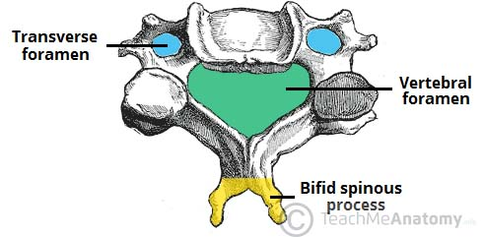
Fig 1 – Characteristic features of a cervical vertebrae

Atlas and Axis
The atlas and axis have additional features that mark them apart from the other cervical vertebrae.
Atlas
The atlas is the first cervical vertebra and articulates with the occiput of the head and the axis (C2).
It differs from the other cervical vertebrae in that it has no vertebral body and no spinous process. Instead, the atlas has lateral masses which are connected by an anterior and posterior arch. Each lateral mass contains a superior articular facet (for articulation with occipital condyles), and an inferior articular facet (for articulation with C2).
The anterior arch contains a facet for articulation with the dens of the axis. This is secured by the transverse ligament of the atlas – which attaches to the lateral masses. The posterior arch has a groove for the vertebral artery and C1 spinal nerve.
Axis
The axis (C2) is easily identifiable due to its dens (odontoid process) which extends superiorly from the anterior portion of the vertebra.
The dens articulates with the anterior arch of the atlas, in doing so creating the medial atlanto-axial joint. This allows for rotation of the head independently of the torso.
The axis also contains superior articular facets, which articulate with the inferior articular facets of the atlas to form the two lateral atlanto-axial joints.
By TeachMeSeries Ltd (2020)
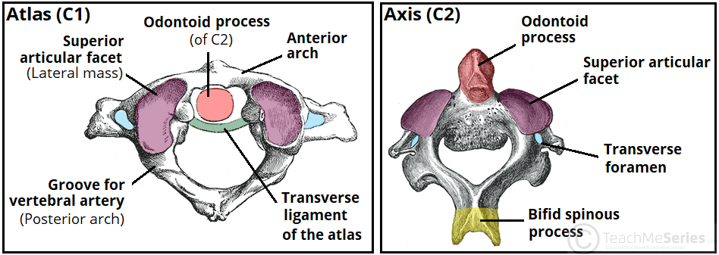
Fig 2 – The bony landmarks of the atlas and axis.

Joints
The joints of the cervical spine can be divided into two groups – those that are present throughout the vertebral column, and those unique to the cervical spine.
Present throughout Vertebral Column
There are two different joints present throughout the vertebral column:
- Between vertebral bodies – adjacent vertebral bodies are joined by intervertebral discs, made of fibrocartilage. This is a type of cartilaginous joint, known as a symphysis.
- Between vertebral arches – formed by the articulation of superior and inferior articular processes from adjacent vertebrae. It is a synovial type joint.
Unique to Cervical Spine
There are two joints unique to the cervical spine – the atlanto-axial (x3) and atlanto-occipital joints (x2).
The atlanto-axial joints are formed by the articulation between the atlas and the axis:
- Lateral atlanto-axial joints (x2) – formed by the articulation between the inferior facets of the lateral masses of C1 and the superior facets of C2. These are plane type synovial joints.
- Medial atlanto-axial joint – formed by the articulation of the dens of C2 with the articular facet of C1. This is a pivot type synovial joint.
The atlanto-occipital joints consist of an articulation between the spine and the cranium. They occur between then superior facets of the lateral masses of the atlas and the occipital condyles at the base of the cranium. These are condyloid type synovial joints, and permit flexion at the head i.e. nodding.

