Course Title: Morphology ll Instructor: Ms. Salma Ishaq
Max Marks: 50
NOTE:
Final term
Name: Hilal Ahmad ID: 14573

Each question carry (10) marks
Q1: Briefly explain the palatal aspect of maxillary 1st molar.
Answer:
Palatal Aspect:
- Outlines reversed from the buccal aspect, still trapezoidal.
- Mesio-palatal largest cusp
- Disto-palatal smallest cusp almost spheroidal
- Has a palatal pit at the end of the disto-palatal groove
- There may be a cusp on the palatal surface of the mesio-palatal cusp.
- This is a fifth cusp called the cusp carabelli , which is visible in addition to the four cusps on the occlusal surface.
- There are 3 roots visible, the palatal root makes most of the aspect.
- No palatal convergence

Outlines of permanent 1st maxillary molar
- Mesial outline:
- Nearly straight and form with the mesial slope of the ML cusp
- Distal outline:
- Convex and form semicircle with the distal slope of the DL cusp.

- Occlusal outline:
- ML cusp is the largest and longest cusp.
- DL cusp is spheroidal Tubercle of Carabelli is also seen in 60 % of the lingual surface of ML cusp Cervical outline: Irregular and slightly convex toward the root.
Anatomical landmarks:
*Convex lingual surface.
*Cusp of carabelli
*Lingual developmental groove.
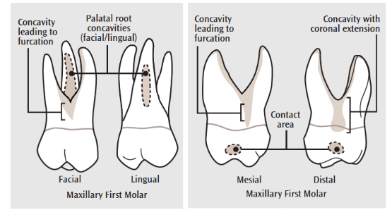

Q2: Specify the function of permanent maxillary canine and 1st pre-molar?
Answer:
- Permanent maxillary canine:
- They are the teeth right next to the four front incisors. These are the sharp, pointy teeth that are sometimes called fang teeth.
- Canines are also known as the cornerstone of the dental arch as they are a big part of forming the curve that leads to the back teeth.
- Canines are also the longest teeth in the mouth. Because of their length, they are commonly used to anchor prosthetic teeth, such as removable partial dentures.
- They are also some of the last teeth lost in the mouth due to periodontal disease.
Canines also have a variety of functions:
1 – Their sharp point allows them to pierce through and tear food. Some animals that hunt for food have very sharp canines. This helps them to catch their prey. Most humans don’t run around hunting with their teeth, so we simply use our canines to pierce through food and tear it as we take bites.
2 – The canines support the lips and face.
3 – The canines help you talk.
4 – They help guide your teeth when you chew. Canines act as the guideposts when you move your jaw to the left or the right. If you slide your jaw to the left right now, you’ll notice that both the upper left and lower left canine teeth are sliding against each other.
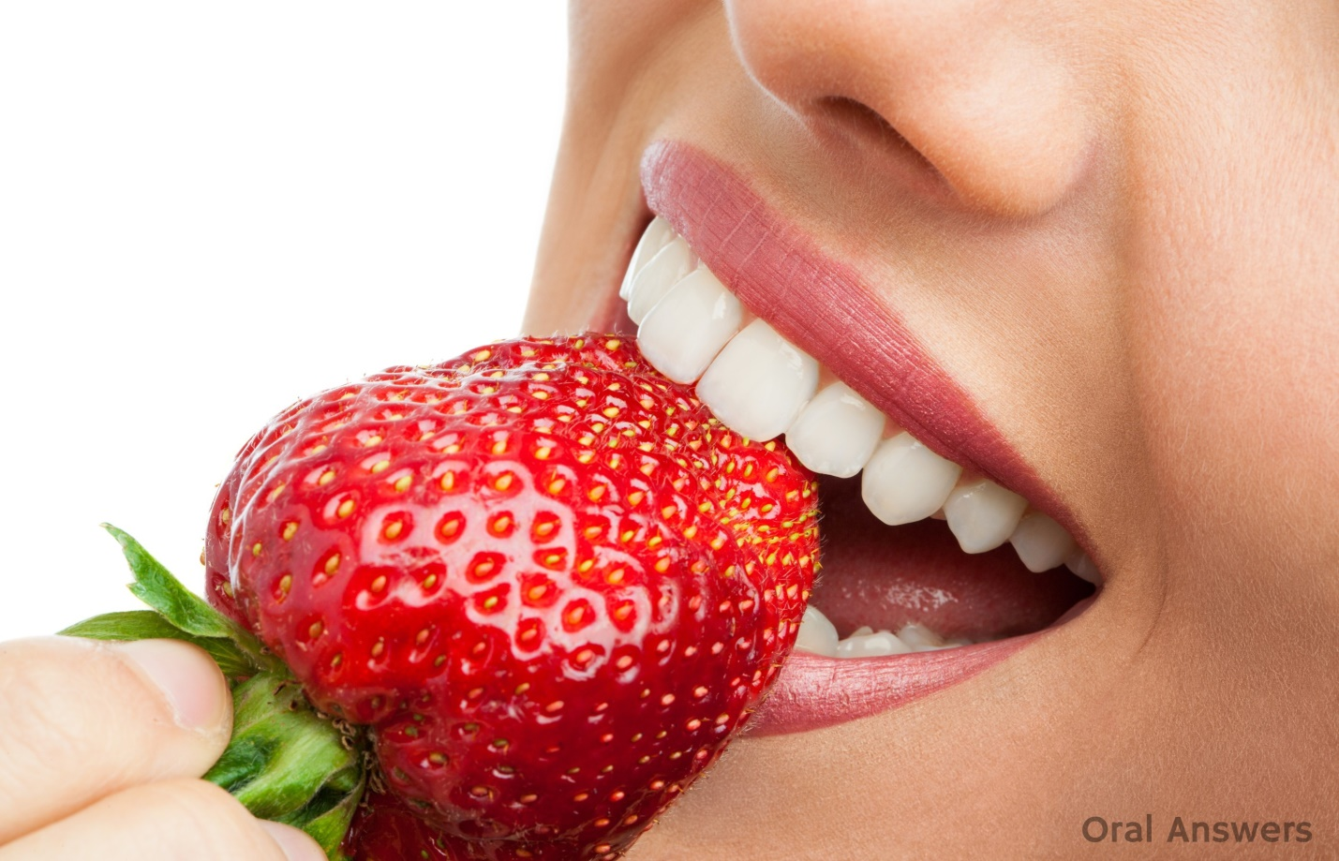
- 1st pre-molar
- Premolars are kind of a mix between canines and molars. They are also the tooth most often extracted when someone with severe crowding gets braces and there’s just not enough room in the mouth for all of the teeth.
They also have varying functions:
i– They help the canines to pierce and tear food. The premolars have a couple of sharp points on them. They aren’t as sharp as the canines, but they can still help pierce and tear food.
ii – They help the molars to crush and grind food during chewing. The premolars also have a broad biting surface, but not as broad as the molars. This helps them to crush and grind food.
iii – They help with aesthetics and speech, but not as much as the canines and incisors. you can see both of her upper premolars. The premolars can show more in some people than others. For example, when I smile my premolar don’t show very much. In people with wider smiles, their premolars show.
iv – Support the facial muscles at the corners of the mouth. The premolars keep the corners of your mouth from sagging inward.
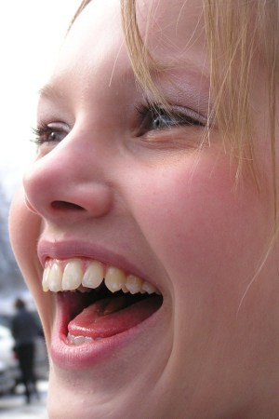

Q3: what is the chronology of mandibular central incisor?
Answer:
Introduction
- Mandibular central incisors are two in number
- Mandibular central incisor and lateral are similar in anatomy and complement each other in function
- They are smaller than the maxillary central incisors
- Mandibular central incisor erupts between the age of 7 and 8
CHRONOLOGY:
- First evidence of calcification. 3-4 months
- Crown completion. 4-5 years
- Eruption 6-8 years
- Root completion 10 years

Development
- It developed from four lobes (three mamelons and one cingulum).
- Shortly after eruption, mamelons are usually worn away by atrition and the incisal edges of all incisors are straight.
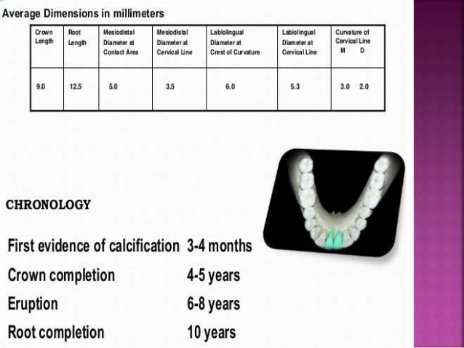

Q4: simplify the geometrical outline of occlusal aspect of mandibular 2nd pre-molar?
Answer:

Geometric outline of the occlusal aspect
- Three cusp type Outline is square
- Ni lingual convergence
- Two cusp type Outline is oval
- Slighty lingual convergence
- When the two lingual cusps are large, the lingual side of the occlusal surfaces will be broader than the buccal side
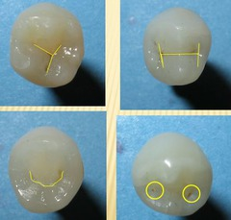

Occlusal Aspect
- The Three-cusp Types
- Elevations
- The three cusps are well developed; the buccal cusp is the larger, followed by the mesio-lingual cusp, and the D disto-lingual cusp is the smallest
- Each cusp has well-formed triangular ridge.
- The three triangular ridges converge toward a central fossa, which has central pit .
- Two marginal ridge
- Depressions
- A central pit is located in the middle of the occlusal surface bucco-lingually and slightly distal to the center mesio-distally.
- There are three developmental grooves on the occlusal surface radiate from the central pit and form a Y shape ( the mesial, distal and lingual developmental grooves ) separate the triangular ridges .
- The long mesial groove extends in a mesio-buccal direction and ends in the mesial triangular fossa just distal to the mesial marginal ridge
- The lingual groove extends lingually between the two lingual cusps to the lingual surface for a short distance.
- This groove is distal to the center of the crown. They form Y shape
- The distal triangular fossa is smaller than the mesial one.
- Note that, the Three-cusp Type of mandibular second premolars do not have either a central developmental groove or a transverse ridge.
- Three pits were located in the lower second premolar 3 cusp types that is Central pit, Mesial & Distal pits.
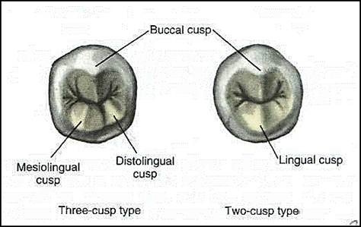

- The Two-cusp Types
- Elevations
- Two cusps
- Lingual cusp
- Buccal cusp
- The buccall cusp is larger than the lingual cusp.

- Elevations
- The triangular ridges of the two cusps form a transverse ridge.
- Mesial & Distal marginal ridges

- Depressions
- There is a central developmental groove extends mesio-distally across the occlusal surface.
- The central groove is most often crescent shaped, forming a U-shaped groove pattern on the occlusal surface.
- Less often, the central groove may be straight, forming an H-shaped groove pattern on the occlusal surface.
- The central groove ends in the mesial and distal fossae.
- The mesial and distal fossae are roughly circular depressions sometimes having supplemental grooves radiating from the central groove and it ends at the marginal ridges.
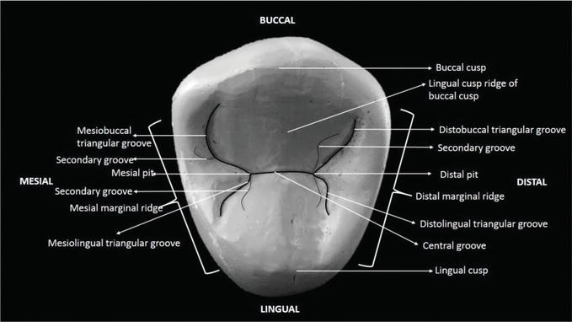

Q5: Why we have molars?
Answer:
- Molars are the tough workhorses of human teeth

- Molars are not useless. they are functional.

- Third molars have become somewhat superfluous because each generation seems to have less room for them to fully erupt.
- THE minimum number of teeth required for function (the shortened dental arch) is 20 including the anterior teeth for esthetics.
- Premolars are required for masticatory function in addition to the anterior while others maintain that a mix of upper and lower molars should be considered In combination with paired premolars
- Referred to as molars or molar teeth, these are the flat teeth located at the back of the mouth. They can vary in size and shape but are the largest teeth in the mouth.
- Molars are rounded and used for grinding food into easily swallowed pieces. The smaller and sharper front teeth are used for biting and tearing food.
- Molars are designed to sustain great amounts of force from chewing, grinding, and clenching, and each molar is anchored to the jaw bone with two to four roots.
- The average adult has twelve molars, with six in the upper jaw (identified by your dentist as "maxillary" for their location in the upper jaw) and six in the lower jaw (identified as "mandibular" by the dentist for their location in the lower jaw). Each side of the upper and lower jaw has three molars

_____________________________________________________________________________________
Thank You

