Iqra national university
program BS Software Engineering Section B
Name: IJAZ KHAN
ID# 16764
Subject object oriented programming
Semester (2)
Submitted to M.Ayub sir .
Date12/July/2020 JAVA LAB ASSIGNMENT

Q1: How to check Even and Odd numbers in java using object oriented approach?

ANS: MY PROGRAM AND ITS OUTPUT:

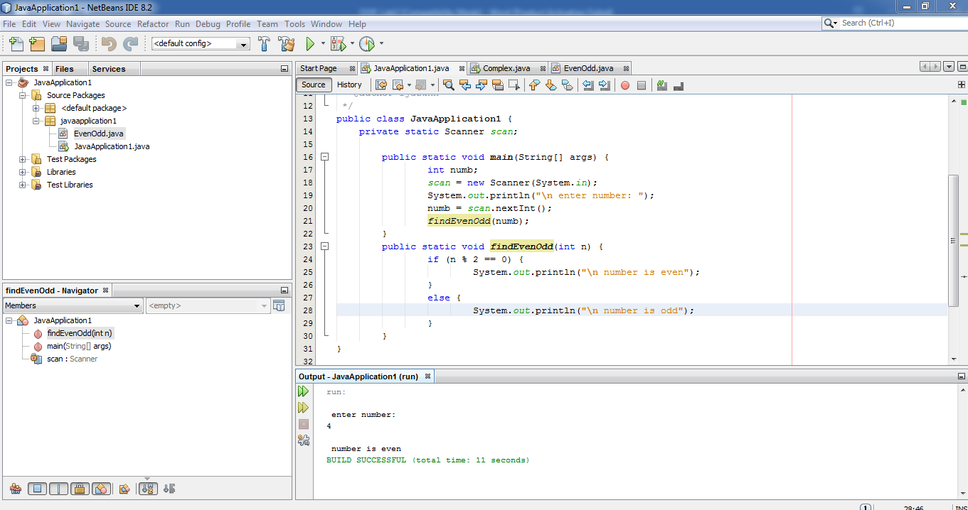
Explanation:
In the above program, I use the plat form NetBeans, in this a scanner object reader is created to read a number from the user's keyboard. The entered number is then stored in a variable numb. Now to check whether number is even or odd, we calculate its remainder using % operator and check if it is divisible by 2 or not.
For this, we use ( if else ) statement in Java. If the number is divisible by 2 we print number is even. And if the number is not divisible by 2 we print that the number is odd.

Q2. How to add 2 complex numbers in java using object oriented approach?

Ans: MY PROGRAM AND ITS OUTPUT:

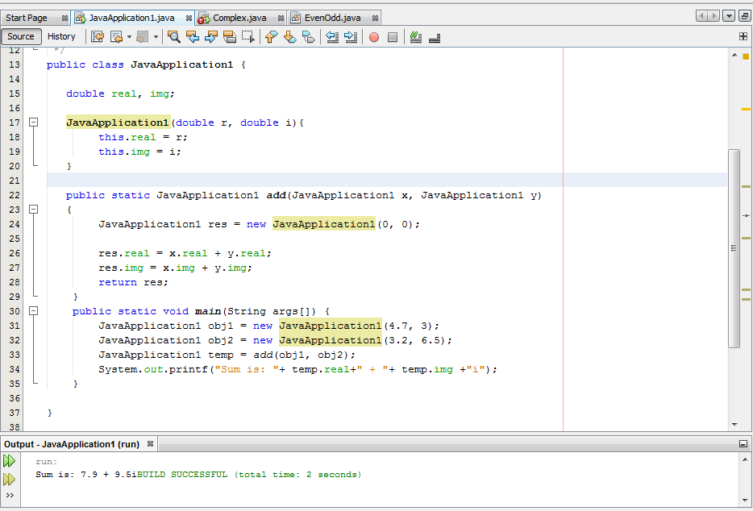
EXPLANATION:
In the above program i use the NetBeans platform, this is about to add the two complex number we took two in the name of java application x, and y, then we take 2 objects and put values in object 1 we put 4.7 and 3 then in object 2 I put 3.2 and 6.5 we add real and img values then I run it and luckily we have no errors and it works.

Q3. How to check Leap year in java using object oriented approach?
Ans: MY PROGRAM AND ITS OUTPUT:

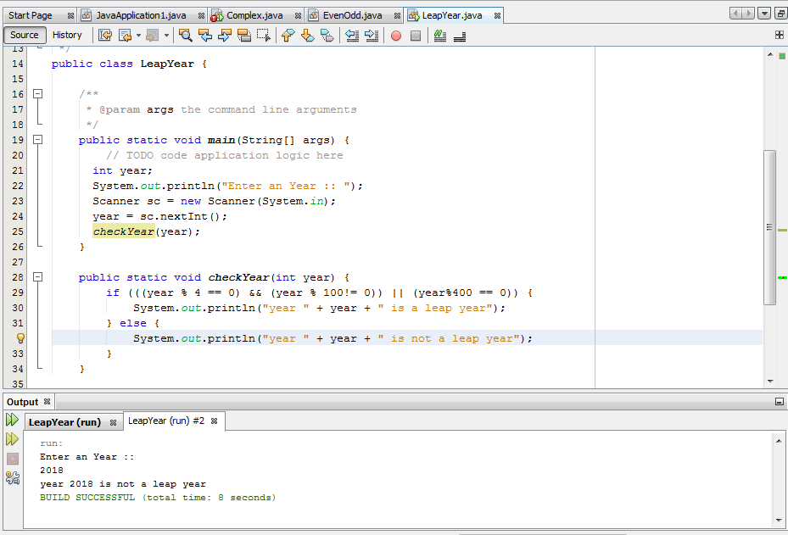

PROGRAM EXPLANATION :
In the above program i use the NetBeans platform this is about to check the leap year in this program I take the value from user and then give to it if else condition it will call the upper method which I gave in first and then it will check that the year is leap year or not leap year so then I run this program luckily there is no errors and I put 2018 and my out put shows me that 2018 is not a leap year because of my condition I gave to it …

Q4. How to check that the input from the user is the vowel or not in java using
object oriented approach?

Ans: MY PROGRAM AND ITS OUTPUT:

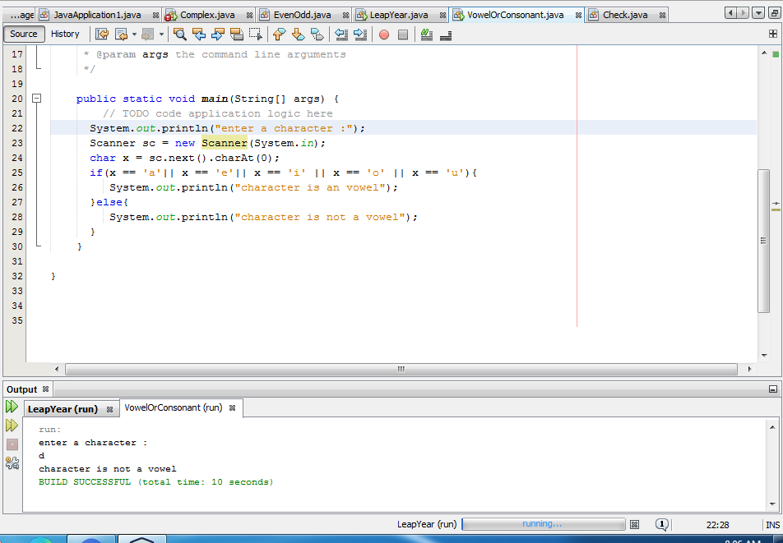

Explanation:
In the above program i use the NetBeans platform in this program I check some alphabets that they are vowels or not vowel so for that ist I took value from user then I gave if else statement that if x is a,e,I,o,u then the character is an vowel else it will not be a vowel then I run it luckily there is no error in my program I put d and it show me in out put that d is not a vowel as I give a condition before.

Q5. How to use power of a number in java using object oriented approach?

Ans: MY PROGRAM AND ITS OUT PUT :

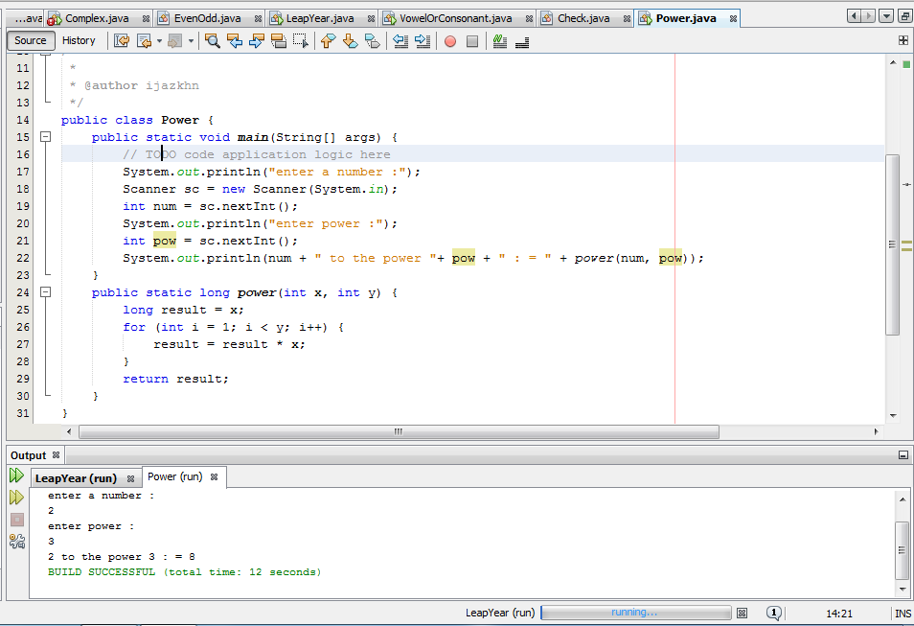

PROGRAM EXPLANATION:
In the above program i use the NetBeans platform in the above program I use power of the number I took two values from the user the one is number it self and the other one will be its power I use for loop in the above program that if I =1 I is less then y and I ++ then I run it and luckily there is no error in my program is I gave 2 and the second power I gave 3 it show that 2 is the power 3 : = 8
THE END….

