Name:Ali Mehran
Id:13724

Final-Term Assignment (Summer-2020)
Course Title: Medical Microbiology
(BS. DT)
Instructor: Pashmina
Time: 4 hours (9-1.30) Max Marks: 50

Q1. Illustrate what are the difference between Sterilization, Disinfection and Antisepsis?
Ans: Disinfection and sterilization are both decontamination processes. While disinfection is the process of eliminating or reducing harmful microorganisms from inanimate objects and surfaces, sterilization is the process of killing all microorganisms. That is the main difference between sterilizing and disinfecting. Sterilization also destroys the spores of various organisms present on surfaces, in liquids, in medication, or in compounds such as biological culture media. Such "extreme" forms of decontamination are needed during critical times like surgery, or in environments like industrial, laboratory or hospital. It is more practical to use disinfection in everyday life.

Comparison chart
Disinfect versus Sterilize comparison chart
 | Disinfect | Sterilize
Definition | To disinfect means to eliminate most harmful microorganisms (not including their spores) from surfaces or objects; inactivate viruses. | To sterilize means to kill ALL microbes - whether harmful or not - and their spores present on a surface or object.
Methods | Phenolic disinfectants, heavy metals, halogens (eg chlorine), bleach, alcohols, hydrogen peroxide, detergents, heating and pasteurization. | Heat, chemicals, irradiation, high pressure, and filtration.
Types | Air disinfectants, alcohols, aldehydes, oxidizing agents, phenolics. | Steam, heating, chemical sterilization, radiation sterilization, sterile filtration.
Application | Disinfection is used mostly to decontaminate surfaces and air. | Sterilization is used for food, medicine and surgical instruments
b)Antisepsis:
Antisepsis relates to the removal, or elimination, of transient microorganisms from the skin and a reduction in the resident flora. The resident flora help protect the patient from infection by competing with pathogens for substrate and tissue receptors. The most common resident organisms of the skin are the coagulase-negative staphylococci, with Staphylococcus epidermidis accounting for more than 90% of resident aerobes.
Techniques may be applied to eliminate contamination (bacterial, viral, fungal and others) present on objects and the skin by means of sterilization and disinfection. Living surfaces, the skin, the operating field and the surgeon's hands cannot be considered sterile. Therefore, the goal of preoperative skin cleansing is to dramatically decrease the resident skin flora to its lowest potential level, realizing that it cannot be totally eliminated.

Q2. What do you know about the Common pathogen prevailing in Pakistan?
Ans: Dengue fever
is a mosquito-borne disease that is transmitted by the bite of an Aedes mosquito infected with the dengue virus. It cannot be spread directly from person to person. Some of the disease’s symptoms include high fever, headaches, muscle pain, vomiting and skin rash. Dengue fever may be mistaken for the flu or other viral infections. However, dengue fever is a severe form of the virus and may cause serious diseases including enlargement of the liver and failure of the circulatory system if not treated in time.In 2011, there was a dengue outbreak in Pakistan, and more than 250,000 suspected cases of dengue fever were reported. Between 2009 to 2011, dengue fever caused 348 deaths in Pakistan. In order to prevent outbreaks of dengue fever from happening again in the future, Pakistan’s government strengthened surveillance and general preventive measures, improved clinical management of patients and implemented targeted vector control activities, according to the WHO. In addition, the government also organized public awareness campaigns for risk mitigation.
Tuberculosis
(TB) is an infectious disease that affects the lungs, which can be spread by coughing and sneezing. The WHO claims that without proper treatment, up to two-thirds of people that are infected with tuberculosis will die. Tuberculosis is one of the common diseases in Pakistan that can have irreversible consequences. Symptoms of tuberculosis include coughing, fever, fatigue, chills and loss of appetite. According to the WHO, Pakistan was ranked eighth out of the 22 countries in the world that are most highly prone to tuberculosis. About 420,000 new tuberculosis cases are reported every year in Pakistan.The government of Pakistan set up the National TB Control Program (NTP) to help reduce the risk of getting tuberculosis. According to the NTP official website, it provides skill training for medics, paramedics and lab technicians. In addition, the program offers a free supply of anti-TB medicines to all diagnosed cases.

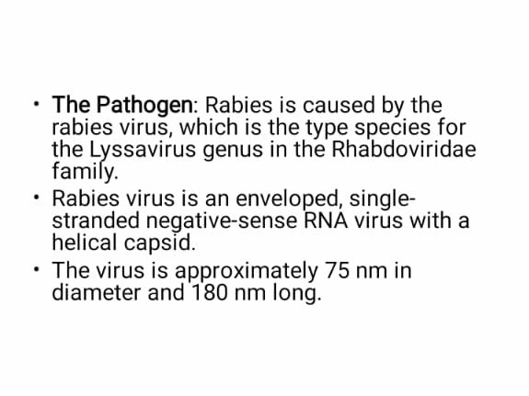
Write-down Disadvantages of some pathogen?

Q3: Write down a brief note on fungal classification and pathogenesis?
Ans: CLASSIFICATION OF FUNGAL:
Fungi are eukaryotic microorganisms. They can occur as yeasts, molds, or as a combination of both forms.
- Some fungi are capable of causing superficial, cutaneous, subcutaneous, systemic or allergic diseases.
- Yeasts are microscopic fungi consisting of solitary cells that reproduce by budding. Molds, in contrast, occur in long filaments known as hyphae, which grow by apical extension.
- Regardless of their shape or size, fungi are all heterotrophic and digest their food externally by releasing hydrolytic enzymes into their immediate surroundings (absorptive nutrition).
- Other characteristics of fungi are the ability to synthesize lysine by the L-α-adipic acid biosynthetic pathway and possession of a chitinous cell wall, plasma membranes containing the sterol ergosterol, 80S rRNA, and microtubules composed of tubulin.
B) Pathogenesis:
Pathogenesis is defined as the origination and development of a disease. Insights into disease etiology and progression, the two major aspects of pathogenesis, are paramount in the prevention, management and treatment of various diseases. In many cases the mechanical properties of the tissue or cellular environment contribute to disease progression or its onset, and this is also true in diseases arising from bacterial infection. For instance, the ability of a bacteria to invade a cell or tissue, to establish an infection within the body and to avoid or even exploit the immune response is often dependent on the bacteria’s ability to manipulate the host cytoskeleton, and exploit various biochemical pathways that respond to changes in mechanical stimuli.

Q4: Explain any one Water borne and Vector borne diseases

ANS: Vector-borne diseases
Vector-borne diseases are human illnesses caused by parasites, viruses and bacteria that are transmitted by vectors. Every year there are more than 700,000 deaths from diseases such as malaria, dengue, schistosomiasis, human African trypanosomiasis, leishmaniasis, Chagas disease, yellow fever, Japanese encephalitis and onchocerciasis.
The burden of these diseases is highest in tropical and subtropical areas, and they disproportionately affect the poorest populations. Since 2014, major outbreaks of dengue, malaria, chikungunya, yellow fever and Zika have afflicted populations, claimed lives, and overwhelmed health systems in many countries. Other diseases such as Chikungunya, leishmaniasis and lymphatic filariasis cause chronic suffering, life-long morbidity, disability and occasional stigmatisation.
Distribution of vector-borne diseases is determined by a complex set of demographic, environmental and social factors. Global travel and trade, unplanned urbanization, .
B)Water borne diseases:
Water-borne diseases are the ones caused by pathogenic microbes spread via contaminated water.
Transmission of these pathogens occurs while using infected water for drinking, food preparation, and washing clothes, among others. Many developing countries do not have proper water treatment plants, especially in the rural areas. In some places, the availability of water is so scarce that people have neither the time nor the money to afford the water purifiers or other water treatment mechanisms.

Water-Borne Diseases and their Impact
The pathogenic microorganisms, their toxic exudates, and other contaminants together, cause serious conditions such as cholera, diarrhea, typhoid, amebiasis, hepatitis, gastroenteritis, giardiasis, campylobacteriosis, scabies, and worm infections, to name a few.

Diarrhea
The most common of all water-borne diseases, diarrhea, mainly affects children below five years of age. The symptoms include dizziness, dehydration, pale skin, and loss of consciousness in severe cases. It usually lasts for a couple of weeks and can turn out to be fatal if it goes untreated.

Q5. Define
- Mycobacteria
Ans: Mycobacteria are a type of bacteria with thick, waxy cell walls. They are known for their ability to lay dormant for decades, surviving harsh conditions and treatment with antibiotics. Mycobacteria infections are notoriously difficult to treat and some are becoming pandemics across the world.
So, what makes mycobacteria so hardy? Their most noteworthy characteristic, like the castle, is their cell wall. Mycobacteria are classified as acid-fast, due to their reaction to a type of dye called carbolfuchsin. The dye is taken up by the special cell wall of mycobacteria using heat. Then, a decolorizer is applied to strip the stain from any bacteria that do not have the special cell wall. The result is bacteria stained red if they are acid-fast.
Mycobacteria have a thick layer of peptidoglycan surrounding the cell membrane made of protein and lipids. Outiside this area is a layer of arabinogalactan, made of sugars that anchor the peptdoglycan layer to outer layers of the cell wall.
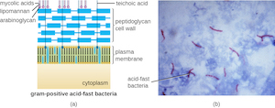
- Heterotrophs
Ans: A heterotroph is an organism that cannot manufacture its own food by carbon fixation and therefore derives its intake of nutrition from other sources of organic carbon, mainly plant or animal matter. In the food chain, heterotrophs are secondary and tertiary consumers.
Carbon fixation is the process of converting inorganic carbon (CO₂) into organic compounds such as carbohydrates, usually by photosynthesis. Organisms, which can use carbon fixation to manufacture their own nutrition, are called autotrophs.
There are two forms of heterotroph. Photoheterotrophs use light for energy, although are unable to use carbon dioxide as their sole carbon source and, therefore, use organic compounds from their environment. Heliobacteria and certain proteobacteria are photoheterotrophs. Alternatively, chemoheterotrophs obtain their energy from ingesting preformed organic energy sources such as lipids, carbohydrates and proteins which have been synthesized by other organisms.
By consuming reduced carbon compounds, heterotrophs are able to use all the energy that they consume for growth, reproduction and other biological functions.
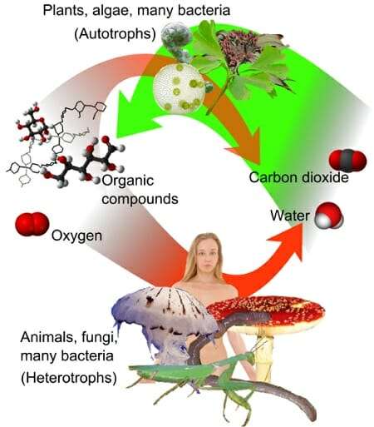
- Metabolism
Ans: Metabolism is a term that is used to describe all chemical reactions involved in maintaining the living state of the cells and the organism. Metabolism can be conveniently divided into two categories:
- Catabolism - the breakdown of molecules to obtain energy
- Anabolism - the synthesis of all compounds needed by the cells
Metabolism is closely linked to nutrition and the availability of nutrients. Bioenergetics is a term which describes the biochemical or metabolic pathways by which the cell ultimately obtains energy. Energy formation is one of the vital components of metabolism

- Photoheterotroph
Ans: they are organisms that use light for energy, but cannot use carbon dioxide as their sole carbon source. Consequently, they use organic compounds from the environment to satisfy their carbon requirements; these compounds include carbohydrates, fatty acids, and alcohols. Examples of photoheterotrophic organisms include purple non-sulfur bacteria, green non-sulfur bacteria, and heliobacteria.[1] Recent research has indicated that the oriental hornet and some aphids may be able to use light to supplement their energy supply
- Cutaneous Leishmaniasis
Ans: CL) is the most common form of leishmaniasis and causes skin lesions, mainly ulcers, on exposed parts of the body, leaving life-long scars and serious disability or stigma. About 95% of CL cases occur in the Americas, the Mediterranean basin, the Middle East and Central Asia. In 2018 over 85% of new CL cases occurred in 10 countries: Afghanistan, Algeria, Bolivia, Brazil, Colombia, Iran (Islamic Republic of), Iraq, Pakistan, the Syrian Arab Republic and Tunisia. It is estimated that between 600 000 to 1 million new cases occur worldwide annually.

Transmission
Leishmania parasites are transmitted through the bites of infected female phlebotomine sandflies, which feed on blood to produce eggs. The epidemiology of leishmaniasis depends on the characteristics of the parasite and sandfly species, the local ecological characteristics of the transmission sites, current and past exposure of the human population to the parasite, and human behaviour. Some 70 animal species, including humans, have been found as natural reservoir hosts of Leishmania parasites.
