SUBMITTED BY : MARIA IKRAM
SUBMITTED TO : MAM AROOBA
SEMESTER : DPT 4TH
ID: 15368
ASSIGNMENT: ANATOMY
DATE : 10 JULY 2020

Q1 : write a note on cerebrospinal fluid , its circulation and absorption?
INTRODUCTION TO CEREBROSPINAL FLUID:
Cerebrospinal fluid (CSF) is a clear, colourless body fluids found in the brain and spinal cord . It is produced by specialised ependymal cells in the choroid plexus of the ventricles of the brain, and absorbed in the arachnid granulation. There is about 125 mL of CSF at any one time, and about 500 mL is generated every day. CSF acts as a cushion or buffer, providing basic mechanical and immunological protection to the brain inside the skull . CSF also serves a vital function in the auto regulation of cerebral blood flow .
Cerebrospinal fluid
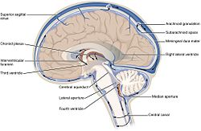
The cerebrospinal fluid circulates in the subarachnoid space around the brain and spinal cord , and in the ventricles of the brain.
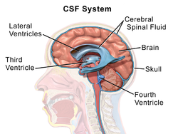
CSF occupies the subarachnoid space (between the arachnoid mater and the pia mater) and the ventricular system around and inside the brain and spinal cord. It fills the ventricles of the brain, cisterns, and sulci , as well as the centeral canal of the spinal cord. There is also a connection from the subarachnoid space to the bony labyrinth of the inner ear via the perilymphatic ducts where the perilymph is continuous with the cerebrospinal fluid. The ependymal cells of the choroid plexuses have multiple mobile cilia on their apical surfaces that beat to move the CSF through the ventricles.
A sample of CSF can be taken via lumbar puncture . This can reveal the intracranial pressure , as well as indicate diseases including infections of brain or its surrounding meninges

There is about 125–150 mL of CSF at any one time this CSF circulates within the ventricular system of the brain. The ventricles are a series of cavities filled with CSF. The majority of CSF is produced from within the two lateral ventricles. From here, CSF passes through the nterventricular foramen to the third ventricle, then the cerebral aqueduct to the fourth ventricle . From the fourth ventricle, the fluid passes into the subarachnoid space through four openings – the centeral canal of the spinal cord, the median aperture , and the two lateral aperture .CSF is present within the subarachnoid space, which covers the brain, spinal cord, and stretches below the end of the spinal cord to the sacrum . There is a connection from the subarachnoid space to the bony labyrinth of the inner ear making the cerebrospinal fluid continuous with the perilymph in 93% of people.
CSF moves in a single outward direction from the ventricles, but multidirectionally in the subarachnoid space Fluid movement is pulsatile, matching the pressure waves generated in blood vessels by the beating of the heart Some authors dispute this, posing that there is no unidirectional CSF circulation, but cardiac cycle-dependent bi-directional systolic-diastolic to-and-from cranio-spinal CSF movements.[4]

Circulation AND ABSORPTION OF CEREBROSPINAL FLUID:
CSF is formed within the ventricles by small, delicate tufts of specialized tissue called the choroid plexus. The solid arrows in the drawing below, cerebrospinalfluid pathway , show the major pathway of CSF flow. Beginning in the lateral ventricles, CSF flows through two passageways into the third ventricle. From the third ventricle it flows down a long, narrow passageway (the aqueduct of Sylvius) into the fourth ventricle. From the fourth ventricle it passes through three small openings (foramina) into the subarachnoid space surrounding the brain and spinal cord. CSF is absorbed through blood vessels over the surface of the brain back into the bloodstream. Some absorption also occurs through the lymphatic system. Once in the bloodstream, it is carried away and filtered by our kidneys and liver in the same way as are our other body fluids.
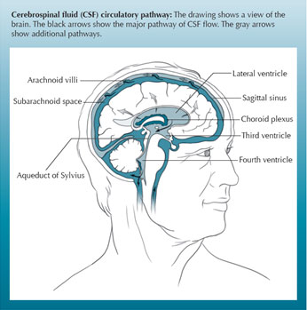
Cerebrospinal fluid pathway
The ventricular system is the major pathway for the flow of CSF. CSF also flows directly from the ventricles into the brain tissue surrounding them. This is shown by the broken arrows. Here the CSF passes through the spaces between the cells to where it eventually enters the subarachnoid space. It is believed that the brain tissue does not absorb any CSF, but simply provides another pathway for the fluid moving to the subarachnoid space. Some small amounts of CSF are also absorbed into lymphatic channels along the membranes covering the nerves (nerve sheaths) as they leave the brain stem and spinal cord .
Our bodies produce approximately a pint (500 ml) of CSF daily, continuously replacing CSF as it is absorbed. Under normal conditions there is a delicate balance between the amount of CSF that is produced and the rate at which it is absorbed. Hydrocephalus occurs when this balance is disrupted. Although there are many factors that can disrupt this balance, the most common is a blockage, or obstruction, somewhere along the circulatory pathway of CSF. The obstruction may develop from a variety of causes, such as brain tumors, cysts, scarring and infection.

After production, CSF movement generally occurs through the ventricular system, assisted, in part, by ciliated ependyma which beat in synchrony. CSF net flow is still generally believed to flow through the ventricular system, initiated at the lateral ventricles. From the lateral ventricles, CSF flows through the left and right foramen of Monro to the third ventricle. Next, it flows through the aqueduct of Sylvius into the fourth ventricle. From the fourth ventricle, the CSF may exit through the foramen of Lushka laterally, or the foramen of Magendie medially to the subarachnoid space. Passing through the foramen of Magendie results in filling of the spinal subarachnoid space. CSF egressing through the foramen of Lushka travels into the subarachnoid space of the cisterns and subarachnoid space overlying the cerebral cortex. The CSF from the subarachnoid space is eventually reabsorbed through outpouchings into the superior sagittal sinus (SSS) known as the arachnoid granulations. Arachnoid granulations act as an avenue for CSF reabsorption into the blood circulation through a pressure-dependent gradient. The arachnoid granulations appear as outpouchings into the SSS due to the pressure in the subarachnoid space being greater than the venous sinus pressure

