Subject : Software requirement specification

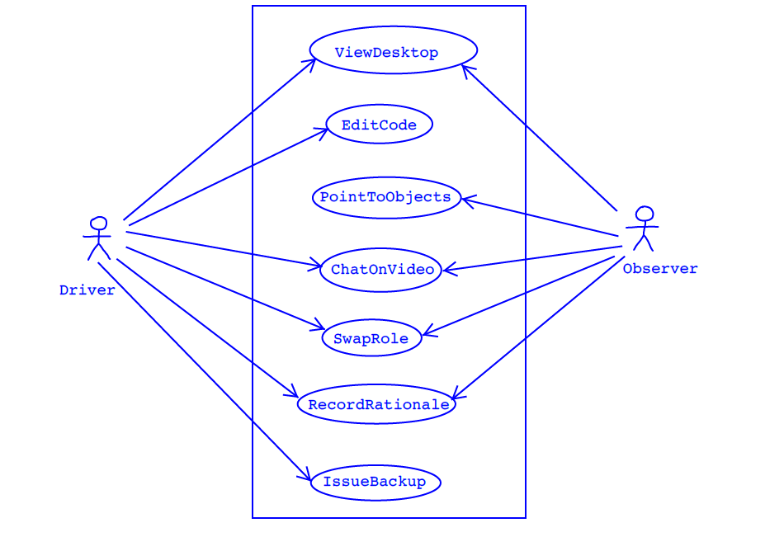

Assumptions:
* when the Driver edits code, we assume that the Observer can see the changes in real-time
through the View Desktop use case, thus there is no arrow pointing back to the
Observer for the Edit Code use case. A similar assumption is made for the PointToObjects
use case, so no arrow points back to the Driver.
* we assume that both the Driver and Observer can initiate the view Desktop, Chat Video,
Swap Role, and Record Rationale use cases.

ANS B:
* Ease of use - the front-end interface must be simple and easy to use.
* Real-time performance - the Observer should be able to see the changes made by the
Driver immediately without delay; the video chat should be smooth without delay also.
* Availability - the system should be available to both programmers all the time.
* Portability - the programmers should be able to use the system regardless of what
computer and operating system used by the programmers.
* Security - the backup code should be kept securely and be protected from unauthorized
access.
* Cost - users should pay no more than $5 per month to use RPP.
* Reliability - the system should be reliable, i.e., it should not crash when the
internet speed is slow and when the internet connection is suddenly down the user should
be able to resume the session at a later time.

ANS C;
Note that since you need to supply only 4 NFRs in part b), you therefore only need to
specify your ordering of the corresponding design constraints.
In your answer, you should explain your ordering, e.g., if you put "ease of use" in
position 1 and "real-time performance" in position 2, then justify why you think "ease
of use" is more important than "real-time performance". You should also discuss
briefly whether there are conflicting design constraints as well and, based on your
ordering, which design constraint should be emphasized on.

