Scour and Mechanism:

Scour can be defined as the excavation and removal of material from the bed and banks of streams as a result of the erosive action of flowing water . Scour occurs in three main forms, namely, general scour, contraction scour and local scour. General scour occurs naturally in river channels and includes the aggradation and degradation of the river bed that may occur as a result of changes in the hydraulic parameters governing the channel form such as changes in the flow rate or changes in the quantity of sediment in the channel . It relates to the evolution of the waterway and is associated with the progression of scour and filling, in the absence of obstacles (Federico et al., 2003). Contraction scour occurs as a result of the reduction in the channel's cross-sectional area that arises due to the construction of structures such as bridge piers and abutments. It manifests itself as an increase in flow velocity and resulting bed shear stresses, caused by a reduction in the channel's cross-sectional area at the location of a bridge. The increasing shear stresses can overcome the channel bed's threshold shear stress and mobilize the sediments . Local scour occurs around individual bridge piers and abutments. Downward flow is induced at the upstream end of bridge piers, leading to very localized erosion in the direct vicinity of the structure . Horseshoe vortices develop due to the separation of the flow at the edge of the scour hole upstream of the pier and result in pushing the down-flow inside the scour hole closer to the pier. Horseshoe vortices are a result of initial scouring and not the primary cause of scour. Furthermore, separation of the flow at the sides of the pier results in wake vortices . Local scour depends on the balance between streambed erosion and sediment deposition. Clear-water scour is the term given to describe the situation when no sediments are delivered by the river whereas live-bed scour describes the situation where an interaction exists between sediment transport and the scour process . The presence of live-bed conditions leads to smaller ultimate scour depths than in clear-water conditions.

Scour poses obvious problems to the stability of bridge structures. Current practice dictates that the depth of scour is determined by the addition of the individual scour depths caused by the aforementioned mechanisms . This is the most critical design case. The scour hole generated has the effect of reducing the stiffness of foundation systems and can cause bridge piers to fail without warning. Notable bridge failures due to scour in Europe include the failure of the Sava bridge in Zagreb and the collapse of the Malahide viaduct .

Loads on Bridge and Mechanism:

Floods often result in significant damage to bridges with piers embedded in riverbeds. While the torrents induce strong lateral loads on bridges, they also sabotage the integrity of bridges by removing the sediment from around bridge foundations. The exposure of foundations substantially reduces the bearing capacity of bridges. The objective of this study is to examine the influence of scour on the behavior of bridge piers subjected to flood-induced loading. In addition, the effectiveness of retrofitting the pier foundation for improving the vulnerability of scoured bridge piers is studied. A complex, nonlinear three-dimensional finite element model that is capable of addressing interactions between bridge columns, pile foundations, soils, and water is developed. The developed model is employed to investigate the behavior of scoured piers during floods. The Shuang-Yuan Bridge that collapsed in a flood event due to excessive scour is adopted as a case study. The influences of scour depths and foundation retrofitting on the behavior of bridge piers are extensively investigated using various performance parameters, including the strength capacity, lateral stiffness, strength retention, and plastic failure mechanism. Furthermore, regression models are suggested to quantitatively represent the correlations between the scour depth and the performance parameters of piers. The foundation retrofitting work is found to be effective in improving the vulnerability of scoured piers only when the scour depth is less than a critical value. Finally, an index is suggested for assessing the safety of piers subject to scour during floods.

Stream channel instability resulting in river erosion and changing angles-of-attack can contribute to bridge scour. Debris can also have a substantial impact on bridge scour in several ways. A build-up of material can reduce the size of the waterway under a bridge causing contraction scour in the channel. A build-up of debris on the abutment can increase the obstruction area and increase local scour. Debris can deflect the water flow, changing the angle of attack, increasing local scour. Debris might also shift the entire channel around the bridge causing increased water flow and scour in another location.[3]

The most frequently encountered bridge scour problems usually involve loose alluvial material that can be easily eroded. However, one should not assume that total scour in cohesive or cemented soils will not be as large as in non-cohesive soils; the scour simply takes longer to develop.

Many of the equations for scour were derived from laboratory studies, for which the range of applicability is difficult to ascertain. Most studies focussed on piers and pile formations, though most bridge scour problems are related to the more complex configuration of the bridge abutment. Some studies were verified using limited field data, though this is also difficult to accurately scale for physical modelling purposes. During field measurements of post scour, a scour hole that had developed on the rising stage of a flood, or at the peak, may be filled in again on the falling stage. For this reason, the maximum depth of scour cannot be simply modelled after the event.

Scour can also cause problems with the hydraulic analysis of a bridge. Scour may considerably deepen the channel through a bridge and effectively reduce or even eliminate the backwater. This reduction in backwater should not be relied on, however, because of the unpredictable nature of the processes involved.

When considering scour it is normal to distinguish between non-cohesive or cohesionless (alluvial) sediments and cohesive material. The former are usually of most interest to laboratory studies. Cohesive materials require special techniques and are poorly researched.

The first major issue when considering scour is the distinction between "clear-water" scour and "live-bed" scour. The critical issue here is whether or not the mean bed shear stress of the flow upstream of the bridge is less than or larger than the threshold value needed to move the bed material.

If the upstream shear stress is less than the threshold value, the bed material upstream of the bridge is at rest. This is referred to as the clear-water condition because the approach flow is clear and does not contain sediment. Thus, any bed material that is removed from a local scour hole is not replaced by sediment being transported by the approach flow. The maximum local scour depth is achieved when the size of the scour hole results in a local reduction in shear stress to the critical value such that the flow can no longer remove bed material from the scoured area.

Live-bed scour occurs where the upstream shear stress is greater than the threshold value and the bed material upstream of the crossing is moving. This means that the approach flow continuously transports sediment into a local scour hole. By itself, a live bed in a uniform channel will not cause a scour hole - for this to be created some additional increase in shear stress is needed, such as that caused by a contraction (natural or artificial, such as a bridge) or a local obstruction (e.g. a bridge pier). The equilibrium scour depth is achieved when material is transported into the scour hole at the same rate at which it is transported out.

Typically the maximum equilibrium clear-water scour is about 10% larger than the equilibrium live-bed scour. Conditions that favour clear water scour are:

Bed material that is too coarse to be transportedVegetated or artificial reinforced channels where velocities are only high enough due to local scour, orFlat bed slopes during low flows.

It is possible that both clear water and live-bed scour can occur. During a flood event, bed shear stress may change as the flood flows change. It is possible to have clear-water conditions at the commencement of a flood event, transitioning to a live bed before reverting to clear water conditions. Note that the maximum scour depth may occur under initial clear-water conditions, not necessarily when the flood levels peak and live-bed scour is underway. Similarly, relatively high velocities can be experienced when the flow is just contained within the banks, rather than spread over the floodplains at the peak discharge.

Urbanisation has the effect of increasing flood magnitudes and causing hydrographs to peak earlier, resulting in higher stream velocities and degradation. Channel improvements or the extraction of gravel (above or below the site in question) can alter water levels, flow velocities, bed slopes and sediment transport characteristics and consequently affect scour. For instance, if an alluvial channel is straightened, widened or altered in any other way that results in an increased flow-energy condition, the channel will tend back towards a lower energy state by degrading upstream, widening and aggrading downstream.

The significance of degradation scour to bridge design is that the engineer has to decide whether the existing channel elevation is likely to be constant over the life of the bridge, or whether it will change. If change is probable then it must be allowed for when designing the waterway and foundations.

The lateral stability of a river channel may also affect scour depths, because movement of the channel may result in the bridge being incorrectly positioned or aligned with respect to the approach flow. This problem can be significant under any circumstances but is potentially very serious in arid or semi-arid regions and with ephemeral (intermittent) streams. Lateral migration rates are largely unpredictable. Sometimes a channel that has been stable for many years may suddenly start to move, but significant influences are floods, bank material, vegetation of the banks and floodplains, and land use.

Scour at bridge sites is typically classified as contraction (or constriction) scour and local scour. Contraction scour occurs over a whole cross-section as a result of the increased velocities and bed shear stresses arising from a narrowing of the channel by a construction such as a bridge. In general, the smaller the opening ratio the larger the waterway velocity and the greater the potential for scour. If the flow contracts from a wide floodplain, considerable scour and bank failure can occur. Relatively severe constrictions may require regular maintenance for decades to combat erosion. It is evident that one way to reduce contraction scour is to make the opening wider.

Local scour arises from the increased velocities and associated vortices as water accelerates around the corners of abutments, piers and spur dykes. The flow pattern around a cylindrical pier. The approaching flow decelerates as it nears the cylinder, coming to rest at the centre of the pier. The resulting stagnation pressure is highest near the water surface where the approach velocity is greatest, and smaller lower down. The downward pressure gradient at the pier face directs the flow downwards. Local pier scour begins when the downflow velocity near the stagnation point is strong enough to overcome the resistance to motion of the bed particles.

During flooding, although the foundations of a bridge might not suffer damage, the fill behind abutments may scour. This type of damage typically occurs with single-span bridges with vertical wall abutments.

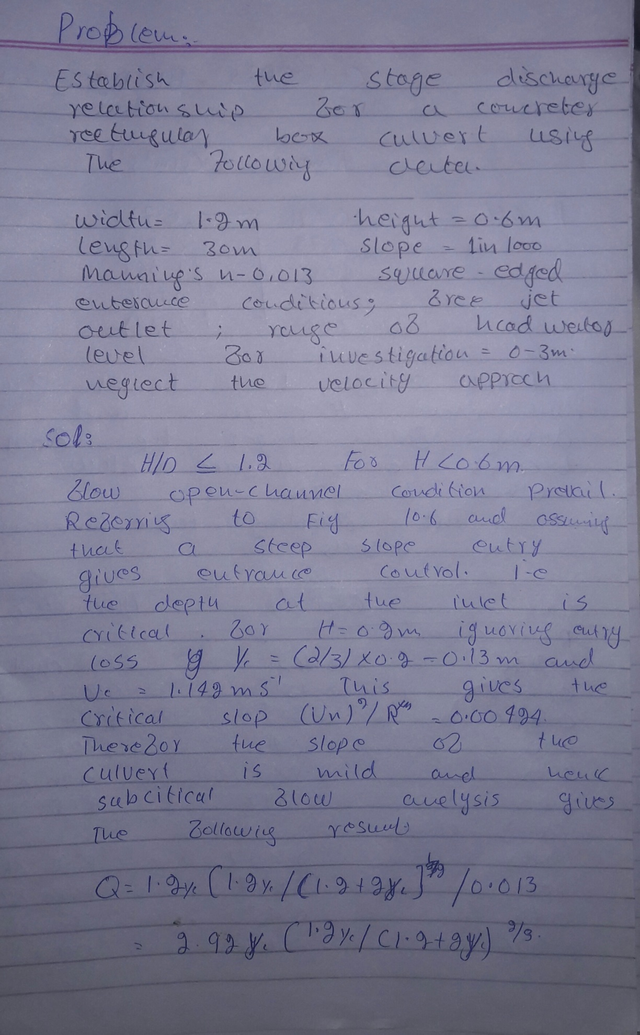
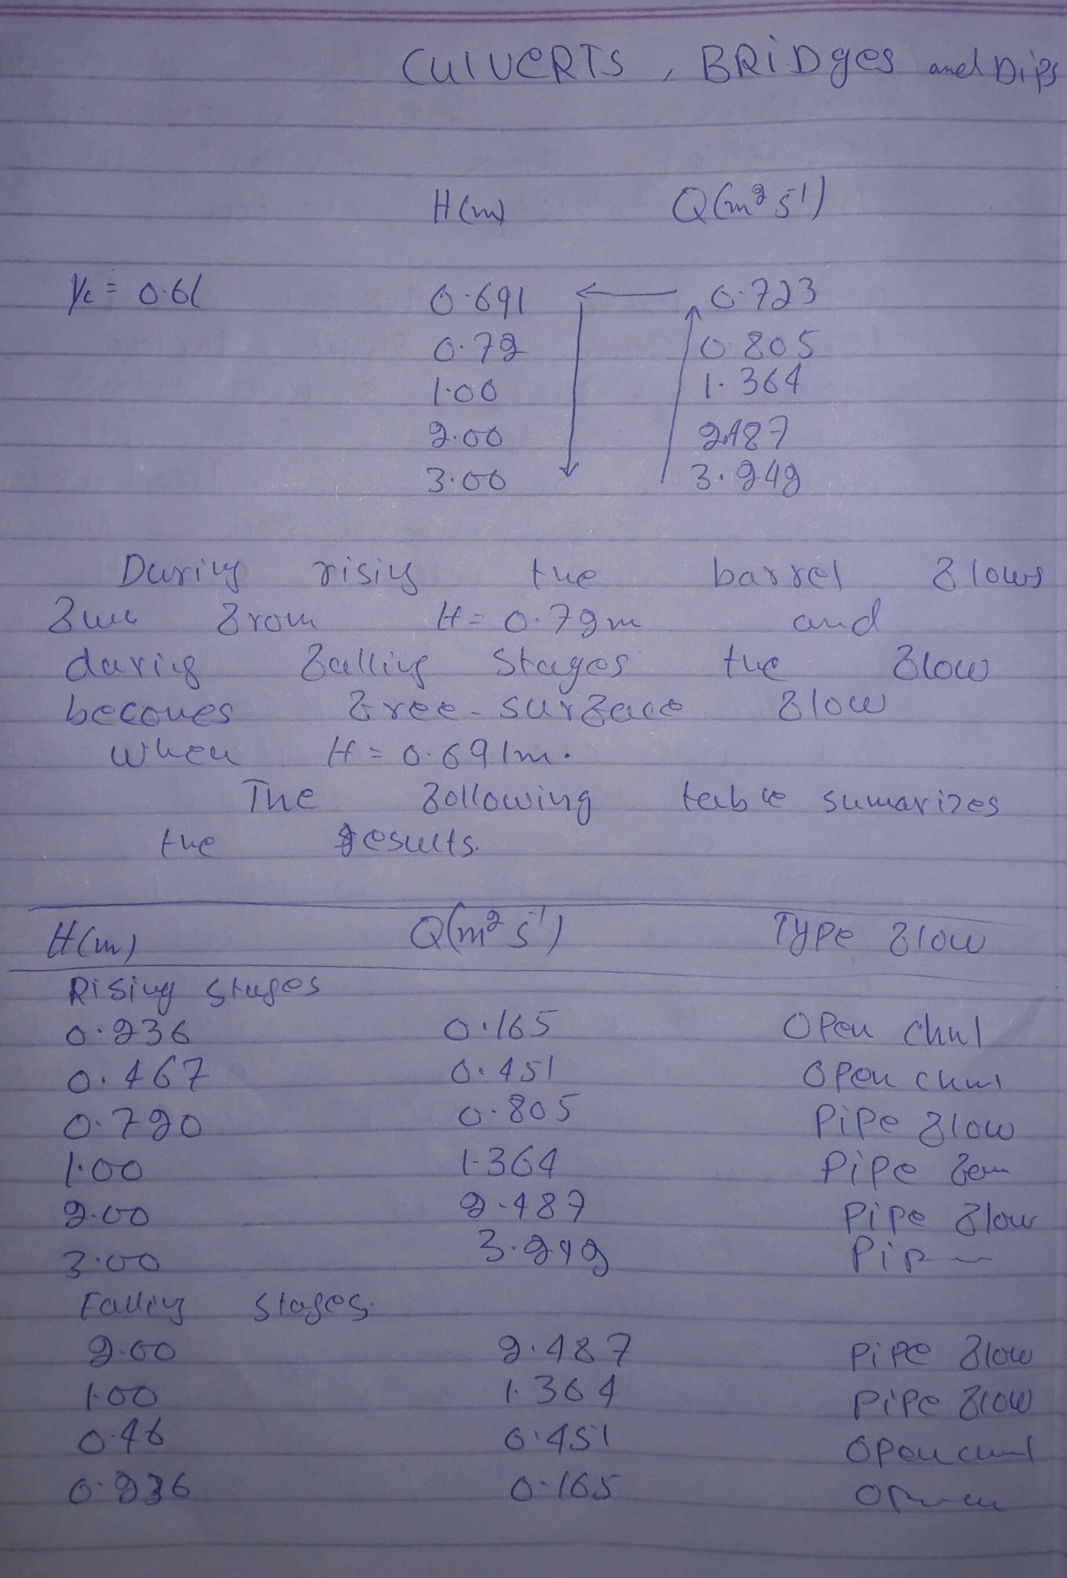

ID : 7550

Assignment : Hydraulic structure

