LAB

Name: M.Zakria Salem
ID# 14459
Subject: Computer Communications and Network
BS(SE)-4th semester
Section (A)

Q:1
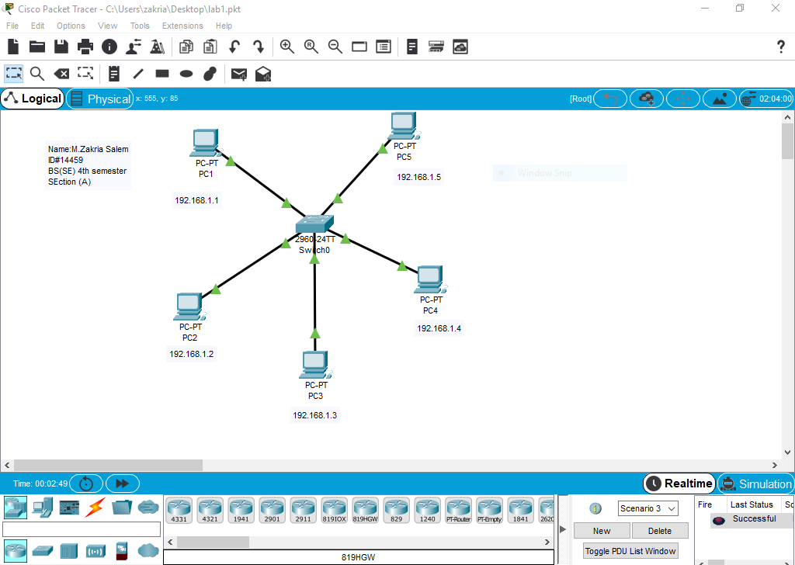

Q:2
