FINAL TERM EXAMINATION
Subject: Water supply and waste water management
Instructor: Engr Muhammad Hasnain
Name: Shahab Shah
ID:: 13020

Answer 1a: Wastewater (or waste water) is any water that has been contaminated by human use. Wastewater is "used water from any combination of domestic, industrial, commercial or agricultural activities, surface runoff or storm water, and any sewer inflow or sewer infiltration".[1] Therefore, wastewater is a by-product of domestic, industrial, commercial or agricultural activities. The characteristics of wastewater vary depending on the source. Types of wastewater include: domestic wastewater from households, municipal wastewater from communities (also called sewage) and industrial wastewater. Wastewater can contain physical, chemical and biological pollutant.
Types of wastewater: There are three types of wastewater, or sewage: domestic sewage, industrial sewage, and storm sewage. Domestic sewage carries used water from houses and apartments; it is also called sanitary sewage. Industrial sewage is used water from manufacturing or chemical processes.
Households may produce wastewater from flush toilets, sinks, dishwashers, washing machines, bath tubs, and showers. Households that use dry toilets produce less wastewater than those that use flush toilets.
Wastewater may be conveyed in a sanitary sewer that conveys only sewage. Alternatively, wastewater can be transported in a combined sewer that conveys both stormwater runoff and sewage, and possibly also industrial wastewater. After treatment at a wastewater treatment plant, treated wastewater (also called effluent) is discharged to a receiving water body. The terms "wastewater reuse" and "water reclamation" apply if the treated waste is used for another purpose. Wastewater that is discharged to the environment without suitable treatment can cause water pollution.
In developing countries and in rural areas with low population densities, wastewater is often treated by various on-site sanitation systems and not conveyed in sewers. These systems include septic tanks connected to drain fields, on-site sewage systems (OSS), vermifilter systems and many more.

Answer 1b: Wastewater is defined as any water that has been negatively affected in quality by humans. Wastewater is comprised of liquid and solid waste that is discharged from domestic residences, commercial properties, industrial plants, and agriculture facilities or land. Wastewater contains a wide range of contaminants at various concentrations.
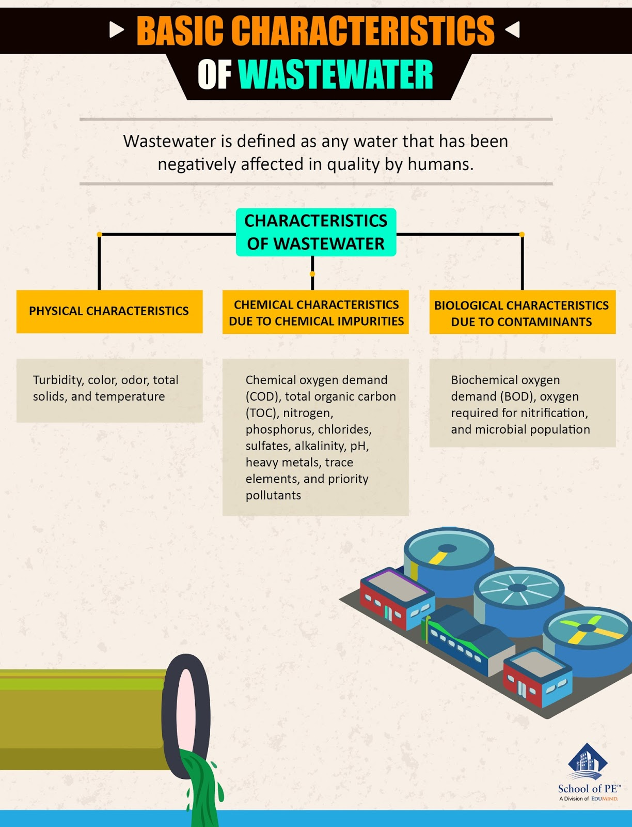

Characteristics of Wastewater
The three main characteristics of wastewater are classified below.

1. Physical Characteristics
· Turbidity
· Color
· Odor
· Total solids
· Temperature

2. Chemical Characteristics due to Chemical Impurities
· Chemical Oxygen Demand (COD)
· Total Organic Carbon (TOC)
· Nitrogen
· Phosphorus
· Chlorides
· Sulfates
· Alkalinity
· pH
· Heavy Metals
· Trace Elements
· Priority Pollutants

3. Biological Characteristics due to Contaminants
· Biochemical Oxygen Demand (BOD)
· Oxygen required for nitrification
· Microbial population

Wastewater characteristics, as well as water treatment processes, are important for environmental engineers to understand. Our FE Environmental exam review course thoroughly reviews the characteristics of wastewater.

Answer 2a: Water treatment is any process that improves the quality of water to make it appropriate for a specific end-use. The end use may be drinking, industrial water supply, irrigation, river flow maintenance, water recreation or many other uses, including being safely returned to the environment. Water treatment removes contaminants and undesirable components, or reduces their concentration so that the water becomes fit for its desired end-use. This treatment is crucial to human health and allows humans to benefit from both drinking and irrigation use.
Coking wastewater treatment for industrial reuse purpose: combining biological processes with ultrafiltration, nanofiltration and reverse osmosis.

A state-of-the-art review on dual purpose seaweeds utilization for wastewater treatment and crude bio-oil production.

Winery wastewater treatment for water reuse purpose: Conventional activated sludge versus membrane bioreactor (MBR): A comparative case study.

Wastewater treatment and water reuse
Current Opinion in Environmental Science & Health.
To implement tariffs and regulations on sanitation and wastewater treatment, as well as for disposal or reuse of treated effluents, it is necessary to know the treatment technologies, which one would be best adapted to the present circumstances of any site and finally if the treated wastewater can be disposed of, legally or reused complying the rules and regulations, in a safe way.
Wastewater treatment has been evolving at different pace along the history, according to the increasing concentration of people in towns and cities. With the in increasing.

Answer 2b: environmental protection is an issue for all of us, flow measurement helps to analyse your systems in terms of consumption and leak detection and enables to reduce the energy consumption and cost.

Flow Measurement Systems

Flow may be measured on an instantaneous or a continuous basis. A typical continuous system consists of a primary flow device, a secondary flow sensor, transmitter, flow recorder, and totalizer. Instantaneous flow measurements can be obtained by using the primary flow device. Techniques which are described later in this Section are available for measuring instantaneous flows with portable equipment.

The typical primary flow devices encountered are the Parshall flume v-notch weir, although there are a variety of flumes and weirs, as well as Venturi meters for closed flow conditions.

A secondary device such as a flow sensor measures the hydraulic responses of the primary flow measurement device and transmit the responses to the recording system. Typical sensors encountered include ultra-sonic transmitters, floats, pressure transducers, capacitance probes, differential pressure cells, electromagnetic cells, etc.

Field Investigation Procedures

The facility’s flow measurement system should measure within +10 percent of the actual flow determined by the primary flow device. The primary flow device and the secondary system will be checked to determine if they conform to the manufacturer’s design and installation standards. Deviations from standard conditions will be documented. The facility chart recorder will be checked to verify that the time and scale are correct.

The accuracy of the flow measurement system is checked by making an instantaneous flow measurement and comparing this reading against the flow measurement system instantaneous flow reading. In addition, EPA flow equipment can be installed to confirm the facility’s totalizer readings. This flow measurement device should be set up at the appropriate head measurement point (1,2,7). An instantaneous flow reading will be documented in the field book or on the flow chart recorder when possible.

Existing facility primary flow devices and flow measurement systems can be used when the accuracy of these devices and the system can be verified. The field investigator will verify that an existing facility flow measurement system (including primary flow device) utilized to measure wastewater flow conforms to recognized design and installation standards, and any deviation from standard conditions will be documented. The accuracy of the secondary system may be checked by making an independent flow measurement. If there is no usable or existing primary flow measuring device or if the device has been located in the wrong place, the investigator may, if so desired, install a portable primary flow device. The accuracy of flow sensors and recorders for open channel flow devices can be checked by making an instantaneous measurement utilizing the primary flow device and comparing this against the recorder reading. If the discharger's flow measurement system is accurate within +10 percent of the actual flow, the investigator can use the existing system.

If non-standard primary flow devices are being used, data supporting the accuracy and precision of the methods being employed should be provided by the permittee. Deficiencies found during the inspection will be recorded by the investigator, and the permittee will be informed that the equipment should be calibrated as soon as possible.

Answer 4b:

The treatment of wastewater subsequent to the removal of suspended solids by microorganisms such as algae, fungi, or bacteria under aerobic or anaerobic conditions during which organic matter in wastewater is oxidized or incorporated into cells that can be eliminated by removal process or sedimentation is termed.
Biological treatment processes
Biological treatment can be defined as “treatment of wastewater by a process involving biological treatment with a secondary sedimentation”. In other words, the secondary treatment is a biological process. The settled wastewater is introduced into a specially designed bioreactor where under aerobic or anaerobic conditions the organic matter is utilized by microorganisms such as bacteria (aerobically or anaerobically), algae, and fungi (aerobically). The bioreactor affords appropriate bioenvironmental conditions for the microorganisms to reproduce and use the dissolved organic matter as energy for themselves. Provided that oxygen and food, in the form of settled wastewater, are supplied to the microorganisms, the biological oxidation process of dissolved organic matter will be maintained. The biological process is mostly carried out bacteria that form the basic trophic level (the level of an organism is the position it occupies in a food chain) of the food chain inside the bioreactor. The bioconversion of dissolved organic matter into thick bacterial biomass can fundamentally purify the wastewater. Subsequently, it is crucial to separate the microbial biomass from the treated wastewater though sedimentation. This secondary sedimentation is basically similar to primary sedimentation except that the sludge contains bacterial cells rather than fecal solids. The biological removal of organic matter from settled wastewater is conducted by microorganisms, mainly heterotrophic bacteria but also occasionally fungi. The microorganisms are able to decompose the organic matter through two different biological processes: biological oxidation and biosynthesis [1]. The biological oxidation forms some end-products, such as minerals, that remain in the solution and are discharged with the effluent (Eq. 1). The biosynthesis transforms the colloidal and dissolved organic matter into new cells that form in turn the dense biomass that can be then removed by sedimentation (Eq. 2). Figure 1 summarizes these processes. On the other hand, algal photosynthesis plays an important role in some cases (Figure 2).
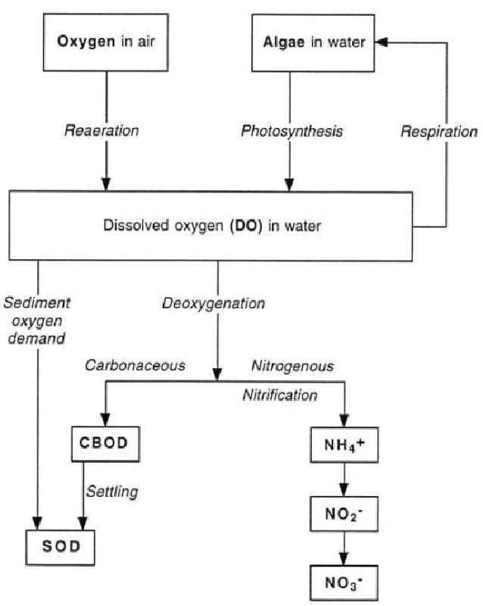
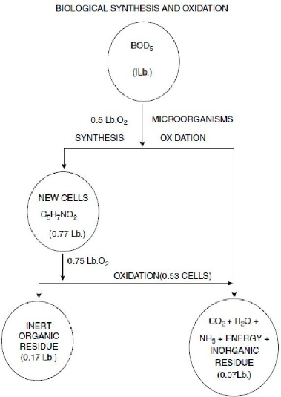
Figure 1 Figure 2

Answer 5a:
Preliminary treatment Preliminary treatment is the removal of untreatable solids that first enter a wastewater treatment plant from the sewer and is comprised of the following two processes (Mara, 2003; Metcalf &Eddy/AECOM, 2014):
- Screening: The removal of floatable or suspended coarse solids in raw wastewater, which includes rags, paper, plastic, rubber, and vegetable matter (Clay et al., 1996). Bar screens are the most commonly used screening devices, with a typical spacing between bars of 15 to 25 mm (Mara, 2003). Bar screens are cleaned manually in small wastewater treatment plants and mechanically in large ones.
- Grit removal: The gravity separation of heavy small solids with a specific gravity greater than putrescible organic matter (e.g., sand, gravel, coffee grounds). Grit is removed in grit chambers, which can be operated manually in small plants or be mechanized in larger plants.
Screenings and grit, if not removed at the beginning of a wastewater treatment plant, can impair downstream treatment processes and damage equipment (e.g., pumps) (Metcalf and Eddy/AECOM, 2014). Figure 1 shows where preliminary treatment is used within the sanitation service chain. Figures 2 through 5 show examples of manual and mechanized preliminary treatment systems in operation.
Figure 1. Locations where preliminary treatment is used within the sanitation service chain.
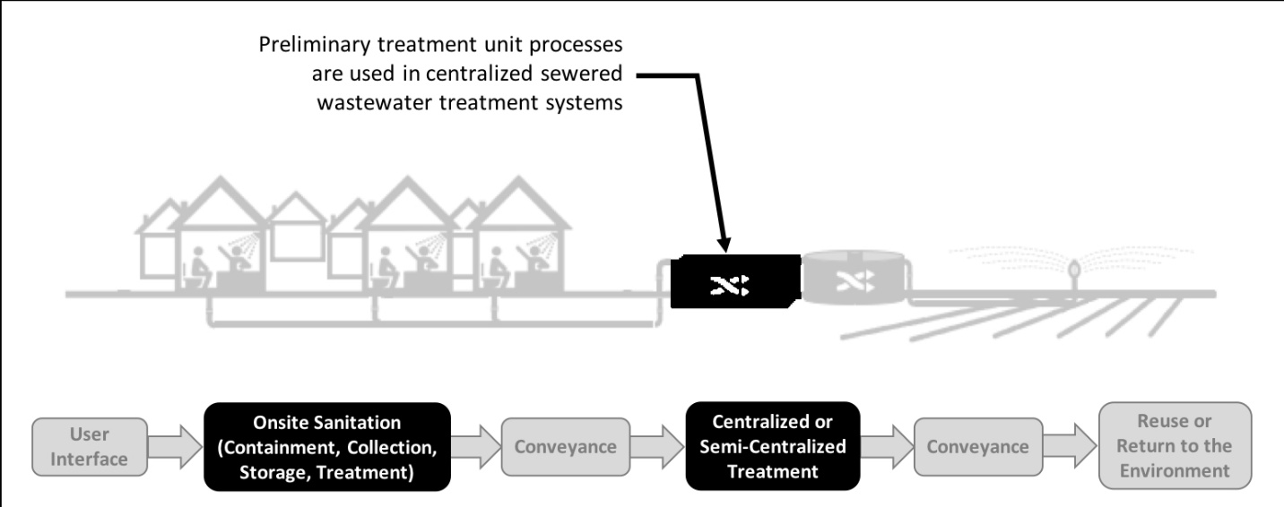

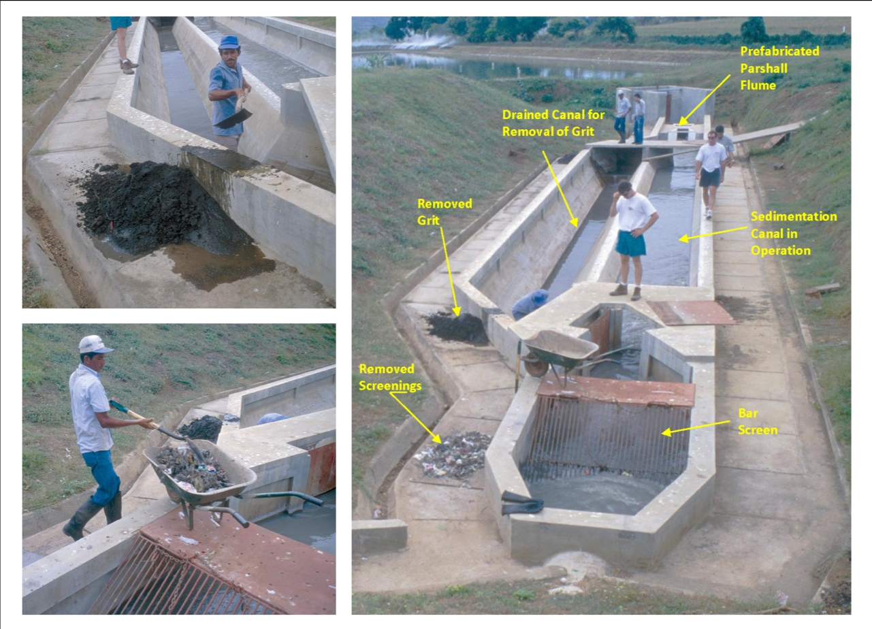
Figure 2. A manual preliminary treatment process with bar rack and horizontal grit chamber for a small wastewater stabilization pond system in León, Nicaragua. Screenings are removed by hand and should be buried or incinerated onsite. Grit, also removed manually, should be buried or stored onsite depending on quantities produced. (photos reproduced with permission of Stewart Oakley)
Answer 5b:

Primary treatment
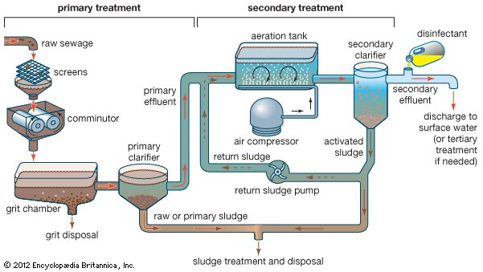
Primary treatment removes material that will either float or readily settle out by gravity. It includes the physical processes of screening, comminution, grit removal, and sedimentation. Screens are made of long, closely spaced, narrow metal bars. They block floating debris such as wood, rags, and other bulky objects that could clog pipes or pumps. In modern plants the screens are cleaned mechanically, and the material is promptly disposed of by burial on the plant grounds. A comminutor may be used to grind and shred debris that passes through the screens. The shredded material is removed later by sedimentation or flotation processes.

Sedimentation tank, also called settling tank or clarifier, component of a modern system of water supply or wastewater treatment. A sedimentation tank allows suspended particles to settle out of water or wastewater as it flows slowly through the tank, thereby providing some degree of purification. A layer of accumulated solids, called sludge, forms at the bottom of the tank and is periodically removed. In drinking-water treatment, coagulants are added to the water prior to sedimentation in order to facilitate the settling process, which is followed by filtration and other treatment steps. In modern sewage treatment, primary sedimentation must be followed by secondary treatment (e.g., trickling filter or activated sludge) to increase purification efficiencies. Sedimentation is usually preceded by treatment using bar screens and grit chambers to remove large objects and coarse solids.
