Final Assignment
Program: BBA/MBA Final Assignment (Spring-2020)
Dated: 24th June, 2020Time allowed: 06 Hours (05:00 PM to 11:00 PM)
Course Title: Project Management Instructor: Zaighum Abbas
Note: Attempt All Questions Total marks: 50
________________________________________________________________________________
Note:This Assignment should be attempted by word or PDF file. After making a word or PDF file upload this file through SIC portal in an assignment section. You have a limited time of 04 Hourswhich will automatically closed after the completion of timeline. No file will be accepted after the given time line.(Plagiarism from one source should not be more than 5% and overall should not be more than 19%)
Q1.
Please share ten key learning outcomes from this subject. What is the practical implementation of this subject?
(10 Marks)
Q2.
What are the components of project budget and sequence of these components and explain it with relevant example?
(10 Marks)
Q3.
What is the project quality, its purpose and project quality management processes?

(15 Marks)

Q4.
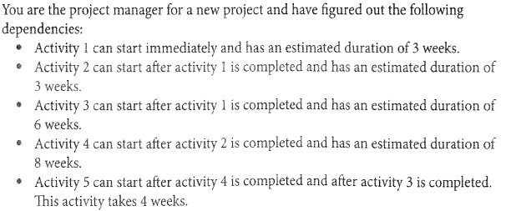
- Draw a Critical path diagram through critical path methods.
- What is the duration of critical path?
- What is the float of activity 3?
- What is the float of activity 2?
- What is the float of the path with the longest float?

Hint for this question
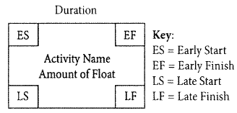
(15 Marks)

Q.1
Please share ten key learning outcomes from this subject. What is the practical implementation of this subject?
Ans:
Following are the ten key learning outcomes from this subject
- The purpose and objectives of the project in clear, concise language.
- Requirements of the project, very high level, not much detail here.
- Project description, a paragraph or two that explains the project.

- Risk Management: Risks that you can ascertain for the project. These are high-level because you haven’t drilled down to every detail yet. You need to capture the major categories of risk however, or you will be unpleasantly surprised later.
- Cost Management: This is a summary of how much the project will cost. You will be wise to do your homework as much as possible ahead of time while preparing this document.
- Schedule Management: You will need to provide a schedule of events with the start and end dates. The major events along the path are called Milestones. You should mark the major milestones so everyone agrees on deliverables or activities that can be expected before the end date of the project.
- Stakeholder Management: Key Players or Stakeholders. This will also be a time to bring the important to the project players to the forefront.
- Requirements from the organization for approval. What must be approved by the governing body of your project? Who will approve and how will you get that approval?
- The document will introduce you and your authority level. It will also give the name and authority level of the Project Sponsor.
- When preparing the project Charter utilize the SMART method. Be Specific, ensure your goals are Measurable, Attainable, Relevant to the project and Timely.

Practical Implementation of this Subject:

This subject helps the peoples to manage their daily activities. Every day we go through a lot of our small daily life projects. For example we daily spend money in purchasing and other events. Cost is what people usually think of the most, But when it is not properly managed, a person may end up in overspending in useless event, and under spending in other more important ones. Having a general idea of the budget, or even a detailed formal plan, is a good aid in controlling the money we spend. Having a cost of the trip are the ticket, accommodation, transportation and daily allowance. Having a clear budget from the beginning helps keeping track of the cost.

If we take the same example of trip in terms of quality management, the expected quality of the trip should be agreed with the family from the beginning. The luxury expectation of the transportation and the accommodation should be properly managed, and therefore quality measures should be put in place throughout the project. For example checking hotel ratings etc.

Communication management is also important. For Example: sometimes prior to the trip the in-laws or the neighbors have to be notified to look after the house.

Risk Management can also part of our daily life. For example a family arrange a dinner party and there may be uncertainties in arranging the function. Contingency plans should be in place and should be implemented if the risk became a reality.

Q2.
What are the components of project budget and sequence of these components and explain it with relevant example?

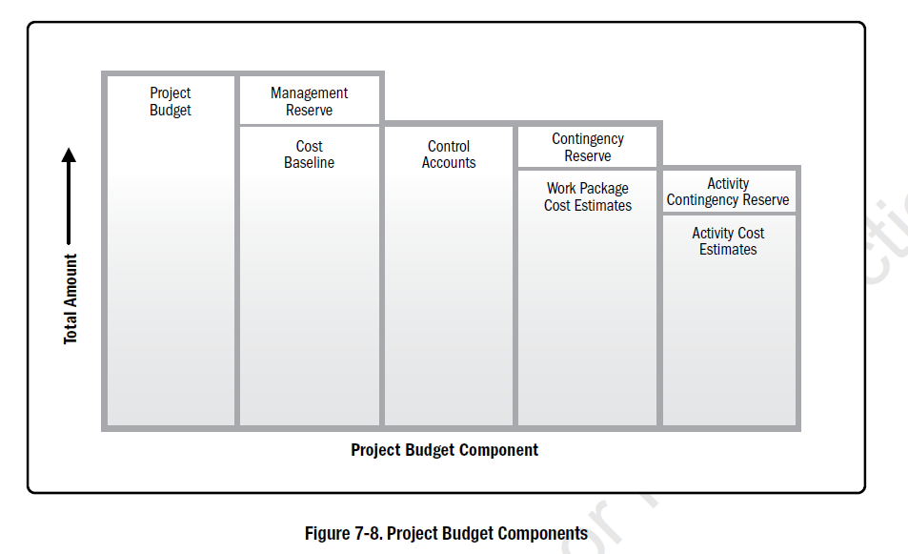

Activity Cost Estimates:
Activity Cost Estimates in budget components is the process where the project manager estimates all the activities involve in the project. In this process the managers keep some resources in reserves for sudden activities that can also be a part of project in future. For Example: All activities happening in constructing a building having an estimated cost.

Work Package Cost Estimate:
Work Packages cost estimate refers to the cost of the activities happening in the same department of an organization. For Example: Rehman Medical College having the Radiology Department So estimating Cost of MRI, X-Rays and other machines and staff are done as a work package.

Control Accounts:
It is difficult to estimate all the activities of a project so the cost managers and other authorities estimates as a whole. For Example Rehman Medical College while preparing a budget of the Radiology department considering X-Rays and Ultrasounds, MRIs etc as a control account of Radiology Department then it is distributed in the work package activity.

Cost Baseline:
Cost baseline is the initial budget of the project approved by the authority. Then the project manager effectively and efficiently uses that budget according to the plan. For Example the budget of BRT was PKR-70 Billion so that is the cost baseline of the BRT project.

Management Reserves:
These are the money and resources which the management keeps as a reserve for uncertain situations so it may helpful without affecting the project.

Q3.
What is the project quality, its purpose and project quality management processes?
Project Quality:
“Project quality is defined as the ability and characteristic of a project to meet the goals for which the project was undertaken.” The quality of the product is that it should be comfort and fit for use. If a project manager build a great project but not meet the purpose for which it was created then it is not suitable for that purpose. The project manager should set the good standards of quality to make the project more comfortable and useful. Every organization have their own standards of quality.
Purpose:
The purpose of the project is that the project should meet the expectations of the stakeholders. The project managers and their team should develop good relationship with stakeholders and donors of a project. Because sometimes the project team just focus on the written form of project requirement and ignore the expectations of stakeholders and donors so it causes the failure of the project. The project team should adjust the scope, schedule and budeget to met the expectations of project donor and stakeholders if they have issue with its quality
Project Quality Management:
Project Quality Management includes the process required to ensure that the project satisfies the purpose and fit for use for which it was undertaken. It occurs at the end of the project to check the output quality. Project Quality Management not only focuses on fixing the errors of the project but also ensure the continuous improvement to the activities of the project. Project Quality Management also ensures the satisfaction of stakeholders and donors by their continuous improvement to the project activities.

QNo.4