Name:Noorkareem
I.D:16246
DPT:2ND
SECTION : B
Final-Term Assignment

Course Title: Biomechanics And Ergonomics I
DPT 2nd semester section B
Instructor: Dr. M .Shahzeb khan (PT)
Marks: 50

Note:
- Attempt all questions, all questions carry equal marks.
- Answer Briefly and to the point, avoid un-necessary details

Q1: (A) What is Humeroulnar Joint? Explain different movements at HU joint.
(B) What is Humeroradial joint? Explain different movements at this joint.
(C) What is carrying angle? Why it is important.

Q2: (A) What is Wrist complex? Explain joints, contribution and ROM of wrist complex
(B) What is carpal Tunnel syndrome?

Q3: (A) Write down definitions of Muscle Twitch, summation and Refractory period.
(B) Explain Types of Muscle contraction with example in your own words
(C) In Grade III muscle strain why we can’t feel pain?

Q4: (A) What is difference between cranial and spinal nerve? How ventral and dorsal ramus form from ventral and dorsal root?
(B) What is difference between Neuropraxia, Axonotmesis and Neurotmesis?
Q5: (A) What is Wolf’s Law?
(B) How fracture repair? Explain different stages of fracture repair

QUESTION:1
ANSWER : 1
(A)HUMEROULNAR JOINT :
Hhumeroulnar joint is part of the elbow-joint. It is composed of two bones, the humerus and ulna, and is the junction between the trochlear notch of ulna and the trochlea of humerus.It is simple hinge joint.It is also called trochlear joint.
=>MOVEMENT AT HUMEROULNAR JOINT:
HUMEROULNAR joint allow the following types of movement :
1.FLEXION:
Flexion in the humeroulnar joint is produced by the action of the biceps brachii and brachialis, assisted by the brachioradialis, with a tiny contribution from the muscles arising from the medial epicondyle of the humerus.
2.EXTENSION :
Extension in the humeroulnar joint is produced by the triceps brachii and anconeus muscle, with a tiny contribution from the muscles arising from the lateral epicondyle of the humerus, such as the extensor digitorum muscle.
3.CIRCUMDUCTION:
There is also slight medial and lateral sliding of ulna.Allowing for full elbow range of motion(ROM). It result in valgus angulation (increase angle)of the joint with elbow extension and a varus agulation (decrease in angle)with elbow flexion.
(B)HUMERORADIAL JOINT:
The humeroradial joint is the joint between the head of the radius and the capitulum of the humerus, is a limited ball-and-socket joint, hinge type of synovial joint.It is a part of elbow joint.
MOVEMENTS AT HUMEROULNAR JOINT:
Following type of movement occure at humeroradial joint.
1.FLEXION AND EXTENSION:
As the elbow flex and extend,the concave radial head slide in the same direction as the motion so with elbow flex the concave head slide Anteriorly with elbow extension it slide posteriorly.
Flexion involves the movement of the hand and forearm toward the shoulder via rotation around the joint. While Extension of the forearm at the elbow joint is the increase of the angle at the elbow to bring the forearm back to the anatomical position from a flexed position. There is one muscle involved in extension, the triceps brachii muscle. It is the only muscle in the posterior compartment of the arm.
With pronation and supination of the forearm,the head of the radius spin at the capitulum.
(C) CARRING ANGLE :
The angle formed between the axis of humerus and the longitudinal axis of forearm.
Normal angle: In Men=5 degree,In WOMEN=10 degree.
The angle is more in women due to wider pelvic.
CUBITIS VALGUS: Increase in carring angle
CUBITIS VARUS: Decrease in carring angle
IMPORTANCE OF CARRING ANGLE:
This angle allows your forearms to clear your hips when you swing your arms, such as during walking. It is also important when carrying objects. ... If the angle is decreased so that the arm points toward the body, it is called a "gunstock deformity."

Question : 2
Answer : 2
(A)WRIST COMPLEX:
The wrist is a complex joint that bridges the hand to the forearm. It is actually a collection of multiple bones and joints. The bones comprising the wrist include the distal ends of the radius and ulna, 8 carpal bones, and the proximal portions of the 5 metacarpal bones .
JOINT AT WREST COMPLEX:
The wrist consit of two compounds joint:
RADIOCARPAL JOINT:
Radiocarpal joint composed of the radius and the radioulnar disk with the scaphoid(S),lunate(L), and the triquetrium(Tq).

MIDCARPAL JOINT:
Midcarpal joint composed of scaphoid,lunate and triquatrium with trapzium(Tm),Trapzoid(Tz) and the Capitate (C) and Hamate (H).
NORMAL RANGE OF MOTION(ROM):
* The wrist complex is biaxial motion of flexion and
extension.
*Ulnar deviation and radial deviation
*pronation and supination may found espacially at the radiocarpal joint.
* Range of motion
…65 to 85 of flexio
…60 to 85 of extension
…15 to 21 of radial deviation
…20 to 45 of ulnar deviation
(B)CARPAL TUNNEL SYNDROM:
When the median nerve compressed with in carpal tunnel,a neurotherapy known as carpal tunnel syndrom(CTS)proposed that the proximal adge of the transvers carpal ligament(TCL)is the most common site for flexion induced median nerve compression.
When the TCL is cut to release median nerve compression the carpal arch may widen.Carpal tunnel syndrome is a common condition that causes pain, numbness, and tingling in the hand and arm. The condition occurs when one of the major nerves to the hand — the median nerve — is squeezed or compressed as it travels through the wrist.
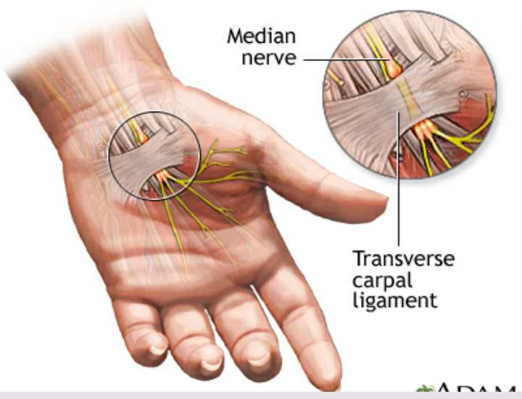
Question : 3
Answer : 3

(A) 1.MUSCLE TWITCH :
Muscle twitching is also called muscle fasciculation. Muscle twitch is an involuntary contraction of a fiber that make up a muscle.Twitching involves small muscle contractions in the body. Your muscles are made up of fibers that your nerves control. Stimulation or damage to a nerve may cause your muscle fibers to twitch. Most muscle twitches go unnoticed and aren't cause for concern.A person can often see or feel these twitches below the skin
SUMMATION OF MUSCLE:
Summation occurs as successive stimuli are added together to produce a stronger muscle contraction.It occurs when a muscle is stimulated and a second stimulation occurs before relaxation is complete. A second contraction develops a greater tension and is joined to the first. ... Tetanus (muscle cramps) occur when the stimuli occur so rapidly the muscles do not have a chance to relax at all.
REFRACTORY PERIOD:
A period immediately following stimulation during which a nerve or muscle is unresponsive to further stimulation.The refractory period is important because it allows us to adjust briefly to a stimulus and limits the amount of action potentials sent per minute.

(B)TYPES OF MUSCLES CONTRATION:
Following are type of muscle contraction:
1.Isometric:
Type of muscle contraction in which the lenght of muscle doesn't change during contraction.
Exemple:Carring an object is example of isometric contraction.since your arm is neither rising nor lowering, so your biceps will be isometrically contracting.
2.ISOTONIC :
Type of muscle contraction in which the length of muscle changes during contraction.
Example:Stair climbing, bicep curls and push-ups.
3.ECENTRIC:
Ecentric contraction is actually is an isotonic contraction where the muscle lengthen.
Example:aThe simplest example of an eccentric contraction is lowering a barbell in a biceps curl.
4.CONCENTRIC:
An isotonic contraction where the muscle shorten.
Example :When lifting a heavy weight, a concentric contraction may occure.
(C)IN GRADE III STRAIN WE CANNOT FEEL PAIN BECAUSE:
Grade III is a severe muscle strain. At gradeIII strain we feel at least minimum or no pain,significant loose of function and complete loose of function occure.In this case complete fiber torn and nerve supply also cut.
QUESTION :4
ANSWER : 4
(A) DIFFERENCE BETWEEN CRANIAL AND SPINAL NERVE:
=> The nerve which originate from cranium is called cranial nerve while the nerve which originate from spinal cord is called spinal nerve.
=>We have 12 pairs of cranial nerve while we have 31 pairs of spinal nerve .
=>Cranial nerves relay information between the brain and parts of the body, primarily to and from regions of the head and neck.
HOW VENTRAL AND DORSAL RAMUS FORM THE VENTRAL AND DORSAL ROOT:
Shortly after a spinal nerve forms from the dorsal and ventral roots of the spinal cord it branches into the dorsal ramus and ventral ramus. Spinal nerves are mixed nerves that carry both sensory and motor information.From spinal cord two roots arises one dorsally and one ventrally,Root on ventral or anterior side is called ventral root while the root on dorsal or posterior side is called dorsal root.
Dorsal root has ganglion ,the dorsal root is the affrent sensory root and carring sensory information to the brain.Ventral root is the effrent motor root that carring information frome the brain.These two root ventral and dorsal unite to form spinal nerve.Each spinal nerve give rise to ventral and dorsal ramus.
(B)DIFFERENCE BETWEEN NEUROPREXIA, AXONOTEMSIS AND NEUROTEMSIS:
Neuroprexia:Neuropraxia is a type of peripheral nerve injury, and is known as the mildest form of nerve injury. It is classified as a transient conduction block of motor or sensory function without nerve degeneration, although loss of motor function is the most common finding.
AXONOTEMSIS:Axonotmesis is an injury to the peripheral nerve of one of the extremities of the body. The axons and their myelin sheath are damaged in this kind of injury, but the endoneurium, perineurium and epineurium remain intact.
NEUROTEMSIS:Neurotmesis (in Greek tmesis signifies "to cut") is part of Seddon's classification scheme used to classify nerve damage. It is the most serious nerve injury in the scheme. In this type of injury, both the nerve and the nerve sheath are disrupted. While partial recovery may occur, complete recovery is impossible.

QUESTION. 5
ANSWER . 5
(A)WOLFF'S LAW:
Wolff's law state that remolding of bone is influenced and modulated by mechanical stresses.When you work your muscles, they put stress on your bones. In response, your bone tissue remodels and becomes stronger.
(B)FRACTURE REPAIR :
Fracture repair is the process of rejoining and realigning the ends of broken bones. This procedure is usually performed by an orthopedist, general surgeon, or family doctor.
DIFFERENT STAGES OF FRACTURE REPAIR :
STEP1:
A:Immediately after the fracture,extensive bleeding occure . Over a period of several hours,a large blood clot or fracture hematoma is develop.
B:Bone cells at the site deprived of nutrients and die,the site become swallon,painful and inflamed.
STEP 2:
* Granulation tissuse is formed as the hematoma is infiltered by capillaries and macrophage,which began to clean tbe debris.
*Some fibroblasts form collagen fibre that span the break,while the other differentiate into chondroblast and being secreating cartilage matrix.
*Osteoblast began to form spongy bone.
*This entire structure is called fibrocartilagenous callus and it splints the broken bone.
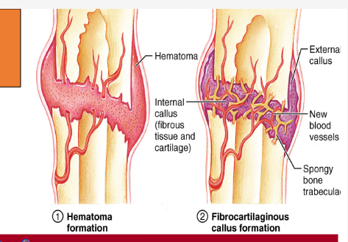
STEP 3 :
A. Bone trabaculae increase the number and convert the fibrocartilagenous callus into a bony callus of spongy bone.typically takes 6 to 8 week for this to occure.
STEP 4:
a.During next several months,the bony callus is continually remolde.
b.Osteoclast work to remove the temporary supportive structure wlile osteoblast rebult the compact bone and reconstructed the bone so it returns to its original shape/structure.
