Hina ali
6924
Surgery 2
Finnal exam
Question /answer
Question: 1
Hydrocephalus:
The word hydrocephalus is the combination of two Greek words hydro and cephalous
The word hydro mean water and cephalous mean head .
As the name indicate that hydrocephalus is the medical condition in which the excessive amount of fluid accumulates in the brain . this fluid is cerebrospinal fluid (csf). The fluid surround the brain and spinal cord .
The excessive amount of fluid accumulation of fluid results in abnormal widening of space in the brain and ventricle ,which creates potentially harmful pressure on the brain .
Epidemiology:
Congenital problem:
How fetus develop .large head is the main sign of hydrocephalus aqueduct stenosis.
Genetic problem
Causes:
The balance between the production and absorption of CSF is critically important. because the CSF is made continuously ,the medical condition that blocks the normal flow or absorption will result in over accumulation of CSF the resulting pressure of fluid against the brain tissue causes of hydrocephalus .
Hydrocephalus may b acquired it can be occur after birth due to ;
- Head injury
- Stroke
- Infection
- Bleeding in brain
- Tumor
Symptoms:
Infants early:
- Abnormal head growth
- Bulging fontanels
- Dilated scalp veins
- Separates suture
- Macewen sign (crack and pop sound of skull bone )
- Poor head control
- Thinning of skull bone
Late infantancy:
- Frontal enlargement
- Depress eye
- Pupils sluggish
- Unequal pupil response to light
Other symptoms :
- Irritability
- High pitch cry
- Lethargy
- Vomiting
- Change in level of consciousness
- Blurry vision
- Balance problem
- Bladder control problem
Types of hydrocephalus :
There are many types of hydrocephalus
- Congenital hydrocephalus
- Acquired hydrocephalus
- Communicating hydrocephalus
- Non communicating hydrocephalus
Congenital hydrocephalus
Its is present at time of birth and may cause by environmental influence during fetal development or by genetic factor
Aquired hydrocephalus :
It is occur short after birth or in some point of life .this types of hydrocephalus can effect individual of all ages or may be cause by injury or diseases
Differentiate between communicating and non communicating hydrocephlus
Communicating hydrocephalus  Communicating hydrocephalus occur when the CSF flow out of ventricales into the spinal canal ,but it is not absorb normally by the surrounding tissue of brain and spinal cord . sometime this types of hydrocephalus is correct itself with in 18 months of age .  Entire ventricular system is enlarged causes are mostly non obstructive  Over production of CSF :choroid plexus papilloma  Deficient reabsorbtion of csf : following meningitist ,subarachnoid hemorrhage and Dural sinus thrombosis | Non communicating hydrocephalus  It occur when the CSF does not flow properly between or out of brain ventricales because of obstruction ,such as from malformation or narrowing head trauma ,infection ,tumors or complication of surgery .  In this case hydrocephalus results from narrowing of aqueduct of sylvius a small passage between the third and fourth ventrical in the middle of brain  Enlargement of only a portion of ventricular system  Major site of obstruction 3rd ventricale →exit foramina in 4th ventricals →CSF can not pass to subarachnoid space→enlargment .  However many people develop normal pressure hydrocephalus even when none of these factors. Also called onstructive hydrocephalus .
Diagnosis:
It can be diagnosis by following methods
- CT scan
- MRI
- Ultrasound
- Intracranial pressure (icp) monitoring
- Lumbar puncture
Effects of hydrocephalus :
It can effect ,
- Eye problem
- Cogitative level
- Language
- Learning
- Practical implication
- Premature puberty
- Psychological development .
Treatment :
Only treatment option today required brain surgery there are three forms
- Shunt system
- Endoscopic thiurds ventriculostomy
- Endoscopic third ventriculostomy with choroid plexus cauterization
Prognosis of hydrocephalus:
Prognosis depend on the causes of hydrocephalus ,the extend 0f symptoms and the timeliness of diagnosis and treatment .although there is some correlation between the specific causes of the hydrocephalus and the out come . prognosis is further complicated by the presence of associated disorder . the degree to which relife of csf pressure following shunt surgery can minimize or reverse damage to brain is not well understood .
Simple aqueduct stenosis treated early ,prognosis of IQ and neurological function is good .
Repeated episodes of raised intracranial pressure and ventriculitis, result in low IQ and neurological function
The affected individual and families should be aware of that hydrocephalus poses the risk on both physical and cogitative development . however many children diagnosis with the disorder benefit from rehabilitation therapies and educational intervention and go on lead normal live with few limitation . neurological damage that may occur prior to treatment is unfortunately irreversible and can have a significant impact on functional social outcomes such as schooling ,social integration and marriages,
Question 2 :
Identify population at risk of developing nephrolithiasis . give surgical management of kidney stone ?
Nephrolithiasis :
Nephrolithiasis is refer to as kidney stone .
Kidney stone is small hard deposition of minerals and acid and salt on the inner side of kidney .stones are classified on bases of their location .some stones or calculi are formed in the urinary track from kidney to bladder by the substance excreted in the urine
Causes
- High sodium intake
- High dose of vitmin C
- Hypercalcemia and hypercalciuria
- Excessive intake of vit D ,milk
- Chronic dehydration
- Immobility
- High uric acid level
Some people are more likely to get kidney stone because of a medical condition or family history tendency to form a kidney stone may also be inherited
Symptoms
- Pain in back and side , below the ribs
- Pain radiate to the lower abdomen
- Pink red or brown urine
- Urine output decreases
- Pale skin
- Poor appetite
- Blood in urine
Population at risk to develop nephroliathasis:
The life time risk of developing nephrolithasis is about 9%in women and 19%in men .
It is more likely to occur after age of 30 but it can also occur earlier
- Gender
- Age (22-30)
- Race
- Diet
- Sedentary life style
- It can also occur to does who have past medical history of
- Diabetes
- hypertension
- Heart problem
- Obesity
- Family of personal history
- High intake of calcium
- Use certain medication
Epidemiology
- Incidence 1:1000 per year
- Peak onset 20 – 30 years
- Male:female 3-4:1
Nutral history :
Recurrence rate
- 40% in 2-3 year
- 55%in 5-7 years
- 75%in 7-10 years
- 100% in 15-20 years
Diagnosis :
- Urine test
- Ultrasound
- Symptoms
- Physical examination
- CT scan
- X-rays
Treatment :
There are two types of treatment
- Operative treatment
- Non operative treatment
Non operative treatment include
- conservative treatment
- medication
- dietary plan
surgical treatment :
ESWL :
Externally applied ,focused , high intensity pluses of ultrasonic energy to causes fragmentation of stone over a period of sound 30-60 mint . use for 0.8 inches stone
Percutaneous nephrolithotomy
it is a surgical procedures to remove stone from kidney by small puncture wound through the skin . it is more suitable to remove stone of more then 2cm in size and which are present near the pelvic area . it is generally done with general anesthesia.
Ureteroscopic surgery
It is a procedure where the kidney stones is remove mechanically using a thin telescope called ureteroscopicis pass through the urethra into the bladder through to the ureter or to the kidney where the stone is stuck . the stone is broken down into smaller pieces using lithotripsy.this is also perform under general anesthesia .its is more effective for having a stone of size 15mm or more .
Open sugery :
In open surgery the surgeon uses incision in a persons abdomen or side to reach the kidney to remove stone .
Question 3
Clinical manifestation of subarachnoid hemorrhage . explain GCS
Subarachnoid hemorrhage :
It is define as the bleeding in the subarachnoid space with in the intracranial valt . it is the space where the csf circulates and is responsible for protecting the brain from injury by serving as a cushion .
This hemorrhage causes coma,paralysis and even death .
Incidence :
- The incidence of SAH is 9.1%per 100,000 annually
- The risk increases in older age 60%higher in age above 80
- The risk of SAH is relatively higher in women over 55 years of age then men
Risk factor :
- Race
- Sex
- Age
- Gender
- Smoking
- Alcohol
Other risk factors
- History of previous SAH
- Family history
- Polycystic diseases
Etiology :
- Head trauma
- Intracranial aneurysm
- Increase blood pressure
- Blood vessel disorder
- Genetic
- Infection
Pathophysiology
Mass effect↔ rupture effect
↓
Rupture of cerebral aneurysm
↓
Bleeding in to sub arachnoids space
↓
Stroke syndrome develop
↓
Increases ICP
Clinical manifestation of subarachnoid
Most unraptures intracranial aneurysm are completely asymptomatic
Aneurysm can undergo small rupture and leak of blood into the subarachnoid space so called sentinel blood
Symptoms are due to rupture . with rupture blood at high pressure gushe in the sub arachnoids space resulting in the following three pattern
- Patient have sever headaches and vomiting and fall unconscious immediately
- Severe generalized headache occur suddenly but patient remain lucid with a vary degree of neck stiffness
- Rarely the patients become suddenly unconscious without preceding any complain
- If the bleeding is massive the patient may die within a mints to hours .
- Seizures may occur
- Neck stiffness
- Impaired level of conscious in some patients
Diagnosis:
- Non contrast CT scan
- MRI of head
- Cerebral angeio graphy
Management :
Acute care
If patient is comatose ventilator assistance
- Cardiac monitoring
- Pain management
Medication
- Steroids
- Ant hypertension
- Analgesic
- Sedatives
Surgical management
- Exovscular clipping
- Surgical clipping
GCS SCALE :
The Glasgow Coma Scale (GCS) is the most common scoring system used to describe the level of consciousness in a person following a trumatic brain injury Basically, it is used to help in the severity of an acute brain injury. The test is simple, reliable, and correlates well with outcome following severe brain injury. The GCS is a reliable and objective way of recording the initial and subsequent level of consciousness in a person after a brain injury. It is used by trained staff at the site of an injury like a car crash or sport injury for example, and in the emergency department and intensive care units.
The GCS measures the following functions:
Eye Opening (E)
4 = spontaneous
3 = to sound
2 = to pressure
1 = none
NT = not testable
Verbal Response (V)
5 = orientated
4 = confused
3 = words, but not coherent
2 = sounds, but no words
1 = none
NT = not testable
Motor Response (M)
6 = obeys command
5 = localizing
4 = normal flexion
3 = abnormal flexion
2 = extension
1 = none
NT = not testable
Using the Glasgow Coma Scale
A patient's Glasgow Coma Score (GCS) should be documented on a coma scale chart. This allows for improvement or deterioration in a patient's condition to be quickly and clearly communicated.
Individual elements, as well as the sum of the score, are important. The individual elements of a patient's GCS can be documented numerically
Every brain injury is different, but generally, brain injury is classified as:
- Severe: GCS 8 or less
- Moderate: GCS 9-12
- Mild: GCS 13-15
Mild brain injuries can result in temporary or permanent neurological symptoms and neuro imaging tests such asCT SCAN/MRI may or may not show evidence of any damage.
Moderate and severe brain injuries often result in long-term impairments incogination (thinking skills),physical skills skills, and/or emotional /behavioral functioning.
Grading /classification of SAH:
There are 5 grads of SAH
Category | criteria
Grad 1 | Asyptomatic or mild headache
Grade 2 | Moderate to sever headache ,nuchial rigidity ,and non neurological deficit other then possible cranial nerve palsy
Grade 3 | Mild altration in mental status
Grade 4 | Stupor and /or hemiparesis
Grade 5 Comatoes
Question 4 :
Vital clinical sign for confirmation of appendicitis ? how can you manage patient with acute appendicitis ?
Appendicitis :
Inflammation of appendix that develop most common in adolescent and young adult . appendicitis is acute inflammation and most common cause for acute , severe abdominal pain
Incidence :
Male are more prone as compare to female
Teenagers are more pron then adult
Higher incidence is between 10 – 30 year
Cause :
It often blocked by stool ,foreign body , infection
Parasites e.g pinworms,stromngyloides
Clinical feature :
The abdomen is most tender at McBurney’s point , one third of the distance from right anterior superior iliac spine to the umbilicus .this corresponds the location of appendix.
- Pyrexia
- Rebound tenderness
- Muscle gurdings
- Bp
- Tempreature
- Pluse
- Respiratory rate
Sign to elicit :
- Pointing sign
Ask to patients to point
- Revosing sing
- Psos sign
Symptoms
- Peri umbilical pain
- Pain shifting to right iliac
- Anorexia
- Nausea/vomiting
acute appendicitis :
Acute appendicitis as name implies ,develop very fast usually in span of several days and hours its very easy to detect and required medical treatment usually surgery . it occur when vermiform appendix is completely obstructed either because of bacterial infection or fecal or other reason .
Management of acute appendicitis:
Surgery is indicated if diagnosis is confirm . to correct or fluid electrolyte imbalance , antibiotics and fluid is administrated until surgery is done .
Antibiots :
Cefotraxime
Levofloxicacine
Appendectomy : removal of appendix is perform as soon as possible . .
Question 5 :
Give lab and radiological investigation for intestinal obstruction ? what can be possible surgical management of intestinal obstruction ?
Intestinal obstruction .
Partial or complete blockage of a lumen of a small intestine or large intestine causing an interruption in the normal flow of intestinal content along the intesinal track .
Risk factors / etiology :
Modifiable :
- Gi track ,abdominal surgery
- Hernia
- Cancer
- Thrombosis, embolism
Non modifiable :
- Age : young-congenital bowel deformities
- Old age
- Family history of colorectal cancer
Sign /symptoms :
- Nausea/vomiting
- Cramps ,abdomenal pain
- Swelling of abdomen
- Poor appetite
- Inability to have bowel or pass gass
Investigation :
To confirm a diagnosis of intestinal obstruction doctor may recommend abdominal X-ray . however , some intestinal obstruction cannot be seen using standard X_ray .
Computerize tomography (CT) . CT scan combines a series of X_rays image taken frm different angle to provide and produce cross section image
Diagnosis
Many test and procedures are used to diagnosis the intestinal obstruction
- Physical exam: if the patient is suspected with the abdominal swollen . doctor will take physical examination ,medical history , symptoms and also take physical examination to asses patient situation . physical examination include
- Inspection :
Abdomenal distension ,scar,visible paristalsis
Palpation:
Mass ,tenderness,gurdness.
Percussion
Tympanic dullness
Auscultation:
Bowel sound are high pitch and increases in frequency
Lab test :
Fbc :leuckocytosis,anameia,hematocrit, platletes
Clotting profile
Arterial blood gases
Ureia,CRT,NA,,LFT,GLUCOSE and LDH
Serum amylase may be elevated
Increases BUN and cretinine
Radiological examination :

- Computerized tomography : also called Ct scan these are also imaging but taken from many angles . it is more accurate then X-rays and is more likely to show intestinal obstruction .
- Role of CT:
Used with IV contrast ,oral and rectal contrast . able to demonstrate abnormality in the bowel wall .
It can define :
The level of obstruction .
The degree of obstruction
The cause: luminal ,mural cause
The degree of ischemia
Free fluid and gas
- Ultrasound : if the intestinal obstruction is found in children , ultrasound is recommended for imaging of intestinal obstruction. In youngsters with an intussusception , an ultrasound will typically show a “bull-eye , representing the intestinal coiled in the intestine .
- Air and barium enema : this type of enhancing image is used in many types of suspected obstructions . this is why it is also used in intestinal obstruction. During the procedure the doctor will insert air or liquid barium into colon through the rectum . for instussusception in children , an air or liquid barium fix the problem and no more treatment is needed .
- X-Rays : X-rays of the abdomen are important in diagnosing the presence of small bowel obstruction. When obstruction occurs, both fluid and gas collect in the intestine. They produce a characteristic pattern called "air-fluid levels". The air rises above the fluid and there is a flat surface at the "air-fluid" interface.

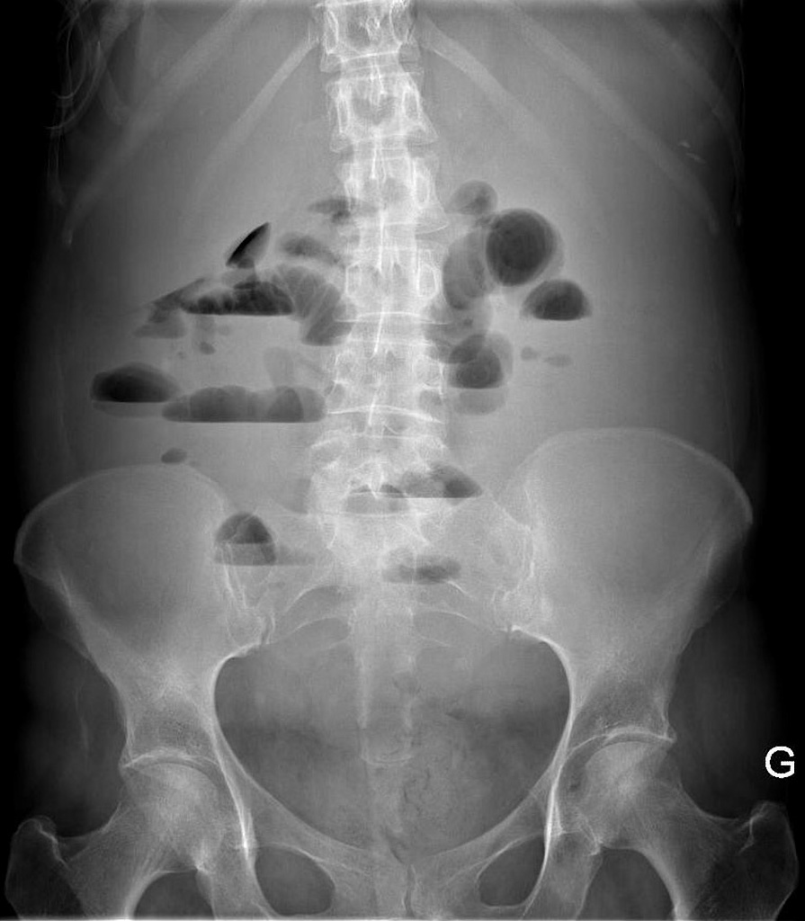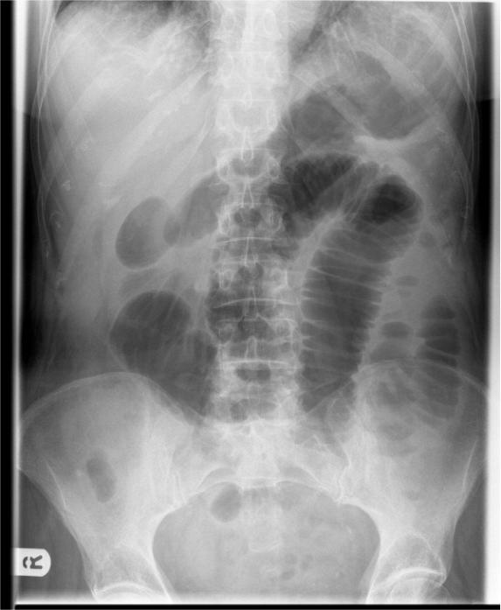

X-rays of intestinal obstruction
Management of intestinal obstruction:
Resuscitation
Conservative treatment
Pervious surgery
Incomplete obstruction
Advance malignancy
Indication for surgery :
General or local peritonitis
Perforation
Close loop
Failure to improve on conservative treatment
Surgical management :
The obstruction is removed to relive the pain of patient and his quality of life .
Stent :A metal tube is insert into the intestine to open the blockage .
Gastrostomy tube: a tube insert through the wall of abdomen directly into the stomach
There are several procedure used to relive intestinal obstruction .
These are treated with surgical resection , removal of adhesion or revascularization .
Resection of the for obstructing lesion or strangulated bowel with end to end anastomosis
Intestinal bypass around obstruction
Temporary ostomy may be indicated
Intestinal obstruction repair(surgical procedure )
Intestinal obstruction repair is surgery to relieve a bowel obstruction. A bowel obstruction occurs when the contents of the intestines cannot pass through and exit the body. A complete obstruction is a surgical emergency.
Intestinal obstruction repair is done while you are under general anesthesia. This means you are asleep and DO NOT feel pain.
The surgeon makes a cut in your belly to see your intestines. Sometimes, the surgery can be done using a laparoscope, which means smaller cuts are used.
The surgeon locates the area of your intestine (bowel) that is blocked and unblocks it.
Any damaged parts of your bowel will be repaired or removed. This procedure is called bowel resection. If a section is removed, the healthy ends will be reconnected with stitches or staples. Sometimes, when part of the intestine is removed, the ends cannot be reconnected. If this happens, the surgeon will bring one end out through an opening in the abdominal wall. This may be done using a colostomy or ileostomy.

