Name : Saima
ID: 16064
BS RAD Section B
Subject: Human Anatomy

MCQS Answers
- B
- A
- B
- A
- B
- A
- B
- B
- C
- A

Q1 Ans

These are three arches In a foot
- medial longitudinal
- lateral longitudinal
- transverse longitudinal

In the young child, the foot appears to be flat because of the presence of a large amount of subcutaneous fat on the sole of the foot.

Medial Longitudinal
The medial marsh of the foot from the heel to the first metatarsal head, is arched above the ground because of the important medial longitudinal arch

Lateral Longitudinal
The pressure exerted on the found by the lateral margin of the foot is greater at the heel and fifth metatarsal head and least between these areas because of the presence of the low lying lateral longitudinal arch

Transverse Longitudinal
The transverse arch involves the bases of the five metatarsals and the cuboid and cuneiform bones .
The foot has been likened to a half _dome, so that when the medial borders of the 2ft are placed together, a complete dome is formed.

FACTOR FOR THE MAINTENANCE
The following factors are responsible for the maintenance of these arch.
- shape of stones
- inferior edges of stones tied together
- uses of tie beams
- suspension bridge.

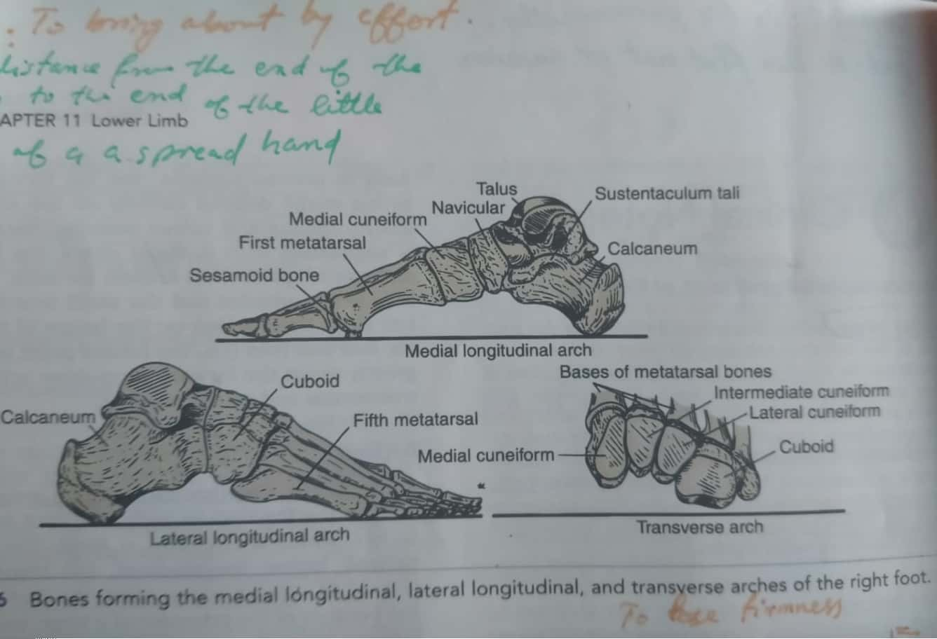

Q2
Ans
Gluteus maximus is the muscle which is largely responsible for the maintenance of buttocks.

Gluteus Maximus
is the main extensor of the hip. It is the largest and most superficial of the three gluteal muscles and makes up a large portion of the shape and appearance of each side of the hips. It is thick flashy mass, In a quadrilateral shape, forms the prominence of the buttocks.

ORIGIN : is from gluteal surface of ilium, lumber fascia sacnum.
NERVE: inferior gluteal nerve supplies the maximus.
ACTION : external rotation and extension of the hip joint, chief antigravity muscles in sitting and abduction of the hip.

Site For Intramuscular Injection :
Upper lateral quadrant of the buttock is the safe site for IM injection.

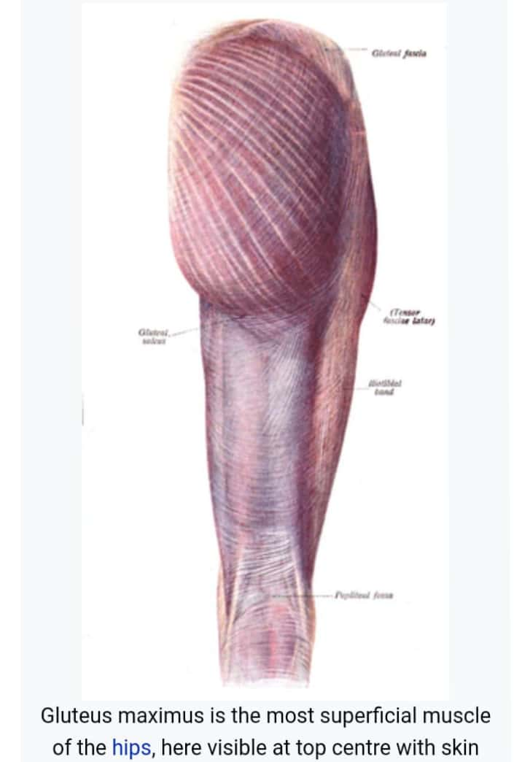

Q3
Ans
greater sciatic foramen:
is an opening in the posterior human pelvis.
It is formed by the sacrotuberous and sacrospinous ligaments.
The pinformis muscle passes through the foramen and occupies most of its volume.
The greater sciatic foramen is wider in women than in men.

Structures Passing Through The Foramen Are Above The Piniformis Are
*superior gluteal vessels
*superior gluteal nerve

Below The Piriformis :
*Inferior gluteal vessels
*internal pudendal nerve
pudenda al nerve
Sciatic nerve
Posterior femoral cutaneous nerve

B) LESSER SCIATIC FORAMEN :
is an opening between pelvis and the back of the thigh. The foramen is formed by the sacrotuberous ligament which runs between the sacrum and the ischial tuberosity and sacrospinous ligament which runs between the sacrum and ischial spine

*STRUCTURES PASSING THROUGH THE LESSER SCIATIC FORAMEN ARE:
the tendon of the obturator internus
Internal pudendal vessels
Pudendal nerve
Nerve to obuturator internus

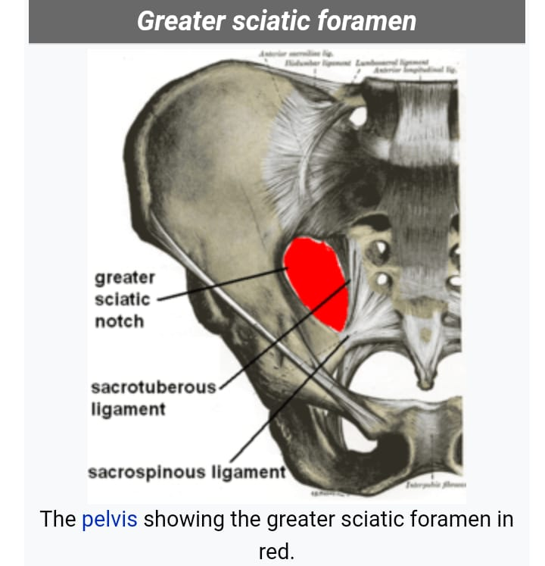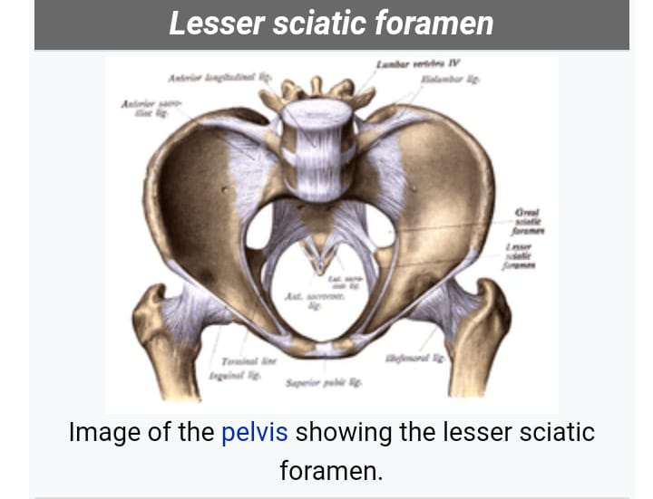

Q4.
Ans
Hamstring Muscles :
in human anatomy, a hamstring is one of the three posterior thigh muscles in between the hip and the knee from medial to lateral.
*semimembranosus, semitendinosus and biceps femurs.
*the hamstring are quite susceptible to injury.

Structure:
these are three muscles of the posterior thigh flex the knee, while all but the short head of biceps femurs extend, the hip. The three "true" hamstring cross both the hip and the knee joint and are therefore involved in the knee flexion and hip extension. The short head of the biceps femurs crosses only one joint (knee) and therefore not involved in hip extension.

Muscle:
1. semitendinosus
2. semimembranosus
3. biceps femons
A) long head
B) short head

Origin:
Ischial tuberosity
Ischial tuberosity
Ischial tuberosity
Linea aspera and lateral supracondylar line of femur.

Insertion:
medial surface of tibia.
Medial tibial condyle.
Lateral side of the head of the fibula.
Lateral side of the head of the fibula.

ARTERY:
Inferior gluteal artery, profound femoris artery.
NERVE :
Sciatic nerve (tibial nerve and common fibular nerve)
ACTION:
flexion of knee, extension of hip.

