NAME : Muhammad Saad
ID : 16097
Department : BE Civil Engineering
Section : A
Instructor : Ar. Aleena Babar
Subject : Architecture & Town Planning

Egyptian Civilization:
Egyptian Civilization have a vast a history of more than 6000 years. Egyptian civilization was not one stable civilization but instead a civilization it have constant changes throughout the periods likewise Egyptian civilization is not consist of one style but a set of style having some similarities and common thing used during each period of Egyptian history.
Egyptian history begin before the pre dynastic period (6000-3150BC) and continuous to the end of Ptolemaic dynasty (323-30 BC).
The early dynastic period in Egypt (3150-2613 BC) built upon the knowledge of those whose had gone before pre dynastic art and so the architecture was improve through time.
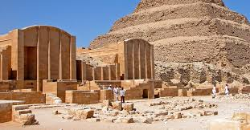
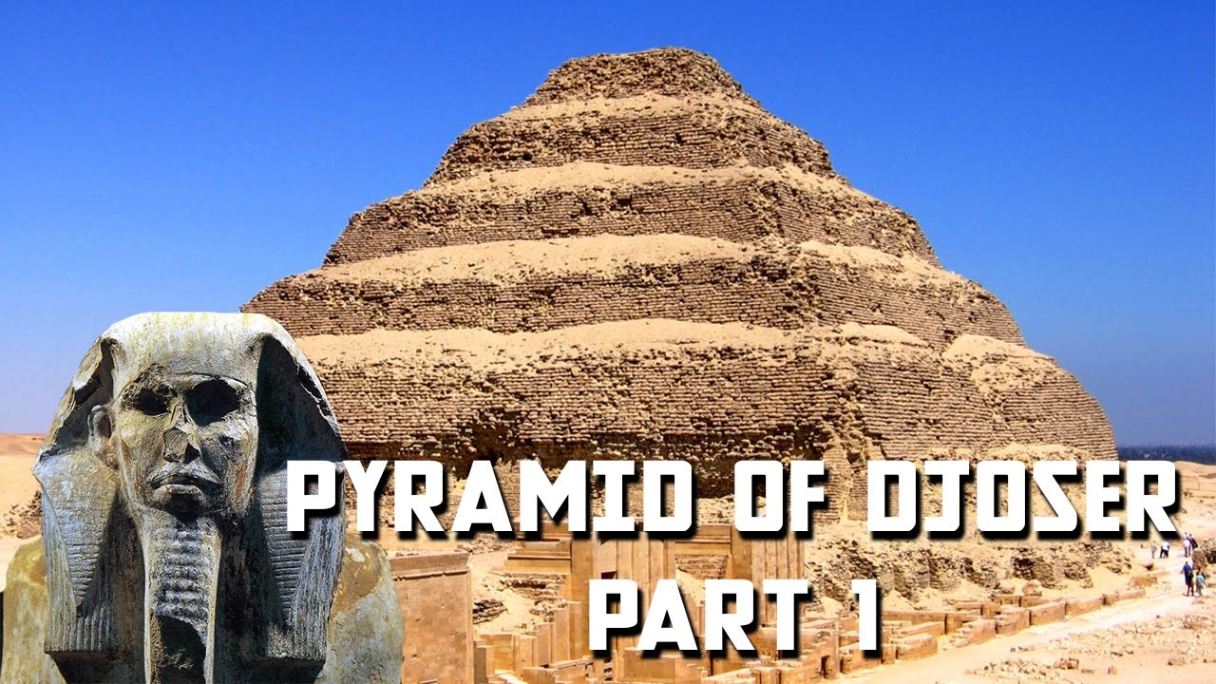
DJOSER’s Step Pyramid at Saqqara
The first pyramid in Egypt Djoser’s step Pyramid at Saqqara comes from the end of this early dynastic period and comparision of this monument and its surrounding with the Mastaba tombs of early centuries shows the difference between the periods of architecture design and
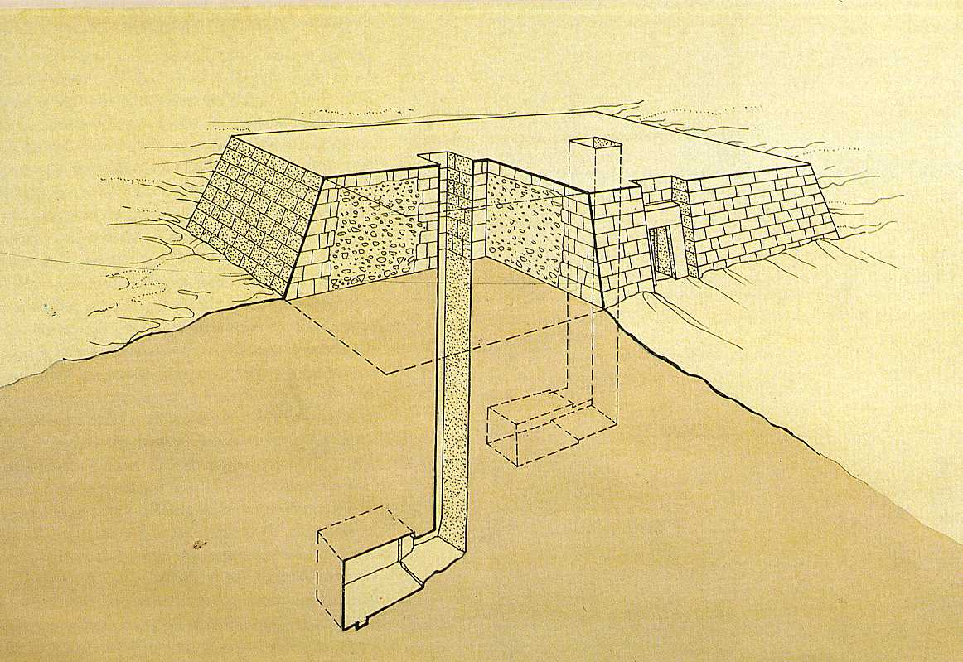 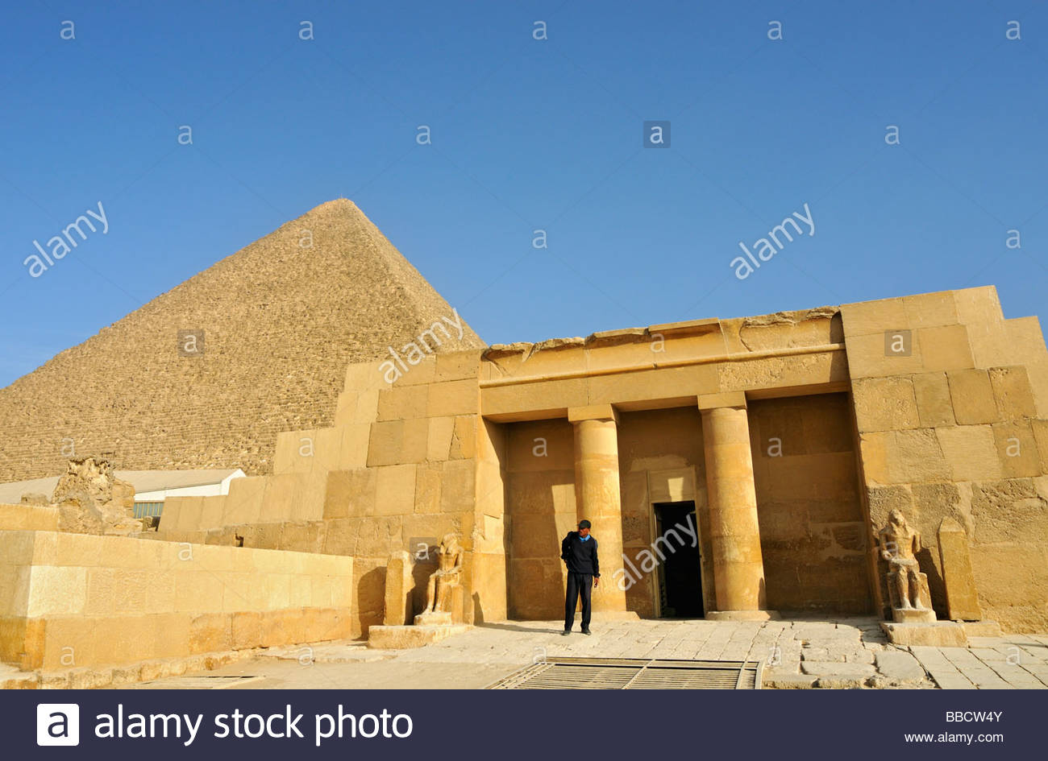
construction improvement this shows the link between these great monuments and those which came after them.
The Egyptian built their Pyramids, Tombs, Temples, with the most durable material although earthquakes, was and the forces of nature have played their role in the destruction of these monumental architecture. The remains of monumental architecture achievements are still visible across the land to tribute the great ness of this civilization. These building projects took a high degree of architecture and engineering skills and the organization of large work force consisting of highly trained and skilled labourers and craftsmen.
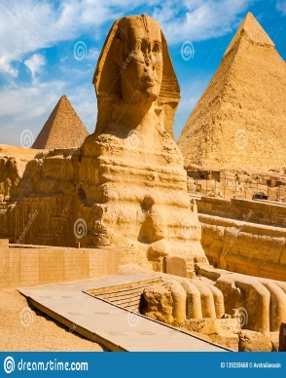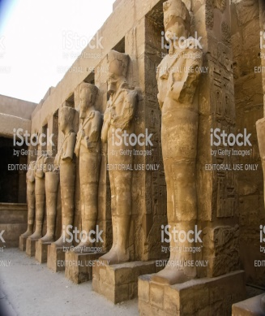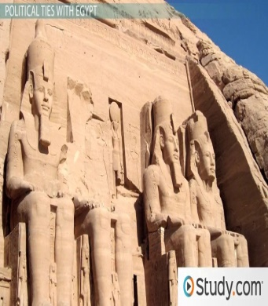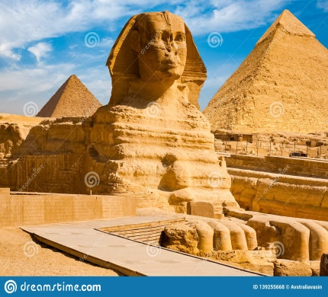
Egyptian civilization was in northeastern Africa concentrated along the middle to lower reaches of the Nile river, reaching its greatest extend the second millennium BC during the new Kingdom. Its stretched from the Nile delta in the north as for south as Jebel Barkal at the forth cataract of the Nile. The geographic range of the Egyptian civilization included at different time areas of the southern levant, the eastern desert and the red sea coastline, the Sinai peni in sula, and the oses of the western desert.
Due to location, most Egyptian buildings were built of stones the most durable material of all mud brick and limestone readily available materials by levied workers monumental building were built via the post and lintel method of construction, and many building were aligned astronomically. Columns were typically adorned with decorated capitals which were made to resemble plants important to Egyptian civilization, such as papyrus plant.
Some features of town planning in the Egyptian civilization were:
The planning of the town were based on two main factors. The nearness to a water source and the height it was built above Nile to make sure the flooding didn’t affect the city.
The Nile river the largest river in the world (6650km), flows through from the heart of Africa to the Mediterranean sea. Its flood plan was a magnet for life human, plant and animal. Humans were drawn because they could grow crops and settle into permanent villages. For centuries the Nile river flood the valley in reaching the land with a thick layer alluvian soils. Flooding occurred from July to September as the result of the tropical rains in Ethiopian table land. The river attained its highest level in October, then begin to decrease to lowest point sometime between April and June.
Towns generally had a boundary wall with only one or two entrances through the wall. Houses were built on the edge of the streets and the houses shared wall with there neighboring houses. The streets were very narrow. Egyptian built canals, dams and dug wells to collect water however some of Egyptian towns were not planned very well.
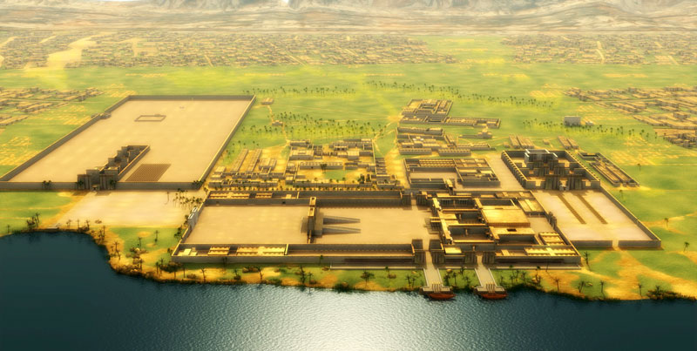
The use of urban planning in Egypt is the matter of continuous debate. Because ancient sites usually survive only in fragments, and many Egyptian cities have been continuously inhabited since there original forms, relatively little is actually understood about the general designs of Egyptian town for any given period.
The Egyptian refers to the most cities as either nwtrdmi. Nwt usually refers to unplanned cities that grew naturally, such as Memphis and Thebes.
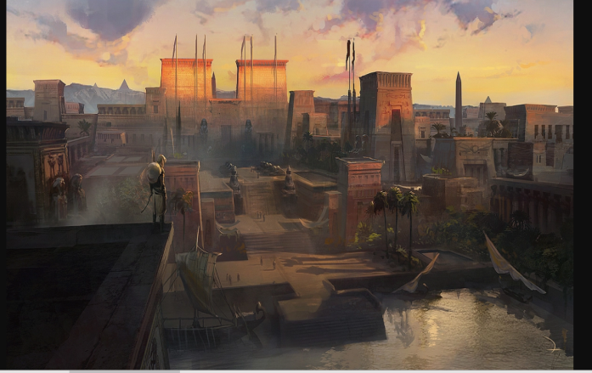 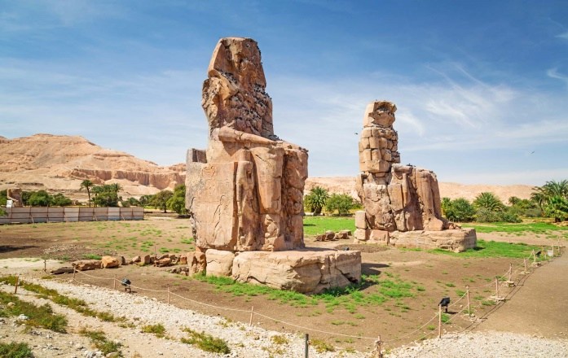
While bmi can be translated as “settlement” and usually refers to town that were laid out along a plan. The archaeological enidence of such cities is best preserved, and have been most thoroughly delved, at El Lahun, deir el-Medina, and Amarnah, those some evidence of urban planning exist at other site as well.
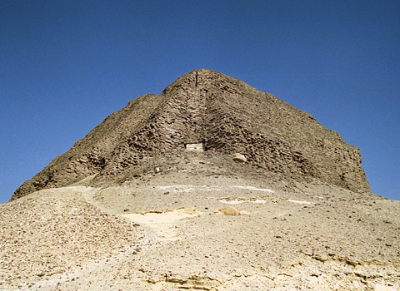 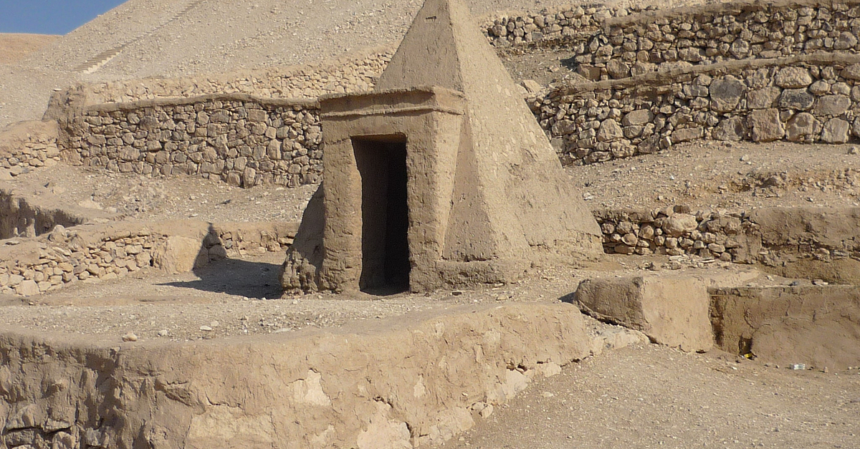 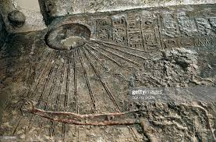
One of the major difficulties face by the early pyramid builders was how to move huge number of heavy stone blocks. It seems that this problem was solved using techniques which involved the following elements. To begin with blocks of stone were lubricated with oil to facilitate movement. Also, based on the excavation of artifacts from certain temples, it seems that builders used a cradle like machine to help roll the stones. Such a technique has been validated in tests conducted by obayashi cooperation, using concrete blocks weighting 2.5 tones, which prove that 18 men could drag a block up 1-in-4 incline ramp, at a rate of roughly 60 feet per minute. However the method use for 2.5 tones of blocks were not applicable for the blocks in the weight range of 15-80 tones.
The most common features and famous form of late prehistoric art, or the pyramids of Egypt which are the world largest funerary or tombs. Develop from the Mastaba tomb, they are one of the most enduring symbol of Egyptian art in general and Egyptian architecture in particular. The Egyptian mostly believe in eternal after life, and the purpose of the pyramids was to protect the pharaoh’s body and all the things he would need after death, and order to facilitate his passage into the after life.

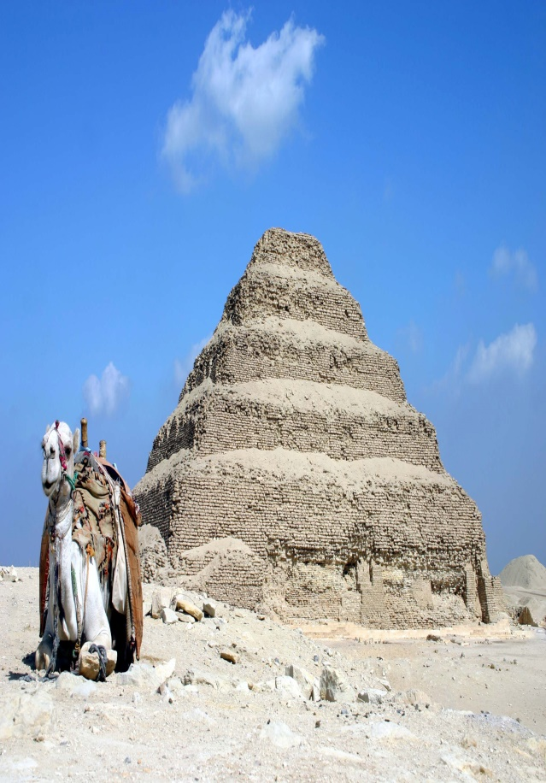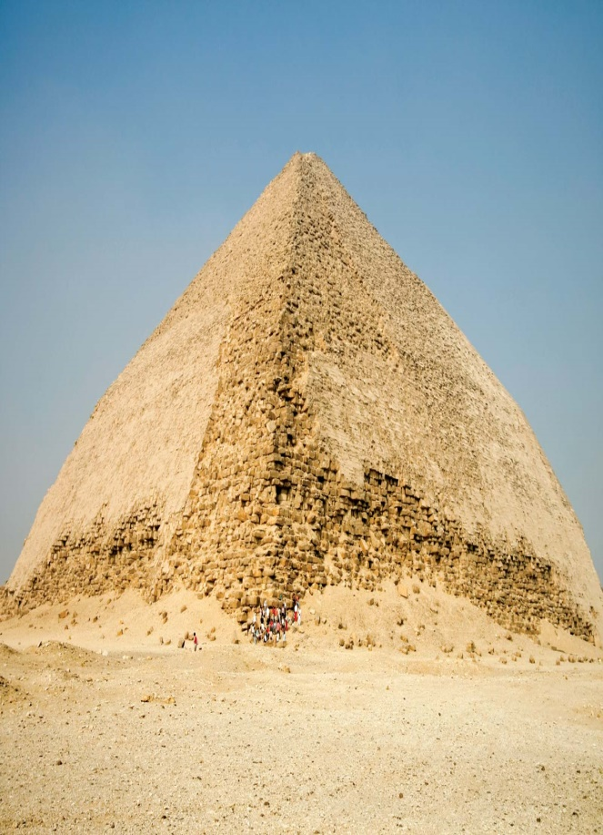
The step Pyramid of Djoser The Red Pyramid of Snefru
(2630BC) (2600BC)
Each Pyramid routinely contained a wide variety of Egyptian’s sculpture, moral painting, jewellery and other type of ancient art necessary to maintain the deceased and his after death existence. About 140 Pyramids have been discovered so far in Egypt, most of which were built as burial tombs for the country pharaohs and their consorts, in the old and middle kingdom periods (2600-1650). The oldest known Egyptian pyramids are located at Saqqara, near Memphis, just south of Nile delta.
All Egyptian pyramids were constructed on the Nile west bank where the sun sets, and the reason for that construction is there believe (the pharaoh soul supposedly joint with the sun during its descent before continuing with it and its eternal journey). Most Pyramid were clad in polished, white limestone in order to give them abrilliant reflective appearance from a distance.

