IQRA NATIONAL UNIVERSITY

Submitted to : Engr. Nadeem Ullah

Submitted by: Mughis ullah

Class ID: 15242

Discipline: MS Civil Engineering

Course Title: Water Demand Supply and
Distribution

Course code: CE-562

Dated: 16/04/2020

Contact: 0300-9093179

Email ID: mughiskhan1234@gmail.com

Hydrological Cycle
Earth's natural water-recycling system which is the sum of all processes through which water transmission occurs from land and ocean surface to atmosphere and back through various precipitation form.
Hydrological cycle is also known as the “water cycle”
The water cycle describes the trajectory of a droplet of water from the
time it comes down to the earth until it evaporates and returns to the atmosphere.
Hydrological cycle includes many process:
1. Evaporation 2. Condensation 3. Precipitation 4. Interception 5.Infiltration etc
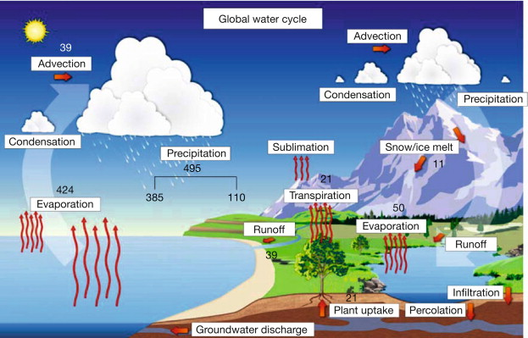

Disruption of water cycle is a reality
Hydrological cycle disruption has provided significant attention in terms of land – atmosphere exchanges, plant physiology, net primary development and the cycling of major nutrients. Climate change intensifies this cycle because as air temperatures increase, more water evaporates into the air.

We interrupt water cycle in two ways:
Withdrawals:
We take water out of the system to irrigate fields, provide
us with drinking water and conduct many of our processes in industry for a direct economic benefit.

Discharges:
We add substances to the water – intentionally or not. As precipitation falls on the ground and moves into rivers, it picks up a whole range of pollutants. Those contaminants may include farm pesticides,
Herbicides, fertilizers etc in rural areas. The contaminants in urban areas may include coal, oil, pet waste, fertilizers and pesticides etc. What happens if rain that falls from the sky or the water that flows through our streams is contaminated?
These contaminants may infect plant or animal life including human beings, or reduce their ability to grow and reproduce.
From above passage, we can conclude that hydrological cycle has been disrupted.

Ground water Sustainability
It is the development and use of groundwater resources to meet current and future beneficial uses without causing unacceptable environmental or socioeconomic consequences.
Main technological strategies for groundwater management include regulation of groundwater pumping to a safe level, regulation of groundwater discharges and management of aquifer regeneration. 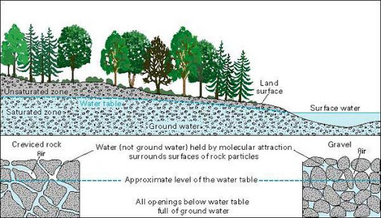

“Rainwater Harvesting” be linked to ground water sustainability
Can be linked in following ways:
- Rainwater harvesting helps ground water sustainability by supplying usable water to consumers during a crisis period, recharging the groundwater and finally reducing the runoff and water logging during the season of heavy rainfall.
- Using rainwater for irrigation and for various other purposes, it means that we are storing water for future uses.
- To reduce the consumption of groundwater, many people around the world are using rainwater harvesting systems.
- The surplus rainwater can be used recharge ground water through artificial recharge techniques, as it is free from pollutants as well as salts, minerals, and other natural and man-made contaminants.
- Reduces Demand on Ground Water with increase in population, the demand for water is also continuously increasing.
- Rain water harvesting is linked to ground water sustainability in the form of the rain water is collected in to the natural reservoir or the infiltration of surface water into subsurface aquifers and this water then found as ground water sustainability
Quality Parameters considered in designing water supply system
Protecting and maintaining water distributions systems is crucial to ensuring high quality drinking water. Distribution systems carry drinking water from a centralized treatment plant or well supplies to consumers’ taps. Broad range of water quality parameters are monitored with main parameters, recorded as pH, alkalinity, salinity, turbidity, nutrients, chlorophyll and metals (aluminum and iron);

- PH is an indicator of acidity or alkalinity. Neutral water has a pH of 7, acidic solutions have values between 0-6 and alkaline solutions have values between 8-14.

- Alkalinity is a measure of the water buffering capacity, or the water's ability to neutralize acids and resist pH. The addition of limestone adds alkalinity to water, helping to neutralize any acid released from the sediments.

- Chlorides are salts often present in areas of urban development. Chlorides in water usually occur as a result of the use of water softeners, road salt, and drainage of swimming pools.
- Turbidity is a measure of the cloudiness or haziness in water caused by suspended solids. Turbidity is expressed in Nephelometric Turbidity Units (NTU) and is measured using a relationship of light reflected from a given sample.

