DENTAL SEC B PHYSIOLOGY, 2ND SEMESTER
MAM KOUSAR SHAH JEHAN
STUDENT NAME_Amjad khan___________ , ID__16976___________
Attempt all questions. Every question carry 10 marks.
Q1. Write the functions and composition of blood?
Ans blood
Blood is body fluid and human and other animal that deliver necessary substance such as nutrient and oxygen to the cell and transport and metabolic waste product away from those cell in vertebrate it is composed of blood cell suspended in blood plasma
composition of blood
blood consist of
liquid plasma (valume 55-60%)
formed element(volume 40-45%)
Blood is classified is a connective tissue and consist of two main component
Plasma which is clear extra cellular fluid formed element which are mad of blood cell and platelets
Formed element are.
Erythrocyte’s .also known as red blood cells RBC
Leukocytes also known as white blood cell WBCs
Functions of blood

BloodBlood has three main functions: transport, protection and regulation.

Transport

The blood carries the following substances.
The gases, namely oxygen (O2) and carbon dioxide (CO2), between the lungs and the rest of the body
tive Nutrients from the digestive and storage areas to the rest of the body
* Liver and kidney waste products should be detoxified or removed
The hormones from the glands in which they are made in their target cells
warm the skin to help regulate body temperature

Protection

Blood has several roles in inflammation:
Leukocytes, or white blood cells, kill invading microorganisms and cancer cells
* Antibodies and other proteins eliminate pathogenic substances
Platelet factors begin to clot and help minimize anemia

Regulation
Helps control blood:
ids pH by interacting with acids and bases
Water balance in tissues and by transferring water

Q2. What is erythrocyte, erythropoiesis, erythrocytosis and erythropenia?
Ans erythrocyte
A cell that contain hemoglobin and carry oxygen to the body also called red blood cell RBC .THE RIDISH COLOULAR IS ERYTHROCYTE are bio concave shape ,which increase the cell surface of area and faculties the diffusion of oxygen and corbondioxide
Erythropoiesis
The formation of red blood cell in blood forming tissue in the early tissue of fetaus , erythoposis take place in the yolk sac ,spleen ,and liver after birth ,all eruthroposis occur in the bone marrow
Erythrocytosis
Also known as polycythemia refer to in increase in red blood cell mass it can be relatives or obsilitive . in relative polycythemia there is increase in plasma volume it making it appear that there is in increase in red blood cell.
Ertheropenia
The defiency of red blood cell (RBC)
Q3. What is platelets and write about clotting mechanism and its all steps?
Ans platelets
Are thrombocyte are small collarless cell fragments in our body that from clot and stop or prevent bleeding . platelets are mad in our bone marrow the spongy like tissue in side bone .bone marrow contain steam cell that developed in to red blood cell ,white blood cell platelets
Clothing mechanism
Coagulation also known as clothing is the process by which change blood change a liquid to a get a forming a blood clot . the mechanism of coagulation involve action adhesion and aggregation of platelets as well as deposition and maturation
Step of blood clot mechanism
- injury
- vessel constriction
- platelet plug
- fibrin clot

Q4. Write a note on ABO system?
Ans BLOOD
Blood type (also called blood group) is a blood classification based on the presence or absence of inherited antigenic substances (proteins) on the surface of red blood cells (RBCs).
Blood types are inherited and represent the partnership of both parents
The two most important ones are the ABO and RH antigen systems, they determine the status of one's blood type (A, B, AB and O + + with + or - Null RhD). Rhesus element level Is an inherited protein (found in red blood cells). If you have protein in your blood, you are Rh positive. If you are deficient in protein in your blood then you are Rh negative
ABO SYSTEM
O 47%
A 41%
B 9%
AB 3%

By Dr. Carl Landsteiner 1900
Inherited from parents
Based on A and B antigens-Agglutinogens
May be,
none of these
One of them
Both of them
agglutinugen
Agglutinogens on the surface of
Agglutinins in blood plasma
May cause blood transfusions
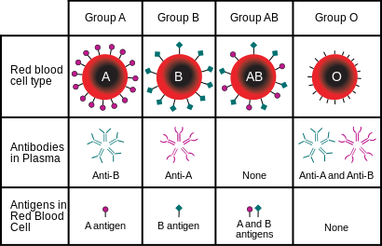

Role of blood groups in blood transfusion

If there is no match, then hemolysis
Blood typing is mandatory

Blood transfusion
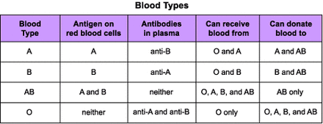

Complications of blood transfusion with reference to ABO incompatibility
Similar blood. Anti-A plasma agglutinins were transferred from A Aglutinogen, ie blood group A, to blood group B with RBC
The agglutinins have bound sites; the agglutinins attach themselves to the RBC antigen ◊ aggregation ◊ hemolysis
- Acute hemolysis
- Jaundice
- Kidney shutdown
Q5A )a person fell dawn formed a tree and become unconscious with bleeding from head , what will do you at a first kid
ANS Stirring is a type of brain injury (or mild TBI). This is when the head moves back and forth with great force due to a blow or injury to the head. It causes chemical changes in the brain and sometimes damages brain cells.
Children and adolescents who follow their healthcare provider's recommendations usually feel better within a few weeks of hesitation.
.

What Are the Signs & Symptoms of a Concussion?
Someone who is hesitant can be knocked down (this is called losing consciousness). But one does not have to be hesitant.
Signs and symptoms of a commotion include:
• Headache
* Blurred vision or double vision
* Dizziness, difficulty balancing or difficulty walking
• Confusion and things that are not understood
Demonstration of slowness in answering questions
• Ambiguous speech
ause nausea or vomiting
can't remember what happened
• not feeling well
Symptoms of melancholy usually immediately. Occurs, but also appears hours or days after an injury. Conflicting youth:
ing Difficulty concentrating
learning is a learning or memory problem
a Headache that gets worse
Sleep is a problem
sad Feeling sad, easily upset or angry, or nervous

Q5 B) you have meet with a friend and you come to know he is covid positive , what precaution measure will you take
- Ans Close contact with each other

- Through a drop of breath produced by a lazy person's cough
Wash your hands
Avoid close contact
Monitor your health
Cover up coughing and sneezing
Cover your mouth and nose with a face mask

THE END

