Ali Hussain Arbab
MS electrical 11391
Analog and digital communication
23-6-2020

Final Exam

Q4. (a) Explain the concept of non-linear modulators and its types in the generation of DSB-SC Signals.

Nonlinear Modulators:
Modulation can also be achieved by non linear devices like diodes or transistors. Below is the figure of one possibility of such scheme, here we are using 2 identical non-linear elements shown by boxes NL.
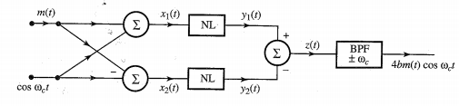

Let the Let the i/p - o/p characteristics of either of the non linear elements be approximated by a power series:
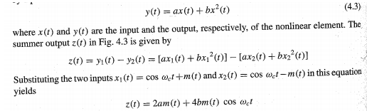
The septum of m(t) is centered at the origin. Whereas the spectrum of m(t)cos Wct is centerd at +/-Wc.
consequently, when z(t) is passed through a band pass filter tuned to Wc, the signal am(t) is suppressed and the desired modulated signal 4bm(t)cos wc t passes through unharmed.
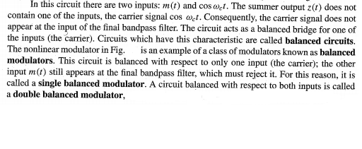
==> As for the types of non linear modulators, given below is a switching modulator which is known as Ring Modulator:

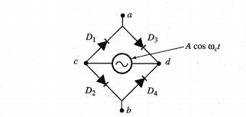
Positive half cycle ---- D1 D3 conducts, other two diodes Open
Negative half cycle ---- D2 D4 conducts, other two diodes Open

Hence
The o/p is equal to m(t) during positive half cycle and to -m(t) during negative half cycle
In effect, m(t) is multiplied by a square pulse train Wo(t).

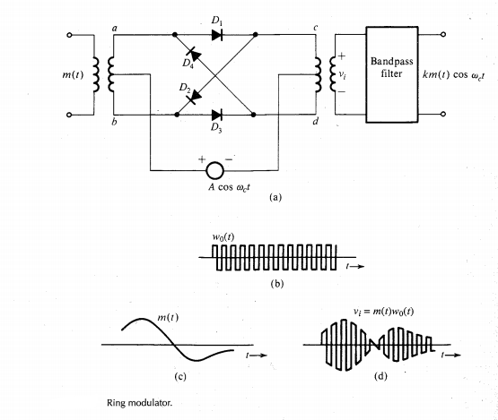
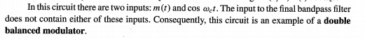
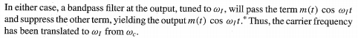

Q4. (b) Explain the process of Demodulation of AM signals. Explain each type along with its diagram.

Demodulation of AM Signals:
The AM signal can be demodulated coherently by a locally generated carrier

However, coherent, or synchronous, demodulation of AM will defeat the very purpose of AM and, hence, is rarely used in practice. We shall consider here two noncoherent methods of AM demodulation: (1) rectifier detection, and (2) envelope detection.

Rectifier Detector:
If an AM signal is applied to a diode and a resistor circuit as shown below
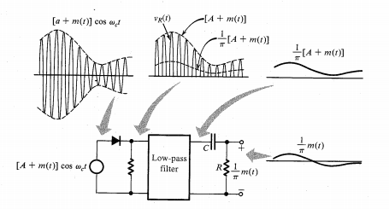

The negative part of the AM wave will be suppressed. The output across the resistor is a half-wave rectified version of the AM signal. In essence, the AM signal is multiplied by w(t). Hence, the rectified output is
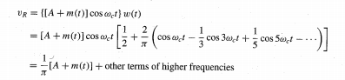

When V_{R} is applied to a low-pass filter of cutoff B Hz. the output is [A + m(t)] /π, and all the other terms in V_{R} of frequencies higher than B Hz are suppressed. The dc term A/π may be blocked by a capacitor C, to give the desired output m(t)/π. The output can be doubled by using a full-wave rectifier.
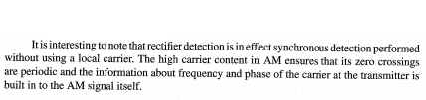

Q2. (a) Explain along with the diagram the concept of equalizers in regenerative repeaters.

Regenerative Repeater:
Basically, a regenerative repeater performs three functions:
(1) Reshaping incoming pulses by means of an equalizer
(2) The extraction of timing information required to sample incoming pulses at optimum instants
(3) Decision making based on the pulse samples

The schematic of a repeater is shown below.
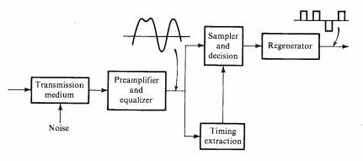

Equalizer:
A pulse train is attenuated and distorted by the transmission medium. The distortion is in the form of dispersion, which is caused by an attenuation of high-frequency components of the pulse train.
Theoretically, an equalizer should have a "frequency characteristic" that is the inverse of that of the transmission medium.
This will restore higher frequency components and eliminate pulse dispersion. Unfortunately, this also increases the received channel noise by boosting its high-frequency components. For digital signals, however, complete equalization is really not necessary, because a detector has to make relatively simple decisions-such as whether the pulse is positive or negative (or whether the pulse is present or absent).
Therefore, considerable pulse dispersion can be tolerated. Pulse dispersion results in ISI and the consequent increase in detection error probability. Noise increase resulting from the equalizer (which boosts the high frequencies) also increases the detection error probability. For this reason, the design of an optimum equalizer involves an inevitable compromise between reducing ISI (inter symbol interference) and reducing the channel noise. A judicious choice of the equalization characteristics is a central feature of all digital communication systems.

Q2. (b) How QAM systems are used in digital communication system. Explain along with the QAM architecture.

Digital Signal Transmission Using Quadrature amplitude modulation (QAM):
We can conveniently use QAM for digital signals as well. Figure below shows the QAM modulator and demodulator. Each of the signals m (1) and m2(t) is a baseband binary polar pulse sequence.
These signals are modulated by a carrier of the same frequency but in phase quadrature. We can transmit and receive both of these signals on the same channel, thus doubling the transmission rate.
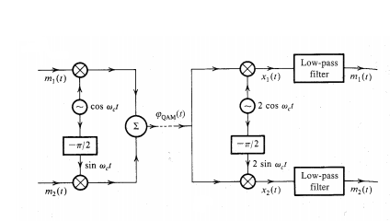

M-ary QAM
We can increase the transmission rate further by using M-ary QAM.
One practical case with M = 16 uses the following 16 pulses (16 symbols):

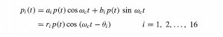

Where

And p(t) is a properly shaped baseband pulse.
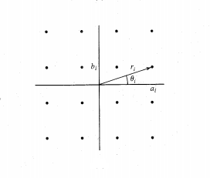
The signal p_{i} (t) can be generated using QAM by letting m₁ (t) = a_{i} p(t) and m₂(t) = b_{i} p(t).

One possible choice of r_{i} and θ_{i}, for 16 pulses is shown graphically in above figure. The transmitted pulse p_{i} (t) can take on 16 distinct forms and is, therefore, a 16-ary pulse.
Since M = 16, each pulse can transmit the information of log₂ 16 = 4 binary digits.
This can be done as follows: There are 16 possible sequences of four binary digits and there are 16 combinations (a_{i} , b_{i}) in Figure above. Thus, every possible 4-bit sequence is transmitted by a particular (ai, bi) or (ri, θ_{i}).
Therefore, one signal pulse ri p(t) cos (w_{c}t-θ_{i}) transmits 4 bits. The bit rate is quadrupled without increasing the bandwidth. The transmission rate can be increased further by increasing the value of M.

Modulation as well as demodulation can be performed by using the same system shown above. The inputs are m₁(t) = a_{i} p(t) and m₂(t) = b_{i} p(t). The two outputs at the demodulator are a_{i} p(t) and b_{i} p(t). And from the knowledge of (a_{i} , b_{i}), we can determine the four transmitted bits.
Such a QAM scheme is used on telephone lines for data transmission. At each end of the telephone line, we need a modulator and a demodulator to transmit as well as to receive data. The two devices, modulator and demodulator, is usually packaged in one unit called a modem.

Q1. (a) How a Line Coder and Regenerative Repeater plays a role in digital communication system. Explain in detail

Line Coder:
The output of a "multiplexer" is coded into electrical pulses or waveforms for the purpose transmission over the channel. This process is called line coding or transmission coding.

There are many possible ways of assigning waveforms (pulses) to the digital data.

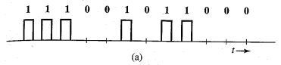
In the binary case (two symbols), for example, conceptually the simplest line code is on-off, where al is transmitted by a pulse p(t) and a 0 is transmitted by no pulse (zero signal), as shown in Fig. 7.1a
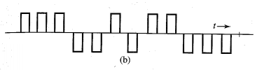
Another commonly used code is polar, where 1 is transmitted by a pulse p(t) and is transmitted by a pulse -p(t) (Fig. 7.1b). The polar scheme is the most power efficient code, because for a given noise immunity (error probability) this code requires the least power.
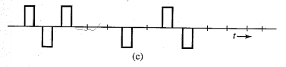
Another popular code in PCM is bipolar, also known as pseudoternary or alternate mark inversion (AMI), where 0 is encoded by no pulse and 1 is encoded by a pulse p(t) or-p(t) depending on whether the previous 1 is encoded by-p(1) or p(t). In short, pulses representing consecutive 1's alternate in sign, as shown in Fig. 7.1c. This code has the advantage that if an error is made in the detecting of pulses, the received pulse sequence will violate the bipolar rule and the error is immediately detected (although not corrected).
In our discussion so far, we have used half-width pulses just for the sake of illustration. We elect other widths. Also full-width pulses are often used in some applications. Whenever full-width pulses are used, the pulse amplitude is held to a constant value throughout the pulse Interval (it does not have a chance to go to zero before the next pulse begins). For this reason these schemes are called nonreturn-to-zero (NRZ) schemes in contrast to return-to-zero (RZ) schemes (Fig. 7.1a, b, and c).
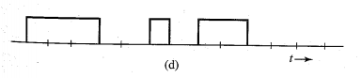
Figure 7.1d shows an on-off NRZ signal
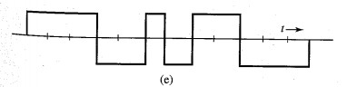
Whereas Fig. 7.1e shows a polar NRZ signal.

Regenerative Repeater:
Regenerative repeaters are used at regularly spaced intervals along a digital transmission line to detect the incoming digital signal and regenerate new clean pulses for further transmission along the line. This process periodically eliminates, and thereby combats, the accumulation of noise and signal distortion along the transmission path.

If pulses transition rate = R_{b} pulses/second,
we require clock signal at R_{b} Hz To sample the incoming pulses at a repeater.
This timing information can be extracted from the received signal itself if the line code is chosen properly.

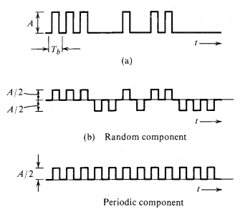

The polar signal in Fig.7.1b, for example, when rectified, results in a periodic signal of clock frequency R_{b} Hz, which contains the desired periodic timing signal of frequency R_{b} Hz. When this signal is applied to a resonant circuit tuned to frequency R_{b}, the output, which is a sinusoid of frequency R Hz, can be used for timing. The on-off signal can be expressed as the sum of a periodic signal (of clock frequency) and a polar signal, as shown in Fig. 7.2. Because of the presence of the periodic component, we can extract the timing information from this signal using a resonant circuit tuned to the clock frequency. A bipolar signal, when rectified, becomes an on-off signal Hence, its timing information can be extracted the same way as that for an on-off signal

The timing signal (the resonant circuit output) is sensitive to the incoming bit pattern. In the on-off or bipolar case, a 0 is transmitted by "no pulse." Hence, if there are too many O's in a sequence (no pulses), there is no signal at the input of the resonant circuit and the sinusoidal output of the resonant circuit starts decaying, thus causing error in the timing information.
A line code in which the bit pattern does not affect the accuracy of the timing information is said to be a transparent line code. The polar scheme (where each bit is transmitted by some pulse) is transparent, whereas the on-off and bipolar schemes are nontransparent.

Q1. (b) Derive a mathematical expression used to find the Power Spectral Density of different line coders used in digital communication systems

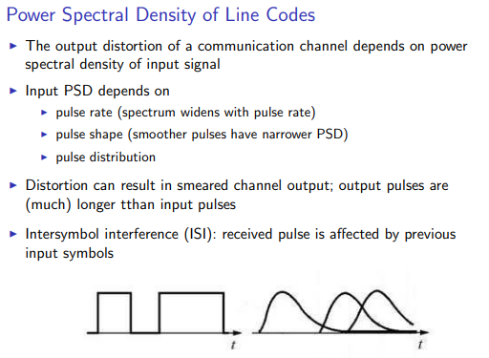
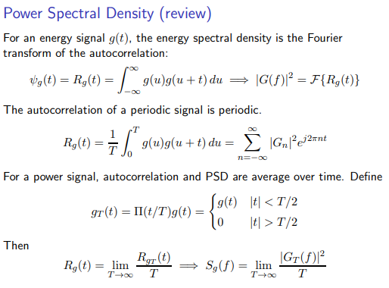
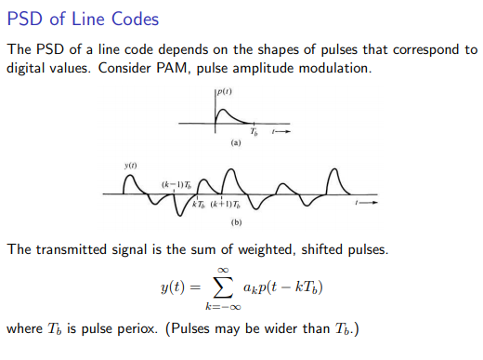
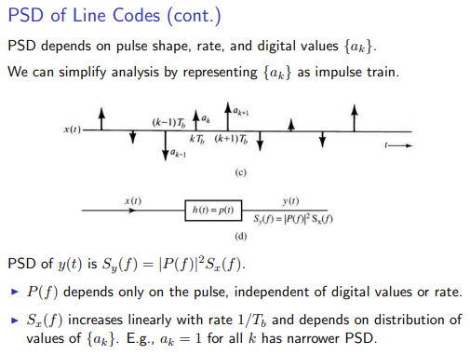
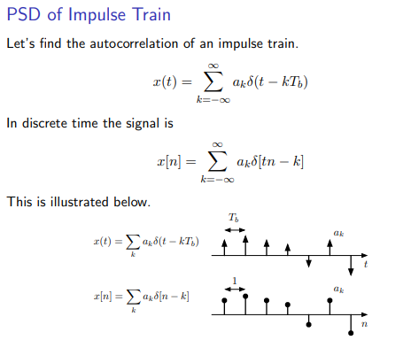
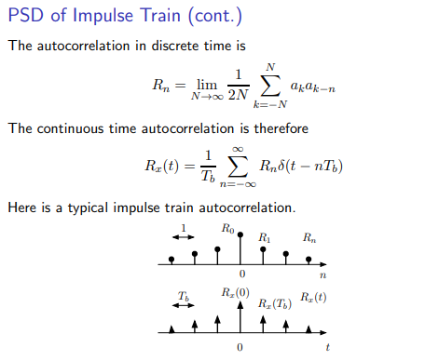
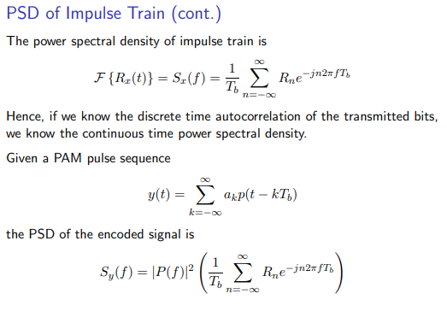
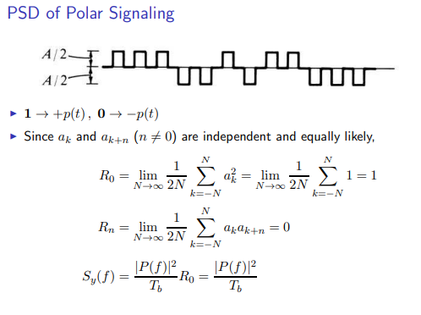
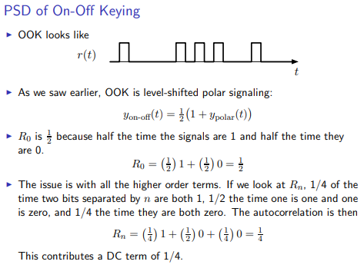
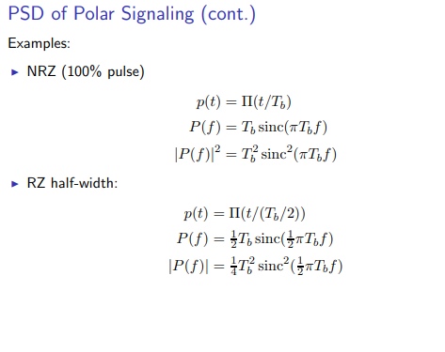
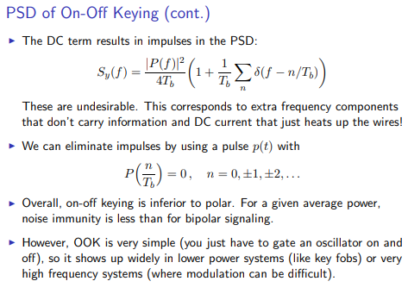

Q3. (a) For (6,3) code, the generator matrix G is
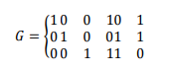

For all eight possible data words.
i. Find the correspond code words and verify that this code is a single error Correcting code.
ii. If the receiver receives r = 100011. Determine the corresponding data word if the channel is BSC and the maximum likelihood decision is used

Solution: (i)
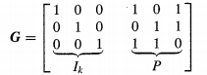

Using c = dG we get
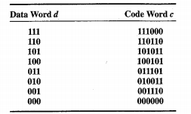

as distance b/w any two code words is at least "three",
so the code can at least correct ONE error !

Solution: (ii)
Syndrome vector (s) : s = r H^{T}
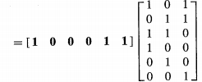

bcoz for modulo-2 operation,
Subtraction is the same as Addition; the correct transmitted code word c is given by
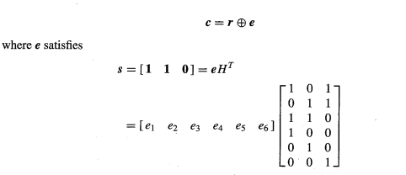
Code word c
Received word r
Error word e
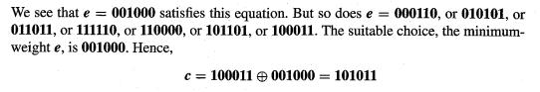

Q3. (b) Construct a systematic (7,4) cyclic code using a generator polynomial g(x) = x3+x2+1 using the data vector d = 1010.

Solution:
We can find the code word directly by Equation

Using the code generator matrix G we can construct our requred table. We compute the code words corresponding to the data words 1000, 0100, 0010, 0001. These are 1000110 0100011, 0010111, 0001101. as recognizing that these four code words are the four row of G. This is because c = dG, and when d = 1000, dG is the first row of G, and so on.

Hence,
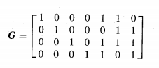

Now, we can construct the rest of the code table using e dG. This is an efficient method because it allows us to construct the entire code table from the knowledge of only n code words.
