NAME = M.ASHRAF
ID = 15240
SUBJECT= BUSINESS MATHEMATHICS
TECHER= DR LIAQAT ALI
EXAM = SUMMER PAPER
PROGRAM = BBA

QUESTION: 1 AND 2
ANSWER:
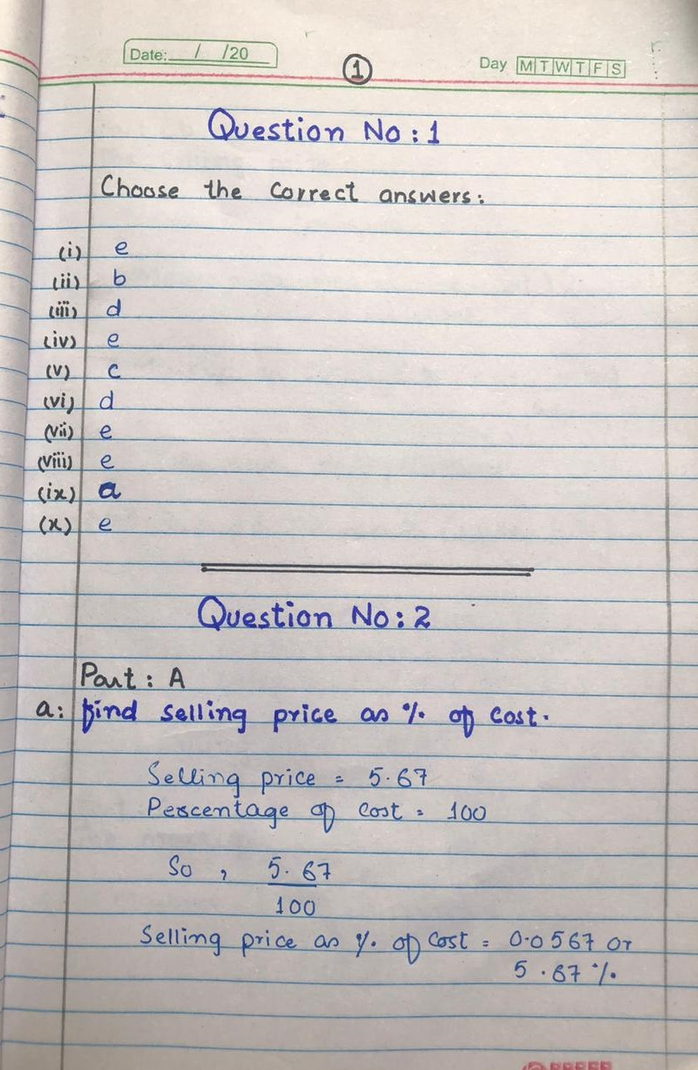

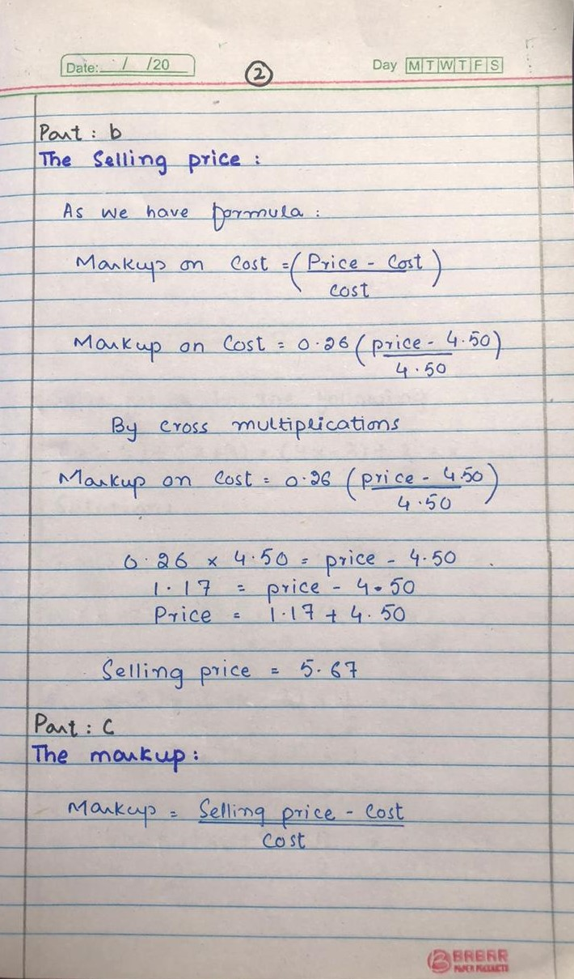

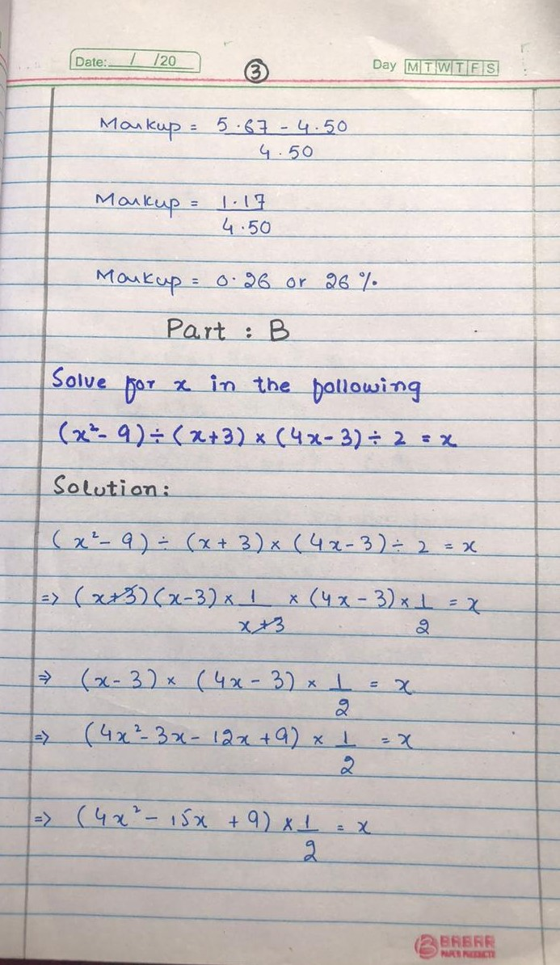

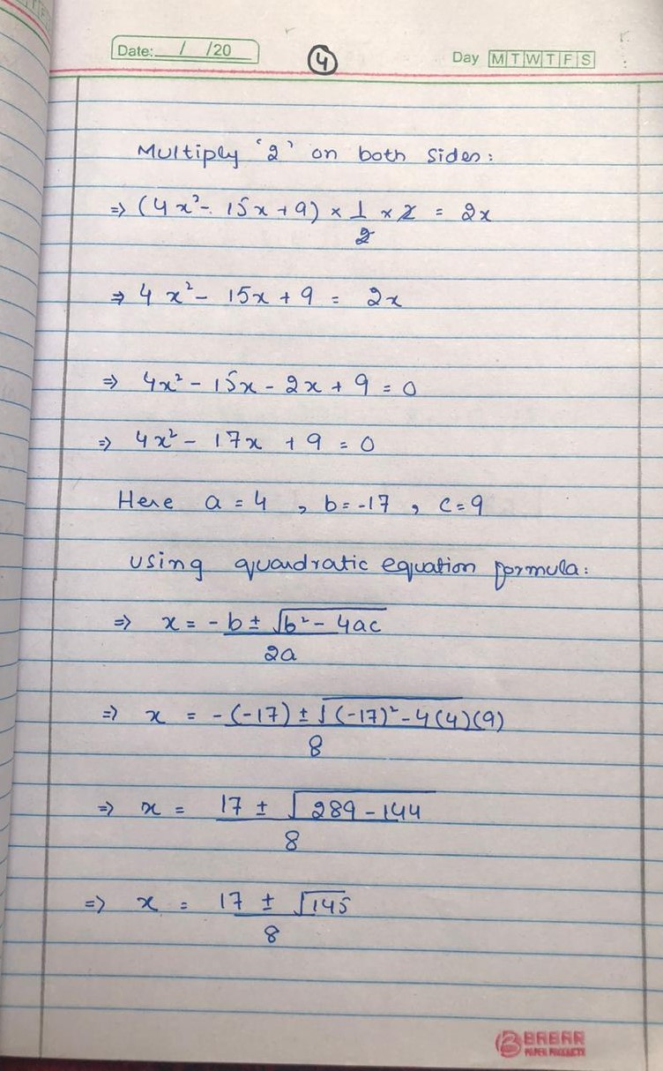

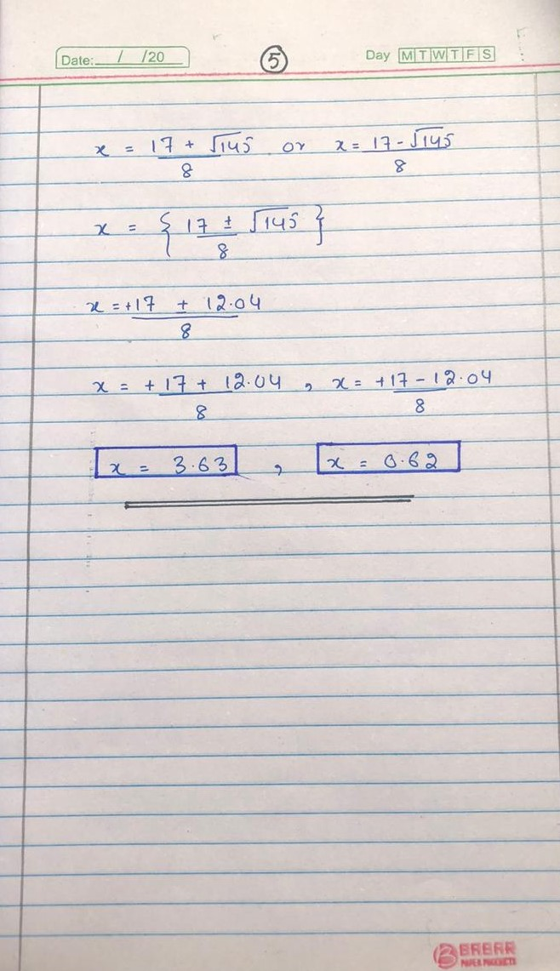

QUESTION NO 3: (a) The sum of the ages of a girl and her brother is 60 years. Two years ago her age was three times the age of her brother. Find the present age of girl and her brother.
- Selling price = $18.75
Cost = $15
Markup based on cost = ?
Percent markup based on cost = ?

ANSWER:
