HISTORY OF ARCHITECTURE
ISLAMIC ARCHITECTURE
(ANDALUSIAN STYLE)
(16083)

Islamic Architecture:
Islamic architecture consists of architecture of styles comprising a building related with Islam. Such as the picture below which is a mosque built according to Islamic architecture.

Andalusian architecture:
The muslim ruled areas of the past including AL-Andulas and Iberian Peninsula have some of the most beautiful and remarkable and unique places including mosques, minarets, fortresses in the continent of Europe. The architecture of andalusian style is considered a beauty and unique architecture in the continent. The Islamic architecture of Spain heritage in the time (711 till 1492AD) was astonishing and beautiful. It is a fact that the time of Andalusia is gone but its historical architecture is still present in the drawings and pictures.

TIMELINE;
The total timeline of the andalusian architecture is 711 to 1492 AD, it consists of many different stages as shown below;
- MOORISH ARCHITECTURE FROM (8 TO 15TH c);
The Moors were the muslims living in the Iberian peninsula, sicily and malta in the middle ages, this term was also used for the muslims in general that used to live in north Africa or spain in the past. The moors used to decorate the interior of the buildings with the most luxurious decorations and the designs made by moors were based on calligraphy geometry and plant designs. The moors made wide and extensive use of horseshoe arch, that can be clearly seen in their works. The great and amazing works that are made by moors are still preserved and their architecture can still be seen in Spain that is in Andalusia. During the period of pre caliphate the architecture of Moorish came under light, in which the great cordoba mosque was extended and beautified by adding ornamental decorations and arches and the arch had a very decorative kind of look and the calligraphy was used as an ornamental work which was an important part of the architecture.
- POST MOORISH OR MUDEJAR ARCHITECTURE FROM (MID 14TH TO LATE 15TH c);
After the muslims were driven and taken their power from, andalusians continued to build churches on the places where there were mosques. The materials that they used to build and decorate these churches were ornamental brickwork, roof tiles and archways. After the reconquista, the muslims who stayed created a new and unique style of architecture called or known as mudejar, these mudejares mean the people referred to as ‘those who were permitted to stay’ were employed on making and building new churches and also palaces on the territories that were reconquered in the conquest, because the mudejares were very good builders. The architecture of these mudejares had a unique style example of which is Salon de Embajadores in Alcazar at Seville. At that time not all of the architecture after the reconquista was mudejar as the style used firstly was Romanesque by the Catholic Andalusia.

LOCATION;
Andalusian architecture is located in Iberian Peninsula, in Al-Andalus, where the muslims of the past ruled.

FEATURES OF ANDALUSIAN ARCHITECTURE;
Andalusia as we know that it is located in a very hot region, and the people living there have religious background which we know from their history. A typical and common feature of the andalusian architecture is that their walls are built as shared wall, this is done so as to lower the heat intensity because of the higher temperatures in Andalusia. Another important feature is that the exterior or the outside of their walls are covered with lime which doesn’t allow the heat to enter and keeps it out. Andalusian architecture is also well known for its decorations which consists of painted ceramic tiles, luxurious landscaping and wrought iron gratings. The most common features of the andalusian architecture were domes, minarets and arches and their decorations.

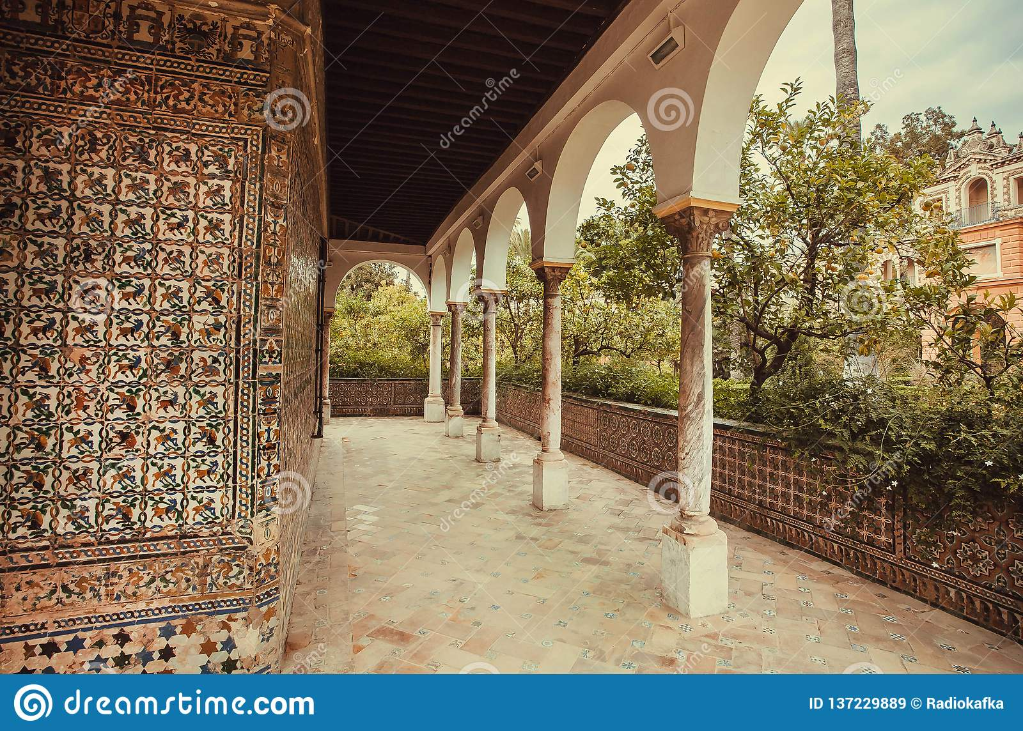
This picture above clearly shows the decorative features of andalusian architecture.
MATERIALS USED IN ANDALUSIAN ARCHITECTURE;
The materials used in andalusian architecture were ceramic tiles, brickwork, lime, ornaments, clay, tile, plaster, and wood etc.

FORM OF BUILDINGS (HOUSES);
The houses or buildings in Andalusia had patios or courtyards which were made of stone and they were built in order to have open and wide spaces in the centre that they used to beautify and decorate with plants, flowers and greenery because they considered it as a custom to decorate to beautify their houses with greenery and flowers followed by fountains, ponds, wells, and fountains. Other decorative also came but they came later on. And with the passage of time as times moved on and things begun to evolve and with trends came the fences, windows, balconies etc for the view.

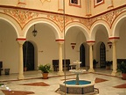

THE GREAT MOSQUE OF CORDOBA:
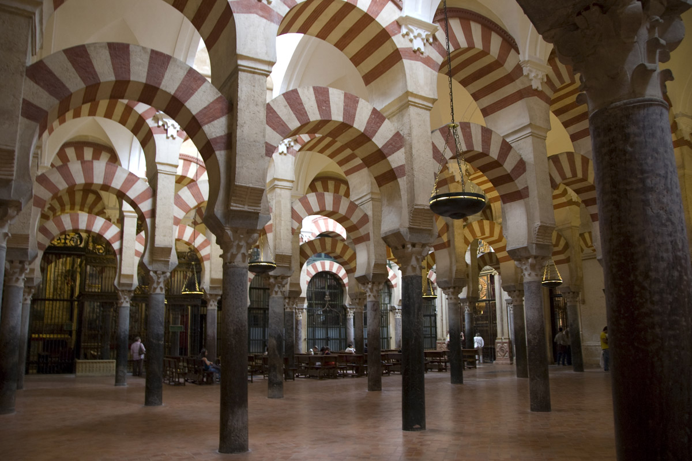
The great mosque of Cordoba is also locally known as Mezquita-Catedral, which is one of the most old structures of AL-Andulas and still remains standing. The muslim caliphs in the past when took rule, the first thing that they did was to build and construct a grand mosque and the mosque of Cordoba is one those actions. This mosque was build in 787 by Abdurrahman the caliph at that time, its costruction continued for years because it was grand mosque to construct and each succeeding caliph which came after the caliph Abdurrahman added their contribution to the construction of the mosque, and it was built so amazingly that it held harmony as if it was built at once. This mosque of Cordoba introduced many architectural techniques that became a significant part of the architecture of Andulas.
ALCAZABA OF MALAGA:
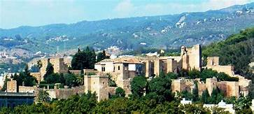.
Alcazaba of Malaga is a citadel in spain preserved from the past which was built by the dynasty of Hammudid in early 11th century. It is a big fortification with double walls and huge entry, this fort or citadel is known to be a military architecture in the period of Taifa. It has a very beautiful location because of the overlooking view it has of the city and water bank. It has well organized pools and gardens which increases its beauty.

END

