Final-Term Assignment

Course Title: Human Physiology II
Rad 2nd semester section A
Instructor: Dr. M .Shahzeb khan (PT)
Marks: 50
Name: Maham Raza
Id no: 16749

Note:
- Attempt all questions, all questions carry equal marks.
- Answer Briefly and to the point, avoid un-necessary details

Q1: (A) How stimulus of smell moves from nostril to brain? Make a Diagram as well

Q 2: (A) What is difference between Haemostasis, Haematopoiesis and Homeostasis?
(B) What is Erythroblastosis fetalis?

Q3: (A) What is Immunity? Explain different types of immunity
(B) What is difference between Antigen and Antibody?

Q4: (A) Write down different functions of Antibody
(B) Write difference between Primary and secondary response to an antigen

Q5: Write difference between cell mediated and Antibody Mediated Immunity

ANSWER #1:
HOW STIMULUL OF SMELL MOVES FROM NOSTRILS TO THE BRAIN:
Olfactory cells in the mucous membranes lining each nostril react to chemicals, we breath in and send messages along specific nerves to the brain. The stimulus of smell moves from nostril to the brain by the following process.
Working/Physiology:
- Like the sense of taste it’s a chemical sense
- They are called chemical senses because they detect chemicals in the environment
- 1) Vaporized odor molecules (chemicals) floating in the air reach the nostrils and dissolve in the mucus (which is on the roof of each nostril)
- 2) Underneath the mucus, in the olfactory epithelium, specialized receptor cells called olfactory receptor neuron detect the odor
- The neurons are capable of detecting thousands of different odors
- 3) The olfactory receptor neurons transmit the information to the olfactory bulbs, which are located at the back of the nose
- 4) From the olfactory bulb the sensations are carried through olfactory tract to olfactory area in the temporal lobe of cerebral cortex
- 5) These brain centers perceives odors and access memories to remind us about people, places or events associated with these olfactory sensations.
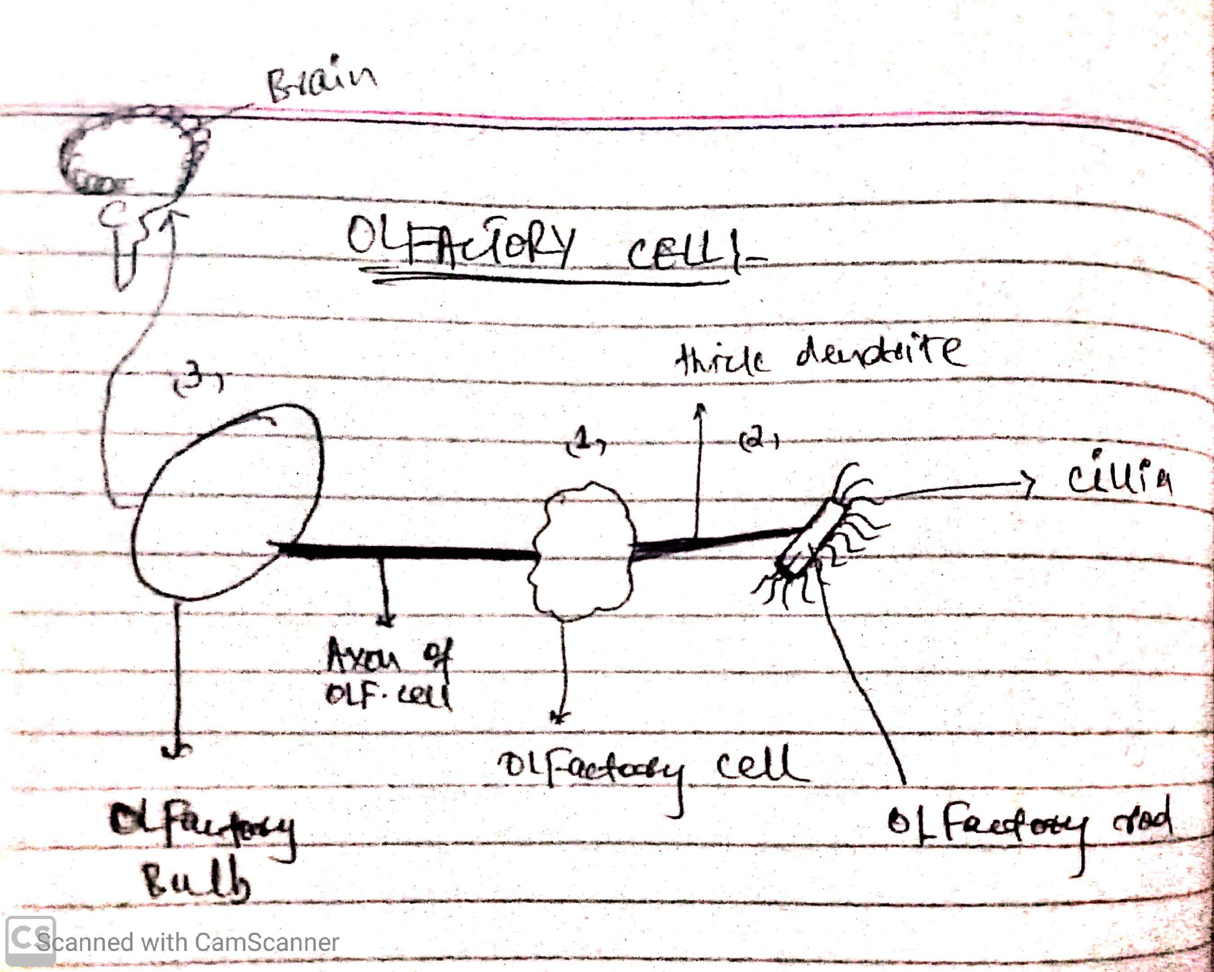
Diagram:

ANSWER #2:
PART A:
DIFFERENCE BETWEEN HAEMOSTASIS, HAEMOTOPOISES AND HOMEOSTASIS:
Haemostasis | Haematopoiesis | Homeostasis
It is defined as arrest or stoppage of bleeding. | The process of formation of blood cells i.e RBCs, WBCs and platelets is called as haematopoiesis. | Homeostasis refers to the body ability to maintain a stable internal environment.
When a blood vessel is injured the injury initiates the series of reactions resulting in haemostasis | Cells responsible to do function of haematopoiesis are first seen in yolk sac of embryo in third week of embryonic development and these cells are called haematopoiesis stem cell. | Homeostasis controls regulating hormones, body temperature and water balance etc.  Homeostasis controls mechanism at three components.
Stages of haemostasis  - Vasoconstriction  - Platelet plug formation  - Coagulation of blood | The site where it occur is known as haematopoietic tissue or organ (bone marrow, liver and spleen) | Components of homeostasis are;  - Receptor  - Integrating center  - Effector

PART B:
ERYTHROBLASTASIS FETALIS:
Definition:
It is the disease of the foetus and new born child characterized by agglutination and phagocytosis of the foetus’s red blood cell.
OR
It is a hemolytic anaemia in the foetus or neonate caused by trans-placental transmission of maternal antibodies to foetal RBCs. The disorder usually results from incompatibility between maternal and foetal blood groups, often Rh antigen.
Symptoms and signs in the fetus:
- Enlarge liver, spleen or heart
- Fluid build up in the fetus’ abdomen seen via ultrasound
Symptoms and signs in newborn:
- Anemia that creates the newborn pallor (pale appearance)
- Jaundice or yellow discoloration of the newborn’s skin
- Enlargement of the newborn’s liver and spleen
- Severe edema of the entire body
- Dyspnea or difficulty breathing

ANSWER #3
PART A:
IMMUNITY:
Resistance exhibited by the host against any foreign antigen and towards injury caused by microorganisms and their products .
OR
Immunity is the ability of the body to protect against all types of foreign bodies like bacteria, virus, toxic substances etc which enter the body.
Human immunity:
Human immunity is divided into two types
- Innate immunity
- Acquired immunity
Innate immunity:
It is also called natural or native immunity consist of mechanisms that exist before infections and are capable of rapid responses to microbes.
Types:
- Species immunity
- Racial immunity
- Individual immunity
Acquired immunity:
Acquired or adaptive immunity is the immunity that is developed by the host in its body after exposure to suitable antigen or after transfer of antibodies or lymphocytes from an immune donor.
Types:
- Active immunity
- Passive immunity
PART B:
DIFFERENCE BETWEEN ANTIGEN AND ANTIBODY:
Antigens | Antibodies
Antigens are substances that induce a specific immune response and subsequently react with the product of specific immune response. | These are substances which are formed in the serum and tissue fluids in response to an antigen and react with that antigen specifically and in some observable manner.
An antigen is a molecule that stimulate immune response. | Chemically they are globulins, hence they are named immunoglobulin.
Or an antigen is a substance which when introduce into a body evokes an immune response to produce a specific antibody with which it react specifically. | They constitute about 20-26% of the total serum protein and are mainly synthesized by plasma cells.

ANSWER #4:
PART A:
ANTIBODY:
An antibody, also known as an immunoglobulin, is a large, Y-shaped protein produced mainly by plasma cells that is used by the immune system to neutralize pathogens such as pathogenic bacteria and viruses.
OR
These are substances which are formed in the serum and tissue, fluids in response to an antigen and react with that antigen specifically and in some observable manner.
Functions:
Major functions of the antibodies are;
- Neutralization of infectivity,
- Phagocytosis,
- Antibody-dependent cellular cytotoxicity (ADCC) (whereby an effector cell of the immune system actively lyses a target cell, whose membrane-surface antigens have been bound by specific antibodies).
- Complement-mediated lysis of pathogens or of infected cells: Antibodies activate the complement system to destroy bacterial cells by lysis
- ADCC is independent of the immune complement system that also lyses targets but does not require any other cell. ADCC requires an effector cell which classically is known to be natural killer (NK) cells
PART B:
PRIMARY RESPONSE TO AN ANTIGEN:
The primary immune response occurs when an antigen comes in contact to the immune system for the first time. During this time the immune system has to learn to recognize antigen and how to make antibody against it and eventually produce memory lymphocytes. Primary response is the immune response of the body to new antigens.

SECONDARY RESPONSE TO AN ANTIGEN:
The secondary immune response occurs when the second time (3rd, 4th, etc.) the person is exposed to the same antigen. At this point immunological memory has been established and the immune system can start making antibodies immediately.
DIFFERENCE BETWEEN PRIMARY AND SECONDARY RESPONSE TO AN ANTIGEN:
1° immune response | 2° immune response
The amount of antibody produce is usually relatively low. | The amount of antibody produce rises to a high level.
Ove time, antibody level declines to the point where it may be undetectable. | Antibody level tends to remain high for longer.
The first antibody produced is mainly IgM. | The main type of antibody produced is IgG.
Long lag phase and low titre of antibody. | Short or negligible lag phase.
Slow, sluggish and short lived. | Prompt, powerful and prolonged
It takes longer time to establish immunity. | Take shorter time to establish immunity.
Primary response appears mainly in the lymph nodes and spleen. | Secondary response appears mainly in the bone marrow, followed by the spleen and lymph nodes.

ANSWER #5:
DIFFERENCE BETWEEN CELL MEDIATED AND ANTIBODY MEDIATED IMMUNITY:
Cell mediated immunity | Antibody mediated immunity
Cell mediated immunity is second line of defence | It comes in third line of defence
This is main defence against intracellular bacteria | Main defence against extracellular encapsulated pyogenic bacteria like staphylococci and streptococci.
Examples are;  - Mycobacterium tuberculosis enters the body  - Ingested by microphages | Antibody synthesis typically involve the cooperation of three cells  - Macrophages  - Helper T cells  - B cells
Bacterium broken down and fragment of it called antigen or epitopes appear on surface of macrophage in association with class II Major Histocompatibility complex (MCH) PROTEIN. | After processing by macrophages, fragements of antigen appear on surface of macrophage in association with class II MHC protein.
The antigen-class II MCH protein complex interact with an antigen specific receptor on surface of helper T lymphocyte. | The antigen-class II MCH protein complex binds to specific receptor om surface of helper T cell which then produce Interlukins 2, 4,5
Activation and clonal proliferation of this antigen-specific helper T cell occur as result of the production of interleukins, the most important of which are interleukin I and II | These factors activate the B cell capable of producing antibodies specific for that antigen.  The activated B cell proliferates and differentiates to form many plasma cells that secrete large amounts of immunoglobulins ( antibody)
These activated helper T cell, aided by activated macrophages and these cells mediate one important component of cellular immunity i.e Delayed hypersensitivity reaction specifically against Myco Bacterium tuberculosis. | Although antibody formation usually involves helper T cells, certain Antigen (bacterial polysaccharides) can activate B cells directly, without the help of T cells, and are called T cell independent antigens
Cytotoxic T lymphocytes are also specific effectors of cellular immune response, particularly against virus infected cells. E.g influenza virus | In this T cell independent response, only IgM is produced by cells  While for IgA, IgG and IgE require helper T cell to be produced.

“THE END”

