Course Title: Morphology ll Instructor: Ms. Salma Ishaq
Max Marks: 50
NOTE: name Muhammad hammad. I'd no 14473
Final term

Each question carry (10) marks
Q1: Briefly explain the palatal aspect of maxillary 1st molar.
Ans:
Lingual aspect: a. General considerations - The lingual surface is about as wide mesiodistally as the buccal surface, and it is also trapezoidal. The lingual surface shows a more general convexity occlusogingivally than does the buccal surface. b. Mesial outline - The mesial outline is similar to the buccal aspect. D c. Distal outline - The distal margin is also similar to the buccal aspect, except it is shorter and the disto-occlusal angle is more rounded, since the DL cusp is much smaller than the DB cusp. d. Cenical outline -The CEJ is slightly and irregularly convex toward the apex.
e. Occlusal margin - As on the buccal surface, a groove (the distolingual groove) separates the occlusal margin into two unequal portions. The mesiolingual cusp outline is much longer and larger, but blunter than the outline of the distolingual cusp. In fact, the mesiolingual cusp is normally the largest and longest cusp on this tooth. f. Other considerations - The distolingual noove originates on the occlusal surface, and crosses onto the lingual surface distal to the midpoint of D the occlusal outline. After slanting mesially and cervically, it normally terminates in a lingual pit but may simply fade out. The termination is at a point which is approximately the middle of the lingual surface. The lingual ridges of the two lingual cusps lie mesial and distal to the concavity containing the distolingual groove. The lingual ridge of the mesiolingual cusp is much the larger and bulkier of the two. Arising from the lingual portion of the mesiolingual cusp is a tubercle or minicusp that is known as the cus~ of Carabelli. A groove normally separates the cusp of Carabelli from the mesiolingual cusp, and is appropriately named the cusp of Carabelli groove. The prominence of the cusp of Carabelli and its accompanying groove varies greatly from tooth to tooth, but most specimens show at least a trace of the trait. The height of contour is located - in the middle third of the lingual surface.
Q2: Specify the function of permanent maxillary canine and 1st pre-molar?
Function of Maxillary 1st Premolar:
In mastication, the first premolar functions basically as a grinding tooth, and contributes to the esthetics and phonetics roles as well.
Function of Maxillary Canine:
In function, the canine's role in mastication is mainly tearing, which is intermediate between the incising of the other anterior teeth, and the grinding of the posterior teeth. They also contribute greatly to the cosmetic and facial support function, and play a part in phonetics as well.
Q3: what is the chronology of mandibular central incisor?
Ans:
Development Table: (Mandibular central incisor)* Initiation of calcification ......................... 3 to 4 months Completion of enamel ................................. 4 to 5 years Eruption ....................................................... 6 to 7 years Completion of root ........................................ 9 years

Q4: simplify the geometrical outline of occlusal aspect of mandibular 2nd pre-molar?
Ans:
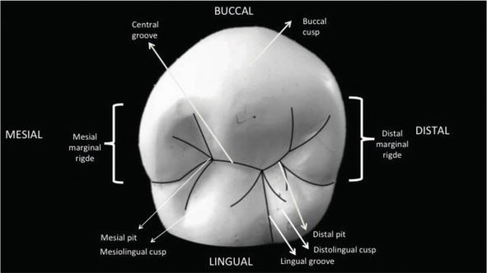
There are two common forms for the occlusal morphology of the mandibular second premolar. In both types of second premolars, there is “central groove” extending between mesial pit and distal pit.

Three-cusp type
Three-cusp type is the more common and square-shaped one. It has a “Y” groove pattern (Figure 12A). The variation of groove patterns is presented in Figure 12. A. “H” groove pattern, B. “U” groove pattern, C. “Y” groove pattern.
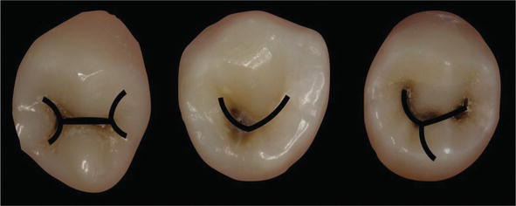

In three-cusp type, “mesiolingual triangular groove, mesiobuccal triangular groove, mesial marginal groove, distolingual triangular groove, distobuccal triangular groove and distal marginal groove” exist. Each of the cusps has “mesial and distal cusp ridges” and “a triangular ridge” connecting the cusp tip with the center of the occlusal surface. There are “mesial and distal triangular fossae.” Mesial triangular fossa originates from “mesial pit.” Distal triangular fossa originates from “distal pit.” The “central pit” is in the center of the occlusal surface in the three-cusp type.
DevelopmentalAns grooves
There are three deep developmental grooves (mesial developmental groove, distal developmental groove, and lingual developmental groove) connecting at the central pit. “Mesial developmental groove” extends from the central pit to the mesial triangular fossa. “Distal developmental groove” runs from the central pit to the distal triangular fossa. “Lingual developmental groove” is lying between two lingual cusps.
Two-cusp type
Two-cusp type is more rounded and has a “U” or “H” groove pattern (Figure 12B and C). The buccal cusp is larger than lingual cusp. No central pit and lingual developmental groove exists. The buccal and lingual cusp triangular ridges connect and create a “transverse ridge.”

Q5: Why we have molars?
Ans:
We have molars for grinding and crushing food.

_____________________________________________________________________________________
Good luck.

