Name: HAFEEZ ULLAH
ID NO: 15043
DEGREE: DPT 4th
SUBMITTED TO: Dr. Arooba.
Assignment for viva.

Question: Write a note on cerebrospinal fluid, its circulation and absorption.
Answer:
CEREBROSPINAL FLUID (CSF):-
Cerebrospinal fluid is a clear fluid that acts as a cushion for the brain and maintains overall central nervous system homeostasis.
- Cerebrospinal fluid (CSF) is a clear, colorless bodily fluid that occupies the subarachnoid space and the ventricular system around and inside the brain and spinal cord.
- CSF acts as a cushion or buffer for the cortex, providing a basic mechanical and immunological protection to the brain inside the skull and serving a vital function in cerebral autoregulation of cerebral blood flow.
- CSF serves five primary purposes: buoyancy, protection, chemical stability, waste removal, and prevention of brain ischemia.
- CSF can be tested for the diagnosis of a variety of neurological diseases through the use of a procedure called lumbar puncture.
- CSF is produced in the choroid plexus in the brain by modified ependymal cells.

PROPERTIES OF CEREBROSPINAL FLUID:-
- Volume: approximately 150mL
- Rate of formation: approximately 0.3 Ml /min
- Specific gravity: 1.005
- Reaction: alkaline

CIRCULATION OF CEREBROSPINAL FLUID:-
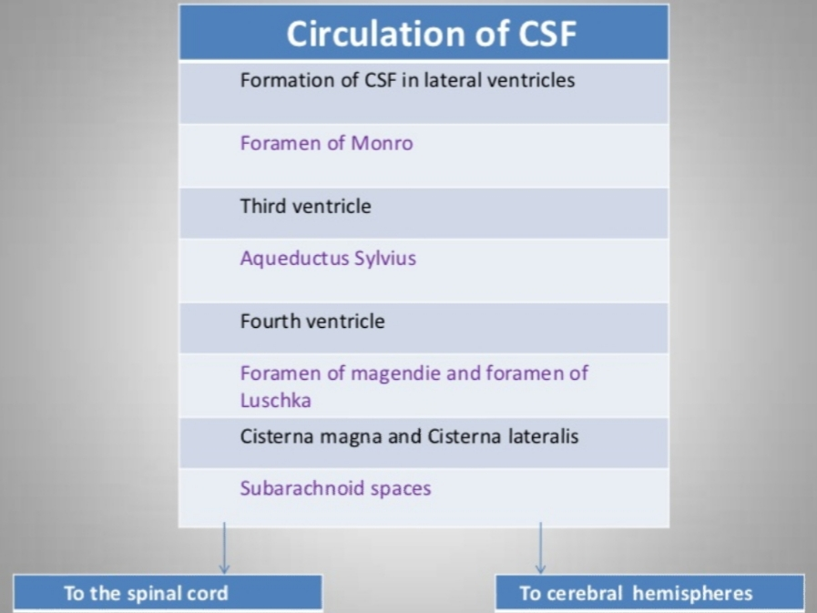

Cerebrospinal fluid (CSF) Circulatory Pathway, show the major pathway of CSF flow.
Beginning in the lateral ventricles, CSF flows through two passageways into the third ventricle. From the third ventricle it flows down a long, narrow passageway (the aqueduct of Sylvius) into the fourth ventricle.
From the fourth ventricle it passes through three small openings (foramina) into the subarachnoid space surrounding the brain and spinal cord.

ABSORPTION OF CEREBROSPINAL FLIUD:-
- Mostly absorbed by the arachnoid villi into dural sinuses and spinal veins.
- Small amount is absorbed along the perineural spaces into cervical lymphatic and in to the perivascular spaces.
- Normally, 500 mL of CSF is formed every day and equal amount is absorbed.
CSF is absorbed through blood vessels over the surface of the brain back into the bloodstream. Some absorption also occurs through the lymphatic system.
Once in the bloodstream, it is carried away and filtered by our kidneys and liver in the same way as are our other body fluids.

MECHANISM OF ABSORPTION OF CSF:-
- By filtration due to pressure gradient between hydrostatic pressure in the subarachnoid space fluid
- And the pressure that exists in the Dural sinus blood.
- The colloidal substances pass slowly and crystalloids are absorbed rapidly.

PRESSURE EXERTED BY CSF:-
- Varies in different position:
Lateral recumbent position= 10-18 cm of H₂O
Lying position= 13 cm of H2O
Sitting position= 30 cm of H2O
Coughing and crying increases the pressure by decreasing the absorption.
Compression of internal jugular vein also raises the CSF pressure.

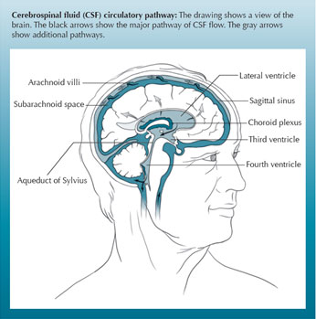

THANK YOU MAM

Thank you

