IQra national university Peshawar
Hayat Abad phase 2.

Name Aziz Ullah Mian
Class BS Radiology
Id no 14665
Paper Radiological positioning
Instructor MS Atoofah Azmat
Module 4th semester
Assignment Viva Final

- Identify the radiological findings and pathologies in the following case studies.
CASE 1
1 2 3
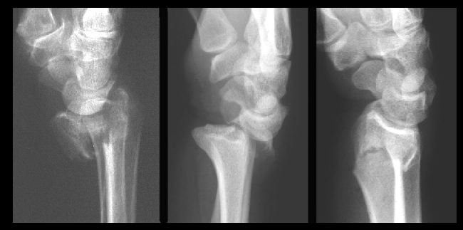
Ans: - in case 1 we have three different radiographs of wrist lateral and each have different type of distal radius fracture and dislocation of wrist joint.
- Dislocation:-
  - Dislocation of distal radius head see in radiograph no 2.
- Fractures :- different fracture of radial head see in radiographs which is
  - Barton’s fracture in radiograph no 1.
  - Colle’s fracture in radiograph no 3.

See Next page

CASE-2
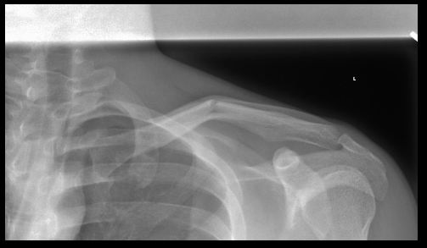
Ans: - in case 2 we have a radiograph of shoulder PA. Two fracture are see in the clavicle bone.
- Mid clavicular fracture.
- Fracture near to scapula.

See Next page

CASE 3
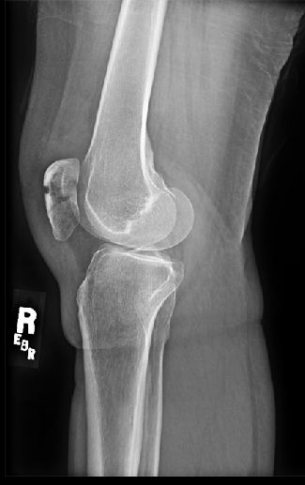
Ans: - in case 3 we have a radiograph of the knee latera.
- No 1 we have seen the fracture of patella.
- No 2 there is some chances of the arthritis.

See Next page

CASE 4
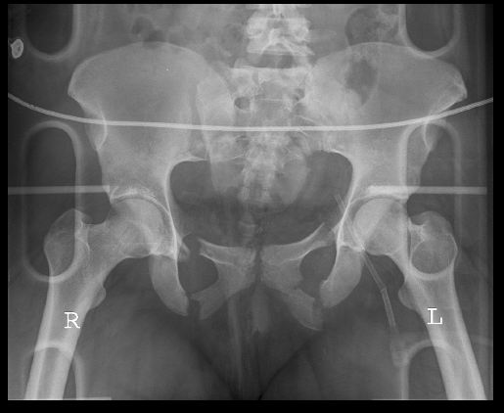
Ans:- in case 4 we have the radiograph of pelvic with a lots of radiological errors.
- No 1 we have seen the fracture of pubis bone with severe trauma.
- Also see the intestinal gases.
- And green fracture of coccyx in left side

THE END

