NAME : SIDRA
ID : 15057
SUBJECT : ANATOMY
DEPARTMENT : DPT ^{(4TH)}
INSTRUDTOR : Dr. AROOBA
UNIVERSITY : IQRA NATIONAL UNIVERSITY.
QUESTION NO: 01) Write a note on cerebrospinal fluid, its circulation and absorption?
ANSWER: -
- CEREBROSPINAL FLUID: -
Cerebrospinal fluid is a clear, colorless body fluid in the brain and spinal card and provide a mechanical barrier against shock.it is produce by specialized ependymal cells in the choroid plexuses of the ventricle of the brain and absorb in the arachnoid granulation.
Cerebrospinal fluid is about 125ml at any one time and about 500ml generated every day.
Cerebrospinal fluid act as a cushion and provide mechanical and immunological protection to the brain inside the skull.
Cerebrospinal fluid also play an important role in the cerebral auto regulation of cerebral blood flow.
- FUNCTION OF CEREBRAL SPINAL FLUID: -
- Cerebrospinal fluid act as a cushion to protect brain inside the skull
- Provide mechanical support to the brain.
- Cerebrospinal fluid circulate nutrient and chemical which is filter from the blood.
- Main function of cerebrospinal fluid to protect brain and spinal card from trauma.
- Cerebrospinal fluid remove waste product from cerebral metabolism.
- CEREBROSPINALFLUID CIRCULATION: -
Average of cerebrospinal fluid is 150 ml in the ventricle system or subarachnoid space.
About 125 ml is intracranial and 25 ml of this volume lies within the ventricles
The ventricle are series of cavities filled with CSF. From here, CSF passes to the interventriculer foramina to the third ventricle, then the cerebral aqueduct to the fourth ventricles, from the fourth ventricles the fluid pass through the subarachnoid space.
The circulating CSF flow from the lateral ventricles to the third and fourth ventricle and into the subarachnoid space. The level at which the CSF enter the subarachnoid space is called cerebellomedullary cistern. The fluid then flow through the sub arachnoid space and surrounding the brain and spinal card. It finally leaves the subarachnoid space and the central nervous system by entering the venous sinuses through the arachnoid granulation. The arachnoid granulation provide a valvular mechanism for flow of CSF into the blood stream without permitting backflow of blood into the cerebrospinal fluid.
DAIGRAM: - 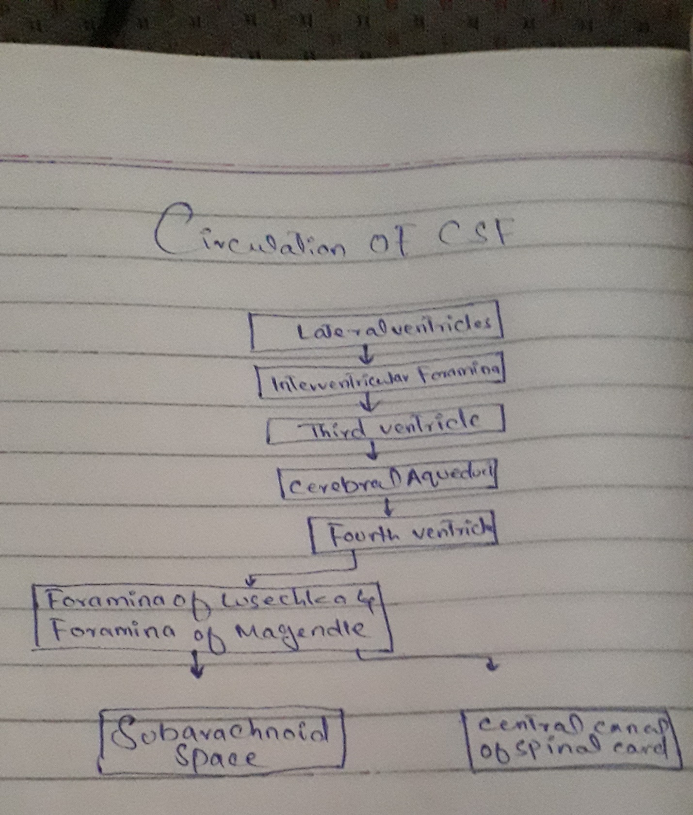

- CEREBRALSPINAL FLUID ABSORPTION:
- CSF are absorb into lymphatic channel along the membrane covering the nerve as they leave the brain stem and spinal card.
- Our body produce approximately 500 ml of CSF daily, continuously replacing CSF as it is absorb under normal condition there is a balance between the amount of CSF that is produced and the rate which it is absorbed.
- MOSTLY absorbed by the arachnoid villi into Dural sinuses and spinal veins.

END

