Q1: Enumerate all hand instruments used in the dental clinic along with their uses in detail and diagrams.
Following instruments:
1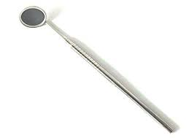 Mouth Mirror - used for reflection, retraction, and visual observation; supplied in various sizes and may have plain faces or faces that magnify the view; some are solid, one piece; others have cone screw-in handles.
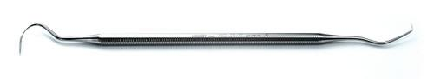2. Explorer - a sharp, flexible, pointed instrument used to detect caries and calculus, to explore restorations, surfaces and furcation’s, to make location marks, and to pick up cotton points or materials; supplied as single- or double-ended with an explorer edge on one side and another type of edge on the opposite side.
3. Cotton Forceps - tweezer-like pinchers used to transport materials to or from the mouth; also called dressing pliers; available with or without a serrated tip.
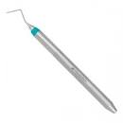4. pen-probe - a double-ended instrument with a probe-marking tip on one end and a pen on the opposite end.
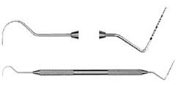5. expro - double-ended instrument with a diagnosing probe tip at one end and an explorer tip at the other end.
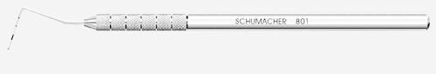6. Periodontal Probe - a longer pointed instrument with measured marks on the tip; used to assess depth of tissue pockets; available with a round or flat blade and may be color-coded to help determine measurements.
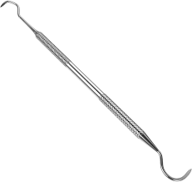7. Scaler - thin-bladed hand instrument with pointed tip and two cutting edges; used to scale (scrape off) hard deposits from teeth.
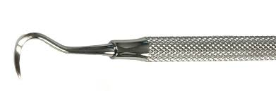8. Sickle Scaler - sharp blade in the shape of a sickle; used to remove calculus from tooth surfaces.
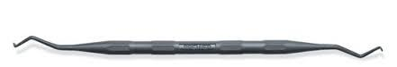9. Implant Scaler/Curette - non-metallic, resin-tipped instrument, designed to remove deposits around titanium implant abutments.
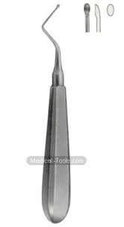10. Curette - round-tipped thin blade with a longer neck and two cutting edges; used to remove sub gingival deposits, and termed universal curette. Other curettes have one cutting edge and are designed for specific use.
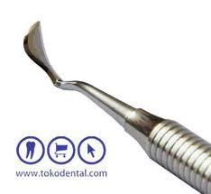11. Periodontal Knife - hand instrument with flat-bladed incision tip of carious shapes and angles; used to remove or raconteur soft tissue.
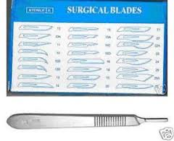12. Scalpel - handle for attachment of blades of assorted sizes and shapes; used to incise (cut into) or remove tissue; also used in specialized dental procedures.
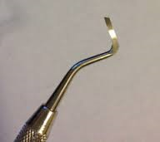13. Gingival Margin Trimmer - hand instrument with long, slender, curved, flat blade; used to break away enamel margins during tooth preparations.
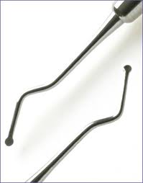14. Excavator - hand instrument with long-necked, cup-like, sharp-edged blades; used to remove soft, decayed tissue from preparations; also may be called spoon excavator.
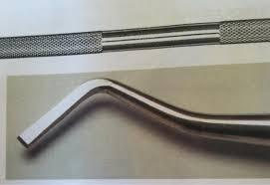15. Hatchet - hand instrument with a sharp-edge, hatchet-like tip; used to remove hard tissue.
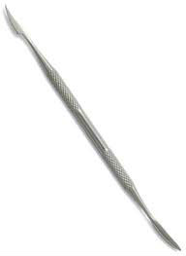16. Carver - thin-bladed hand instrument used to remove decay or carve newly placed restorative material; blade faces come in various shapes; a popular type is the Hollenbeck.
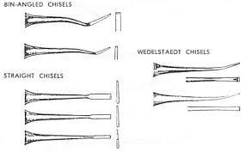17. Chisel - hand instrument with cutting edge that is used to cut away enamel tissue. Chisels have straight shafts, or a curved shaft, such as the Wedelstaedt chisel, or may have an extra angled shaft, such as bangle chisels.
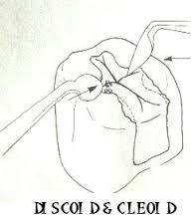18. Cleoid/Discoid Carver - double-ended, long-necked carving instrument with a pointed tip on one end (cleoid) and a disc-shaped blade on the other end (discoid); used to carve anatomy features in newly placed restorations, or can be used to remove decay and tooth tissue during cavity preparations.
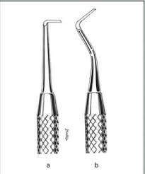19. Hoe - smaller blade instrument with a tip resembling a farm hoe; used to break or pull away enamel tissue during preparations.
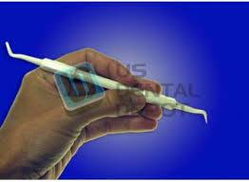20. Plastic Filling Instrument (PFI) - hand instrument with a flat blade; used to carry, transfer, and pack materials, or to carve restorative material.
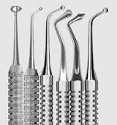21. Burnishes - hand instrument with a smooth, rounded head that comes in various shapes; used to smooth restorative material or other metal surfaces, such as a matrix strip.
22. Condenser - hand instrument with a thick, rounded or oval shaped, flat head that is sometimes serrated. It is used to pack or condense restorative material into the cavity preparation.
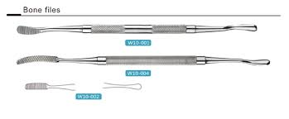23. File - hand instrument with a flat blade with serrated edging; used to smooth off and contour restorations or hard surfaces.
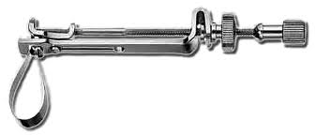24. Matrix Holder, Matrix Strip and Wedge - holder device used to maintain artificial wall) matrix strip) around the tooth preparation. A wooden or resin triangular wedge is used to hold the strip in place and prevent the material from leaking.
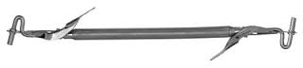25. Amalgam Carrier - hand instrument with holding cylinder for the transfer or amalgam material while in a plastic form; has a spring lever pusher to expel the material into the preparation. The instrument is supplied in assorted sizes with various cylinder materials on the end tips. Another type of amalgam carrier is the amalgam fun with a thumb spring push to expel the material. Both amalgam carriers may be loaded by pressing into the plastic load of restorative material in the amalgam well.
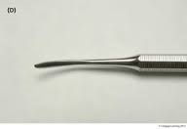26. Beaver-tail Burnished - a burnishes with a beaver tail-shaped blade extending from the round nib or tip; used to smooth and carve restorative material while in the plastic, pliable shape, and to apply medication such as Decal to a cavity preparation.
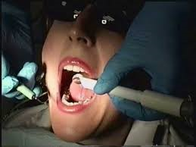27. Saliva Ejector Tip - smaller suction tip that is inserted into the evacuation tubing from the dental unit; used for steady, constant fluid removal from the oral cavity.

Thank you

