Name: AHMED KHAN
ID: 14595
SUBJECT: CONTEMPPRARY ADVERTISING
FINAL EXAM

Colgate has the proof!

Just one brushing with

colgate dental cream

- Remove up to 85% of decay causing bacteria
- Stop bad breath instantly
- Nation favourite for taste
Only the colgate way does all treat clean your breath while it clean your teeth and protects them against decay
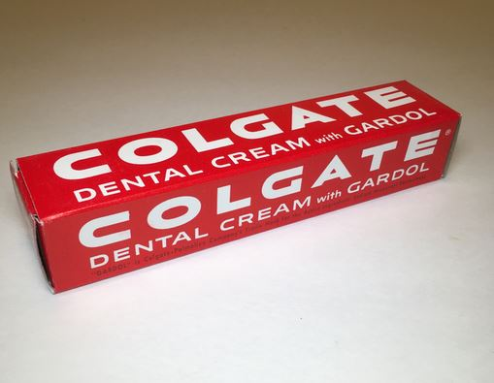

Advertising campaingn:
The following is the campaingn for universities keeping in mind the pandemic scenario:
Our plan is to develop strategies and tactics to convince students for universities during this pandemic situation- i.e
- We offer best online courses as long as this pandemic lasts.
- We will analyze the campaign idea by conducting market research i.e to interview students how they want their online courses and what kind of social media they prefer to communicate during this pandemic scenari . for example:
If you are designing a campaign to convience the target market to try new university you want to examine perception of the courses prior to launching the campaign .you can this through focus groups or audience surveys.

- After market research we will implement our campaign .

Our university provide
- A topnotch education at an affordable price
- The variety of degree ,certification, and workforce training available.
- Technical and academic skills gained that will support student throughout their career.
- Financial aid available to all work force student.
Our website with colorfull, oversized images and engaging content:
- Each button is a clear call to action, directing students to engage.
- Different aspects of university life are divided into clearly delineated section, making it easier to find and read content .
- Students stories and college cost are included on the home page , putting the information that students want most fornt and center.
Our best step will involve evaluation
This will provide an opportunity for us to see wether our efforts succeeded in accomplishing the stated goals .i.e how many students responded fortunately.

