ASSIGNMENT FOR VIVA..Radiology sec b 2nd semester
Supervisor: Kousar Shah Jehan
Name : Shehla Hayat
I'D : 16589
Programme : B.S(radiology)
Section : "B"
Viva : Physiology
Submitted to : Dr Kousar Shah Jehan...!

Q1. (i) Write a note on cardiovascular system?
Ans: Cardiovascular System :-
The cardiovascular system can be thought of as the transport system of the body. This system has three main components. The heart the vessel and the blood itself. The heart is the system's pump and the blood vessels are like the delivery roules. The heart is a pump, usually beating about 60 to 100 time perminute with each heartbeat the heart sends blood throughout our bodies. The heart then sends the blood to the lungs to pick up more oxygen. This cycle repeats over and over again.
What does the circulatory system do?
The circulatory system is made up of blood vessels that carry blood away from and towards the heart.Artries carry blood away from the heart and veins carry blood back to the heart. The circulatory system carries oxygen, nutrients, and hormones to cells, and removes waste products, like carbon dioxide. These roadways travel in one direction only, to keep things going where the should.
Parts of the heart :-
The heart has four chambers two on top and two on bottom .
The two bottom chambers are the right ventricle and the left ventricle. The pump blood out of the heart. A wall called the interventricular sptum is between the two ventricles.
The two top chambers are the right atrium and the left atrium. They recive the blood entering the heart. A wall called the intwratrial septum is between the atria.
Diagram:-
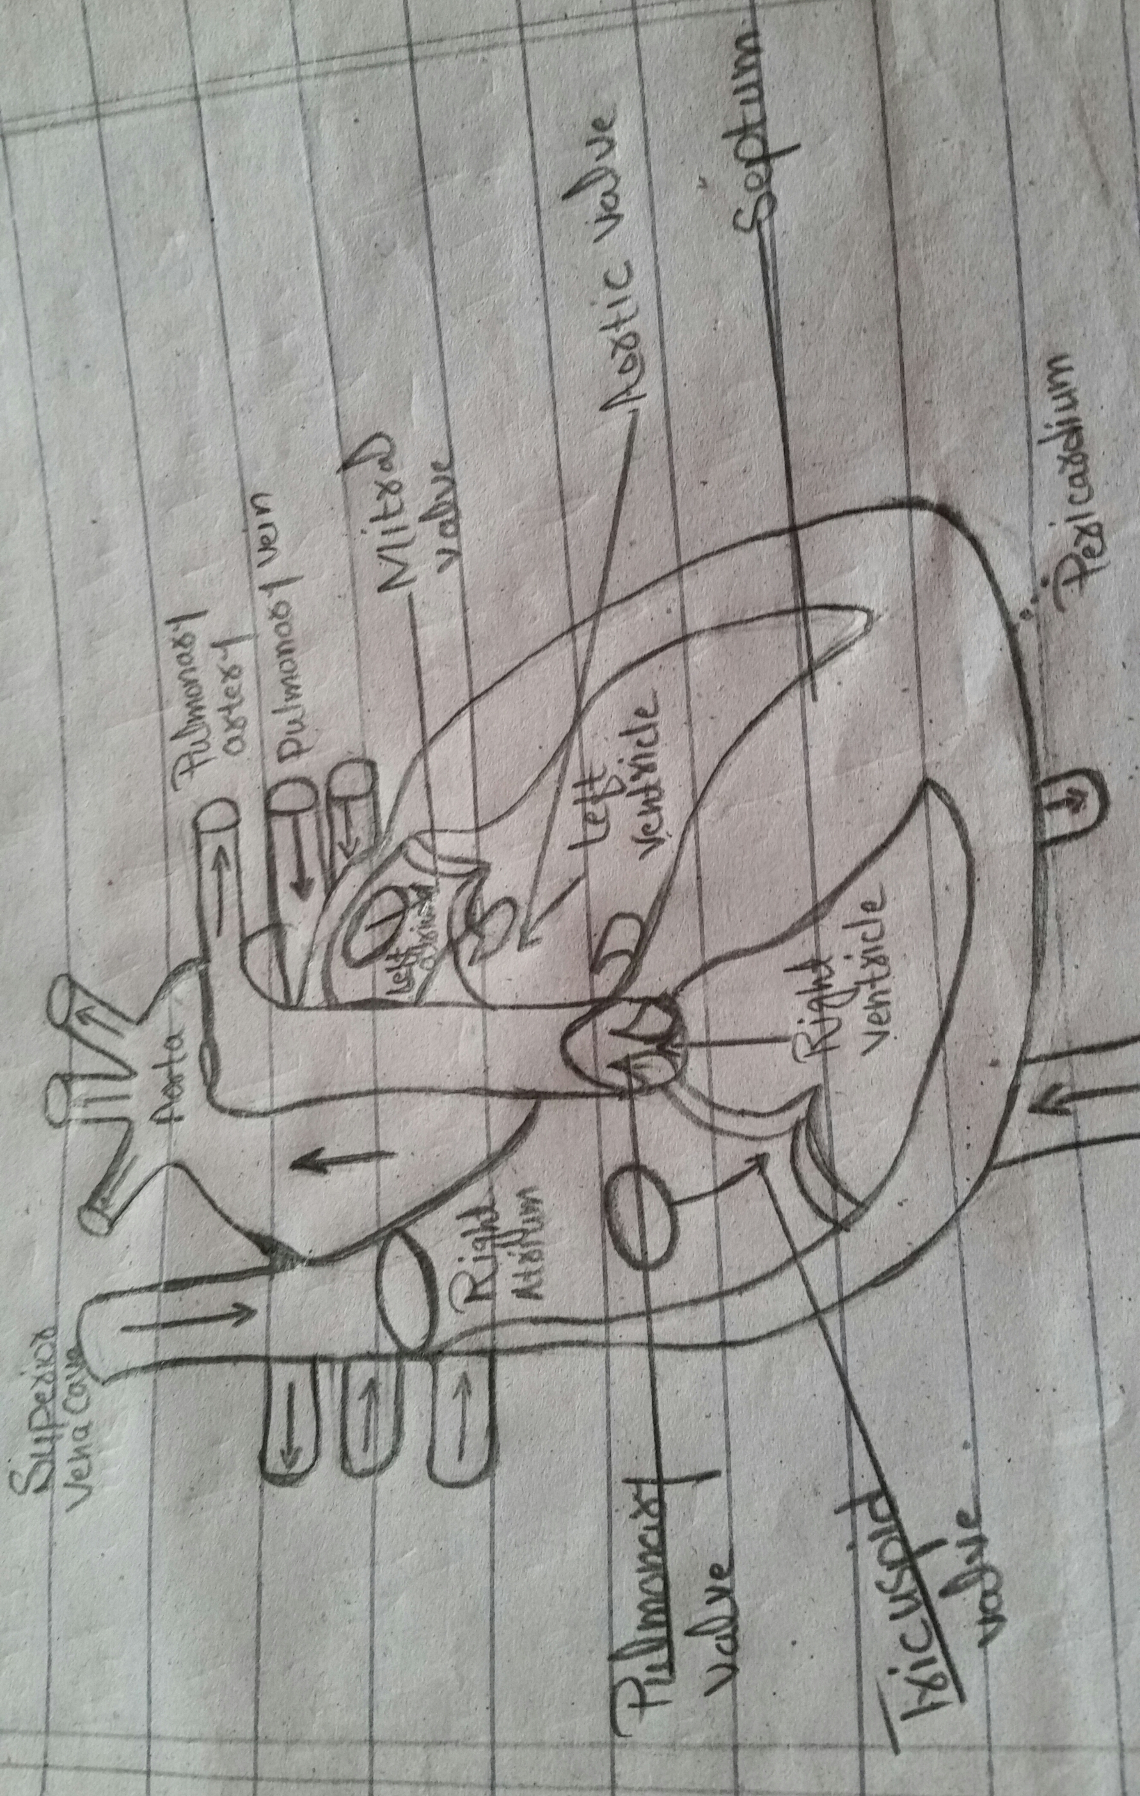
The atria are separated from the ventricles by the atrioventricular valves.
- The tricupid valve separates the right atrium from the right ventricle.
- The mitral valve separates the left atrium from the left ventricle.
- Two valve also separate the ventricle from the large blood vessels that carry blood leaving the heart.
- The pulmonic valve is between the right ventricle and the pulmonary artery, which carries blood to the lungs.
- The aortic valve is between the left ventricle and the aorta, which carries blood to the body.
Parts of the circulatory system :-
Two pathways come from the heart.
- The pulmonary circulation is a short loop from the heart to lungs and back again.
- The systematic circulation carriers blood from the heart to all the other parts of the body and back again.
Heart Beat :-
The heart gets messages from the body that tell it when to pump more or less blood depending on a person's needs. For example when you're sleeping it pumps just enough to provide for the lower amounts of oxygen needed by your body at rest. But when you're exercising, the heart pumps faster so that you're muscle get more oxygen and can work harder.
One complete heartbeat is made up of two phases.
- The first phase is called Systole. This is when the ventricles contract and pump blood into the aorta and pulmonary artery . During Systole, the atrioventricular valve close. Creating the first sound(the lub)of a heartbeat. When the atrioventricular valves close, it keeps the blood from going back up into the atria. During this time, the aortic and pulmonary valves are open to allow blood into the aorta and pulmonary artery. When the ventricles finish contracting, the aortic and pulmonary valves close to prevent blood from flowing back into the ventricles. These valves closing is what creates the second sound(the dub) of a heartbeat.
- The second phase is called Diastole. This is when the atrioventricular valves open and the ventricles relax . This allows the ventricles to fill with blood from the atria, and get ready for the next heartbeat.
How can I help keep my heart healthy?
To help keep your heart healthy.
- Get plenty of exercise.
- Eat a nutrition diet.
- Reach and keep a healthy weight.
- If you smoke, quit.
- Go for regular medical checkups.
- Tell the doctor about any family history of heart problems.

(ii) what are the symptoms of high and low blood pressure?
Ans: Blood pressure :-
The blood pressure is the pressure of the blood within the arteries. It is produced primarily by the contraction of the heart muscle. The first (systolic pressure) is measured after the heart contacts and is highest. The second (distolic pressure) is measured before the heart contacts and lowest.
High blood pressure :-
Most people who have high blood pressure do not have symptoms. In some cases, people with high blood pressure may have a pounding feeling in their head or chest, a feeling of lightheadedness or dizziness or other signs.
Symptoms of hypertension :-
Hypertension is generally a silent condition. Many people won't experience any symptoms. It may take years or even decades for the condition to reach levels severe enough that symptoms become obvious. Even then, these symptoms may be attributed to other issues.
Symptoms of severe hypertension can include:-
- Headache
- Shortness of breath
- Nosebleeds
- Flushing
- Dizziness
- Chest pain
- Visual Change
- Blood in the urine.
Low blood pressure :-
Within certain limits, the lower your blood pressure reading is, the better. There is also no specific number at which day-to-day blood pressure is considered too low, as long as none of the symptoms of trouble are present.
Symptoms of low blood pressure :-
Most doctors will only consider chronically low blood pressure as dangerous if it causes noticeable signs and symptoms, such as.
- Dizziness or lightheadedness.
- Neusea
- Fainting(syncope)
- Dehydration and unusual thirst .
- Lackof concentration
- Blurred vision
- Cold, clammy,pale skin
- Rapid, shallow breathing
- Fatigue
- Depression.

(iii) what is the treatment of high and low blood pressure?
Ans : Treatment for low blood pressure :-
The treatment for low blood pressure depend on what causea conditions.four doctor will work with you to address the cause of the hypotension. In severe cases of hypotension your doctor may give you IV fluids to raise your blood pressure.
Depending on a variety of factors such as your age and the type of hypotension, your doctor may recommend one or more of the following :dietary changes lifestyle changes and for medications.
To make dietary changes, your doctor might tell you to
. Stay hydrated by drinking more water throughout the day .
. Drink less alcohol.
. Increase your salt intake slightly because sodium raises bloodpressure.
. Eat smaller, healthy meals and limit carbohydrates you can take several steps to avoid a sudden drop in blood pressure. You doctor may recommend that you make the following lifestyle changes.
. Wear compression stockings.
. Get up slowly after you've been sitting or lying down.
. Avoid standing for long periods of time.
. Sit up and breath deeply for a few minutes before getting out of bed.
Your doctor might prescrib medications like :
. Fludrocortisone, which increases blood volume.
. Midodrine, which increases blood pressure.
Treatment of high blood pressure :-
A number of factors help your doctor determine the best treatment option for you. These factor include which type of hypotension you have and what causes have been identified.
Primary hypertension treatment options :-
If your doctor diagnosis you with primary hypertension, lifestyle changes may help reduce your high blood pressure. If lifestyle changes alone are not enough, or if they stop being effective, your doctor may prescribe medications.
Secondary hypertension treatment options :-
If your doctor discovers an underlying issue causing your hypertension, treatment will focus on that other condition. For example, if a medicine you've started taking is causing increased blood pressure your doctor will try other medicines that don't have this side effect.
Sometimes,hypertension is peristent despite treatment for the underlying cause in this case, your doctor may work with you to develop lifestyle changes and prescribe medications to help reduce your blood pressure.
Treatment plans for hypertension often evolve. What worked at first may become less useless over time .your doctor will continue to work with you to refine your treatment.

Thank you...!

