NAME: Sheharyar Tahir

ID# 13484

SUBMIITED TO : Mrs Mehwish

SUBMISSION DATE : 15/11/2020

Assignment # 1
CONTENT

1. Launching a product
1.1 Introduction
1.2 Slogan
1.3 Ingredients
2. Current market situation
3. SWOT analyses
4. Mission and Visions
5. LOGO
6. Brand Name
7. Market P’s
7.1 Price
7.2 Place
7.3 Promotion
8. Market Segmentation
8.1 Geographical Segmentation
8.2 Demographic Segmentation
9. Conclusion

LAUNCHING A PRODUCT

INTRODUCTION

We belong to a region where our country weather is warm, due to this mostly 8 months of year the climates remains hot and warm.
Every individual in summers needs an energy drink to refresh themselves which is easily accessible to them. Chocolate smoke soda is a carbonated drink product which flavor coated with chocolate and appearance with smoke. Chocolate improves blood flows and lower blood pressures while carbonated soda benefits for digestion.
Chocolate Smoke Soda is not only for those who likes carbonated drink but is also for those who hate preferences over chocolate. The new product is for all the ages but we segmented specially for kids, students, adults, employs who wants something more energetic drinks.
Chocolate with soda and appearance with smoke keeps a unique idea and I am going to introduce it in the coming summers.

SLOGAN
Drink Different!

INGREDIENTS
Chocolate
Sugar
Soda
Dry Ice

CURRENT MARKET SITUATION
Chocolate Smoke soda is our first ever product that we will going to introduce in Peshawar for the first time. Our product is developing to meet customer’s expectations at its best. We will be specially targeting those who loves chocolate. It is a product inspired by kids and students. Coca cola and Pepsi are the two trending competitors of our product at present. We will soon launch our first shop in Saddar Peshawar.
SWOT ANALYSIS

STRENGTHS
- Chocolate Affection with Soda.
- Halal Certified.
- Quality product
- Sole proprietorship
- First time ever smoke with Soft Drink

WAEKNESS
- Changing Customers trend
- Perishable ingredients
- Competitive Market

OPPORTUNITIES
- Warm weather
- Unique Idea
- No competitor of soda along with chocolate

THREATS
- Increasing costs
- Low per capita income
- Environmental and Health regulations regarding carbonated drinks.
- Political stability

MISSION AND VISION
Our mission is to provide the best version of our product to the customers. To expand our products hubs through different famous places.

LOGO

Logo is the important part of the product. Our LOGO is as mentioned below

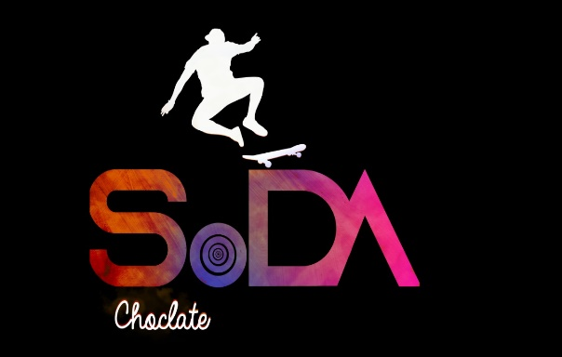

BRAND NAME
The Brand name is Mr. Trust. The customers will find this product under the name of Mr. Trust.

MARKET P’s

PRICE
Chocolate smoke soda is economically affordable. Chocolate soda has a verity of substitutes available like coca cola, Pepsi but there is no substitute available for chocolate smoke soda in market.

PLACE
Chocolate smoke soda can be found in most grocery stores, retail stores, super markets. Chocolate smoke soda to remain competitive.

PROMOTION
the promotion chocolate smoke soda contains a verity of elements through personal and non-personal selling. As we are launching a new product we will start with less prices so customers will have a try to our product.

MARKET SEGMENTATION

GEOGRAPHICAL SEGMENTATION
Mr Trust will try to target different areas of Peshawar specially
- Saddar
- Hayatabad
- Gul bahar

DEMOGRAPHIC SEGMENTATION
Demographic segmentation will be on the following basis
- Age (8 years onwards)
- Gender (Male and Females)
- Lifestyle
- Income
- Occupation (students, professionals)

COCLUSION
Mr trust will be able to successfully promotes its product at the same time. Our message is consistent and our coordinated our promotion to ensure that consumers are well informed about our product.

