Med Exam Paper: - Immunology And Serology paper

Name Munir khan
Submitted to Saima Hadi
ID 6941
Subject Immunology and Serology
Semester 6Th

Iqra National University
Phase-II, Hayatabad Peshawar Khyber Pakhtunkhwa,
Phone No: 091-5822897 Webs: www.inu.edu.pk

QNO 1
ANS: The Following term with example;
- Auto graft: It is the process of transferring tissue from one section of over an organism body to another region of that same organism. These processes occur in same organism.
E.g. the skin of my hands is very badly burned, so the surgeon can take the skin part from another place of my body and put on burned area, so it is called Auto graft.
- Syngeneic graft: It is a transplantation or change of tissue material or organ from one individual to another individual of different species but of same genetic makeup.
Example kidney transplanted from one identical twin to the other.
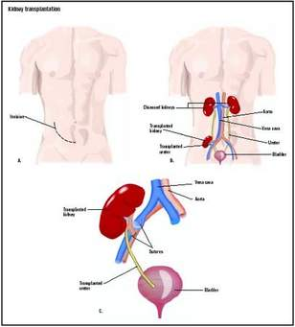
- Xenograft: Xeno means different species; it is the transfer of tissue graft between different species. A common example is the use of pig heart valves in humans.
- Allograft: Allografting means between same pieces, In these type of tissue grafting we can take tissue or organ from individual and we can transplant that into some other individual of same species.
Example of allograft are, Joint reconstruction in the knee and ankle, Lung transplantation, Liver transplant.
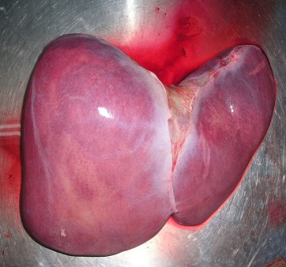

QNO 2
ANS: Major Histocompatibility Complex (MHC):
Major Histocompatibility complex is the membrane attached protein which work on reorganization of antigen between self and non-self-body and antigen presentation. The function of MHC molecule is to bind peptide fragments derived from pathogens and display them on the cell surface for recognition by the appropriate T cells.

HLA (HUMAN LUEKOCYTE ANTIGEN):
HLA is the MCH molecule present in human beings. It is a set of surface protein present on all nucleated cells. They are responsible for graft rejection (destruction of transplanting tissue or organ).
- The Adaptive immunity plays function in HLA.
- HLA gives defense against infection.
- HLA sometime expressed on cancer cell destruction.
- HLA genes are located on short arm of chromosome 6.
- HLA has four types of (HLA-A, HLA-B, HLA-C, and HLA-D).
- The first three proteins is code for class I MCH and HLA-D is code class II MCH.
CLASSES OF MCH MOLECULES:
- Class I MCH Molecule: These are glycoproteins found on the surface of virtually all nucleated cells. The complete class I protein is composed of a 45,000-molecular-weight heavy chain no covalently bound to a β2-microglobulin.
- Class II MCH Molecule: These are glycoproteins found on the surface of certain cells, including macrophages, B cells, dendritic cells of the spleen, and Langerhans' cells of the skin. They are highly polymorphic glycoproteins composed of two polypeptides, which are no covalently bound.
- Class III & IV MCH Molecule: Class III & IV is not important in transplantation, they are less function, they work in complement system as a cofactor or work for T cell.

QNO 3
ANS: COOMBS CLASSIFICATION OF HYPER SENSITIVITY
According to coombs classification, hypersensitivity is of four types
1-Type I - immediate (atopic, or anaphylactic)
2-Type II - antibody-dependent
3-Type III - immune complex
4-Type IV - cell-mediated or delayed

1-Type I - immediate (atopic, or anaphylactic)
This reaction occurs when the immune system is re exposed to a particular antigen. This reaction is mediated by IgE antibodies and immediate release of histamine striptease, arachidonate and derivatives of basophils and mast cells. Are results an inflammatory reaction within seconds. The reaction may be local or systemic and symptoms may vary from mild to sudden death.
Some examples:
Allergic asthma
Allergic conjunctivitis
Allergic rhinitis ("hay fever")
2-Type II - antibody-dependent
This reaction is produced when the patient antibodies binds to the antigens on its own cells. The IgG and IgM bind to these antigens form complexes and activates complement system which results in the elimination of cells representing foreign antigens.as a result the mediators of acute inflammation are generated at site and membrane attack complexes causes’ cell lysis and death.
Examples include autoimmune hemolytic anemia, transfusion reaction and hemolytic disease of new born.
3-Type III - immune complex
Caused by immune complex deposition in tissues which triggers immune response to classical pathway of complement activation.
Examples includes Rheumatoid arthritis, Systemic lupus erythematous etc.
4-Type IV - cell-mediated or delayed
Unlike other reactions, it is cell mediated reaction not antibody mediated and often takes 48 hours to 72 hours so it is also delayed type hypersensitivity.
Examples are
Contact dermatitis (poison ivy rash, for example)
Transplant rejection.

QNO 4
ANS: COMPLEMENT SYSTEM:
Complement system is a part of the immune system; consist of a series of protein found in serum in inactive form. Complement protein mainly produce by the liver cell The term "complement" refers to the ability of these proteins to complement, i.e., augment, the effects of other components of the immune system, e.g., antibody. Complement is an important component of our innate host defenses.
FUNCTION OF COMPLEMENT SYSTEM:
- Lysis of cell, bacteria and viruses- the major effector of the humeral branch of the immune system.
- Opsonization, which promotes phagocytosis of particulate antigens.
- Binding to specific complement receptors on cells of the immune system, triggering specific cell function and secretion of immunoregulatory molecules.
- Immune clearance, which removes immune complexes from the circulation and deposits them in the spleen and liver.
- Generation of mediator of inflammation.
ALTERNATIVE PATHWAY OF COMPLEMANTRY SYSTEM:
- AMPLIFICATION
- Factor B is then cleaved by factor D into Ba and Bb.
- C3bBb remains which acts as a C3 converts (C3- C3 a and C3b)
- C3bBbC3b is formed which acts as a C5 convertase.
. 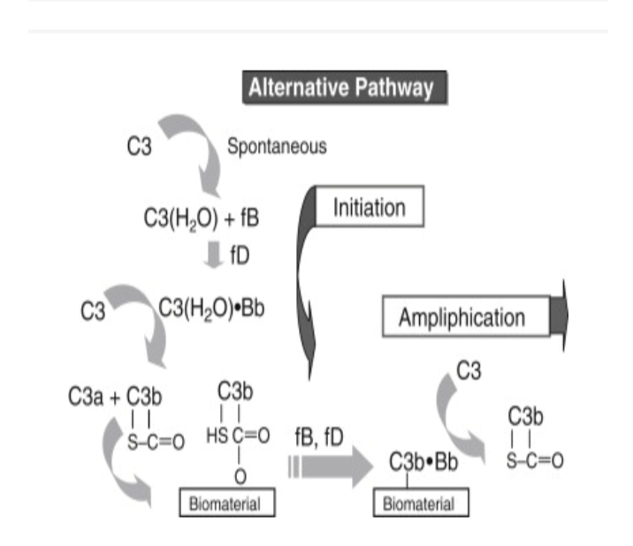

QNO 5
ANS:
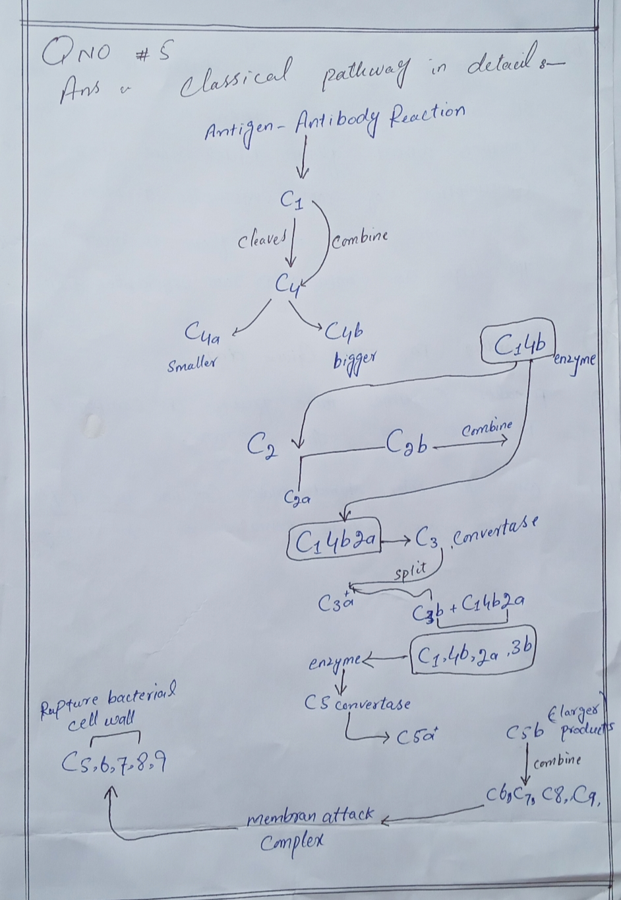
END

