Student ID: 15352

Answer 01
Desalination is a process that takes away mineral components from saline water.
Saltwater is desalinated to produce water suitable for human consumption or irrigation.
Methods of Desalination:
Distillation:
Distillation relies on evaporation to purify water. Contaminated water is heated to form steam.

Electrodialysis is an electrochemical process in which ion transfer separates salt from water. ... When electrodes, connected to a suitable direct current supply, are immersed in a salt solution, current will flow, carried by the ions.

Freeze desalination (FD) is used for water treatment by separating fresh water from saline solution in the form of ice crystals then followed with melting. ... Contrary to distillation being multistage flashing or Direct contact Membrane [10-12], the freezing method utilizes the phase change of water from liquid to solid.

Reverse osmosis
Reverse osmosis uses a pressure gradient as the driving force to move high-pressure saline feed water through a membrane that prevents the salt ions from passing.

Reverse osmosis is an effective means to desalinate saline water, but it is more expensive than other methods. As prices come down in the future the use of reverse osmosis plants to desalinate large amounts of saline water should become more common.
Reverse osmosis is also the most economic process for the desalination of brackish water and seawater. When we compare this process to the traditional thermic process of distillation, the capital investments and the energy use are much lower.

Answer 02

The aim of a distribution system is to supply a community with the appropriate quantity and quality of water. There are four distribution types:
- Dead end system
- Grid iron system
- Ring system
- Radial system

Dead End Water Distribution System
Dead end system, the name itself defining that it contains dead ends in the pipe system. So, the water does not flow continuously in the dead end system. In this system the whole pipe network is divided into several sub networks. Those are namely main line, sub mains, branch lines and service connections.

Advantages of Dead End System
- Pipes in this network can be laid easily.
- The pressure and discharge in each pipe can be determined very easily and accurately which makes design calculations very simple.

Disadvantages
- The pressure is not constant and is very less at remote parts.
- Because of dead ends water stagnation takes place which results in deposition of sediment. To remove this sediments, more number of scour valves are to be provided at the dead ends which increase economy.

Grid Iron Water Distribution System
Grid iron system also contains main lines, sub mains and branch lines. But in this system dead ends are eliminated by interconnecting all the lines. Hence, the water flow continuously in this system without stagnating. So, this system is also called as interlaced system or reticulation system. It is more suitable for well-planned cities.

Advantages of Grid Iron System
- Water will flow continuously without any dead ends or sediment deposits.
- Head loss is minimum in this case because of interconnection of pipes.
- The discharge will meet the required discharge for firefighting.

Disadvantages
- Because of circulating flow from all directions, the pipes used in this system should be of large diameters and longer lengths.
- We cannot determine the accurate discharge, velocity or pressure in a particular pipe. So, design is difficult.
- Laying of pipes will be done by skilled workers which consume more cost.
- Cutoff valves required should be more in this system.

Ring Water Distribution System
Ring system, can also be called as circular system in which the main pipe line is provided around the city or area i.e., peripherally. From this main line, the branch lines are projected perpendicularly and they are also connected with each other.

Advantages of Ring System
- No stagnation of water
- Repair works can be done without affecting larger network.
- Large quantity of water is available for firefighting.

Disadvantages
- Longer length and large diameter pipes are required.
- More number of cutoff valves are necessary.
- Skilled workers are necessary while laying pipes.

Radial Water Distribution System
Radial system is quite opposite to the ring system. In this system, whole area is divided into small distribution districts or zones and an individual distribution reservoir is provided for each distribution zone. The reservoir provided is generally of elevated type. From this reservoir the pipe lines are laid radially to the surrounded streets.

Advantages of Radial System
- The water distributed with high velocity and high pressure.
- Head loss is very small because of quick discharge.

Disadvantages
Cost of the project is more because of number of individual distribution reservoirs.

Water distribution systems in hilly areas are always divided into several zones due to the undulating terrain.
I would suggest the dead end distribution system for newly proposed township in hilly area due the following reasons.
- Pipes in this network can be laid easily.
- The pressure and discharge in each pipe can be determined very easily and accurately which makes design calculations very simple.
- The diameters of pipes of main, sub mains and branches can be designed based on the required demand of population. So, cost of the project can be reduced.

The zones having high altitudes in the township may be supplied by the radial system by providing surface tanks.

Answer no.03

Types of reservoirs in water supply system:

There are two types of reservoirs in water supply system:

- Surface reservoirs
- Elevated storage reservoirs

Surface reservoirs:

These are also called ground reservoir with circular or rectangular tank.
Surface reservoirs are built structures for water storage that help improve water security for local communities. The types and sizes of reservoirs vary, from damming natural water bodies for storage to ground excavation in low-lying plains fed either by rainwater or diverted rivers. Stored water can be used for numerous purposes, including irrigation, industry, domestic use, hydropower generation and flood control. Surface reservoirs are particularly important in regions with lengthy dry seasons and high rainfall variability, as well as areas where seasonal water availability is predicted to increase as a result of a changing climate. Surface reservoirs are therefore one of the most important adaptation technologies in regions with limited and varying water availability.
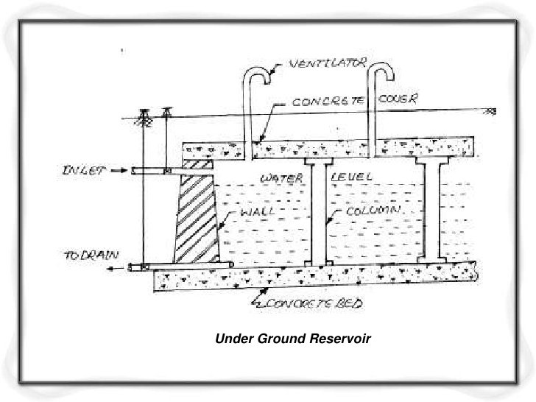
Elevated storage reservoirs:

Elevated storage reservoirs are also called overhead tanks and are usually provided in the areas where the gravity distribution system is not possible.
They are at a reasonable height from the ground depending upon the population to be served by the reservoir.They may be rectangular or circular in shape.
They are provided in the areas where combine gravity and pumping system of water distribution is adopted.

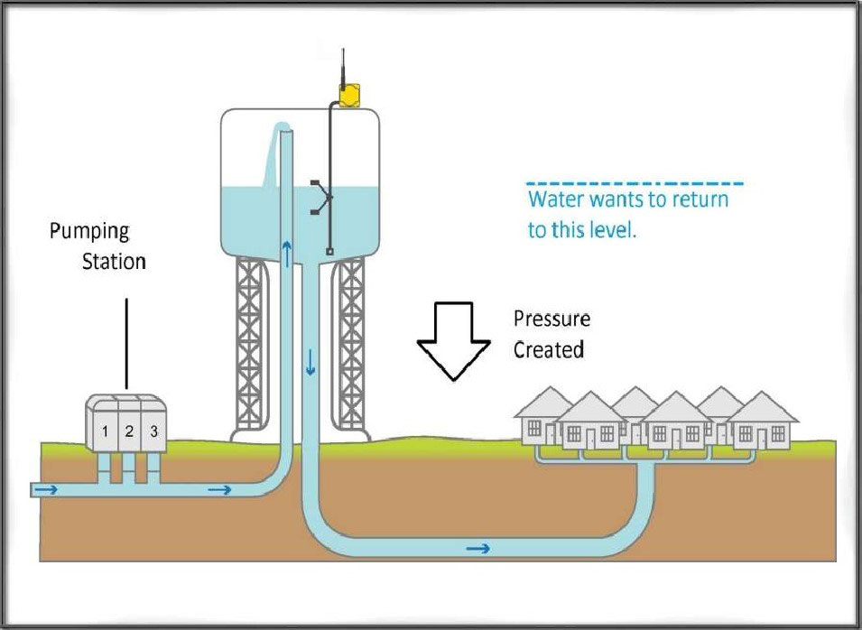
Elevated storage reservoir

Storage capacity of a reservoir:

The storage capacity of a reservoir is the summation of
- Balancing storage
- Brakdown storage
- Fire storage

Balancing storage: The main and primary function of the distribution reservoir is to meet the fluctuating demand with a constant rate of supply from the treatment plant. The quantity of water required to be stored in the reservoir for equalizing or balancing this variable demand against the constant supply.

Breakdown storage: It is also called emergency storage. Or the storage preserved in order to tide over the emergencies posed by the failure of pumps, electricity or any other mechanism driving the pumps.
A value of about 25% of the total storage capacity of reservoirs or 1.5 to 2 times of the average hourly supply may be considered as enough provision for accounting this storage.

Fire Storage: This storage is kept in order to overcome the fire extinguishing demand.

Answer no.04
Pumps are used in water supply schemes because they delivers a constant flow of water at a constant pressure for any given set of conditions.

Reading a Pump Curve
Let’s look at an example situation to help you pick out the right pump for your application using just pump head and gallons per minute to help us come to a decision on the right pump.
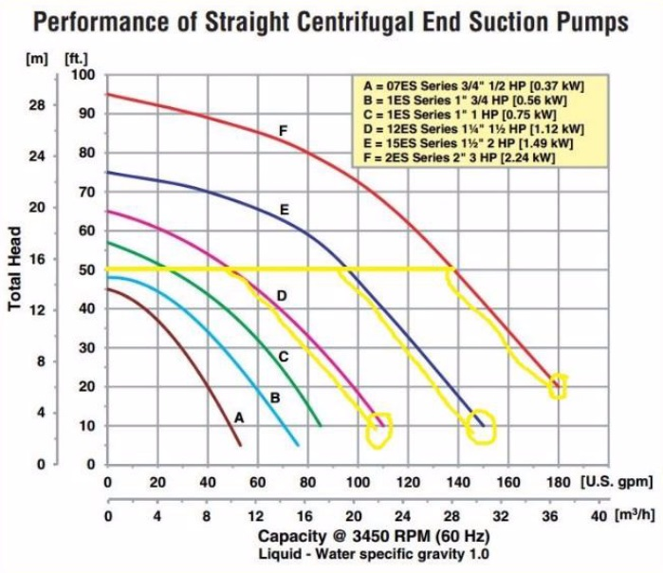
Situation #1: You are replacing an old pump that already has the pipes in place that are 2” going into the pump and 2” going out. The old pump is pumping water from a 5,000 gallon tank and pumping the water to a second tank that is 50 feet above the first tank. Your old pump was pumping approximately 100gpm (gallons per minute) and you would like to try to get a pump that will perhaps get you to 150gpm due to increased production demands.
So we can determine the following:
- You need a pump with a 2” inlet diameter and a 2” outlet diameter
- You have a minimum pump head of 50 feet
- You would like a pump that will give at least 150gpm
Looking at the pump curve below, which of the following 2” pumps will work for your application?
Step #1: Start with your required pump head (50 feet) on the left-hand side of the curve
- We can see that pumps A & B are below our required head, so we can rule them out.
- We now have 3 pumps on this curve that meet our total pump head requirement of 50ft.

Step #2: Determine which pump is capable of 125gpm or more
- From the left of the curve, starting at 50ft, draw an imaginary line to the right.
- Then follow each pump curve down towards the GPM.
- We can see that pump D will give us the 50 feet of head we require but will only give us 110gpm. It’s probably similar to the pump you are replacing.
- Pump E will meet our 50ft head requirement (it’s capable up to 75ft) and at 50ft head it will give us 145gpm. Pump F at 50ft of head will give us 180gpm.
Step #3: Decision Time!
You have 3 pumps to choose from that meet your requirements but you still have a few things to consider:
- Pump D:
  - Pro: similar to the pump you are replacing
  - Con: no real increase in performance in GPM (110gpm total)
  - Pro: guaranteed to be lower cost than pumps E & F
- Pump E:
  - Pro: increase of 45gpm compared to your old pump (145gpm total)
  - Pro: gets you close to your desire of 150gpm
  - Con: 5gpm lower than your 150gpm goal
  - Con: higher price than pump D
- Pump F:
  - Pro: increase of 80gpm compared to your old pump
  - Pro: 35gpm greater than pump E
  - Pro: gets beyond your desire of 150gpm (180gpm total)
  - Con: higher price than pumps D & E

