Final-Term Assignment

Course Title: Human Physiology II
Rad 2nd semester section A
Instructor: Dr. M .Shahzeb khan (PT)
Name : Marwa ID: 16690 Marks: 50

Note:
- Attempt all questions, all questions carry equal marks.
- Answer Briefly and to the point, avoid un-necessary details

Q1: (A) How stimulus of smell moves from nostril to brain? Make a Diagram as well

Q 2: (A) What is difference between Haemostasis, Haematopoiesis and Homeostasis?
(B) What is Erythroblastosis fetalis?

Q3: (A) What is Immunity? Explain different types of immunity
(B) What is difference between Antigen and Antibody?

Q4: (A) Write down different functions of Antibody
(B) Write difference between Primary and secondary response to an antigen

Q5: Write difference between cell mediated and Antibody Mediated Immunity

Answer : 1
Nose :
Our nose help us to smell and its a big part that helps and able us to taste things. The nose is also the main gate to the respiratory system, our boby system for breathing.
Nose parts :
The nose has two holes called nostrils. The nostrils and the nasal passages are separated by the wall called the septum. Deep inside our nose close to our skull, our septum is made of very thin pieces of bone. Closer to the tip of our nose the septum is made of cartilage which is a flexible bone its not as hard as bone. Behind our nose in the middle of our face is a space called the nasal cavity. It connects with the back of the throat. The nasal cavity is separated from the inside of our mouth by the palate (root of our mouth).
Smell move from nostril to brain :
Olfactory nerve :
When the smell receptors are stimulated, signals travel along the olfactory nerve to the olfactory bulb. Olfactory bulb is the front of our brain just above the nasal cavity. Signals are sent from the olfactory bulb to other parts of the brain to be interpreted as a smell you may recognize. Identifying smell is our brains way of telling us about our environment. Our sens of smell also can help us keep safe for example it can warm us not to eat something that smells rotten. In the cavity of nose mucous membrane is present which have smell receptor connected to the olfactory nerve.olfactory has a thin end called olfactory rod. From rod cilia proect to the mucous surface cilia reacts to order inthe air and stimulate the olfactory erve. Olfactory nerve receive the information from the axon of olfactory receptir neurons and transfer it to brain.

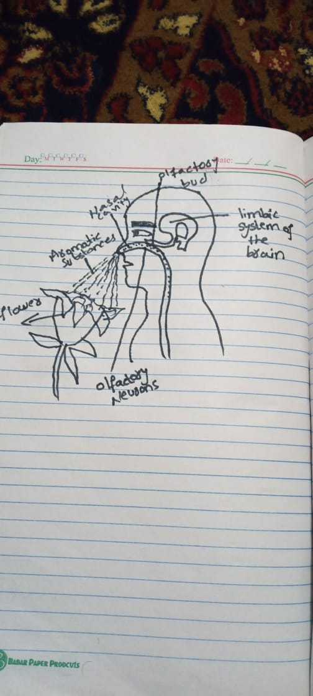

Answer : 2 (a)
Haemostasis:
The stoppage of bleeding the stoppage of blood flow through a blood vessel or organ of the body. Hemostasis is the arrest of bleeding.

Haematopoiesis :
Hematopoiesis is the term used to describe the differentiation of blood cells from hematopoietic stem cells. This process is continually required to maintain the levels of circulation blood cells in the body.

Homeostasis :
Any self regulating process by which biological systems tend to maintain stability while adjusting to conditions that are optimal for survival. If homeostasis is successful, life continues if unsuccessful, disaster or death ensures. The stability is actually a dynamic equilibrium in which continues changes occurs yet relatively uniform conditions prevail.

Difference :
Haemostasis :
- Haemostasis is the stopping of a flow of blood from the circulation system.
- Helps the circulatory system to perfuse the right organs.
- Prevents blood loos from the circulation when a blood vessel is ruptured.
- Wound healing and blood clotting are example.

Haematopoiesis :
- Haematopoiesis is the differentiation and maturation of blood cells from HSCs.
- Five types are found in haematopoiesis.
- Proerythroblast lymphoblast, myeloblast and megakaryoblast are the first committed cells.
- Regulated by a variety of growth factors.

Homeostasis :
- Homeostasis is the tendency to maintain a relativity stable internal conditions by a system of feedback controls.
- Mechanism by which the biological system maintains an equilibrium state.
- Maintains stable internal conditions.
- Regulation of the body temperature, acidity and alkalinity are examples.

Answer : (b)
Erythroblastosis fetalis :
Erythoblastosis fetalis is a hemolytic anemia in the fetus or neonate, caused by trans-placental transmission of material antibodies to fetal RBCs. The disorder usually results from incompatibility between maternal and fetal blood groups, often Rh antigens.
Disease of the newborn :
Hemolytic disease of the newborn is a blood problem in newborn babies. It occurs when the baby RBCs break down at a fast rate. Its also called erythroblastosis fetalis.
- Hemolytic means breaking down of red blood cells.
- Erythroblastosis means making immune red blood cells.
- Fetalis means fetus.
- In erythroblastosis fetalis, if the mother Rh is negative and the father Rh is positive the baby has inherited the the Rh positive antigen from the father, and the mother develops anti-Rh agglutinins from exposure to the fetus Rh antigen.
- Then the mothers agglutinins diffuse through the placenta in to the fetus and cause red blood cell agglutination.
Syptoms and sign in the fetus :
- Enlarged liver spleen, or heart.
- fluid in the fetus is seen while abdomen ultrasound.
Syptoms and sign in newborn :
- High output heart failure and pallor.
- Enlarged liver/spleen.
- Generalized Edema.
- Ascites and Respiratory (breathing difficulty).

Answer : 3(a)
Immunity :
A condition of being able to resist a particular disease espacially through preventing development of a patogenic microorganism or by counteracting the effects of its products. Lake of immunity is known as susceptibility. Protection against diseases.
Types of immunity :
There are two types of immunity.
- Innate immunity.
- Adaptive (acquired) immunity.
Innate immunity :
Innate immunity plays an important role in protection against infection that relies on mechanisms that exist before infection, are capable of a rapid response to microbes, and reacts against the infections.
- Exist at birth.
- Work against infection.
Types of innate immunity :
There are three types of innate immunity.
- Species immunity.
- Racial immunity.
- Individual immunity.
Species immunity:
It is the total immunity shown by all members of a species against pathogen e.g birds immune to tetanus.
Racial immunity :
It is that in which various races show marked difference in their resistance to certain infectious diseases.
Individual immunity:
It is very specific for each and every individual despite having same racial background and opportunity for exposure.

Adaptive immunity :
- Antigens can have multiple antigenic determination called epitopes. Each epitope is capable of producing an immune response.entire microbes may act as an antigen, but typically just certain small parts (epitopes), a large antigen complex trigger a response.
- once stimulated by antigen presentation, helper T cells become activated.
- Activated helper T cells are capable f activating other lympocytes to become T.
Types of adaptive immunity :
- Naturally :
Active immunity :
It is a type of specific immunity a host develops after exposure to foreign substance.
Passive immunity :
Transfer of antibodies e.g mother to fetus across placenta, mother to infant in breast milk.

- Artificially :
Active immunity :
Intentional exposure to a foreign material.
Passive immunity :
Perform antibodies or lymphocytes produced by one host are introduced into another host.

Answer : (b)
Antigen :
Definition :
- Antigen is a substance that causes your immune system to prompts the generation of antibodies.
- Antigens can be proteins, polysaccharides, conjugates of lipids with proteins (lipoproteins) and polysaccharides (glycolipid).
- An antigens may be a foreign substance from the environment such as chemicals, bacteria, viruses.
- An antigen may also be formed with in the body, as with bacterial toxins or tissue cells.

Antibody :
Definition :
Antibody is also called immunoglobulin, a protective protein produced by the immune system in response to the presence of a foreign substance, called an antigen. Antibodies recognize and latch onto antigen in order to remove them from the body. A wide range of substances are regarded by the body as antigens, including disease causing organisms and toxic materials such as insect venom.
Difference between antigen and antibody :
Antigen :
- An antigen is any substance that triggers an immune response in the body.
- Also called immunogens.
- Can be either proteins carbohydrates, lipids, or nucleic acid.
- Interacting domain with the antibody is called the epitope.
- Cause either diseases or allergic reactions.
- The four types include exogenous antigens, endogenous antigens, autoantigens, and neoantigens.
Antibody :
- An antibody is a blood protein that is produced against a specific antigen.
- Also called immunoglobulins.
- Glycoproteins.
- Variable site can bind to the epitope.
- Protect the body from antigens either by immobilizing the antigen or lysing the pathogen.

Answer : 4 (a)
Antibodies :
- Antibody is large protein, constitutes Y-gloublin produced by plasma cells.
- It is used by the immune system to identify and nutralize pathogens such as bacteria and viruses.
- Antibodies are also called immunogloublins.
- The antibody recognizes a unique molecule of the harmful agent called ANTIGEN, via the variable region.
Functions of antibodies :
- The most important functions of antibodies are to neutralize toxins and viruses.
- To opsonize microbes so they are more easily phagocytosed.
- To activate complement, and to prevent the attachment of microbes to mucosal surfaces.
- Antibodies also have a catalytic (enzymatic) capability.
- Neutralization (blocking).
- Complement activation (direct killing, enhancing phagocytosis).

Answer : (b)
Primary immune response :
Primary immune response is the reaction of the immune system when it contacts an antigen for the first time.

Secondary immune response :
Secondary immune response is the reaction of the immune system when it contacts an antigen for the second and subsequent times.

Difference between primary and secondary immune response :
Primary response :
- Small number of pathogen specific cells respond at the start.
- Delay before pathogen specific antibodies are produced.
- Non isotype switched antibody having a mixture of affinities for the pathogen is produced at the start.
- High threshold of activation.
- Delay before effector T cells are generated and are able to enter infected tissues.
- Innate immunity works alone until an adaptive response is generated.

Secondary response :
- Large number of pathogen specific cells respond immediately.
- Pathogen specific antibodies already present.
- Antibodies are isotype switched and have high affinity for the pathogen.
- Lower threshold of activation.
- Effector T cells are present and can enter infected tissue immediately.
- Close cooperation between innate and adaptive immunity from the start.

Answer : 5
Cell mediate immunity :
- Keep in mind that naive T cells do not produce effector cytokines or the molecules to kill other cells.
- The development of the effector T cells of CMI involves the sequence of antigen recognition, clonal expansion, and differentiation.

Antibody immunity :
An antibody also known as immunoglobulin, it is a large Y shaped protein produced mainly by plasma cells that is used by the immune system to neutralize pathogens such as pathogenic bacteria and viruses.

Difference between cell mediate and antibody immunity :
Cell mediate immunity :
- Cell mediate immunity refers to the other component of the adaptive immunity, which is mediated by the activated antigen specific T cells.
- Mediated by T cells.
- Mediated by helper T cells, cytoxic T cells, natural killer cells, and macrophages.
- Acts on intracellular microbes such as bacteria, and parasites and tumor cells.
- Involves TCR receptors.
- CD2, CD3, CD4, CD8, CD28, and integrins are the accessory receptors.
- Antigens are processed and presented by MHC complex.
- T cells secrete cytokines .
- A delayed type hypersensitivity.
- Acts on tumor cells and transplants .

Antibody immunity :
- Antibody immunity refers to a component of the adaptive immunity where B cells secrete antibodies, which circulates in the blood as a soluble protein.
- Mediated by B cells.
- Mediated by T cells, B cells and macrophages.
- Acts on extracellular microbes and their toxins.
- Involves BCR receptor.
- Iga, CD40, CD21, and Fc receptors are the accessory receptors.
- Recognizes unprocessed antigens.
- Plasma B cells secrete antibodies.
- Does not act on the tumor cells and transplants.

End !

