Name: Sabawoon Atif
Id # 16681
Section: A
Semester: 2nd ( BBA )
Final Term Assignment: Principles of Marketing
Submitted to: Sir Shahzeb Anwar

Question: 1
What is SWOT analysis? Why companies use it ? Develop a SWOT analysis for Iqra National University?
Answer:
SWOT ANALYSIS:
SWOT stands for Strength, weakness, opportunities and threats. It is a technique used to help a company or an organization identify its strength, weakness, opportunities and threats related to its business. SWOT Analysis is used to make the most of what a company have got to their maximum advantage. Similarly, the company can lower the chances of failure, by understanding what they are lacking, and reducing hazards.
Why Companies use it
We know that every company or organization needs a clear planning for growing its business. Likewise, every company needs clear direction in order to become the best version of themselves and the only to start is by using SWOT analysis. By analyzing strength, weakness, opportunities and threats, a company will be able to avoid unimportant matters and focus on what really matters.
The management will be able to identify the internal and external factors that will affect the company’s future performance. The company’s strengths and weaknesses are the internal factors, on the other hand, opportunities and threats are related to external factors of the company .Here are the following reasons why companies use it
1) SWOT analysis helps the company’s to determine how to allocate resources in a manner that will result in the highest possible potential for revenue growth and profitability.
2) SWOT allows the management team examines where the company can perfrom most effectively. So the company can effectively finds out that it has competitive strengths that have not been fully used in the past.
3) It allows a company to seek out new opportunities which includes new customer groups, broader product distribution, developing new kinds of products and services . In a SWOT analysis, the company can identify emerging opportunities to take advantage of them right now and tries to predict longer term opportunities so advance planning can be made in order to make it ready to enter the market when the time is right.
SWOT analysis for Iqra National University
Strength | Weakness | Opportunities | Threats
1)Provide education at affordable rate  2) Dedicated and committed Faculty staff  3) Foreign Accreditation/ Affiliations  4) Publication of research papers  5) Chartered with HEC 6) Students leader ship program  7) Artistic and cultural performance  8)Safety measures  9) Discipline  10) Promote Islamic values | 1)No flexible and extracurricular program for changing  2) Leading Competitors Location e.g CECOS and Qurtaba universities. | 1) Strong collaboration with local companies  2) Introduction of new specialization to attract more students from the state of KPK.  3) High probability of growth potential  4) New constructions 5) Scholarship | 1) Political and Socio economical negative conditions  2) Emergence of new business schools and universities each year  3) Negative public perception about growing private universities.

Question: 2
Discuss New Product Development Process and draw its model?
Answer;
New Product Development Process:
New product development is define as the complete 8 steps, techniques and processes of bringing new products to the current market of business and engineering. In today world if a company wants to be more successful from its competitors, they have to make new products so they can be a head of the curve. There are thousands of products introduced every time, only a handful reach the market. In other words, there is no better way around a systematic, customer-driven new product development process for finding and growing new products. There are eight major steps in the new product development process which will be discussed as follow:

- Idea Generation
The new product development process starts with idea generation. It refers to the systematic search for new product ideas. Two sources of new ideas can be identified. Internal idea sources: the company finds new ideas internally. That means R&D, but also contributions from employees. External idea sources: the company finds new ideas externally e.g. distributors, suppliers and also competitors.
- Idea Screening
Idea screening is the second step which means filtering the ideas to pick out good ones. In addition, all ideas generated are screened to pick the good ones and drop the bad ones as soon as possible. The reason is that product development costs rise greatly in later stages. Therefore, the company would like to go ahead only with those product ideas that will turn into profitable products.
- Concept development
The third step is concept development which has two parts. First, it shows a detailed version of the new product idea in consumer terms. Second, the concept is tested with large number of consumer targets to find out if the concept has a potential.
- Marketing Strategy development
In this fourth step a promising concept will be developed and tested. It has three parts
- The first part is a description of the target market, the planned value proposition, and the sales, market share and profit goals for the first few years
- The second part is an outline of the product’s planned price, distribution and marketing budget for the first year
- The third part is the planned long-term sales, profit goals and the marketing mix strategy.

- Business Analysis
This fifth step in the new product development process includes a analysis of the sales, costs and profit plans for the new product to find out whether these factors satisfy the company’s objectives. If they do, the product can be moved on to the product development stage.
- Product Development
The sixth step includes if the product concept passes the business test, it must be developed into a physical product to ensure that the product idea can be turned into a workable market offering. The R&D department will develop and test one more physical versions of the product concept which will lead to a successful prototype.
- Test Marketing
In the second last stage the product is pass through two tests concept test and product test. Similarly, if it passes both of them it enters the marketing step. In this stage market programs will be introduced in a marketing set up. This is extremely important because correct marketing helps in the promotion of the product and making the general public aware of it.
- Commercialization
The last stage is commercialization which means to introduce a new product into the market. Test marketing has given management the information needed to make the final decision, launch or do not launch the new product. At this point, the highest costs are considered the company may need to build or rent a manufacturing facility
Model of New product Development
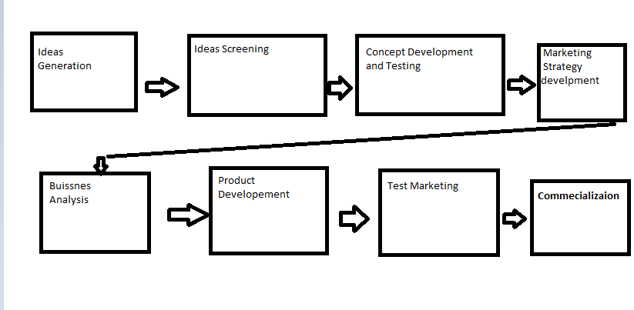

Question: 3
Write briefly about product Life cycle and draw its model ?
Answer;
Product Life Cycle:
In order to make sure that when a new product is introduced in a market it has maximum life expectancy. So the company can make a decent profit to cover all the cost associated during launching of the product. The product life cycle is divide into five stages, product development, introduction, growth, maturity and decline. In addition, it helps a lot management of a company to decide the right timing for increasing advertisement, lower prices and redesign the product if necessary. The five stages are follow as
- Product development begins when the company passes through all of the eight previous steps of product development which means that it have successfully develop a new product in the market. In the beginning, money is invested on the product with zero sales.
- Introduction means the size of the market for the product is small, which means sales are low, although they will be go up. On the other hand, the cost of things like research and development, consumer testing, and the marketing needed to launch the product can be very high because profits are almost zero at this stage.
- Growth stage is typically followed by a strong growth in sales and profits, and because the company can start to benefit from economies of scale in production. Finally, it will allow businesses to invest more money in the promotional activity to maximize the level of the growth stage.
- Maturity is when a product achieved recognition among buyers and is accepted. The sales growth slows down or even come to a dead stop which lead to decline in profits level. It is really a competitive challenge for most of companies. Finally, they need to consider any innovations in the product or production process which can give them an advantage over competitors.
- Decline starts when the market for a product starts to grow shrink, and this is what’s known as the decline stage. This shrinkage could be due to the fact that all the customers who will buy the product have already purchased it or because the consumers are switching to a different type of product and as a result the sales and profits drops.
- 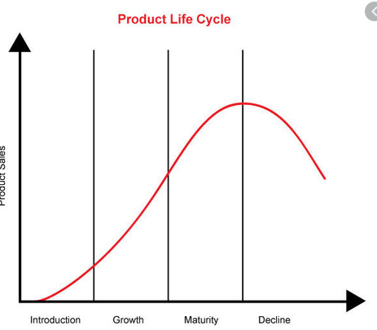

Question: 4
Write briefly about Branding along with examples ?
Answer;
BRANDING:
Branding is define as the marketing practice of creating a name, term, symbol, logo or design that identifies and differentiates one company product from the rest of other products is called branding. When company enter into the world of business and to target their audience is very crucial, In this early problem, they should implement comprehensive and well-strategized branding for their business.
For Example, It gives your business its identity and persona. It also helps to represent what your company offer as a business, what they sell, and how different you are from other products or services. MacDonald’s provide fast and junk food services while YouTube is a social video media platform which can be differentiated by looking at their brand logos. Your brand is like the public face and personality of your company. Finally, coco cola, has its own logo that helps it identify it from other soft and cold drinks.

The End

