NAME: YOUSAF KHAN
ID # 13751
SUBJECT: STATISTICAL INFERENCE
TEACHER’S NAME: MS. WAJIHA AMIN
SEMESTER: 7TH
MID ASSIGNMENT

Q1 The average rainfall in an area recorded is 9.22cm for a month. Given the distribution to be normally distributed with a standard deviation of 2.83cm,
- Find the probability that the rainfall in the next month will be less than 1.84cm.
- Rainfall will be between 7 cm and 13.8cm.
Rainfall is more than 11.05 cm
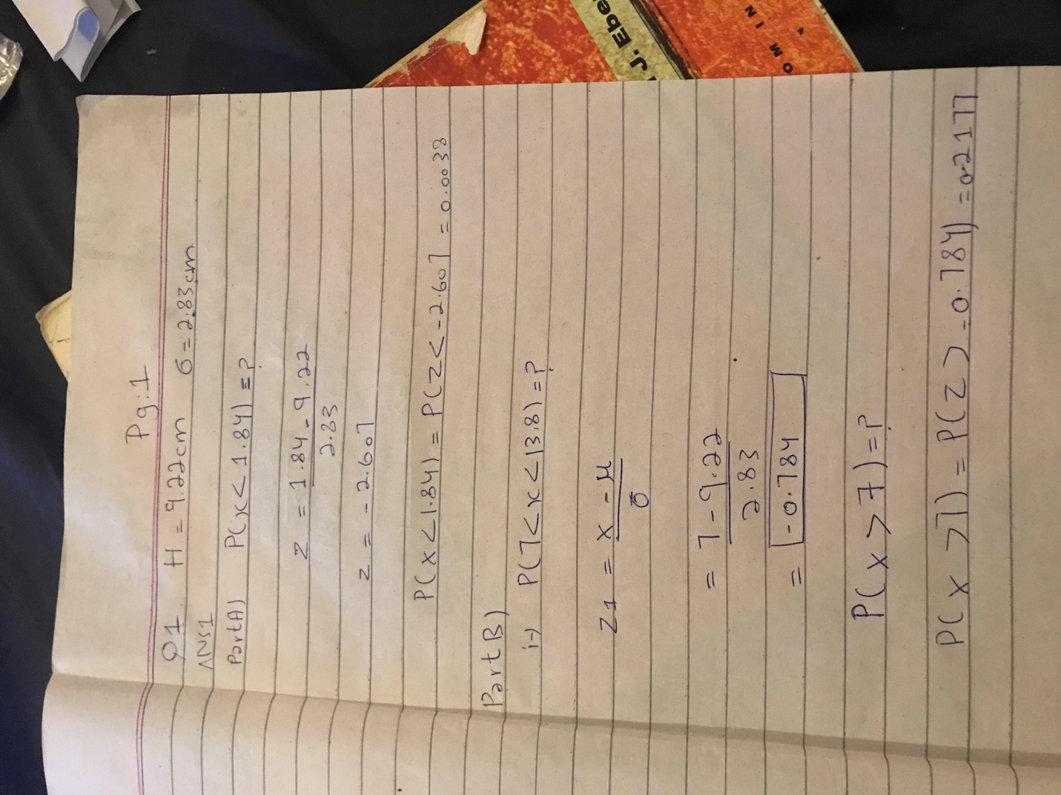

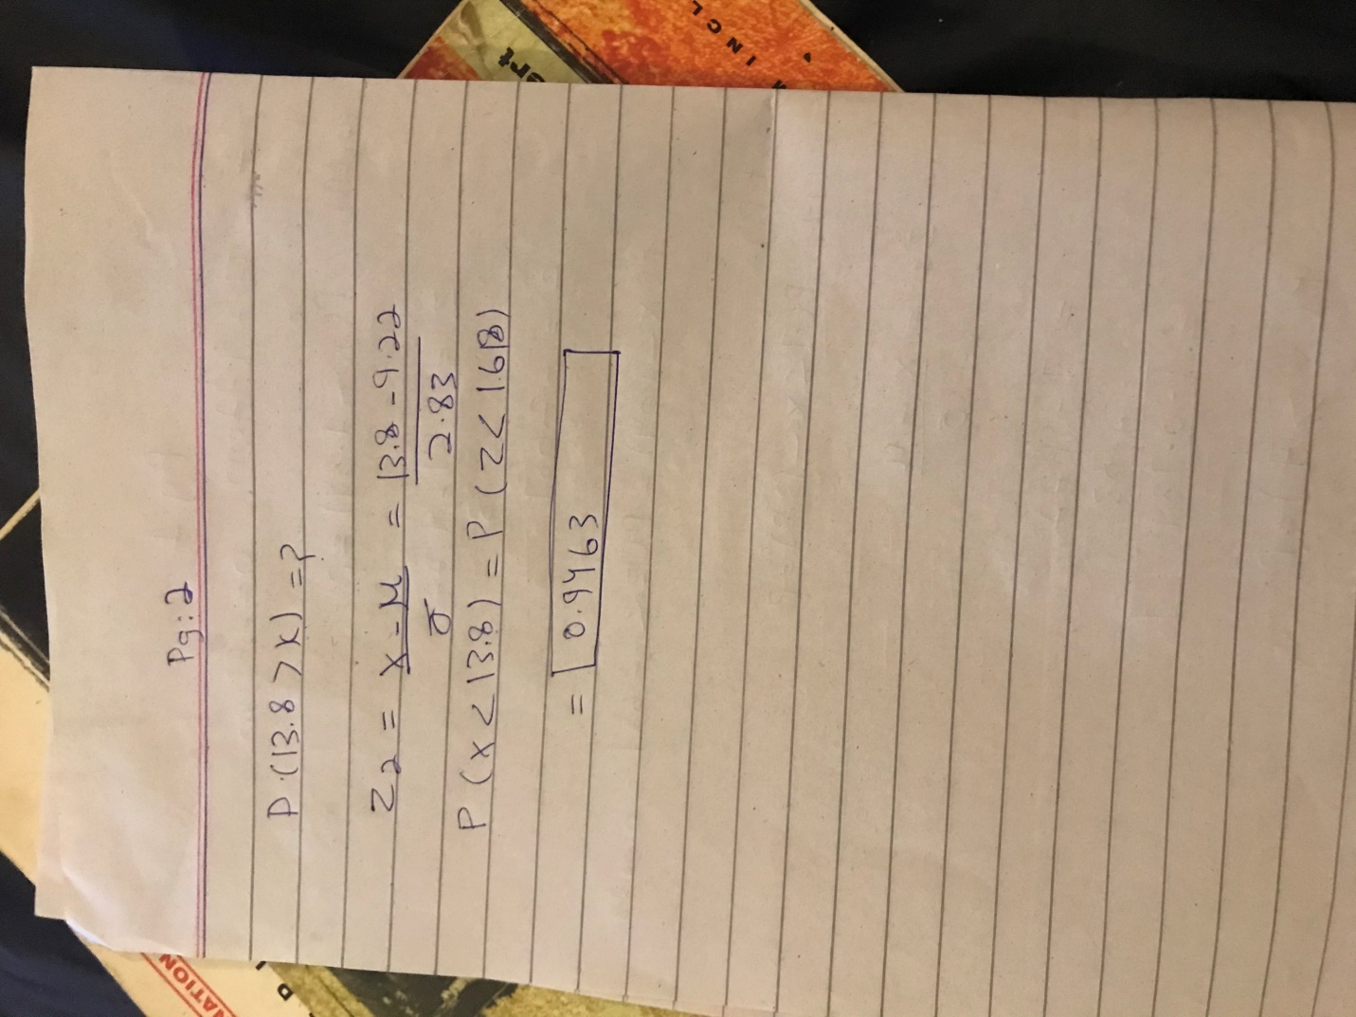

Q2: (a) Discuss any 3 characteristics of normal distribution and discuss its uses in the business world.
A2: The characteristics of normal distribution are as follows:
The distribution is symmetric and its skewness measure is zero and apart from that the entire family of normal distribution is defined by its mean and its standard deviation.
The highest point on the normal curve is at the mean, which is also the median and the mode and the mean either be positive negative or even zero.
The standard deviation decides the width of curve and larger values result in wider flater curves.
A business needs proper information in time so that it can make timely and accurate decisions manage all the risks and confirms the effective application of decisions. Now for this purpose our business heavily depends on statistics as it can provide qualitative and quantitative information for a specific purpose and then after that it analyzes and interprets the collected information and all of it aids in decision making.
Normal distribution is of utmost importance it helps to decide certain characteristics of data and also provides as a base for using other statistical tools for decision making. It helps in quality control, cost managemen and business operations just to determine the most sensitive part of the variable.
(b) Suppose you are going to be conducting a study on students, asking for their opinion on an issue of interest to you (could be related to the university, or a wider societal issue).Describe how you would carry out the sampling of students using the following methods:
(i) simple random sampling
(ii) stratified sampling
(iii) cluster sampling Think about what attributes of the student population make sense to stratify vs. cluster
A 2)
Part B)
Simple random sampling: Simple random sampling is a subset of a statistical population in which each number of the subset has an equal probability of being chosen. A simple random sample is meant to be an unbiased representation of a group.
It would be the names of 25 students being chosen out of a hat from a batch of 250 students. In this case the population is all 250 employees and the sample is random because each employee has an equal chance of being chosen. Random sampling is used in science to conduct randomized control test or for blinded experiments.
Stratified sampling: Stratified sampling is a method of sampling that involves the division of a population in to smaller sub-groups known as strata.
I will now divide all of the students into two groups then conduct a questioner test then will select the ones with the best results .
This is conducted to save time and money.
The result of a subset of population which represents the entire population.
Cluster sampling: It is known as the probability sampling technique . Researchers divide the population in to multiple groups called clusters . Then random groups are selected with a systematic random sanpling technique for data analysis.
I will divide the students in different clusters then select the best group for the test.
I think the cluster formation will be best for the students division.
Q3 ) : (a) Determine the type of sampling used (simple random, stratified, systematic, cluster, or convenience).
1. A group of test subjects is divided into twelve groups; then four of the groups are chosen at random.
2. A market researcher polls every tenth person who walks into a store.
3. The first 50 people who walk into a sporting event are polled on their television preferences.
4. A computer generates 100 random numbers, and 100 people whose names correspond with the numbers on the list are chosen.
Ans 3 The type of sampling technique used in part 1 is cluster
2. In part 2 it is systematic sampling technique
3. Convenience type of sampling technique
4. Simple random technique used

(b) Differentiate between
- Descriptive statistics and inferential statistics
- Variance and standard deviation
- Cluster and strata

Ans 3 ) Descriptive statistics and inferential statistics:
Part b) Descriptive statistics describes sets of data and inferential statistics draws conclusions about the sets of data based on sampling. Descriptive and inferential they both give different insights into the nature of the data gathered one alone just cannot provide you with the whole picture
Variance and standard deviation: The variance measures the degree to which each point differs from the mean while on the other hand the standard deviation looks at how spread out a group of numbers is from the mean just by looking at the square root of the variance.
Cluster and strata: The main difference between cluster sampling and stratified sampling is that in cluster sampling the cluster is treated as the sampling unit so sampling is done on a population of clusters (at least in the first stage). In stratified sampling, the sampling is done on elements within each stratum

